# Project: Analyzing a Market Test

## Step 1: Plan Your Analysis

*To perform the correct analysis, you will need to prepare a data set. (500 word limit)*

*Answer the following questions to help you plan out your analysis:*

1. What is the performance metric you’ll use to evaluate the results of your test?

* The performance metric is the profit increase at least 18%.

1. What is the test period?

* The test period is 12 weeks.

1. At what level (day, week, month, etc.) should the data be aggregated?

* I will aggregate data to week period

## Step 2: Clean Up Your Data

*In this step, you should prepare the data for steps 3 and 4. You should aggregate the transaction data to the appropriate level and filter on the appropriate data ranges. You can assume that there is no missing, incomplete, duplicate, or dirty data. You’re ready to move on to the next step when you have weekly transaction data for all stores.*

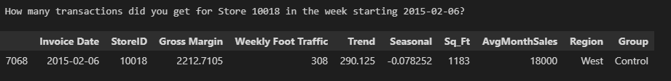

## Step 3: Match Treatment and Control Units

*In this step, you should create the trend and seasonality variables, and use them along with you other control variable(s) to match two control units to each treatment unit. Note: Calculate the number of transactions per store per week to calculate trend and seasonality.*

*Apart from trend and seasonality...*

1. What control variables should be considered? Note: Only consider variables in the RoundRoastersStore file.

* Control variables to be used are Sq_Ft and AvgMonthSales

1. What is the correlation between your each potential control variable and your performance metric?

* Control variable Sq_Ft has weak correlation with aggregated weekly store gross margin.
* Control variable AvgMonthSales has strong correlation with aggregated weekly store gross margin.

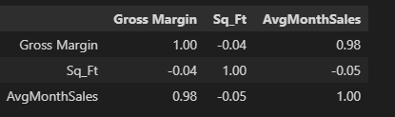

1. What control variables will you use to match treatment and control stores?

* I will use AvgMonthSales due to its high correlated to performance as control variables.
* I will also use Trend and Seasonal as control variables.
* Total I will have three control variables named AvgMonthSales, Trend and Seasonal

1. Please fill out the table below with your treatment and control stores pairs:

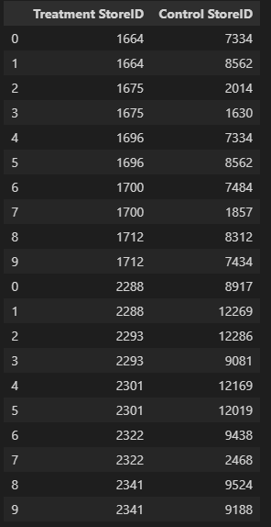

## Step 4: Analysis and Writeup

*Conduct your A/B analysis and create a short report outlining your results and recommendations. (250 words limit)*

*Answer these questions. Be sure to include visualizations from your analysis:*

1. What is your recommendation - Should the company roll out the updated menu to all stores?

* I recommend the company to roll out the updated menu

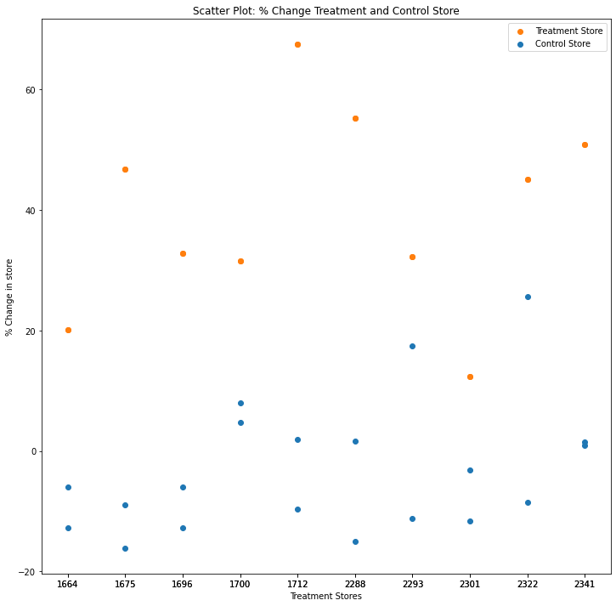

1. What is the lift from the new menu for West and Central regions (include statistical significance)?

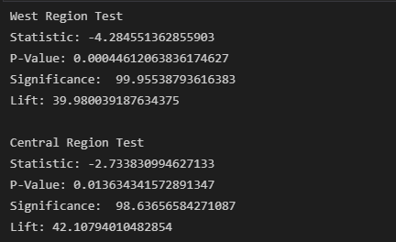

1. What is the lift from the new menu overall?

