# Program: Lesson 7 Calorie Counter
# Programmer: Douglas Rosenfield
# Date: 02/22/19
# Purpose: The purpose of this program is to count the calories of food items based on user input.

# banner
print ("welcome to my calorie counter program")

# define variables
cont = "" # sentinel
item_cnt = int(0) # item count
tot_cals = int(0) # total calories

# define functions

def calc_cals(g_type, grams):
if g_type == "f":
return grams * 9
else:
return grams * 4

while cont.lower() != "y" and cont.lower() != "n":
cont = input("Would you like to track a meal? (y/n)> ")

while cont.lower() == "y":
valid_data = False #bool flag

# capture input
while not valid_data:
item_name = input("Please enter the item> ")
if len(item_name) > 20:
print("Not a valid food name")
elif len(item_name) == 0:
print("You must enter a name")
else:
valid_data = True

valid_data = False
while not valid_data:
try:
g_carbs = int(input("Enter grams of carbs> "))
valid_data = True
except Exception as detail:
print("carbs error: ", detail)

valid_data = False
while not valid_data:
try:
g_fats = int(input("Enter grams of fats> "))
valid_data = True
except Exception as detail:
print("fats error: ", detail)

valid_data = False
while not valid_data:
try:
g_prot = int(input("Enter grams of proteins> "))
valid_data = True
except Exception as detail:
print("protein error: ", detail)

# math below
cals = calc_cals("c", g_carbs) + calc_cals("f", g_fats) + calc_cals("p", g_prot)
# confirmation of add to meal block here
valid_data = False # bool flag
while not valid_data:
incl = input("Add {} to your meal? (y/n)> ".format(item_name))
print()
if incl.lower() == "y":
tot_cals = tot_cals + cals
item_cnt += 1
print("{} has been added to your meal!\n".format(item_name))
valid_data = True
elif incl.lower() == "n":
print("{} was not added to your meal.\n".format(item_name))
valid_data = True
else:
print("Your input was not valid. Please input either 'y' or 'n'.")

# output
print ("Total calories for {} are {}".format(item_name, cals))
cont = input("Would you like to track another item? (y/n)> ")

print("Your meal has {} items and contains {} calories.".format(item_cnt, tot_cals))
print("Thank you, have a nice day!")

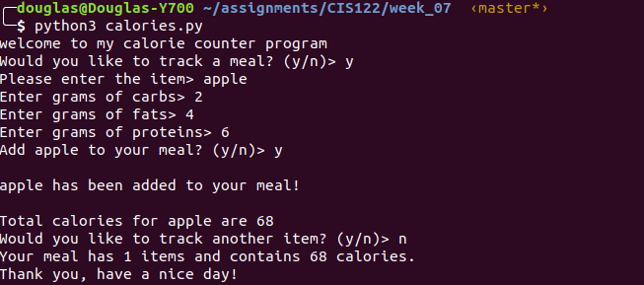
# Program: Lesson 7 Girl Scout Cookies Order Form
# Programmer: Douglas Rosenfield
# Date: 02/22/2019
# Purpose: To create an order form using try to validate data in user inputs

#variables
import locale
locale.setlocale( locale.LC_ALL, '')

item_cnt = 0 # count of items ordered
order_total = 0.0 # accumulated total dolars
price = 3.5 # all cookies are #3.50 per box

# define functions
def disp_items():
#display cookie list
#This is a simple function that displays available
#cookie flavors.
print("Please choose one of our flavors. Enter the item number to choose.")
print("num\tflavor")
print("1. \tSavannahs")
print("2. \tThin Mints")
print("3. \tTag-A-Longs")
print()

def calc_tot(qty):
# function accepts a passed quantity
# multiplies it by price, returns total
return qty * 3.5

def print_order():
# displays order totals
fmt_total = locale.currency(order_total, grouping = True)
print("\nYou ordered {} item(s) for a total price of {}".format(item_cnt,fmt_total))

# Banner
print("BUY COOKIES. IT IS MANDATORY.")
user = input("Please enter your name> ")

# Validate data entry
cont = "" # set cont to neither "y" nor "n"
while cont.lower() != "y" and cont.lower() != "n":
cont = input("Would you like to place an order? (y/n) > ")

while cont.lower() == "y":
print()
valid_data = False #bool flag

#input and data validation

while not valid_data:
# display cookie list
disp_items()
item = input("enter item number> ")

if item == "1" or item == "2" or item == "3":
valid_data = True
else:
print ("\nThat was not a valid choice, please try again.")

valid_data = False #reset bool flag
while not valid_data:
try:
while not valid_data:
qty = int(input("enter quantity> "))
if 1 <= qty <= 10:
valid_data = True
else:
print("Please enter a number between 1 and 10")
except Exception as detail:
print("quantity error: ", detail)
print("Are you sure you entered a number?")

# determine totals
item_total = calc_tot(qty)
fmt_total = locale.currency(item_total, grouping=True)

# determine cookie name for output display
if item == "1":
name = "Savannah"
elif item == "2":
name = "Thin Mints"
else:
name = "Tag-a-longs"

print("\n{} {} {} {}".format(name, qty, price, fmt_total))
print()

# verify inclusion of this item
valid_data = False

while not valid_data:
incl = input("Would you like to add this to your order? (y/n)> ")
print()
if incl.lower() == "y":
order_total = order_total + item_total #can += item_total work here?
item_cnt += 1
valid_data = True
print("{} was added to your order".format(name))
elif incl.lower() == "n":
print ("{} was not added to your order".format(name))
valid_data = True
else:
print("That was not a valid response. Please input either y or n." )

# add another item?
cont = input("\nWould you like to add another item? (y/n)> ")

print_order()
print("Thank you for your order, {}!".format(user))

