**­­**

**CS 480**

**Project Plan**

**Document Control**

Document Information

|  |  |
| --- | --- |
| **©** | **Information** |
| Document Owner | *Group B* |
| Issue Date | *1/16/2024* |
| Last Saved Date | *1/16/2024* |
| File Name | *Group1_InitialProjectPlan.docx* |

Document History

|  |  |  |
| --- | --- | --- |
| **Version** | **Issue Date** | **Changes** |
| *1.0* | *1/16/2024* | *Scope, Schedule, and Milestones addressed.* |
| *1.1* | *1/28/2024* | *Remaining sections addressed* |
|  |  |  |
|  |  |  |

**Table of Contents**

1 Planning Basis 2

1.1 Scope 2

2 Project Plan 2

2.1 Schedule 2

2.2 Milestones 2

2.3 Phases 2

2.4 Tasks 2

2.5 Effort 2

2.6 Resources 3

2.7 Dependencies 3

2.8 Assumptions 3

2.9 Constraints 3

3 Budget, Risks and Change Management 3

Appendix 4

# Planning Basis

## Scope

The scope of this project is from January 28th, the submission of our initial project plan, to March 17th, the day the project is presented. All contents within this plan are intended to be complete during this time frame.

# Project Plan

## Schedule

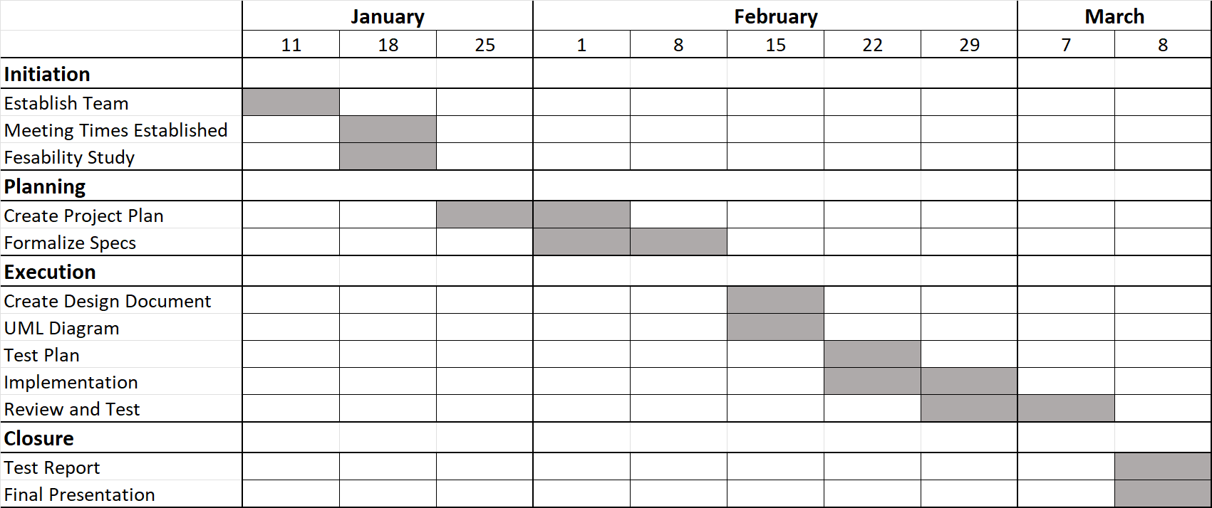

## Milestones

|  |  |  |
| --- | --- | --- |
| **Milestone** | **Description** | **Delivery Date** |
| Initial Project Plan | Brief outline of project scope, detailed task identification, and task duration estimates. | 01/28/2024 |
| Software Requirements Specification | Detailed documentation of software needs and functionalities. | 02/04/2024 |
| Updated Project Plan | Revised plan reflecting progress and adjustments in scope or timelines. | 02/11/2024 |
| Project Design | Blueprint of the project's architecture, interfaces, and design elements. | 02/18/2024 |
| Test Plan | Strategy and methodology for testing software functionalities and performance. | 02/25/2024 |
| Implementation | Execution phase for developing and coding the software. | 03/03/2024 |
| Test Report | Comprehensive analysis of testing outcomes, including bug reports and performance assessments. | 03/10/2024 |
| Presentation | Final demonstration and overview of the project, its outcomes, and future recommendations. | 03/17/2024 |

## Phases

|  |  |  |
| --- | --- | --- |
| **Phase** | **Description©** | **Sequence** |
| Initiation | Organize team and establish goals | 1 |
| Planning | Planning what needs to be done and how to do it | 2 |
| Execution | Begin development and testing of project | 3 |
| Closure | Finalize project and report results of testing and present to stakeholders | 4 |

## Tasks

A ‘*task*’ is simply an item of work to be completed within the project. List all tasks required to undertake each activity, within the following table:

|  |  |  |  |
| --- | --- | --- | --- |
| **Phase** | **Activity** | **Task** | **Sequence** |
| 1 | Establish Teams | Organize Team | 1st |
| 1 | Feasibilty Study | Survey of skills | 1st |
| Determine feasible goals | 2nd |
| 1 | Choose Tech Stack | Choose Frontend technology | 1st |
| Choose Backend Technology | 2nd |
| Choose Database Technology | 3rd |
| 2 | Create Project Plan | Develop Schedule | 1st |
| Risk Assessment | 2nd |
| Finalize and Review | 3rd |
| 2 | Formalize Specs | Write Software Introduction | 1st |
| Write Software Overview | 2nd |
| Determine Specific requirements | 3rd |
| 3 | Create Design document | Data Design | 1st |
| Software Design | 2nd |
| UI Design | 3rd |
| 3 | Test Plan | Defect Management Plan | 1st |
| Test Cases | 2nd |
| 3 | Implementation | Implement Database | 1st |
| Build UI | 2nd |
| Implement Back-end | 3rd |
| 3 | Review | Review and finalize code | 1st |
| Run Tests from Test Plan | 2nd |
| 4 | Test Report | Write up Test Results | 1st |
| 4 | Final Presentation | Plan Presentation | 1st |
| Perform Presentation | 2nd |

## Effort

|  |  |
| --- | --- |
| **Task©** | **Effort** |
| Organize Team | *1 day* |
| Survey of skills | 2 days |
| Determine feasible goals | 1 day |
| Choose frontend technology | 1 day |
| Choose backend technology | 1 day |
| Choose database technology | 1 day |
| Develop schedule | 2 days |
| Risk assessment | 2 days |
| Finalize and review | 2 day |
| Write software introduction | 1 day |
| Write Software overview | 3 days |
| Determine specific requirements | 3 days |
| Data Design | 2 days |
| Software Design | 2 days |
| UI Design | 2 days |
| Defect Management Plans | 2 days |
| Test cases | 4 days |
| Implement Databases | 2 days |
| Implement UI | 7 days |
| Implement Back-end | 7 days |
| Review and finalize code | 2 days |
| Run Tests from test plans | 1 day |
| Write up Test Results | 2 days |
| Plan Presentation | 3 days |
| Perform Presentation | 1 day |

## Resources

|  |  |
| --- | --- |
| **Task©** | **Resource** |
| Basic Web Traversal | *React.js* |
| Graph Representation of stocks | *Matplotlib* |
| Web Host | *Django* |
| Database | *MySQL* |

## Dependencies

|  |  |  |
| --- | --- | --- |
| **Activity** | **Depends on©** | **Dependency Type** |
| Pull Data | Creating Database | Finish-to-start |
| Graphical Representations of Data | Pulling data and sorting into database | Progress-to-start |
| UX Design | UML and Environment Diagrams | Finish-to-start |
| Web Environment | UX Design | Finish-to-start |

## Assumptions

* It is assumed the project will not change in scope.
* The specified resources will be readily available.
* The specified resources will work in tandem with our project goals.

## Constraints

* The project must be completed within a short-term scope.
* The project team must deliver the software with no additional hardware.
* The project must be presentable remotely.
* Members must be readily available throughout the scope period.
* Members must complete project milestones within a given period of time.

# Budget, Risks and Change Management

**3.1 Project Budget**

|  |  |  |  |  |  |
| --- | --- | --- | --- | --- | --- |
| WBS | Task | Labor | Materials | Budget | Actual |
| 1 | Data Pull | $0 | $0 | $0 | $0 |
| 2 | Graph Creation | $0 | $0 | $0 | $0 |
| 3 | UX Design | $0 | $5 | $5 | $5 |
| 4 | UX Implementation | $0 | $0 | $0 | $0 |

**3.2 Risk Log**

|  |  |  |  |  |  |
| --- | --- | --- | --- | --- | --- |
| ID | Risk | Impact | Response | Risk Level | Risk Owner |
| 1 | API Pull Delay | Schedule | Backup | Moderate | Steiner, Michael |
| 2 | Data Manipulation Delay | Schedule | Backup | Moderate | Steiner, Angel, Dillon |
| 3 | UX Delay | Schedule | Backup | Moderate | Jeff, Issa, Michael |
| 4 | UX Formatting Issue | Project Appeal | Cater to constraint or ask for assistance | High | Jeff, Michael, Issa |
| 5 | Unable to update stock data to web application | Project Success | All members research a fix | High | Steiner, Angel, Dillon |

**3.3 Change Management**

|  |  |  |  |  |  |
| --- | --- | --- | --- | --- | --- |
| Date Identified | Request | Impact | Approval | Date Started | Date Completed |
|  |  |  |  |  |  |
|  |  |  |  |  |  |
|  |  |  |  |  |  |

# Appendix