**AEDA**

Final Project

Raúl García Gómez

Marc Monclús

Table of contents

Report 3

Dataset origin 3

Exploratory Data Analysis 3

k-median and Partitioning Around Medoids (PAM) algorithms: 4

PLOTS & SUMMARY 5

R Script 10

# Report

For the realization of this final project of data analysis, a database from NASA of discovered planets has been used with enough data in columns to meet the specifications of having:

* ID
* Name of the planet
* One binary categorical variable:
  + Controversial Flag (originally an integer class converted to a Boolean)
* 2 polyatomic categorical variables (or more):
  + Discovery method
  + Discovery Year
  + Discovery Facility
  + Spectral Type
* Seven numerical variables.
  + Number of Stars
  + Number of Planets
  + Orbital Period [days]
  + Planet Radius [Earth Radius]
  + Planet Mass or Mass*sin(i) [Earth Mass]
  + Eccentricity
  + Equilibrium Temperature [K]
  + Distance (parsec)
  + Orbit Semi-Major Axis

## Dataset origin

The database has been obtained from the NASA Exoplanet Archive in the following link:

<https://exoplanetarchive.ipac.caltech.edu/cgi-bin/TblView/nph-tblView?app=ExoTbls&config=PS>

First of all, the database that contains the link is made up of a large number of columns that we consider prior to downloading in .csv format that are not necessary and it is decided to dispense with them even before downloading the data set itself. Is attached to this project.

Next, so that RStudio can correctly read the data set, the comments are extracted from the file by opening it in notepad and thus saving the csv as a conventional csv (the #comments that correspond to a legend about what each column is are attached in a txt in the present work to understand better the data used).

When importing the database in RStudio, the data that has been considered excessive for the analysis is finished, but. Even so, some more data has been left than is necessarily required for this project due to pure added interest, such as the semi-major axis or some of the variables such as the distance in parsec and the spectral facility.

# Exploratory Data Analysis

To treat the data before doing the analysis, as usual, we dispense with the records in the database that contain Not Available (NA) in any of the variables.

On the other hand, it is important to eliminate the outliers to facilitate the observation of the results without having values that are excessively distant from the group that makes up the records of the same variable.

# k-median and Partitioning Around Medoids (PAM) algorithms:

The choice of using the k-median and partitional around medoids (PAM) algorithms is due to the sensitivity of the k-medians with the outliers and to the random selection of centroids.

# PLOTS & SUMMARY

#Line 198

#summary(pl_clean_df_2_scaled)

|  |  |  |  |  |  |  |  |  |  |  |  |  |  |  |
| --- | --- | --- | --- | --- | --- | --- | --- | --- | --- | --- | --- | --- | --- | --- |
| pl_name | sy_snum | sy_pnum | discoverymethod | disc_year | disc_facility | pl_controv_flag | pl_orbper | pl_orbsmax | pl_rade | pl_bmasse | pl_orbeccen | pl_eqt | st_spectype | sy_dist |
| Length:179 | Min. :1.000 | Min. :1.00 | Length:179 | Min. :2009 | Length:179 | Mode :logical | Min. : 0.1797 | Min. :0.00580 | Min. : 0.718 | Min. : 0.4 | Min. :0.00000 | Min. : 353 | Length:179 | Min. : 8.074 |
| Class :character | 1st Qu.:1.000 | 1st Qu.:1.00 | Class :character | 1st Qu.:2016 | Class :character | FALSE:179 | 1st Qu.: 2.4218 | 1st Qu.:0.03424 | 1st Qu.: 4.151 | 1st Qu.: 26.0 | 1st Qu.:0.00000 | 1st Qu.: 957 | Class :character | 1st Qu.: 115.698 |
| Mode :character | Median :1.000 | Median :1.00 | Mode :character | Median :2018 | Mode :character | NA | Median : 3.4655 | Median :0.04500 | Median :11.904 | Median :163.4 | Median :0.00000 | Median :1370 | Mode :character | Median : 271.103 |
| NA | Mean :1.179 | Mean :1.33 | NA | Mean :2017 | NA | NA | Mean : 4.0537 | Mean :0.04649 | Mean :10.269 | Mean :215.9 | Mean :0.03091 | Mean :1306 | NA | Mean : 338.286 |
| NA | 3rd Qu.:1.000 | 3rd Qu.:1.00 | NA | 3rd Qu.:2020 | NA | NA | 3rd Qu.: 4.8530 | 3rd Qu.:0.05600 | 3rd Qu.:14.325 | 3rd Qu.:305.8 | 3rd Qu.:0.05850 | 3rd Qu.:1613 | NA | 3rd Qu.: 512.714 |
| NA | Max. :3.000 | Max. :4.00 | NA | Max. :2022 | NA | NA | Max. :12.2519 | Max. :0.09800 | Max. :21.017 | Max. :940.7 | Max. :0.17600 | Max. :2492 | NA | Max. :1148.930 |

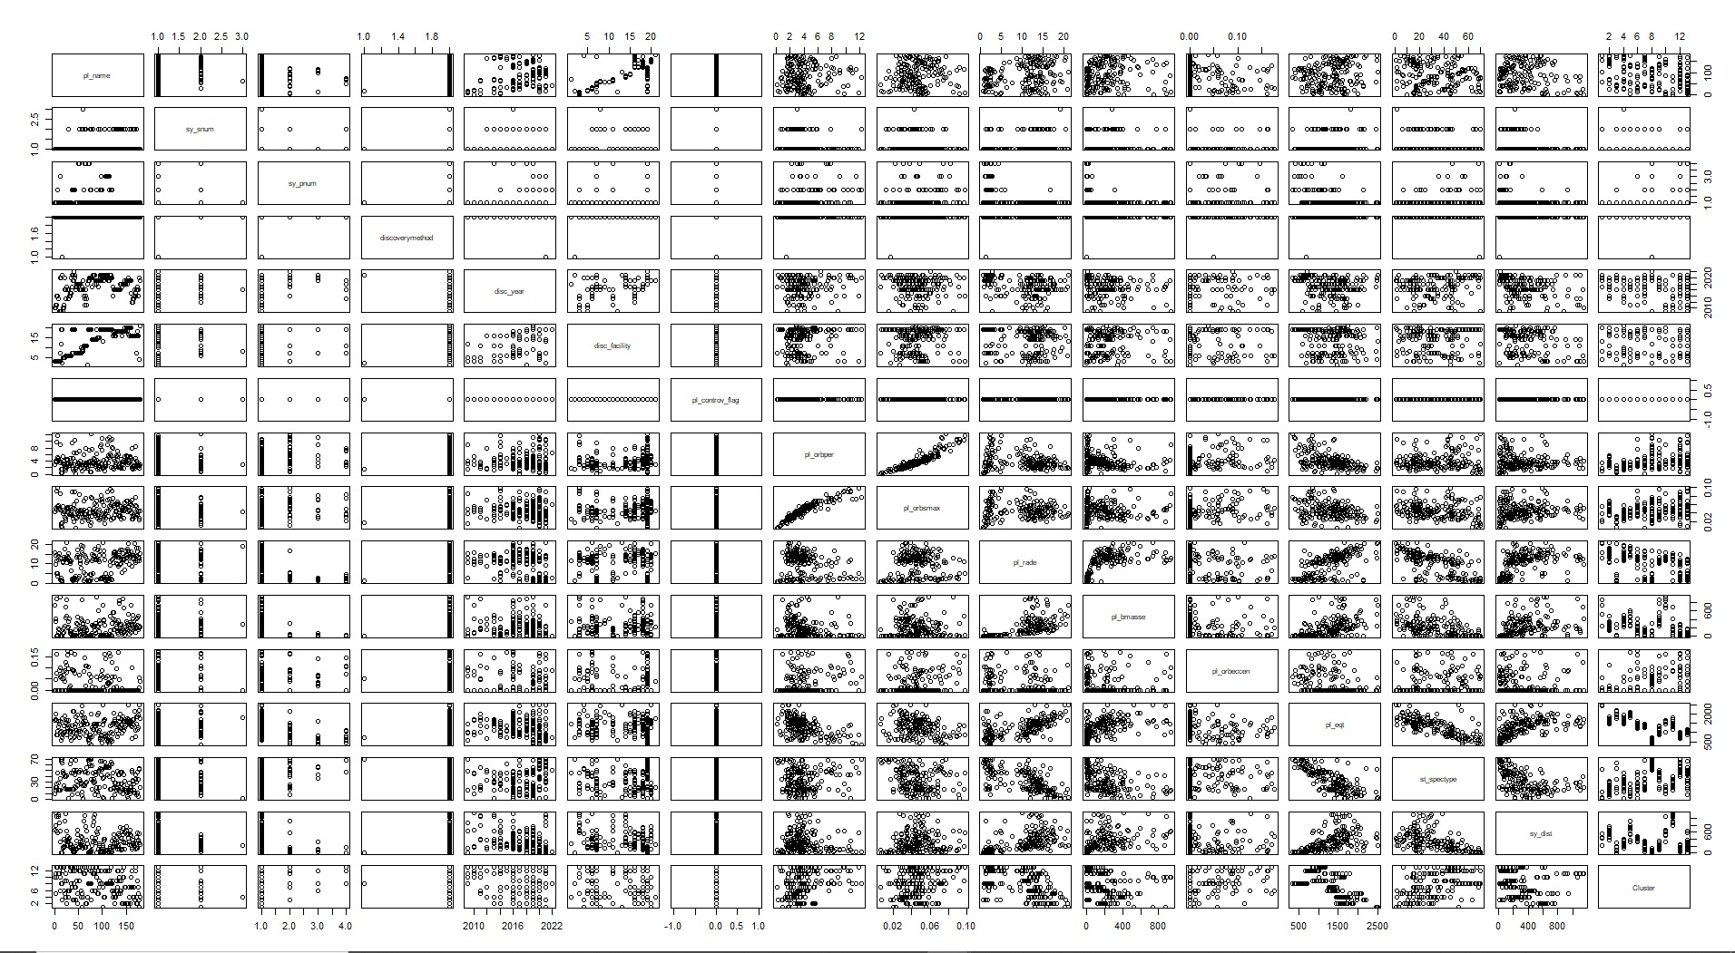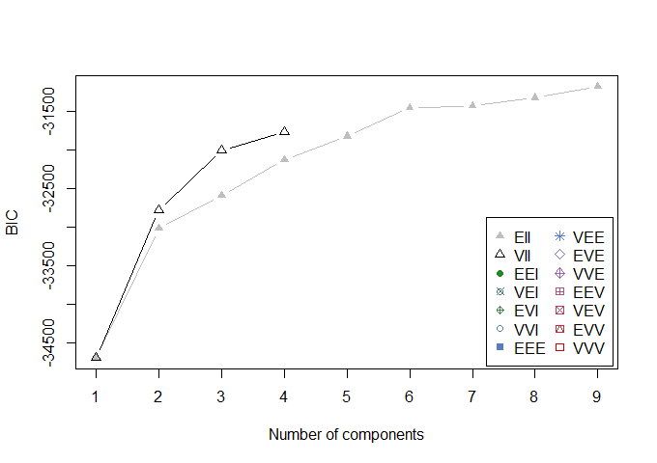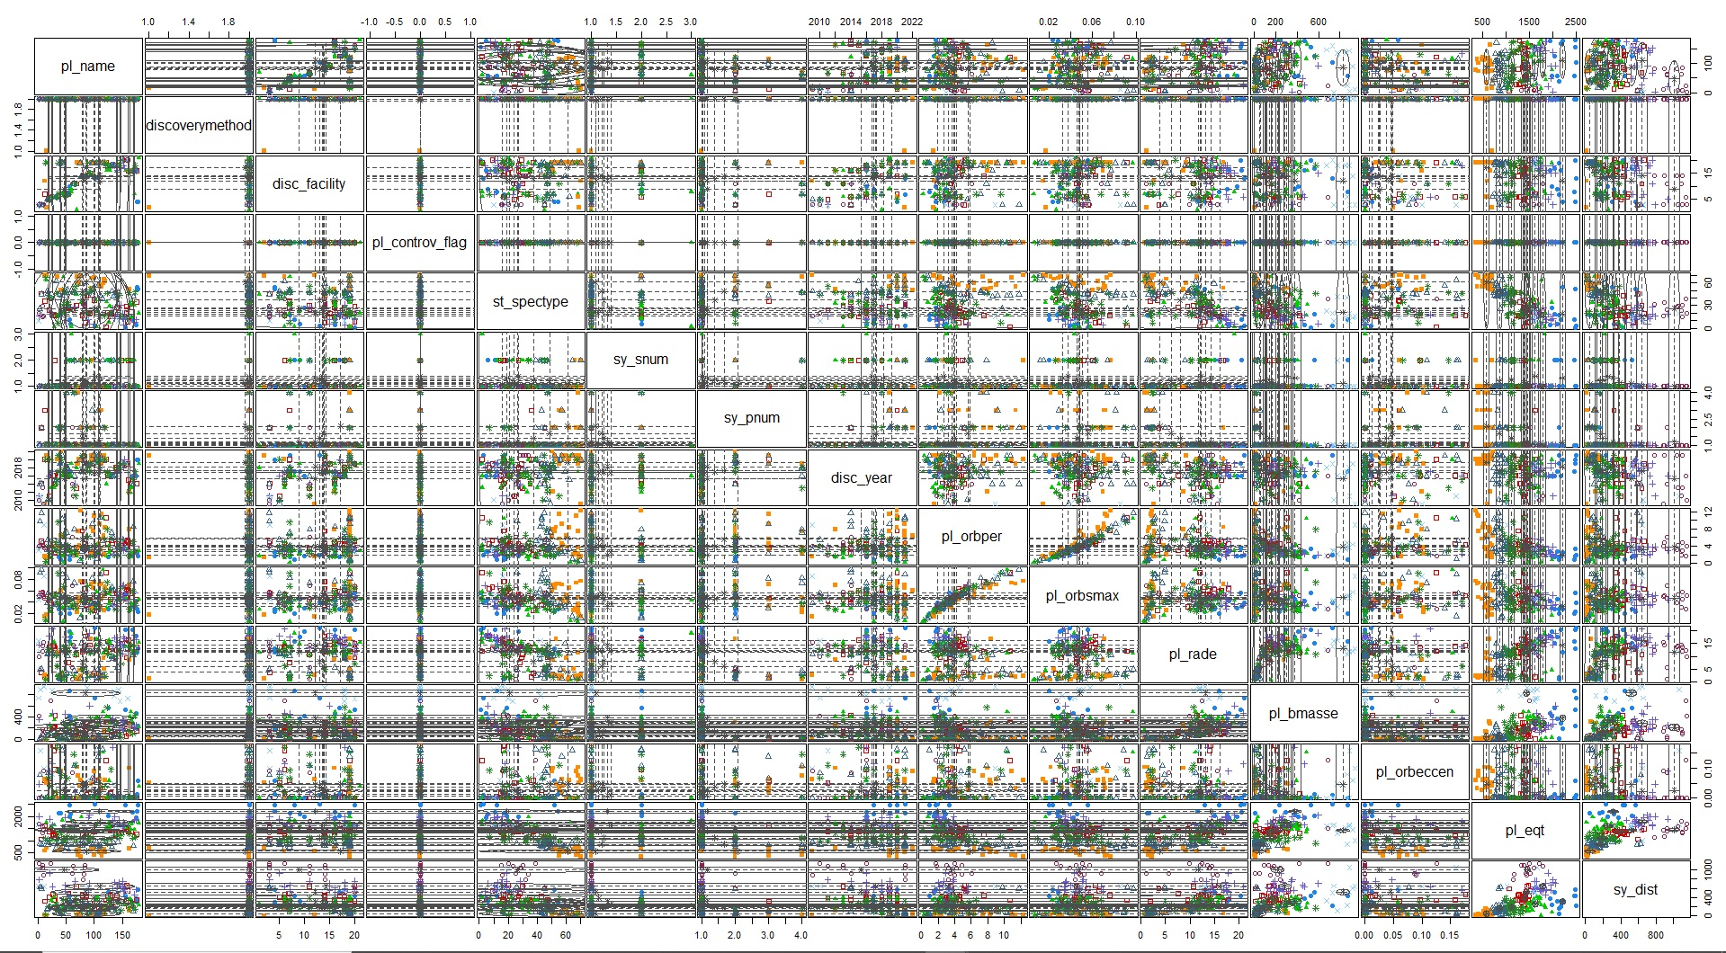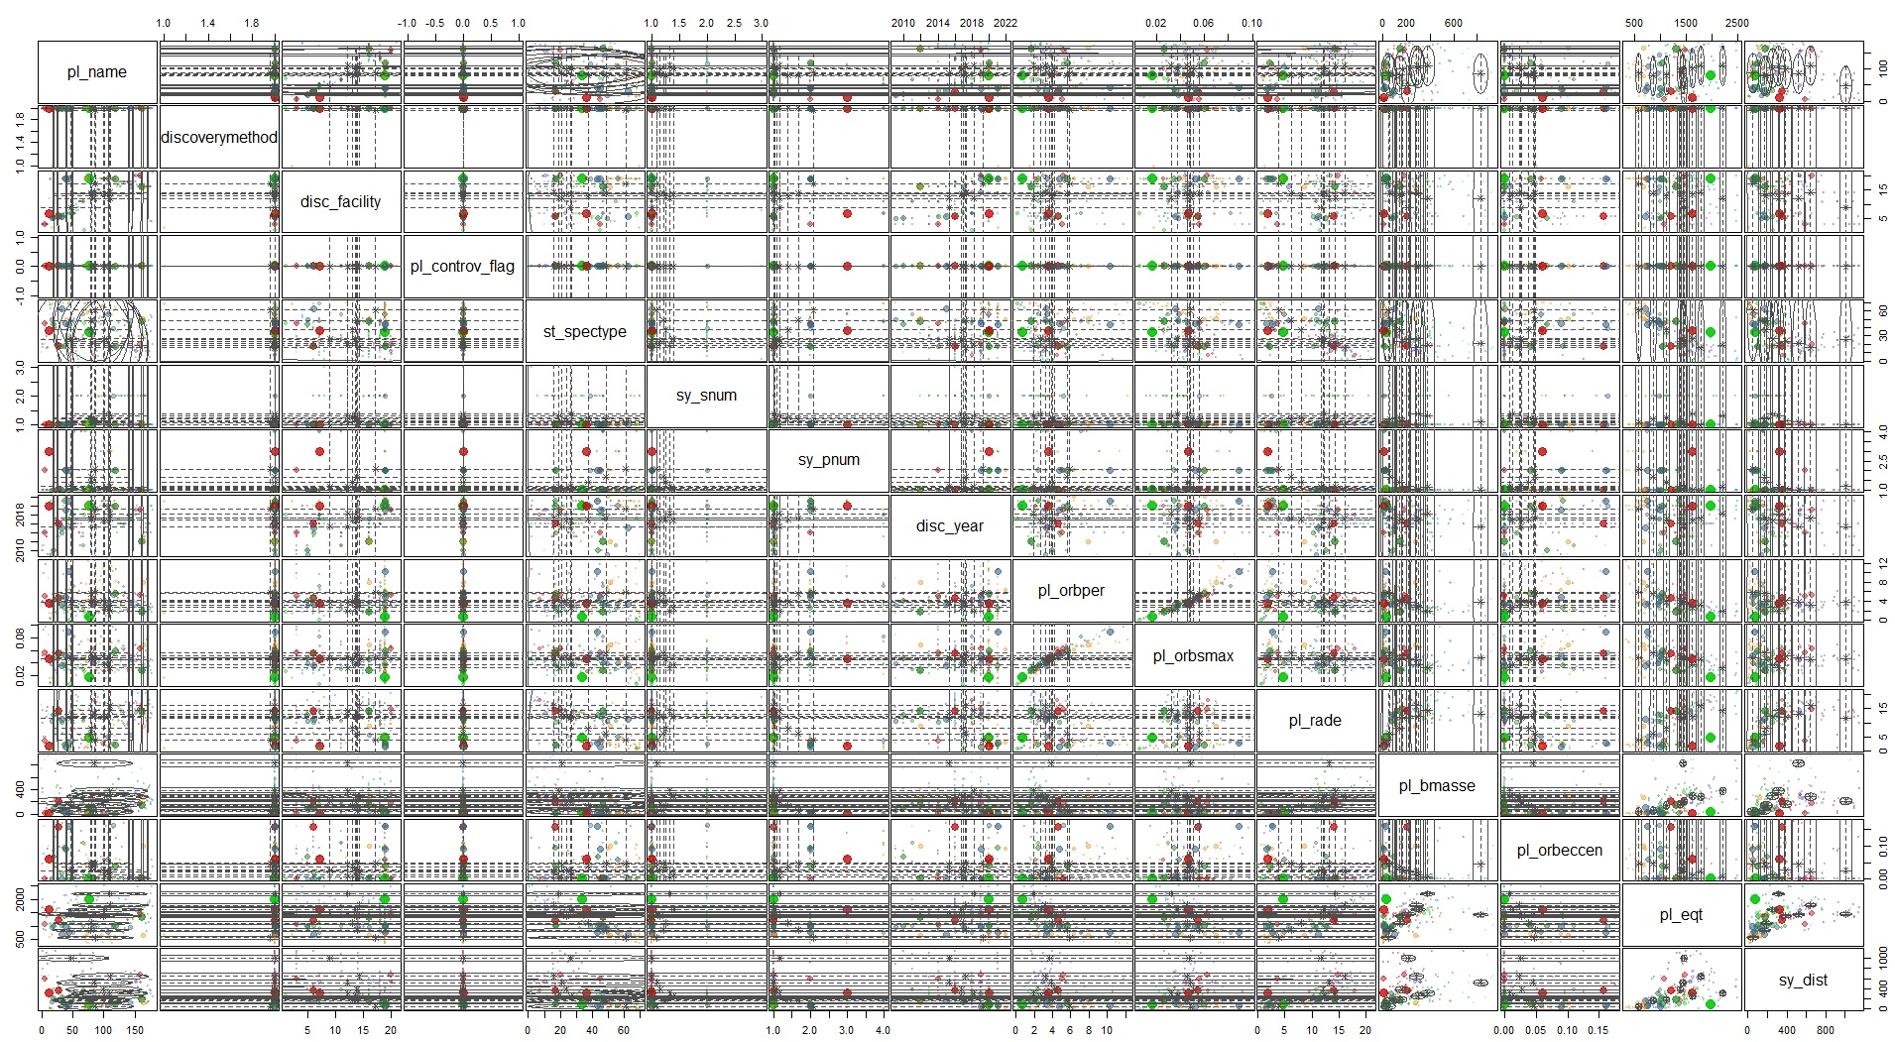

# R Script

## Advanced Engineering Data Analysis FINAL PROJECT

## PLANETARY SYSTEMS DATA ANALYSIS

#Authors:

# Marc Monclús Montalvez Master's Degree in Space and Aeronautical Engineering

# Raúl García Gómez Master's Degree in Industrial Engineering

#Professor:

# Daniel Fernandez Martinez

################################################################################

##### LEGEND

# This file was produced by the NASA Exoplanet Archive http://exoplanetarchive.ipac.caltech.edu

# Fri Mar 25 12:15:35 2022

#

# See also: https://exoplanetarchive.ipac.caltech.edu/cgi-bin/TblView/nph-tblView?app=ExoTbls&config=PS

#

# User preference: *

#

# CONSTRAINT: where (default_flag = 1)

# CONSTRAINT: order by pl_rade desc

#

# COLUMN pl_name: Planet Name

# COLUMN sy_snum: Number of Stars

# COLUMN sy_pnum: Number of Planets

# COLUMN discoverymethod: Discovery Method

# COLUMN disc_year: Discovery Year

# COLUMN disc_facility: Discovery Facility

# COLUMN pl_controv_flag: Controversial Flag

# COLUMN pl_orbper: Orbital Period [days]

# COLUMN pl_orbsmax: Orbit Semi-Major Axis [au])

# COLUMN pl_rade: Planet Radius [Earth Radius]

# COLUMN pl_bmasse: Planet Mass or Mass*sin(i) [Earth Mass]

# COLUMN pl_orbeccen: Eccentricity

# COLUMN pl_eqt: Equilibrium Temperature [K]

# COLUMN st_spectype: Spectral Type

# COLUMN sy_dist: Distance [parsec]

################################################################################

## Cleaning Data

rm(list = ls())

#Library - Packages import

library(tidyr)

library(dplyr)

library(cluster)

library(ggplot2)

library(factoextra)

library(NbClust)

library(mclust)

## Work Directory (change if needed)

getwd()

setwd("D:/ESEIAAT/Data_Analysis/Final_Project")

plantetary_df <- read.csv("PS_2022.03.25_12.15.35.csv")

# Here we only want specific data, therefore we need to remove the excess.

data_del <- c("default_flag","pl_radj", "pl_bmassj", "pl_bmassprov", "pl_insol",

"ttv_flag", "pl_insol", "st_teff",

"st_rad", "st_mass", "st_met",

"st_logg", "sy_vmag", "sy_kmag", "sy_gaiamag")

planetary_short_df <- plantetary_df[ , !(names(plantetary_df)%in%data_del)]

## here we delete rows with empty or NA values (tidyr library)

drop_na_df <- planetary_short_df

drop_na_df[drop_na_df == ""] <- NA

drop_na_df <- drop_na_df %>% drop_na(pl_name)

drop_na_df <- drop_na_df %>% drop_na(sy_snum)

drop_na_df <- drop_na_df %>% drop_na(sy_pnum)

drop_na_df <- drop_na_df %>% drop_na(discoverymethod)

drop_na_df <- drop_na_df %>% drop_na(disc_year)

drop_na_df <- drop_na_df %>% drop_na(disc_facility)

drop_na_df <- drop_na_df %>% drop_na(pl_controv_flag)

drop_na_df <- drop_na_df %>% drop_na(pl_orbper)

drop_na_df <- drop_na_df %>% drop_na(pl_orbsmax)

drop_na_df <- drop_na_df %>% drop_na(pl_rade)

drop_na_df <- drop_na_df %>% drop_na(pl_bmasse)

drop_na_df <- drop_na_df %>% drop_na(pl_orbeccen)

drop_na_df <- drop_na_df %>% drop_na(pl_eqt)

drop_na_df <- drop_na_df %>% drop_na(st_spectype)

drop_na_df <- drop_na_df %>% drop_na(sy_dist)

###Other methods that can be used:

#planetary_short2_df<-planetary_short1_df[complete.cases(planetary_short1_df$pl_orbper),]

#planetary_short_df[!is.na(planetary_short_df$pl_orbper)]

#after removing NA's we get a dataframe of 466 rows from 5005 observations

pl_clean_df<-drop_na_df

################################################################################

#class of "plantetary_df$default_flag"

class(pl_clean_df$pl_controv_flag)

################################################################################

#we need to convert this column to a binary

pl_clean_df$pl_controv_flag = as.logical(pl_clean_df$pl_controv_flag)

pl_clean_df_2<-pl_clean_df

#Remove outliers

#Some are not checked because the outliers are interesting (like the Controversial flag)

#or because thy cannot be outliers (like discovery center)

#outlierx2<-boxplot.stats(pl_clean_df_2$sy_snum)$out

#outlierx2rows<-which(pl_clean_df_2$sy_snum %in% c(outlierx2))

#outlierx2rows

#pl_clean_df_2<- pl_clean_df_2[-which(pl_clean_df_2$sy_snum %in% outlierx2),]

#outlierx3<-boxplot.stats(pl_clean_df_2$sy_pnum)$out

#outlierx3rows<-which(pl_clean_df_2$sy_pnum %in% c(outlierx3))

#outlierx3rows

#pl_clean_df_2<- pl_clean_df_2[-which(pl_clean_df_2$sy_pnum %in% outlierx3),]

#outlierx4<-boxplot.stats(pl_clean_df_2$discoverymethod)$out

#outlierx4rows<-which(pl_clean_df_2$discoverymethod %in% c(outlierx4))

#outlierx4rows

#pl_clean_df_2<- pl_clean_df_2[-which(pl_clean_df_2$discoverymethod %in% outlierx4),]

#outlierx5<-boxplot.stats(pl_clean_df_2$disc_year)$out

#outlierx5rows<-which(pl_clean_df_2$disc_year %in% c(outlierx5))

#outlierx5rows

#pl_clean_df_2<- pl_clean_df_2[-which(pl_clean_df_2$disc_year %in% outlierx5),]

#outlierx6<-boxplot.stats(pl_clean_df_2$disc_facility)$out

#outlierx6rows<-which(pl_clean_df_2$disc_facility %in% c(outlierx6))

#outlierx6rows

#pl_clean_df_2<- pl_clean_df_2[-which(pl_clean_df_2$disc_facility %in% outlierx6),]

#outlierx7<-boxplot.stats(pl_clean_df_2$pl_controv_flag)$out

#outlierx7rows<-which(pl_clean_df_2$pl_controv_flag %in% c(outlierx7))

#outlierx7rows

#pl_clean_df_2<- pl_clean_df_2[-which(pl_clean_df_2$pl_controv_flag %in% outlierx7),]

outlierx8<-boxplot.stats(pl_clean_df_2$pl_orbper)$out

outlierx8rows<-which(pl_clean_df_2$pl_orbper %in% c(outlierx8))

outlierx8rows

pl_clean_df_2<- pl_clean_df_2[-which(pl_clean_df_2$pl_orbper %in% outlierx8),]

outlierx9<-boxplot.stats(pl_clean_df_2$pl_orbsmax)$out

outlierx9rows<-which(pl_clean_df_2$pl_orbsmax %in% c(outlierx9))

outlierx9rows

pl_clean_df_2<- pl_clean_df_2[-which(pl_clean_df_2$pl_orbsmax %in% outlierx9),]

#No outliers in here

outlierx10<-boxplot.stats(pl_clean_df_2$pl_rade)$out

outlierx10rows<-which(pl_clean_df_2$pl_rade %in% c(outlierx10))

outlierx10rows

#pl_clean_df_2<- pl_clean_df_2[-which(pl_clean_df_2$pl_rade %in% outlierx10),]

outlierx11<-boxplot.stats(pl_clean_df_2$pl_bmasse)$out

outlierx11rows<-which(pl_clean_df_2$pl_bmasse %in% c(outlierx11))

outlierx11rows

pl_clean_df_2<- pl_clean_df_2[-which(pl_clean_df_2$pl_bmasse %in% outlierx11),]

outlierx12<-boxplot.stats(pl_clean_df_2$pl_orbeccen)$out

outlierx12rows<-which(pl_clean_df_2$pl_orbeccen %in% c(outlierx12))

outlierx12rows

pl_clean_df_2<- pl_clean_df_2[-which(pl_clean_df_2$pl_orbeccen %in% outlierx12),]

outlierx13<-boxplot.stats(pl_clean_df_2$pl_eqt)$out

outlierx13rows<-which(pl_clean_df_2$pl_eqt %in% c(outlierx13))

outlierx13rows

pl_clean_df_2<- pl_clean_df_2[-which(pl_clean_df_2$pl_eqt %in% outlierx13),]

#outlierx14<-boxplot.stats(pl_clean_df_2$st_spectype)$out

#outlierx14rows<-which(pl_clean_df_2$st_spectype %in% c(outlierx14))

#outlierx14rows

#pl_clean_df_2<- pl_clean_df_2[-which(pl_clean_df_2$st_spectype %in% outlierx14),]

outlierx15<-boxplot.stats(pl_clean_df_2$sy_dist)$out

outlierx15rows<-which(pl_clean_df_2$sy_dist %in% c(outlierx15))

outlierx15rows

pl_clean_df_2<- pl_clean_df_2[-which(pl_clean_df_2$sy_dist %in% outlierx15),]

#Scaling for clustering

pl_clean_df_2_scaled <- pl_clean_df_2

pl_clean_df_2_scaling <- pl_clean_df_2

pl_clean_df_2_noscaling <- pl_clean_df_2

pl_clean_df_2_scaling <- pl_clean_df_2[c(2,3,5,8,9,10,11,12,13,15)]

pl_clean_df_2_noscaling <- pl_clean_df_2[c(1,4,6,7,14)]

pl_clean_df_2_scaled <- scale(pl_clean_df_2_scaling)

pl_clean_df_2_scaled<- cbind.data.frame(pl_clean_df_2_noscaling, pl_clean_df_2_scaling)

#PAM looking for 13 clusters because an heuristic says choosing square root of number

#of rows is a good choice

pl_clean_df_2_scaled_PAM <- pam(pl_clean_df_2_scaled, 13)

plot(pl_clean_df_2_scaled_PAM, which.plots=2, main="")

plotPAMcluster <- cbind(pl_clean_df_2, Cluster = pl_clean_df_2_scaled_PAM$clustering)

plot(plotPAMcluster)

#Model based clustering

pl_clean_df_2_scaled_Mcluster <- Mclust(pl_clean_df_2_scaled)

summary(pl_clean_df_2_scaled_Mcluster)

plot(pl_clean_df_2_scaled_Mcluster)

# Legend of variables

* pl_name: Planet Name
* sy_snum: Number of Stars
* sy_pnum: Number of Planets
* discoverymethod: Discovery Method
* disc_year: Discovery Year
* disc_facility: Discovery Facility
* pl_controv_flag: Controversial Flag
* pl_orbper: Orbital Period [days]
* pl_orbsmax: Orbit Semi-Major Axis [au])
* pl_rade: Planet Radius [Earth Radius]
* pl_bmasse: Planet Mass or Mass*sin(i) [Earth Mass]
* pl_orbeccen: Eccentricity
* pl_eqt: Equilibrium Temperature [K]
* st_spectype: Spectral Type
* sy_dist: Distance [parsec]