t;ldr
- For this example to work you need to comment/uncomment a line in the rodos-sources for your copy, to redirect the flow of Debug messages
- connect UART-Adapter and the UART-Bluetooth Dongle as shown on the photo on the 2nd page
- We are here rodos/support/support-programs/middleware-python/examples/examples-discovery-mw-printf

In order to use the example in this directory you must set the appropriate settings. You want connect the Bluetooth Dongle RX and TX lines to PD5 and PD6, its VCC and GND lines to 5V and GND on the discovery board respectively. Hence you have to tell RODOS, which pins will be used for which UART Interface.
There is a file called platform-parameter.h in
rodos/src/bare-metal/stm32f4/platform-parameter/discovery/platform-parameter.h

Note: You can find the file with find . | grep -i searchpattern

by default the file platform-parameter.h contains this block of definitions close to its beginning:

you need comment, the line that defines UART_DEBUG and uncomment another definition for UART_DEBUG, if you want to use this example
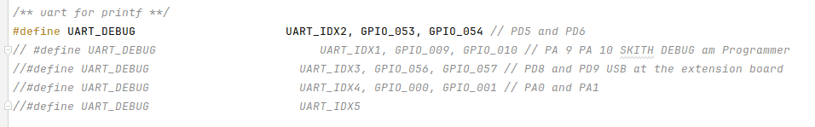Code 1: platform-parameter.h before change

Here we set UART_DEBUG to be UART_IDX3, which sets the default UART Output for PRINTF(...) and the boot splash to PD8 and PD9 (left side of discovery board, viewed from above) Compile the rodos library for the discovery board with
rodos-lib.sh discovery

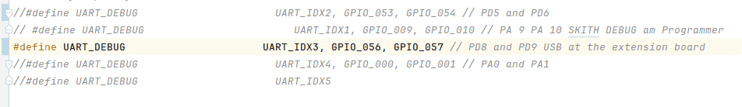Code 2: platform-parameter.h after the change

Next page for Pinout
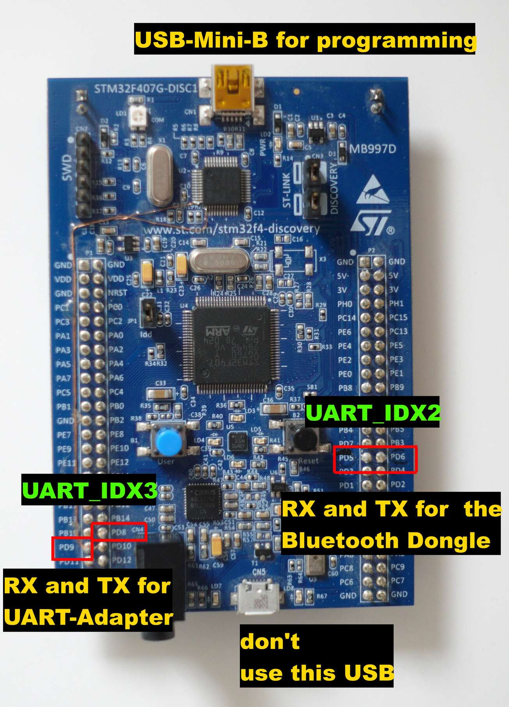Image 1: Relavant Pinout that shows where to connect the UART and the Bluetooth dongle

Devices: Discovery Board (STM32), UART-Bluetooth Dongle, PC running Linux

If everything is connected you can compile the program with doit.sh.
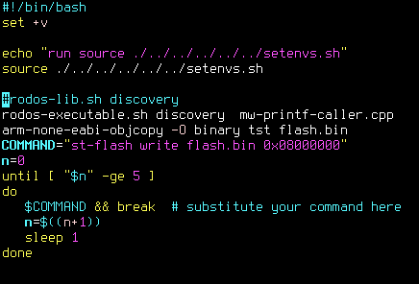

doit.sh compiles the mw-printf-caller.cpp file. The script flashes the program to the discovery board, make sure its USB-Mini-B is connected to your Linux PC.

Connect the bluetooth dongle with your PC, on Linux use these commands for example to bin the serial data stream of the bluetooth device to /dev/rfcomm2

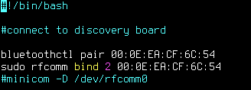

Lastly reboot the the discovery board, and run the example python script. Make sure it acceses the right Serial/Bluetooth Device. Regular PRINTF(...) will appear on the Serial Adapter and MW_PRINTF(...) Message will be shown by the python-framework

Good Luck, any problems? Contact Sebastian Kind on the Rocket Chat, need a Discovery Board for your thesis/Hiwi Work -> ask Mr. Faisal

