Dear SITL,

Here are suggestions for (1) using the new dynamic SITL window system, and (2) making SITL selections of dayside phenomena and magnetosheath turbulence campaign.

1. Operating the new Dynamic SITL Window system:

* **Please download the latest SPEDAS.**
* **Very useful for SITLs:** Here is the link to see the availability of data (so you don’t have to load the data to see what is available) and metrics, etc.:

<http://www.ssl.berkeley.edu/~moka/eva/index.html>

* Instructions by Mitsuo for the EVA buttons and strategies can be found at:

<https://lasp.colorado.edu/galaxy/display/mms/EVA+Manual>

* If possible, please send out the draft report 2-3 days before the window closing time, and do the ‘uplink’ 1-3 days before the clock runs out. This is because the onboard data may be deleted before the window closing time, since the SITL window is now 5-day long.
* Please select and submit one SROI at a time, unless the data is fully available for more than one SROI at the time of data loading.

1. Selection strategies.

* Please read and follow **Dayside FOM guidelines** at the SITL website <https://lasp.colorado.edu/galaxy/pages/viewpage.action?spaceKey=mms&title=SITL>

For example, complete MP crossings are Cat 1 (FOM~150), partial MP crossings are Cat 2 (~100-120), boundary layers are Cat 3 (~60-80). Note that boundary layer crossings are partial crossings from the magnetosphere into the boundary/MP without seeing changes in the magnetic field. Partial MP are crossings from the magnetosheath into the MP (seeing B changes) without getting into the very low density magnetosphere proper.

* When selecting the magnetopause or bow shock, please make sure that the interval is long enough to cover the context around. It is good to look at many parameters (B, N, V, spectrograms) to determine the context.
* When there are multiple crossings of the magnetopause or bow shock that are not too far separated in time (e.g., gaps less than one or two minutes between crossings), please select a long interval that contains multiple crossings with the same FOM.
* Suggest loading the ‘dayside basic’ parameter set to make selections of magnetopause and bow shock and related phenomena.
* Suggest loading the ‘Solar wind CS’ parameter set to make selections of solar wind reconnection events.
* Please see the updated description of magnetosheath current sheet selections in the Dayside FOM guidelines. Very few need to be selected.
* **NEW for the turbulence campaign during February and March 2023: Please read the next 5 slides of instructions prepared by Rick and Alex.**

1. If you encounter issues with EVA or submission/uplink, please alert Mitsuo Oka, Tai Phan, Rick Wilder, Barbara Giles, and Bob Ergun ([moka@berkeley.edu](mailto:moka@berkeley.edu), [phan@ssl.berkeley.edu](mailto:phan@ssl.berkeley.edu), frederick.wilder@uta.edu, [barbara.giles@nasa.gov](mailto:barbara.giles@nasa.gov), [Bob.Ergun@lasp.colorado.edu](mailto:Bob.Ergun@lasp.colorado.edu))
2. For questions about burst data selections or FOM guidelines, please email Tai Phan and Rick Wilder.

Unbiased Sheath Campaign

These are steps that we have outlined to help streamline the selections for the unbiased magnetosheath campaign. Do this for selections during the inbound SROI of each orbit during the campaign. This will be SROI3. Follow these steps to make this as simple as possible.

1. Do your normal magnetopause and bow shock selections for the SROI first. Do not do the normal magnetosheath selections of individual current sheets or turbulence.
2. Once these are done, in EVA, go to File – Preference as seen below.

1. When you open “Preference,” go to the “SITL” tab, and type “18” into the “split size” box. This will allow you to split large segments into smaller 3 minute segments.

1. Identify the end of your last bow shock selection and the beginning of your first magnetopause selection. Select the ENTIRE INTERVAL between these two times with a FOM of 105. In the “comment” field, label the selection (all lowercase):  
     
   unbiased magnetosheath campaign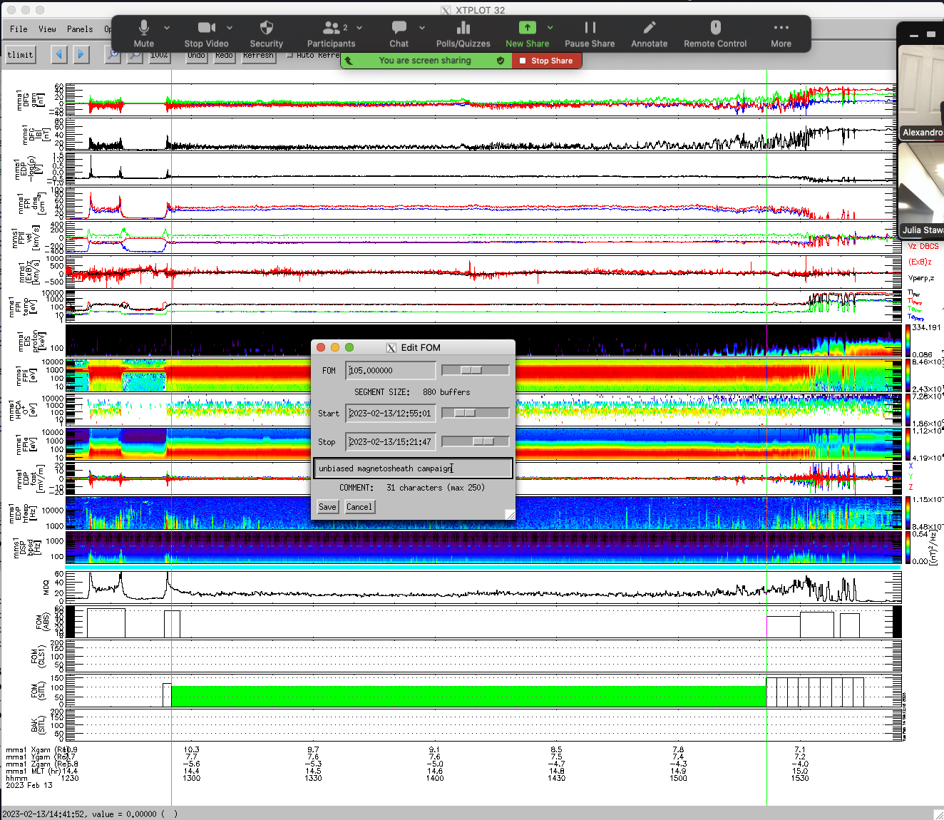  
   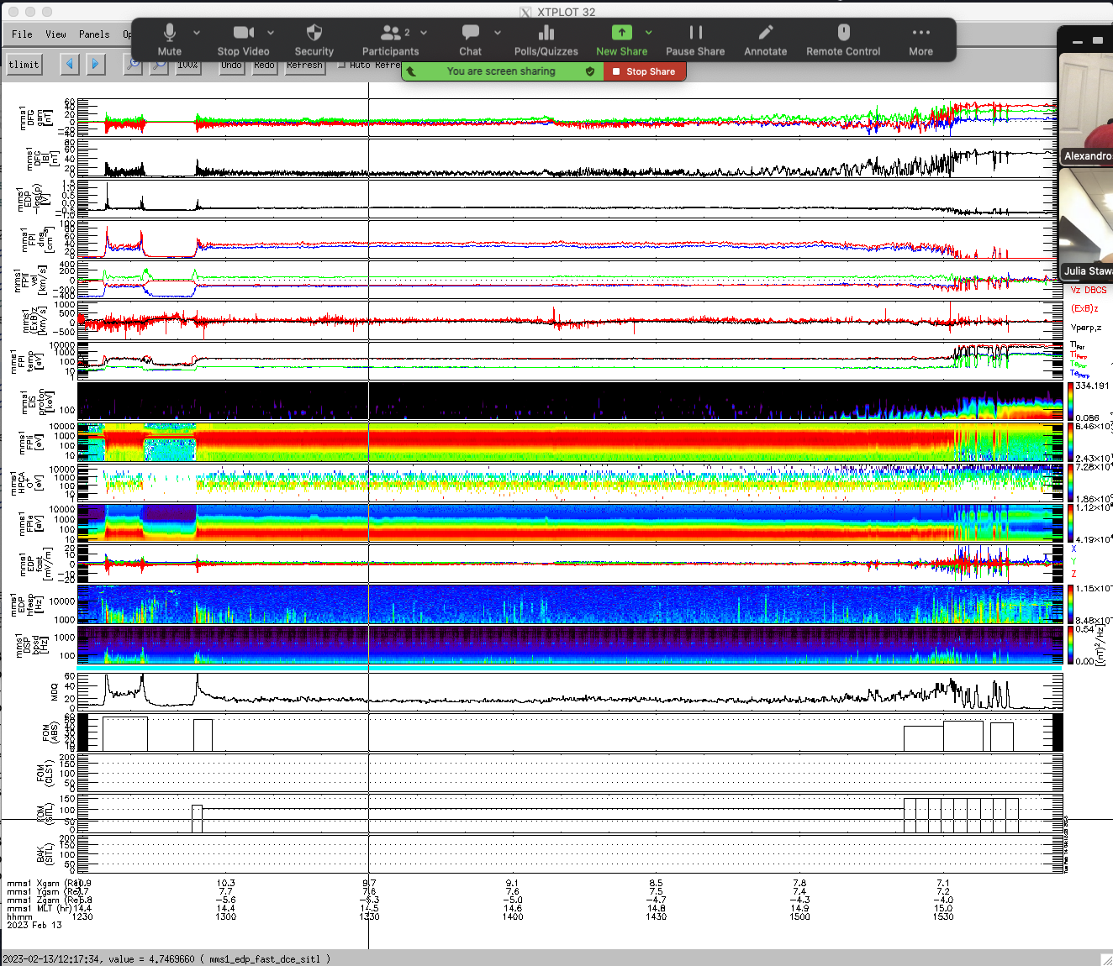
2. Use the “split” button in EVA to split the campaign selection into 3 minute segments.

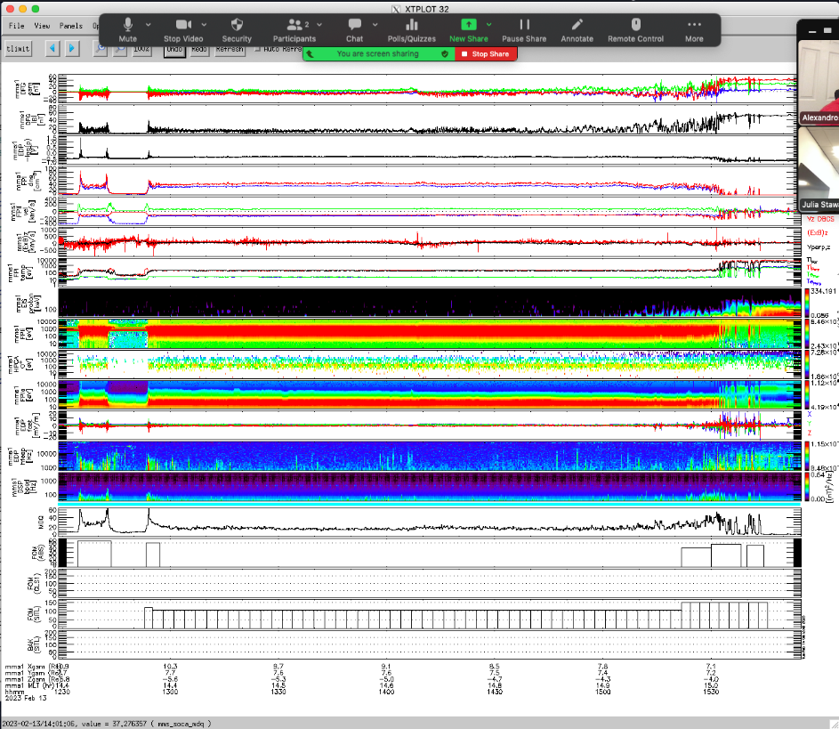

1. Keep the first out of every 3 segments (e.g. delete the second two segments of every three).

