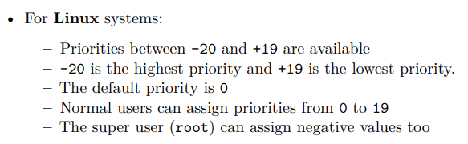
Luca De Simone 1592157
VFAT:
No journaling; meta in FAT; no hardlink
nur dir entries, keine inodes.
File names up to 255 chars (unicode)
FAT[cluster_number] = cluster > fixed size
ext3:
dir entries die auf inodes zeigen ; scales well; permissions
4kb pro address cluster
12 pointer pro block -> 4 * 12 = 48kb,
alles darüber hinaus mit indirect pointers:
pointer auf einen block mit 12 pointer: ...
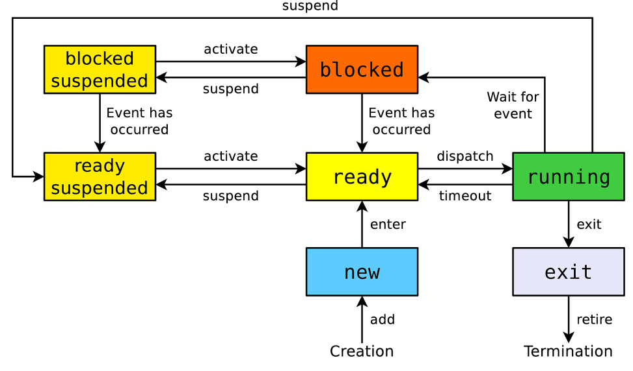
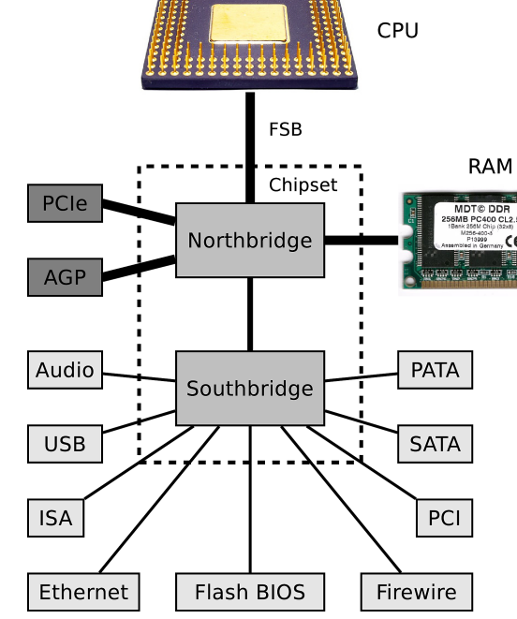
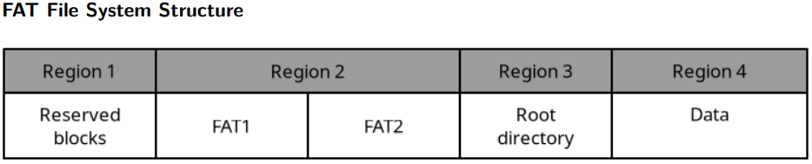
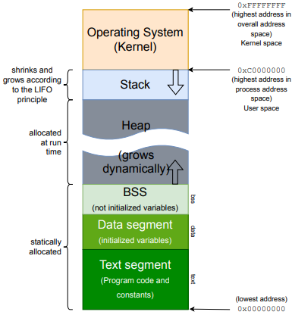
Non-Preemptive-Sched.: process will either run until end or voluntarily yield
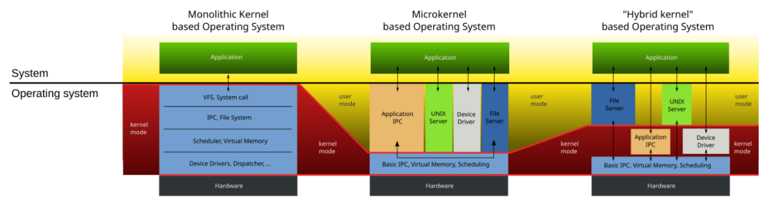
Preemptive-Sched.: System can reeasign CPU
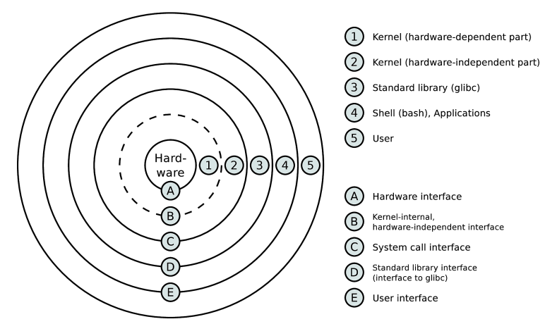
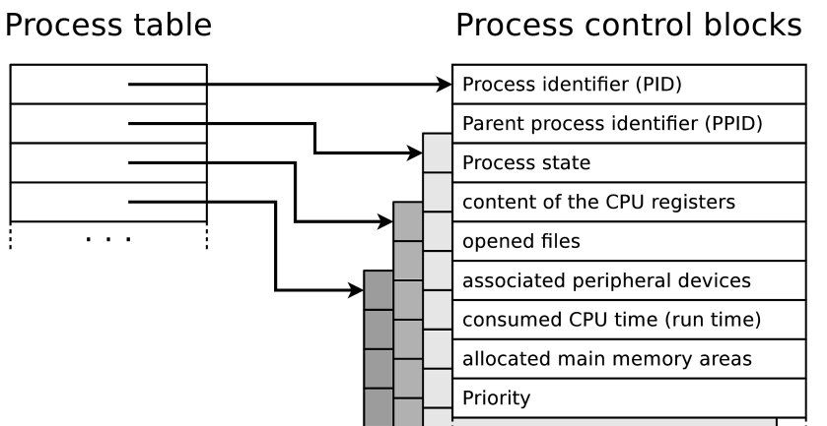
Priority Driven: Just prio >; FCFS:FIFO; LCFS:LIFO; LCFS-PR:Stack; EDF:Earliest Deadline First; SJF:Shortest First;
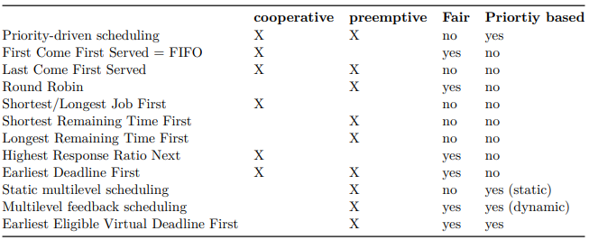
Hardware Interrupts: Await phys. Signal, timer tick
Exceptions: 0 div, throw …, segfault, s.ovfl., …
Traps: Software interrupt to cause change of op. Mode
IRQ: Interupt Request
Seq. Interrupt Req.: One Interrupt after the other
+: Simpler -: No prio > bad reaction
Nested Interrupt Req.: Interrupt Handlers can be Interrupted (when higher p)
-: complicated, Interrupts may starve / delay because prio
ISR: Interrupt service routine: Int. > Save prog. > Routine > Load prog. > end
„A system call is a function call in the operating system that triggers a switch from user mode to kernel mode“
IPC: Inter Process Communication: Comm. (msg) & Cooperation (shared)
- Files, Signals/Flags, Shared mem, msg q, pipes, sockets
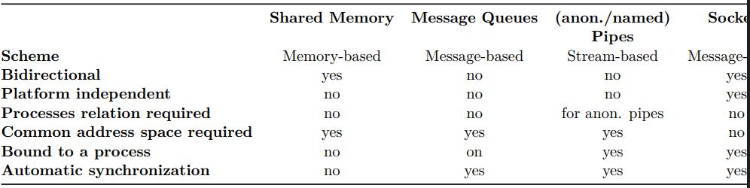
A deadlock situation can arise if these conditions are all fulfilled – Mutual exclusion ∗ At least one resource is either occupied by exactly one process or is available ⟹ non-sharable resource – Hold and wait ∗ A process, which currently occupies at least one resource, requests additional resources which are being held by another process – No preemption ∗ Resources occupied by a process cannot be deallocated by the OS but only be released by the holding process voluntarily – Circular wait ∗ A cyclic chain of processes exists ∗ Each process requests a resource that the next process in the chain occupies.
Graph:: Process: Circle, Resource: Rectangle
Current allocation Matrix: What we have currently
Request Matrix: What each process needs.
Semaphore: P(), V(), =counter
P: if sema > 0: sema --; else block process
V: sema++; if process waiting: wake one up
Mutex: Bin. Sema. > „Besitzer“ > only one controller

LC

