
SWE-A Project
B.Sc. Computer Science

Faculty for Computer Science
Frankfurt University of Applied Sciences

Delil Celik, Faycal El Amin, Elissar Abdullah and Luca De Simone

Faculty for Computer Science
Frankfurt University of Applied Sciences
Smart Travel Companion

Declaration of Authorship

We hereby certify that the project report We are submitting is entirely our own original work except where otherwise indicated. We did not submit this work anywhere else before. We are aware of the University's regulations concerning plagiarism, including those regulations concerning disciplinary actions that may result from plagiarism. Any use of the works of any other author, in any form, is properly acknowledged at their point of use.
- We did not use any artificial intelligence-based writing tools nor any other artificial intelligence applications, nor have we incorporated texts or sections generated by artificial intelligence applications into our written examination.
OR
- We used artificial intelligence-based writing tools and/or other artificial intelligence applications to write our assignment. We used these tools for guidance only. We confirm that most of the assignment is in our own words. We have listed as tools all artificial intelligence applications used, including their product name and source (URL), and provided a complete overview of all functions used for the purpose of writing this examination. We have marked all texts and sections which were generated by and copied from artificial intelligence-based writing tools or other artificial intelligence applications accordingly.

The used AI-based writing tool is ChatGPT (OpenAI), which is available at https://chat.openai.com


Delil Celik 1552139:


Faycal El Amin 1551439:

Elissar Abdullah 1501054:

Luca De Simone 1592157:

Table of Contents
Table of Contents 3
1 Introduction 4
1.1 Idea 4
1.2 Product 4
1.2.1 AR Building Recognition and Historical Information 4
1.2.2 Guided AR Route Navigation 5
1.2.3 App Loggin with Iris 6
2 Contribution 7
3 Implementation 7
3.1 Use Case Diagram 7
3.2 Class Diagram 8
3.3 UC – 1: AR Building Recognition & Historical Information 9
3.3.1 Snowcard 9
3.3.2 Use Case Specification 9
3.3.3 Activity Diagram 10
3.3.4 Sequence Diagram 11
3.3.5 GUI Mock-Up 12
3.3.6 Technical Description 13
3.4 UC – 2: Guided AR Route Navigation 14
3.4.1 Snowcard 14
3.4.2 Use Case Specification 14
3.4.3 Activity Diagram 15
3.4.4 Sequence Diagram 16
3.4.5 GUI Mock-up 16
3.4.6 Technical Description 17
3.5 UC – 3: App Loggin with Iris 18
3.5.1 Snowcard 18
3.5.2 Use Case Specification 18
3.5.3 Activity Diagram 19
3.5.4 Sequence Diagram 20
3.5.5 Technical Description 20
4 SCRUM Meetings 21
5 Tables 25
5.1 List of Abbreviations 25
5.2 List of Figures 25
5.3 AI Prompt Table 25

Introduction

Idea
Our Main idea was a Smart-Glasses-Application, which allows tourists to experience a well guided and interesting holiday. To ensure this, we wanted to develop an App which guides you through the city of your stay and shows you all the interesting things it has to offer.

Product

AR Building Recognition and Historical Information
Going sight-seeing seems to have become the new trend when going into foreign waters, especially when the target location has to offer beautiful and interesting structures.
Most of these stunning structures have one thing in common: Their history. Because of this, most cities have established a tour-guide culture, where you listen to the history of all those beautiful structures by listening to a tour guide who is barely understandable while talking about things you don’t want to know. To solve this age old problem, we have come up with a smart and modern solution for such an old problem.
Our Application connects to your Smart Glasses and enables them to render everything you want to know about those interisting structures and monuments right infront of your eyes; understandable and clear.
Once set up, our system automatically registers when you are looking at a known building, instantly displaying you everything you want and need to know about what you are looking at.

Guided AR Route Navigation
To fully experience all the beautiful monuments and points of interest your destination has to offer, you first need to get there - and not just quickly, but safely and enjoyably. The route you take should provide a pleasant journey as well as ensure your safety, which is especially important in countries where unfamiliar surroundings can pose challenges for tourists.
To address this, we developed a Guided AR Route Navigation System that identifies the route best suited for your stay. The system combines multiple factors such as safety, beauty, and accessibility to generate the optimal path. Rather than simply providing the shortest or fastest route, it prioritizes paths that offer cultural highlights, pedestrian-friendly streets, and visually appealing surroundings, enhancing the overall travel experience.
Additionally, the system adapts in real-time, considering dynamic conditions such as traffic, temporary road closures, or areas with higher security risks. By integrating AR overlays, it also guides users visually, highlighting points of interest, providing contextual information, and suggesting route changes that enrich the journey.
Finally, this approach transforms navigation from a mere utility into an exploration experience, ensuring that every step of the journey contributes to both safety and enjoyment, allowing tourists to immerse themselves fully in the destination.

App Loggin with Iris
Having an Account to store the data and preferences of the User is a standard of today’s internet society. It’s crucial for satisfying a fast and simple experience when transitioning from one device to another, or when restoring data that was lost.
To implement this, the user must log in. This is often satisfied with an E-Mail Address and / or username in combination with a password. This, however, can take its time and be frustrating if this data is not at hand, and the time does not allow for calling your mother back home, to ask her to look up your password in some hidden folder.
To solve this modern problem, a modern solution is needed. In this case, the modern solution is an Iris Scanner. To shorten up the time it takes to Log-In, and to keep people from stealing your password, A mandatory or optional Iris Scan can be selected as a Log-In option. This will scan your Iris and save it at our secure databases, so that in the future, you can put on your Smart Glasses and experience our Smart Features seamlessly, and without unnecessary Log-In procedures.
Finally, because we are very interested in protecting the user’s data, we ensure that data collected by the Iris Scan Feature will not be sold or used in any way that the user did not consent to.

Contribution
Use Case ID | Name | Members
UC - 1 | AR Building Recognition and Historical Information | Delil Celic 1552139  Faycal El Amin 1551439
UC - 2 | Guided AR Route Navigation | Luca De Simone 1592157  Elissar Abdullah 1501054
UC - 3 | App Login with Iris | Luca De Simone 1592157

Implementation

Use Case Diagram
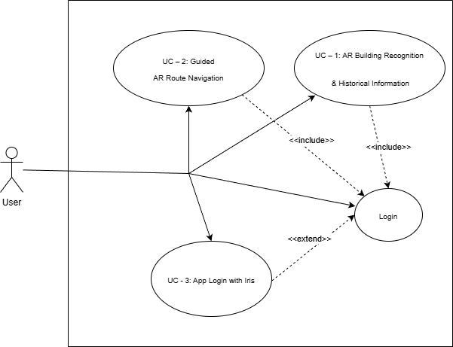
Figure 1: Use-Case Diagram

Class Diagram

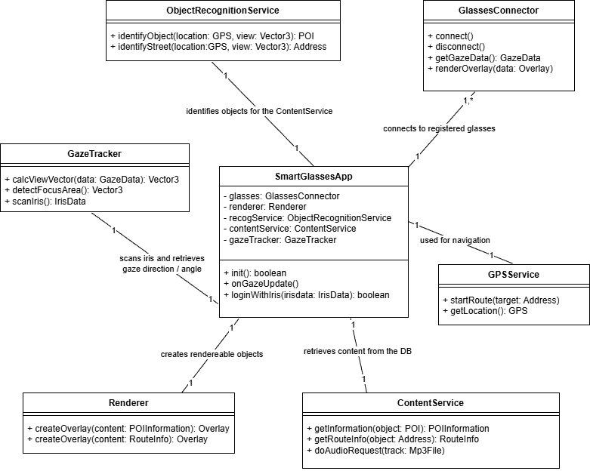
Figure 2: Class Diagram

UC – 1: AR Building Recognition & Historical Information

Snowcard
Requirement Type functional
For Whom? customer
User Satisfaction high
User Dissatisfaction low

Use Case Specification
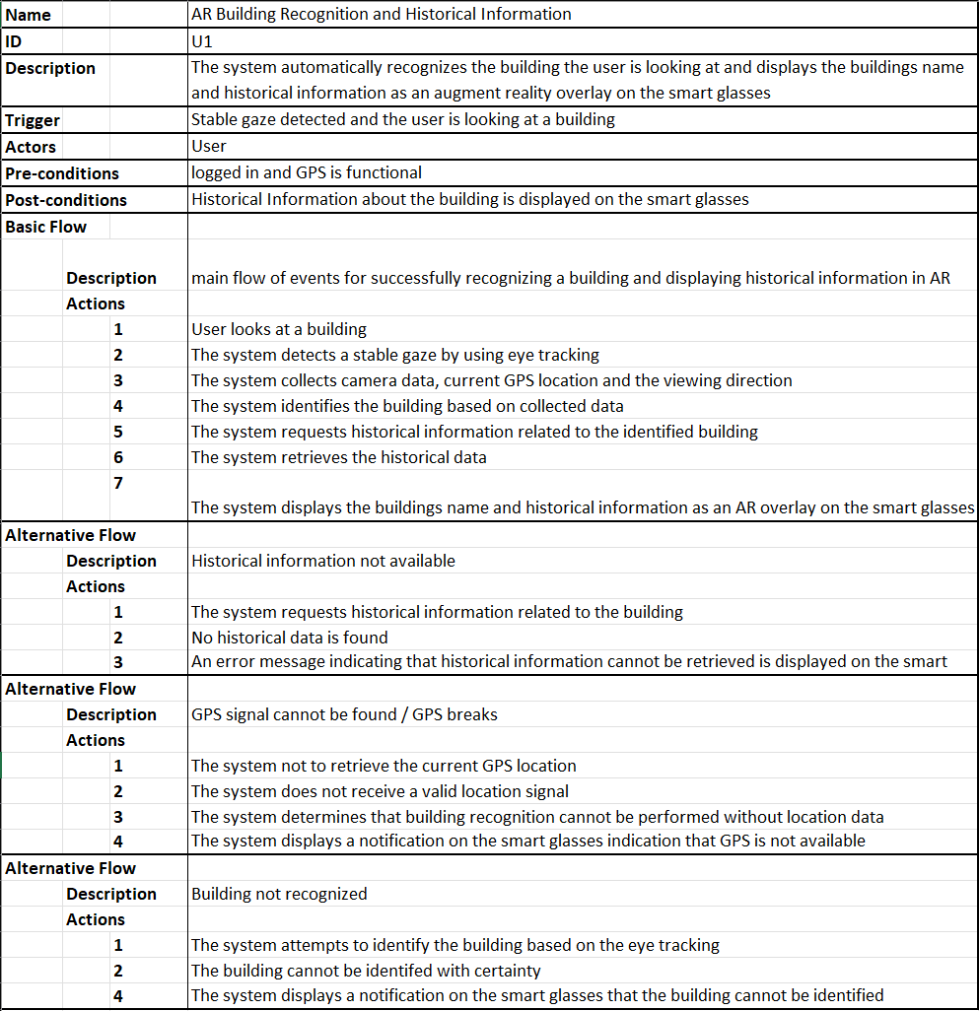
Figure 3: UC-1 Specification Table

Activity Diagram
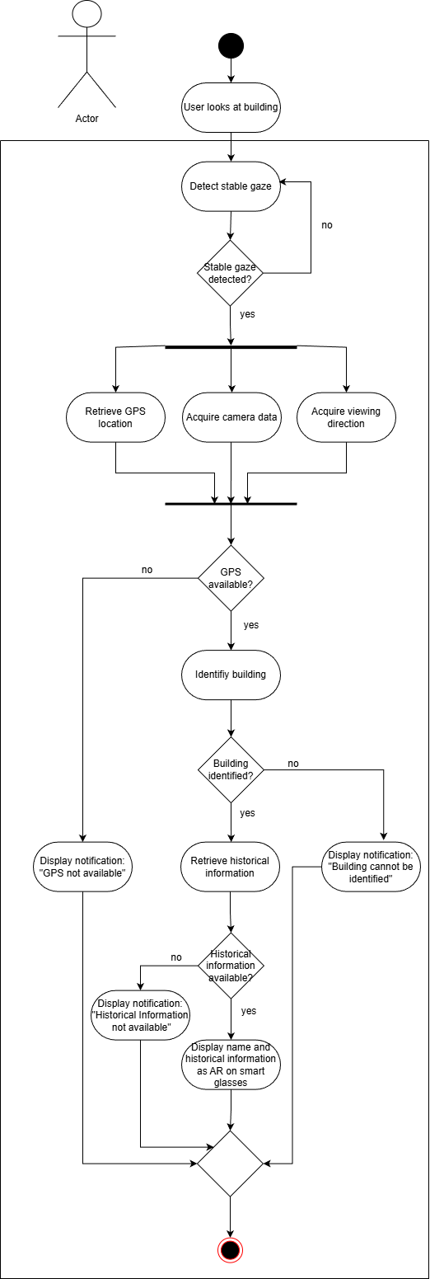
Figure 4: UC-1 Activity Diagram

Sequence Diagram
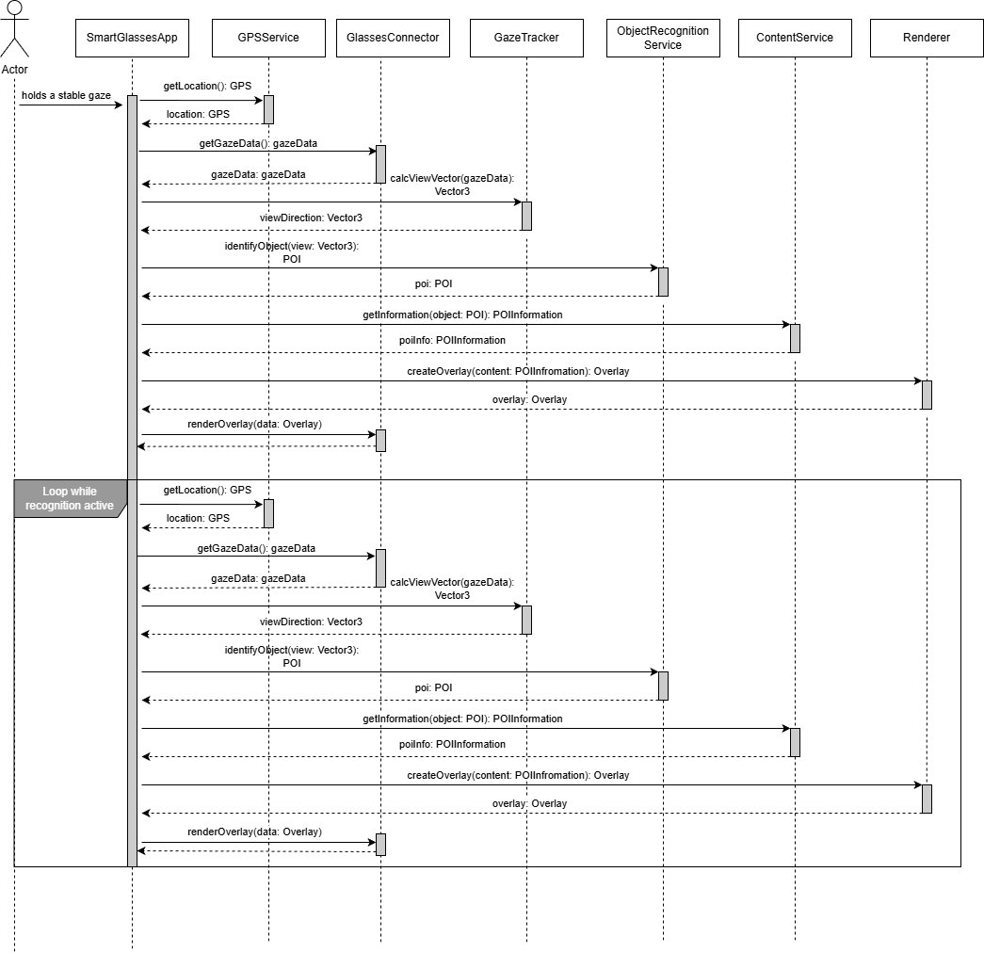

Figure 5: UC-1 Sequence Diagram

GUI Mock-Up
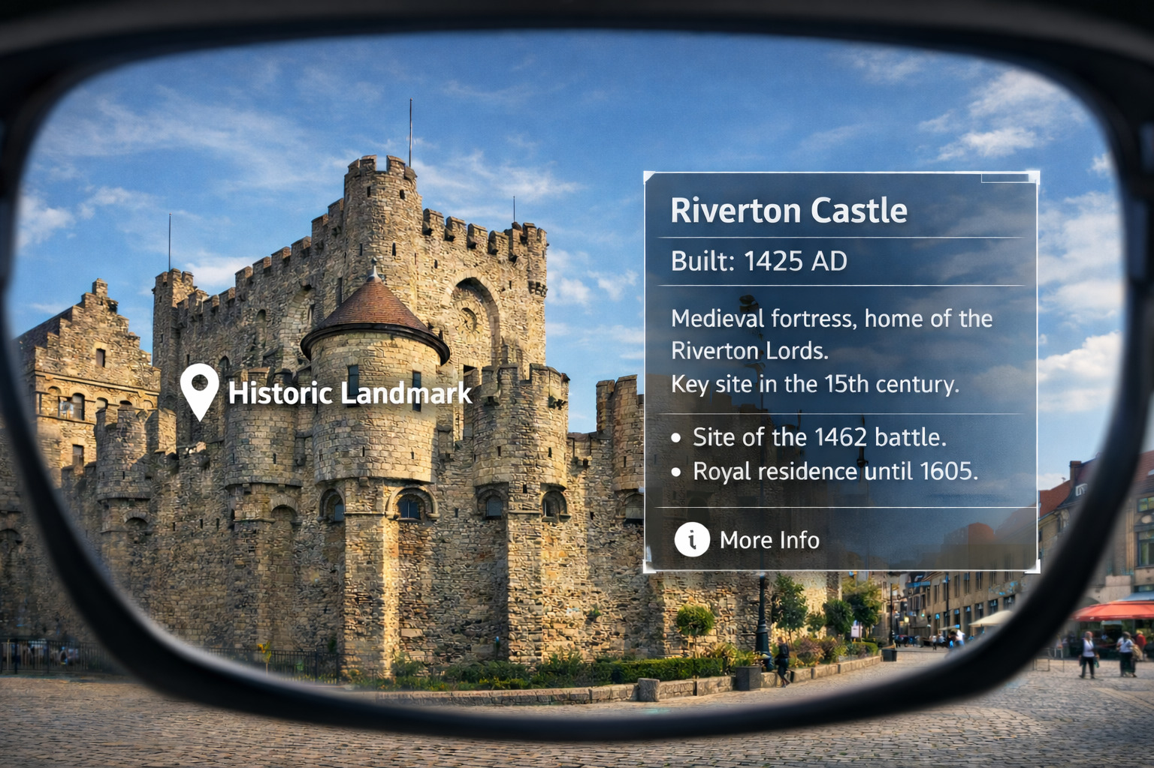
Figure 6: UC-1 GUI Mock-Up

Technical Description
This UC (Use case) allows the user to retrieve information about buildings they are looking at, displayed on their Smart Glasses.
To implement this, the geographical location as well as an image of their FOV (Field of view) are retrieved. We call this their Gaze Data. This data is then sent to our servers via the user’s app, which then evaluate what the user is looking at based on our algorithms.
Once the POI (Point of Interest) the user is looking at has been established, information, such as historical data and reviews, are packaged and send off back to the user. Upon retrieving the data, the App renders the information on the Smart Glasses.
This process is continuously repeated, automatically rendering the information without requiring action from the user, ignoring cases where no data could be retrieved.

UC – 2: Guided AR Route Navigation

Snowcard
Requirement Type functional
For Whom? customer
User Satisfaction high
User Dissatisfaction low

Use Case Specification
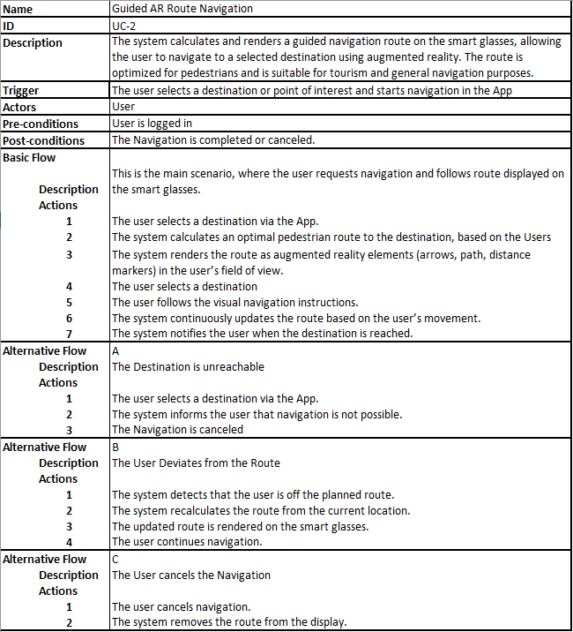
Figure 7: UC-2 Specification Table

Activity Diagram
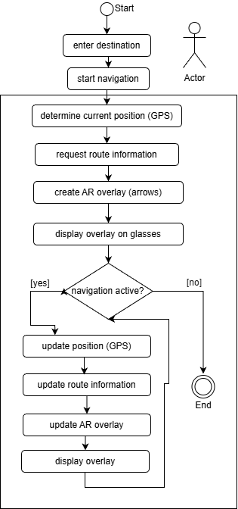

Figure 8: UC-2 Activity Diagram

Sequence Diagram
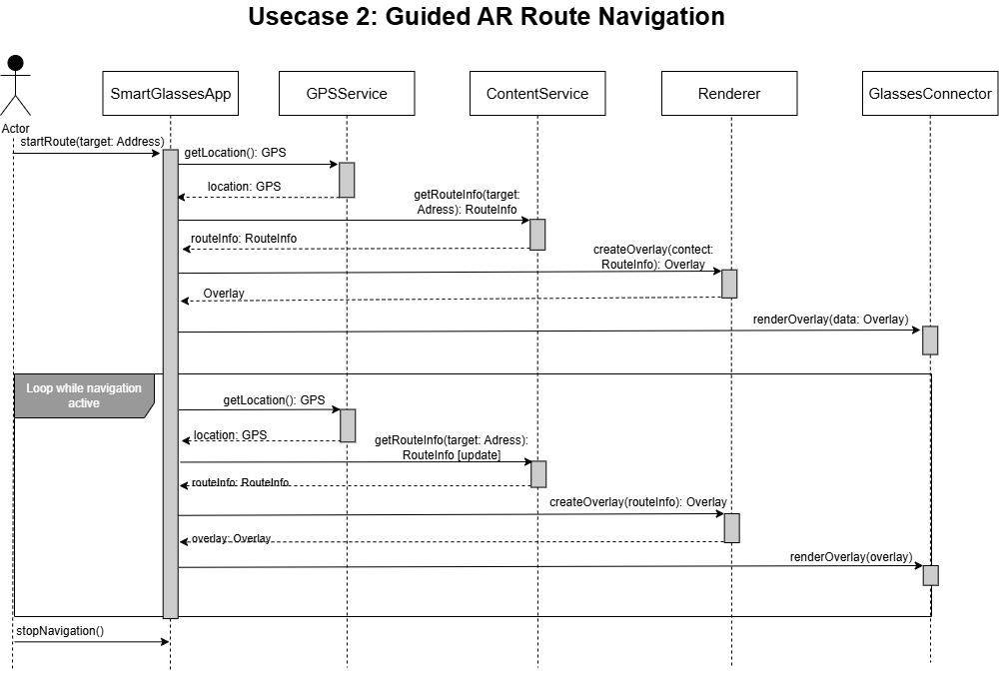
Figure 9: UC-2 Sequence Diagram

GUI Mock-up
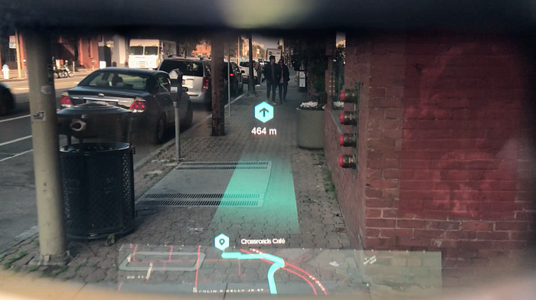
Figure 10: UC-2 GUI Mock-Up
Source: https://miro.medium.com/v2/resize:fit:720/format:webp/0*MqJFT-uDEa1-Crmv.png

Technical Description
This UC navigates the user to their desired destination by rendering the route right in front of them.
This is done by first establishing the user’s location and their desired destination via the App. Once this is done, the data is sent to our servers, where our algorithms calculate the safest and most pleasing route for the user, respecting environment and possible danger.
Once this is done, the route data is repeatedly sent to the user, updating in real time based on the new GPS location of the user. The App then renders the path right on the Smart Glasses, augmenting reality by placing it right on the ground.
Should this route not be up to the users’ preferences, the ability to cancel or modify the route is available in the App.

UC – 3: App Loggin with Iris

Snowcard
Requirement Type non-functional
For Whom? customer
User Satisfaction high
User Dissatisfaction none

Use Case Specification
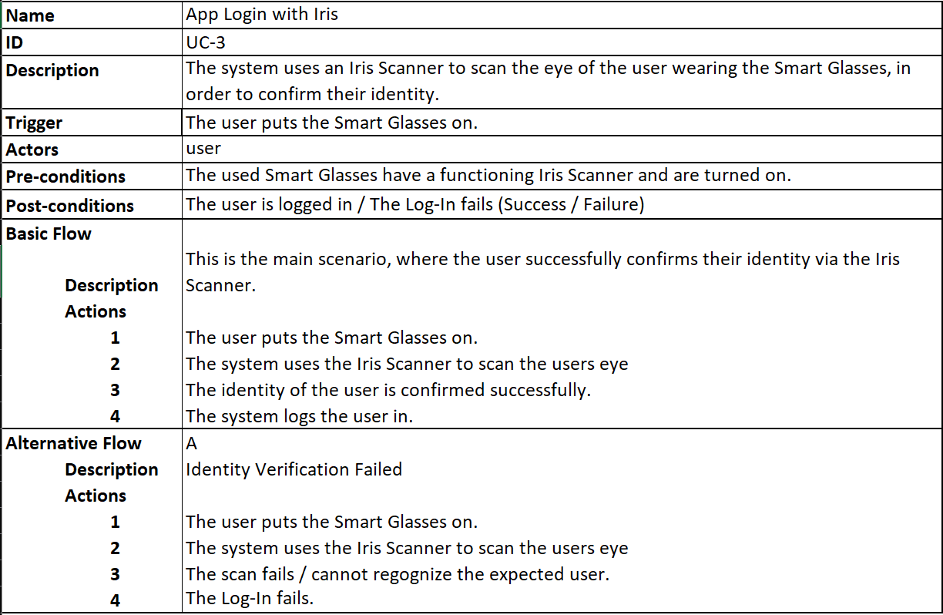
Figure 11: UC-3 Specification Table

Activity Diagram
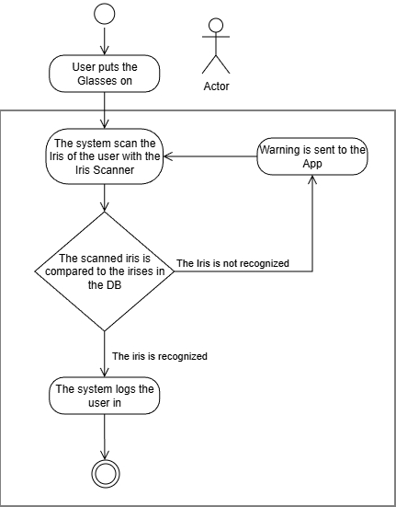
Figure 12: UC-3 Activity Diagram

Sequence Diagram
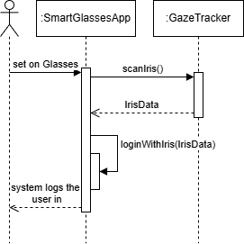
Figure 13: UC-3 Sequence Diagram

Technical Description
This UC allows the user to log into the App by just putting on the Smart Glasses.
Upon activating this option in the App, the system tries to scan the user’s iris upon startup, waiting until the identity of the user is confirmed, or until the user manually logs into the App via its menu.
To set this up, the user is instructed to wear the Smart Glasses, allowing the system to scan their iris and store it on our databases as reference for later log-ins. Multiple users may be registered in the App, letting them share the device, while maintaining the same account.
This feature also allows parents to monitor the usage of the Smart Glasses App for each individual child.

SCRUM Meetings

Monday, 15. Dezember 2025
Meeting Protocol #1

Sprint Planning Meeting

Attendants / Roles
Faycal El Amin – Product owner
Delil Celik – Scrum Master
Elissar Abdullah – Developer
Luca De Simone – Developer

Discussion Points and Decision:

- Sprint Goal: The goal of this sprint was to define the core ideas of the project and agree on the overall vision of the Smart Travel Companion.
- The team discussed the general problem space of tourism and navigation in unfamiliar cities
- It was agreed to develop a Smart Glasses application that supports tourists using augmented reality

- Sprint Backlog:
- Define project idea and vision
- Identify the target users(tourists)
- Define the main value of the application

- Acceptance criteria:
- Project idea and vision are clearly defined
- All team members share a common understanding of the project goal

Monday, 22. Dezember 2025
Meeting Protocol #2

Sprint Planning (Requirements & Use Cases) Meeting

Attendants / Roles
Luca De Simone – Product owner
Elissar Abdullah – Scrum Master
Delil Celik – Developer
Faycal El Amin – Developer

Discussion Points and Decision:

- Sprint Goal: The goal of this sprint was to define the system requirements and describe the use cases from the user’s perspective.
- Functional requirements were discussed based on user needs.
- The final set of three use cases was defined:
- AR Building Recognition and Historical Information
- Guided AR Route Navigation
- App Login with Iris

- Sprint Backlog:
- Write textual descriptions for all use cases
- Define functional and non-functional requirements
- Assign use cases to team members

- Acceptance criteria:
- All use cases are clearly described in text form
- Requirements reflect the user’s expectations
- Scope of the system is clearly defined

Monday, 05. January 2026
Meeting Protocol #3

Sprint Planning (UML Design)

Attendants / Roles
Elissar Abdullah – Product owner
Faycal El Amin – Scrum Master
Delil Celik – Developer
Luca De Simone – Developer

Discussion Points and Decision:

- Sprint Goal: The goal of this sprint was to model the defined requirements using UML design.
- The use case diagram was created based on the previously defined use cases
- Class, activity, and sequence diagrams were designed to describe the system behaviour
- It was agreed that UML diagrams must reflect the textual use case descriptions
- Diagrams were reviewed internally for correctness and consistency

- Sprint Backlog:
- Create use case diagram
- Create class diagram
- Create activity and sequence diagrams for all use cases
- Review UML diagrams within the team

- Acceptance criteria:
- UML diagrams correctly represent the requirements
- Diagrams are UML-compliant and consistent
- All use cases are covered by UML models

Monday, 12. January 2026
Meeting Protocol #4

Sprint Review & Retrospective

Attendants / Roles
Delil Celik – Product owner
Luce De Simone – Scrum Master
Faycal El Amin – Developer
Elissar Abdullah – Developer

Discussion Points and Decision:

- Sprint Goal: The goal of this sprint was to finalize the project structure and prepare the report for submission
- The overall structure of the project report was finalized
- All chapters were aligned with the UML diagrams and requirements
- Formatting, consistency, and language were reviewed
- In the retrospective, the team reflected on the process and collaboration

- Sprint Backlog:
- Finalize project structure
- Final proofreading of the report
- Final consistency check of diagrams and text
- Prepare final submission

- Acceptance criteria:
- Project structure is clear and consistent
- All requirements content is included
Project is ready for submission

Tables

List of Abbreviations
UC: Use case
POI: Point of interest
FOV: Field of view
GUI: Graphical User Interface
AR: Augmented Reality

List of Figures
Figure 1: Use-Case Diagram 7
Figure 2: Class Diagram 8
Figure 3: UC-1 Specification Table 9
Figure 4: UC-1 Activity Diagram 10
Figure 5: UC-1 Sequence Diagram 11
Figure 6: UC-1 GUI Mock-Up 12
Figure 7: UC-2 Specification Table 14
Figure 8: UC-2 Activity Diagram 15
Figure 9: UC-2 Sequence Diagram 16
Figure 10: UC-2 GUI Mock-Up 16
Figure 11: UC-3 Specification Table 18
Figure 12: UC-3 Activity Diagram 19
Figure 13: UC-3 Sequence Diagram 20

AI Prompt Table
Prompt | Result
“A first-person view through AR smart glasses, showing a historic building in an outdoor city square with an AR overlay displaying information about the building” | Figure 6

The second and third paragraph were written by the authors and then enhanced by ChatGPT (OpenAI)
This Image was generated using Artificial Intelligence. The prompt can be found in the AI Prompt Table.

