JAVA面试
关于多态
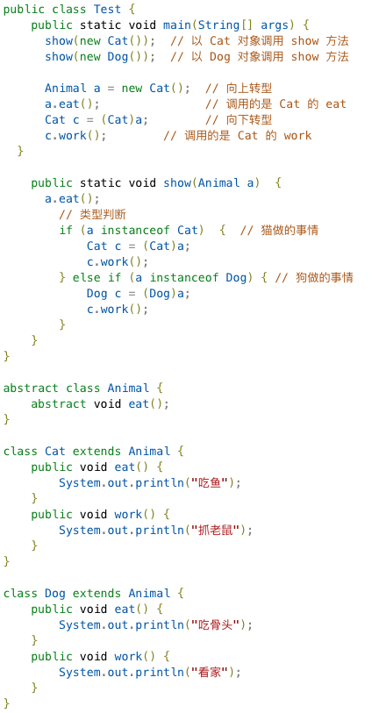

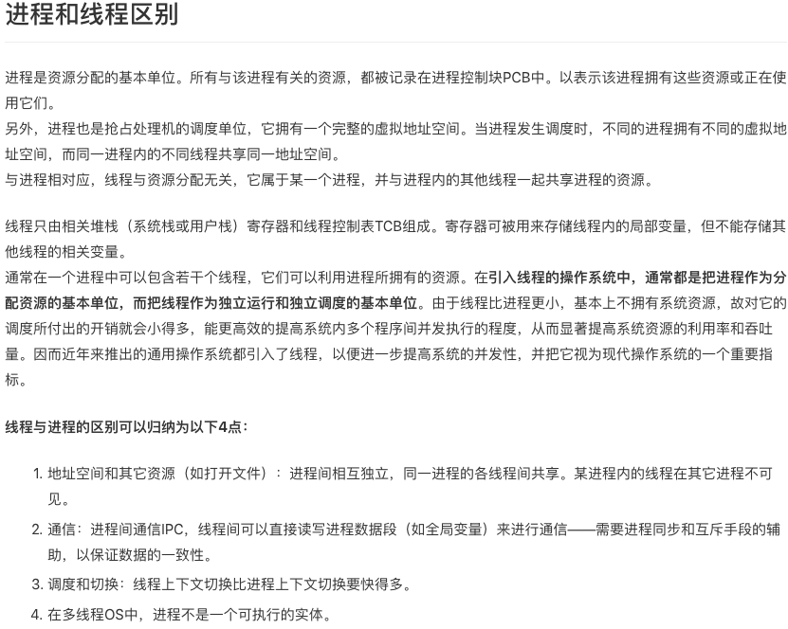
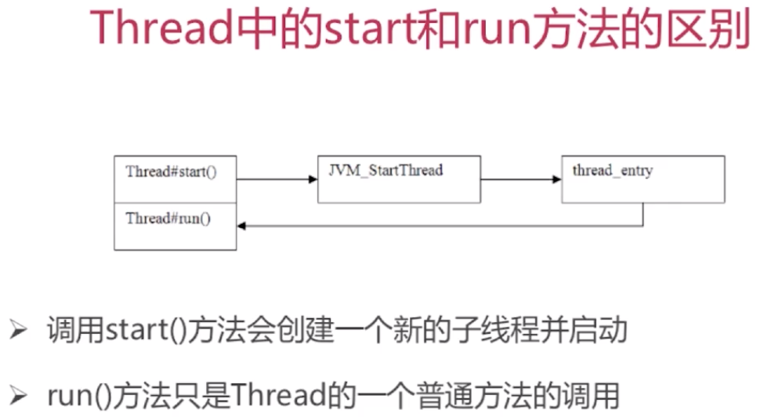
class threadTest {
private static void attack() {
System.out.println("Fight");
System.out.println("Current Thread is: " + Thread.currentThread().getName());
}
public static void main(String[] args) {
Thread t = new Thread() {
public void run() {
attack();
}
};
System.out.println("current main thread is: " + Thread.currentThread().getName());
t.start();
}
}


public class MyThread extends Thread {
private String name;
public MyThread (String name) {
this.name = name;
}

@Override
public void run() {
for (int i = 0;i < 10; i++) {
System.out.println("Thread start: " + this.name + ",i=" + i);
}

}
}
public class ThreadDemo {
public static void main(String[] args) {
MyThread m1 = new MyThread("Thread-1");
MyThread m2 = new MyThread("Thread-2");
MyThread m3 = new MyThread("Thread-3");

m1.start();
m2.start();
m3.start();

}
}
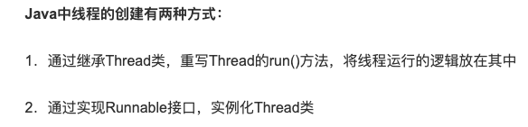


主线程等待法：
public class CycleWait implements Runnable {
private String value;
public void run() {
try {
Thread.currentThread().sleep(5000);
} catch (InterruptedException e) {
e.printStackTrace();
}
value = "Now we have value";
}

public static void main(String[] args) throws InterruptedException {
CycleWait cw = new CycleWait();
Thread t = new Thread(cw);
t.start();
while (cw.value == null) {
Thread.currentThread().sleep(100);
}
System.out.println("value: " + cw.value);
}
}



