

Piri Reis University

Faculty of Economics and Administrative Science

**Management Information System Department**

**PROJECT REPORT – YBS414**

**TECHNOLOGICAL TRANSFORMATION (GROUP A)**

**Aleyna KARACENGEL- 201735023**

**Yaren ÇANĞA- 201735009**

**Zeynep Büşra SÜRGÜ- 20200305305**

**Mehmet Mert ÖREN-201735011**

Advisor: Assoc. Prof. Batuhan KOCAOĞLU

İstanbulDec, 2021

Table of Content

Introduction 4

2. Requiered Tools 6

2.1. Microsoft Access 6

2.2. Visual Basic 6

2.3. Microsoft 10 7

3. SOLUTION APPROACH 7

3.1. Flowchart 7

3.2. GanntChart 8

SYSTEM DEVELOPMENT PROCESS 9

4.1. The Installation of The Required Tools 9

4.1.1 Step 1 9

4.1.2 Step 2 9

4.1.3. Step 3 10

4.1.4. Step 4 10

4.1.5. Step 5 11

4.2 Database Diagram 12

4.3. Development Environments and Development Process 12

4.3.1. Project Stages in Order: 13

4.4. Project Github Link 13

BUSINESS CASE 14

5.1 Explain the Installation 14

5.1.1. Main Page 14

5.1.2. Add User 15

5.1.3. Add Department 15

5.1.4. Add Faculty Program 16

5.1.5. Questionnaire Page 16

5.1.6. Results Report 17

5.1.7. Report Detail 17

5.1.8. Assesment Results 18

5.2 Draw Use Case Diagram : 19

5.3. Manual for Admin and for End User 19

5.3.1. Step 1 19

5.3.2. Step 2: 20

5.3.3 Step 3 20

5.3.4. Step 4 21

5.3.5. Step 5 22

5.3.5.1. Choices 22

5.3.5.2. Questions 23

5.3.6 Step 6 23

5.3.6.1 24

5.3.7 Step 7 24

5.3.7.1 Faculty Screen 25

5.3.8 Step 8 25

5.3.8.1. 26

5.3.8.2 26

5.3.9. Step 9 27

5.3.9.1 27

CONCLUSIONS 28

6.1 Advantages and Drawbacks of The Developed Project 28

6.2 Problems Encountered and Solutions 28

6.3 Possible Improvements for Further Studies 29

6.4 Similar Projects and Commercialization Potential 30

6.5 What The Project Has Contributed To Us 31

REFERENCES 32

INTRODUCTION

In this project, a general form system was designed in which we can learn how successful the technological transformation in schools can be and the attitudes of university students about them. Technology, which is one of the most important issues of our age, is dominant in many areas of our lives, and of course, it is tried to be used very effectively in the field of education. But the most important thing is how much we place technology in the field of education. First of all, technological transformation starts at a young age and continues, and of course, it is necessary to give a lot of place to technology in schools starting from primary school. Universities are the place where this technological transformation should be ensured the most because it is necessary to adapt to technology while pursuing higher education. (www.gomodus.com, 2021)

Everything works through technology in universities in all European and world countries. Especially with the covid-19 pandemic, running everything from home reminded us of the importance and value of technology. The fact that the courses are online and the exams are held on online platforms is the biggest example of the technological transformation of education. However, in this transformation, while some universities were successful, some universities failed. There are many factors such as not fully involving students in technological transformation, old and useless computers in computer laboratories in universities. (small.business.chron.com, 2021)

In this project we did, we designed a project in which we will find answers to how much universities are involved in technological transformation, how many students are involved in the process, and many similar questions. In this project, we want to ask certain questions to the students and, if they wish, to the teachers at the university, to learn how good or bad the technological transformation is and their suggestions for improvement. Especially while designing the project, we made a lot of inferences based on our own university and evaluated it. At the end of the project we will have access to an evaluation report and we will be able to draw conclusions. (www.umityildirim.com, 2021)

While designing this project, the place where we were inspired the most was the surveys that we, as Piri reis university, are made regularly every year. We wanted to design a form related to technology similar to it. We investigated how much adaptation to technological transformation can be achieved in this education in other countries, especially in Turkey.

2. Requiered Tools

2.1. Microsoft Access

Microsoft access is a program that allows you to create and edit databases. It offers a Jet database engine, a graphical user interface, and a software tool in the same package. Thanks to the wizard tools, there is no need to log in to the design environment, it allows you to efficiently prepare the database using only the wizard tool. (support.microsoft.com, 2021)

**Acces Download Link:** <https://www.microsoft.com/tr-tr/download/details.aspx?id=50040>

2.2. Visual Basic

Visual basic is an integrated development environment developed by Microsoft. A code writing panel for the operation of buttons and similar operations in the form. (veriakademi.com, 2021)

2.3. Microsoft 10

It is an operating system developed by Microsoft. (www.penta.com, 2021)

Solution Approach

3.1. Flowchart

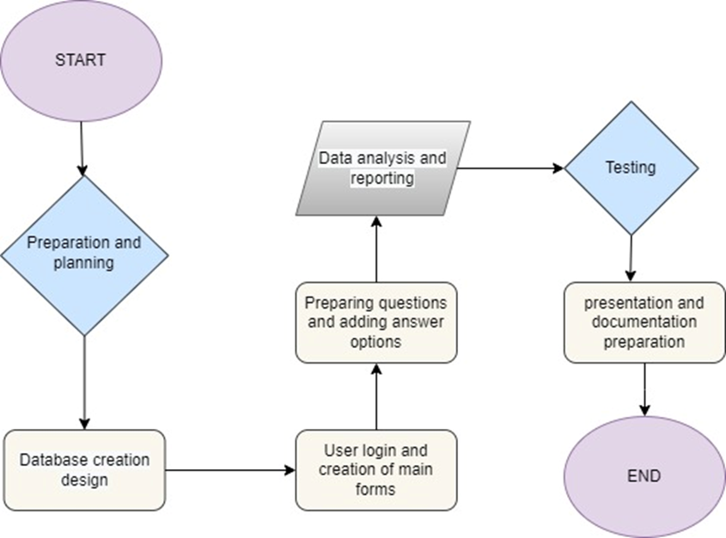

**Figure1: Flowchart (app.diagrams.net, 2021)**

3.2. Gannt Chart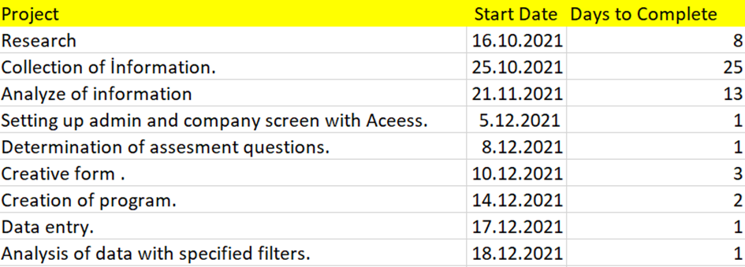

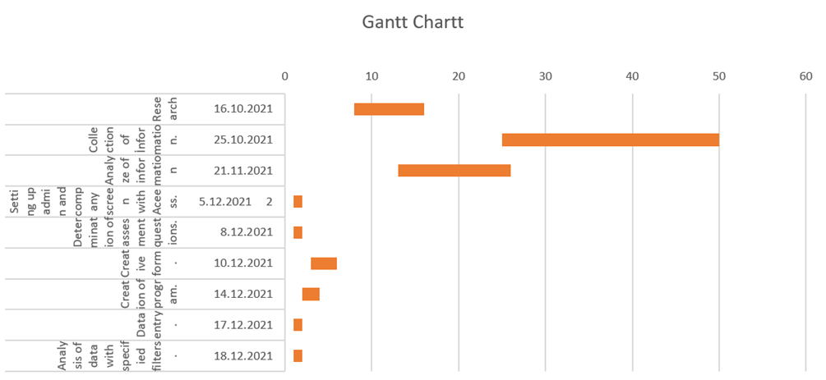

**Figure 2: Gantt Chart (youtube.com, 2021)**

SYSTEM DEVELOPMENT PROCESS

4.1. The Installation of The Required Tools

4.1.1 Step 1

Click the download button.

metin içeren bir resim

Açıklama otomatik olarak oluşturuldu

**Image 1: Download Page (microsoft.com.tr, 2021)**

4.1.2 Step 2

Click the Click on the x64 or x86 exe extension and then click the Download button. And then click Next..

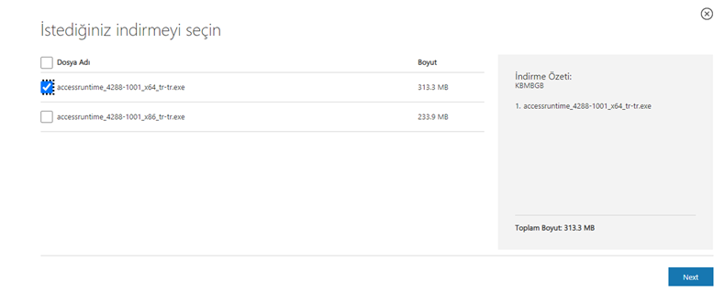

**Image 2: Download Page (microsoft.com.tr, 2021)**

4.1.3. Step 3

Click after the file is fully loaded.

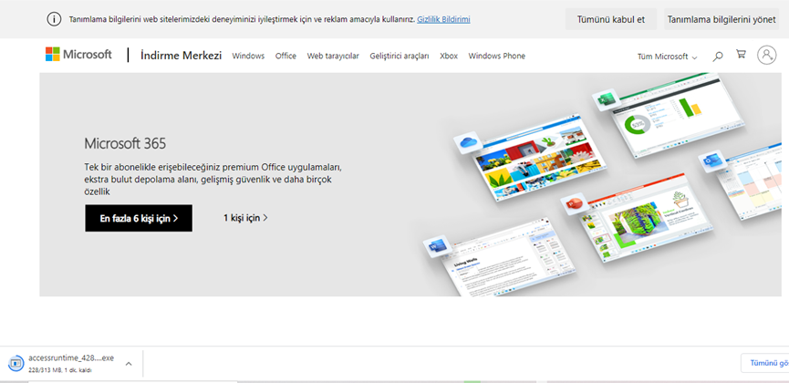

**Image 3: Download Page (microsoft.com.tr, 2021)**

4.1.4. Step 4

Click the “I accept the terms of this contract.” And then click Continue.

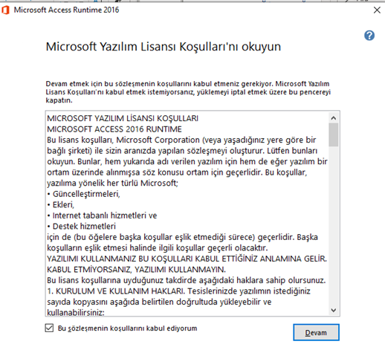

**Image 4: Download Page (www.youtube.com, 2021)**

4.1.5. Step 5

Microsoft acces installation is complete.

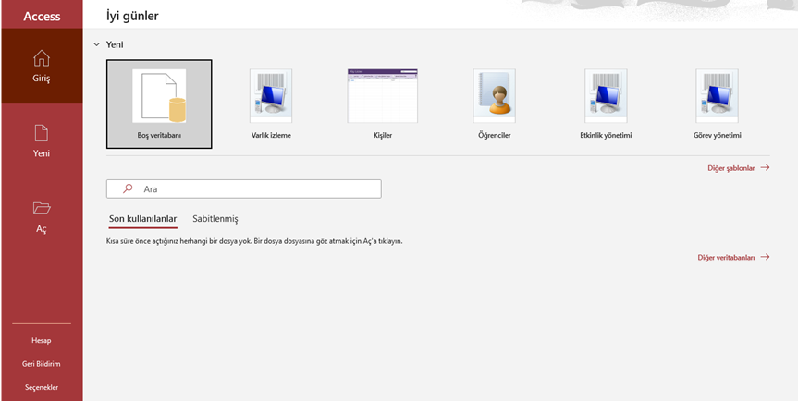

**Image 5 : Access Home Page (www.youtube.com, 2021)**

4.2 Database Diagram

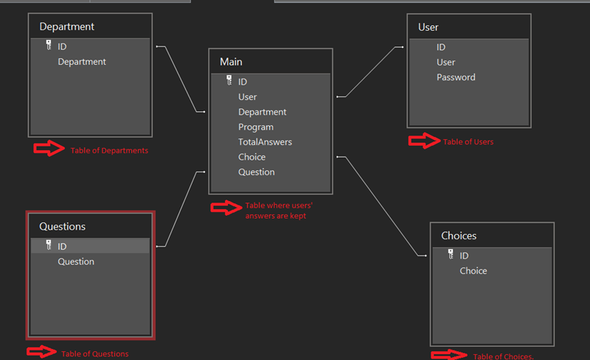

**Image 6:Database Diagram**

4.3. Development Environments and Development Process

First, we divided the project into some phases in order to better manage the project development process. The division of the project into phases made this process easier and at the same time easy monitoring and control of the process.

Initially, many ideas were presented about the project, necessary research was made about the ideas presented and information that would form the basis of the project was collected. Then, what exactly the project will benefit and what purpose it will serve has been defined. It was determined how the project would be developed in the design. During the development phase of the project, the implementation phase of the project started with Microsoft Access.

4.3.1. Project Stages in Order:

* Determination of purpose.
* Research
* Collection of information.
* Analysis of information.
* Setting up admin and company screen with Access.
* Determination of assessment questions.
* Creative form with Access.
* Creation of program.
* Test of program.
* Data entry.
* Analysis of data with specified filters.
* Results.

4.4. Project Github Link

<https://github.com/Spacellm/ERP_Project>

BUSINESS CASE

5.1 Explain the Installation

The program starts with the input interface. Here you can enter the program by entering the username and password and pressing the login button.

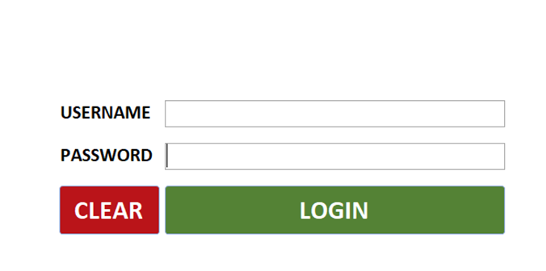

**Image 7: Login Screen**

5.1.1. Main Page

Then the main screen of the program opens. From this page, you need to choose whichever action you want to take.

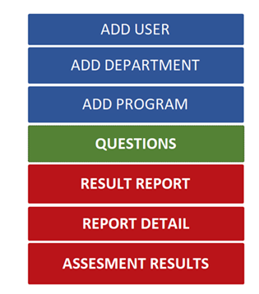

**Image 8: Main Page**

5.1.2. Add User

If your user information has not been created before or if you want to add a new user, you can do so from this page. Here the id is automatically assigned to each user differently.

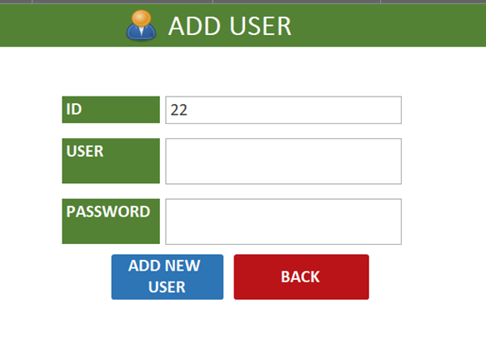

**Image 9 :Add User Page**

5.1.3. Add Department

If the department you are in is not added, you can add options on this page.

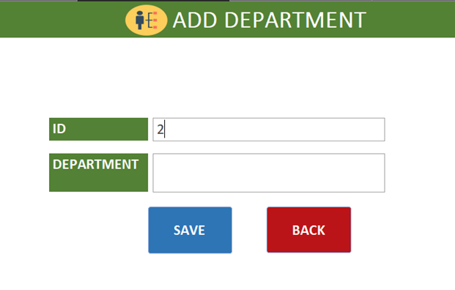

**Image 10: Add Department Page**

5.1.4. Add Faculty Program

If your faculty is not added, you can add options on this page.

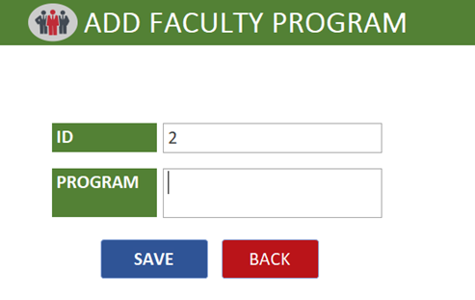

**Image 11: Add Faculty Program Page**

5.1.5. Questionnaire Page

The main page and the form part where we will get all the information are on this page.

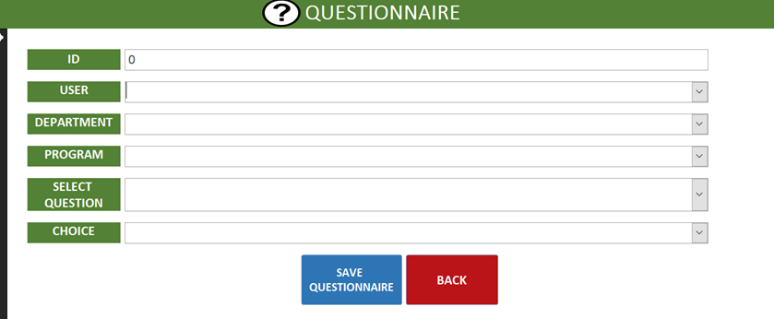

**Image 12: Questionnaire Page**

5.1.6. Results Report

This is the main page where the answers to the questions can be seen. On this page, the desired information can be obtained by filtering.

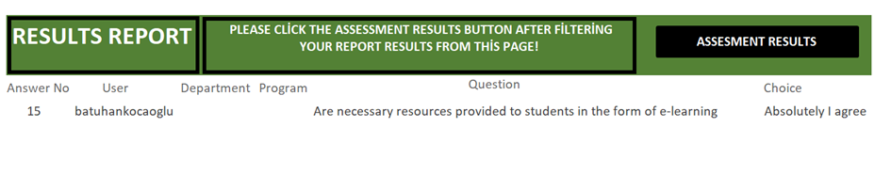

**Image 13:Result Report Page**

5.1.7. Report Detail

Analysis information is seen in this section. Here, what percentage of users answered and the percentage of answers given.

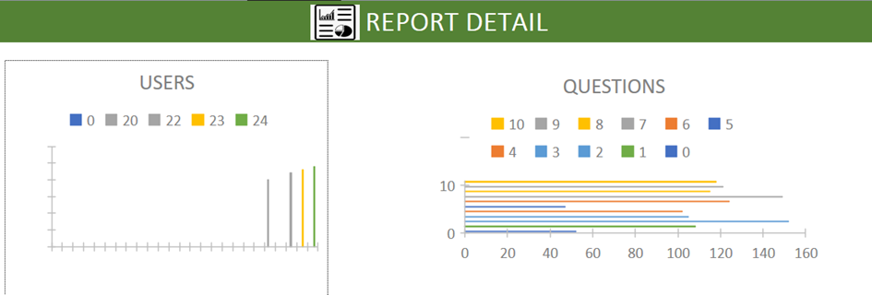

**Image 14: Report Detail Page**

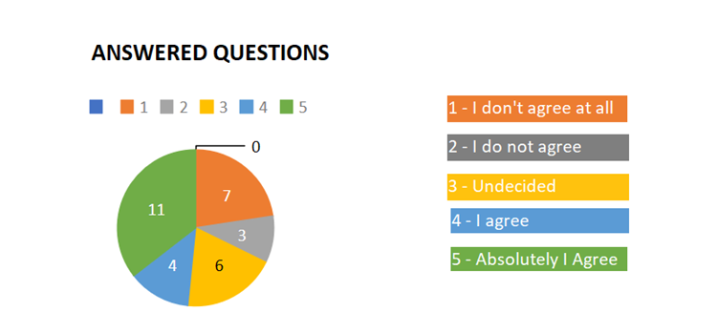

**Image 15: Report Detail Page**

5.1.8. Assesment Results

The part where it will be clear how the overall results will be evaluated and whether they have adapted to how much technological transformation.

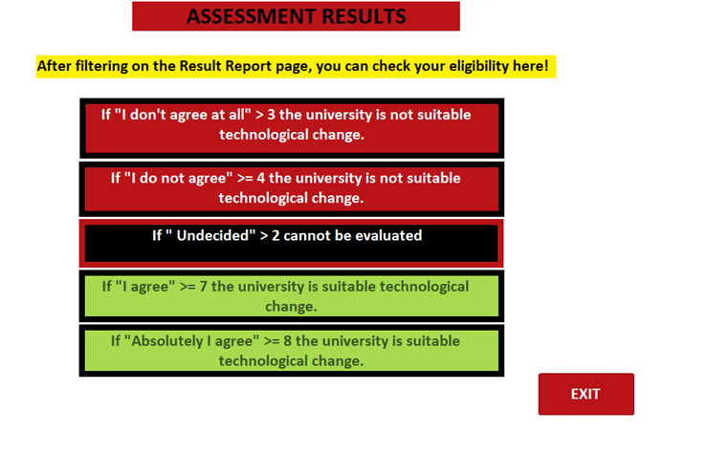

**Image 15: Assesment Results Page**

5.2 Draw Use Case Diagram :

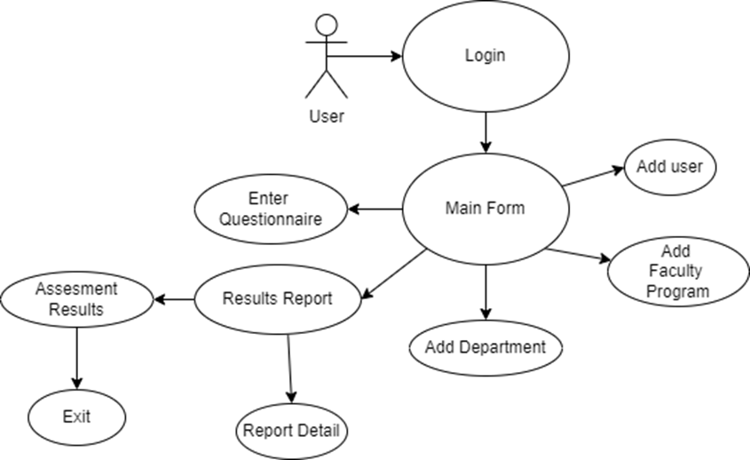

**Image 16: Use Case Diagram (app.diagrams.net, 2021)**

5.3. Manual for Admin and for End User

5.3.1. Step 1

Open the project file from MS Access application.

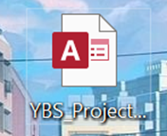

**Image 17: YBS Project File**

5.3.2. Step 2:

Login form opens via MS Access.

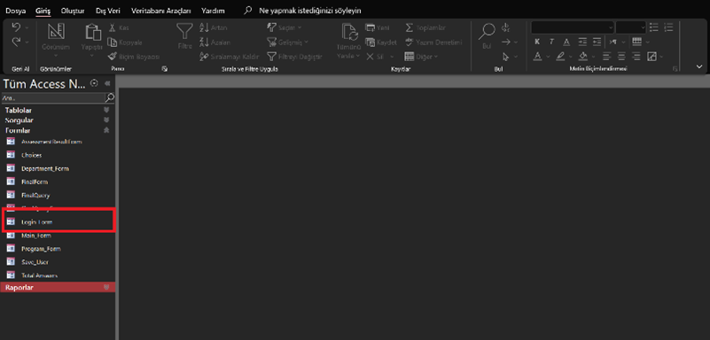

**Image 18: Login Form**

5.3.3 Step 3

After opening the login form, enter your username and password that was sent to your e-mail before. If you log in correctly, you will see the text "successful".

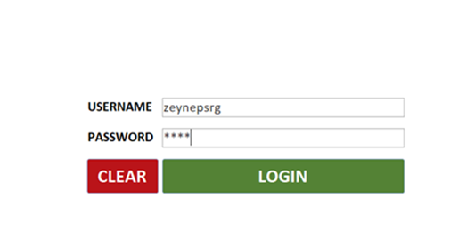

**Image 19: Login Screen**

.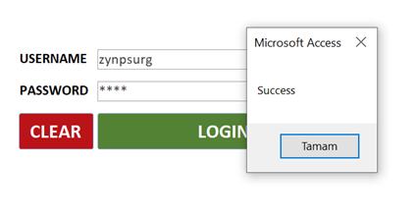

**Image 20:Login Screen 2**

5.3.4. Step 4

After entering the correct password, the main screen will appear. Here you have to choose the action to take

.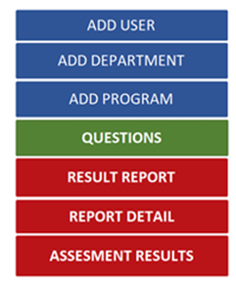

**Image 21: Main Screen**

5.3.5. Step 5

After choosing the user name, department and program, he should answer the questions from the select question one by one. Choose the answer that suits him from the options and click "save questionnarie". If the user cannot see their department and program, they should click Back and return to the main form.

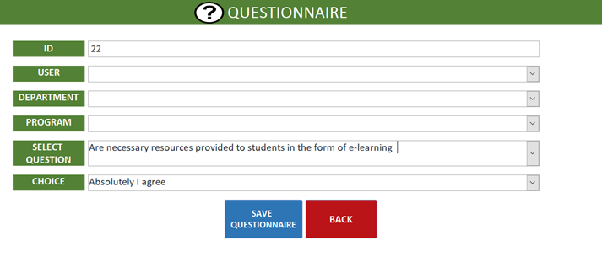

**Image 22: Questıonnaire Screen**

5.3.5.1. Choices

These are the answers you can give to the questions.

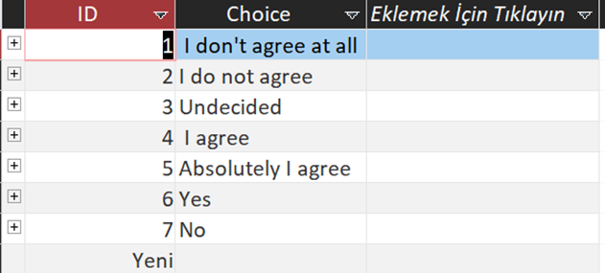

**Table 1: Choice Table Screen**

5.3.5.2. Questions

The questions that users will answer are those that have undergone a general evaluation and that we can get the most accurate answer about technological transformation.

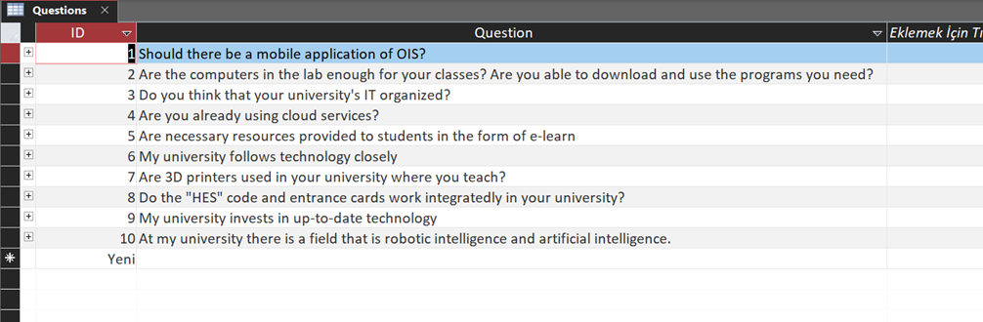

**Table 2 : Questions Screen**

5.3.6 Step 6

If the user does not see his department, he can add his own department from the Add Department field. Here, the id number is automatically assigned. As soon as it says Save, the department is saved. If he clicks Back, he can switch to the question screen again.

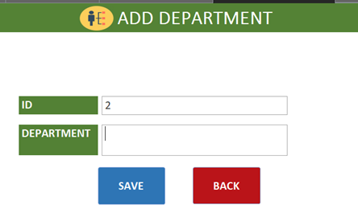

**Image 23: Add Department Screen****5.3.6.1**

These are the departments defined in the program.

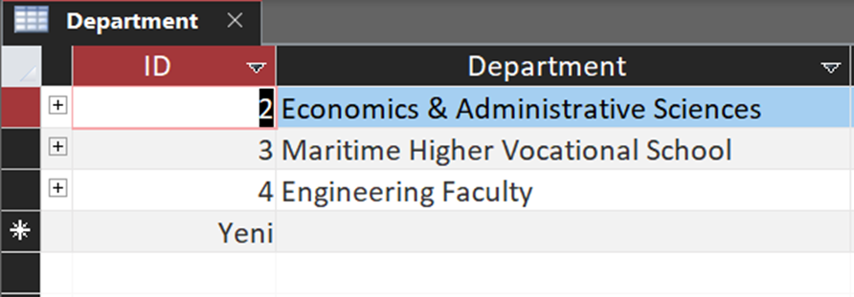

**Table 3: Department Screen**

5.3.7 Step 7

If the user does not see his faculty, he can add his own faculty from the Add Fculty program area. Here, the id number is automatically assigned. As soon as he says Save, his faculty is saved. If he clicks Back, he can switch to the question screen again.

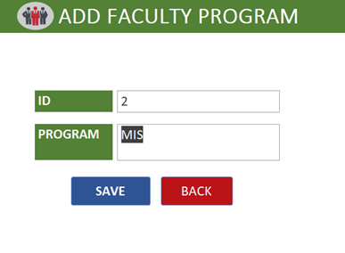

**Image 24 : Add Faculty Program**

5.3.7.1 Faculty Screen

These are the faculties defined in the program.

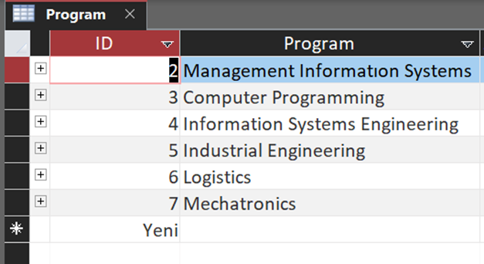

**Table 4: Fcaulty Screen**

5.3.8 Step 8

The user can view the questions answered here as a report format. You can see your own answers by filtering in the report. After filtering, it should go to the assessment results.

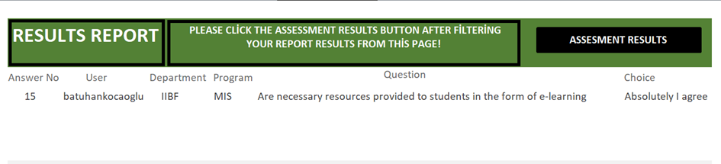

**Image 25 : Result Report Screen**

**5.3.8.1.**

This button displays the assessment result.

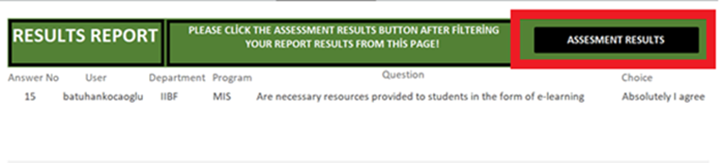

**Image26: Result Report Screen**

5.3.8.2

The user can finally exit the application after evaluating their own answers here.

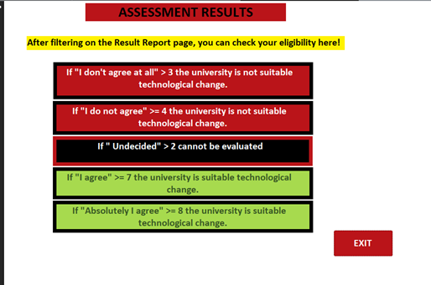

**Image 27: Assesment Results Screen**

**5.3.9. Step 9**

Here, it shows the report graphically how many questions each user answered. It is possible to see which answers were given to the questions and their ratio. The main analysis part is on this page, it can be understood whether the university is successful in technological transformation or to what extent it is successful.

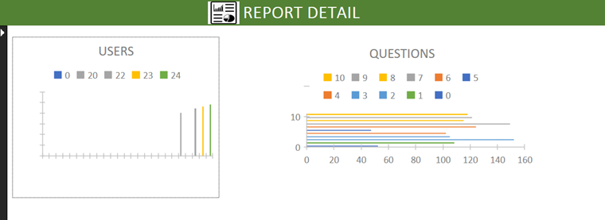

**Image 28 : Analysis Screen**

5.3.9.1

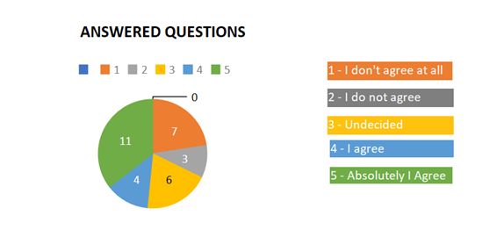

**Image 29 : Analysis Screen**

CONCLUSIONS

6.1 Advantages and Drawbacks of The Developed Project

**Advantages:** It provides the user with the opportunity to see if it is suitable for technological transformation.

**Disadvantages:** Inconsistency of report evaluations when incomplete or incorrect information is entered. It may be that the admin and user panels cannot be parsed for an evaluation of the program.

6.2 Problems Encountered and Solutions

**Problem1:** The most difficult issue we have is listing the recorded data and pulling it into the report.

**Solution1:** In fact, another project is being worked on in this video. We solved the problem in our project thanks to this video using useful information. (www.youtube.com, 2021)

**Problem2:**  Problems caused by a lack of information in access,in visual basic,in the coding sections.

**Solution2:** We solved this problem by getting help from a page that addresses possible problems with visual basic codes. (docs.microsoft.com, 2021)

**Problem:3** Problems with dec relationship between databases.

**Solution3:** The problem was solved by watching this video. (www.youtube.com, 2021)

**Problem4:** Integrating the clear button in the input section.

**Solution4:** Research was conducted on how to solve the problem. The problem was solved by writing blocks of code in Visual basic.

**Problem5:** Integrating buttons with macros in the Main section.

**Solution5:** Access is solved by learning macros from tutorial sources.

6.3 Possible Improvements for Further Studies

* A work schedule could have been made by minimizing all possible risks of the project being interrupted or disrupted.
* The graphics used in the project and the data visualization could be reproduced.
* Data can be replicated and more results can be obtained.
* Adjustments could be made to allow more people to use the Form.
* Further development of menus in the program.

6.4 Similar Projects and Commercialization Potential

It was the "Industry 4.0 Preparation Online Self-Check for Businesses" that allowed him to develop and learn our thoughts about the project. This project is related to Industry 4.0.

To briefly mention Industry 4.0. (www.industrie40-readiness.de, 2021)

Industry 4.0 is a goal the main purpose of which is to bring industry and information technologies together. With Industry 4.0, production and technology will be integrated, and the systems will work integrated with each other. Industry 4.0 is a huge transformation process.

Industry. 4.0 examples: Smart Factories , Smart Robots, Cloud Computing System, IOT,Big Data.

Preparation for Industry 4.0, although it is not very similar to our project Thanks to the impressions we received from the online Self-Check for Businesses page, we brought a different perspective to our project and developed it. (www.tarnet.com.tr, 2021)

From our point of view, adapting technological transformation to the field of school and education is a very valuable issue. Schools are an indispensable part of our educational life, and the people who work here should not lag behind the ever-evolving technology. It is inevitable that students and lecturers will criticize this issue. Designed and

this form, which provides the necessary reports, allows us to have an idea of how much schools are developing technologically. That is why every school needs this Form a in order to carry out its work more efficiently and for students to benefit more efficiently from technological developments. We see the Commercialization potential of this project, which we have developed and named Technological Transformation, as a positive one. (www.stendustri.com, 2021)

6.5 What The Project Has Contributed To Us

* To have knowledge about access and to get to a level where you can use access.
* Development of research skills.
* To acquire the ability to solve the problems arising during the project.
* Learning visual basic through the project.
* Getting inspiration from different projects.
* Work harmoniously with teammates.
* Being informed and informed about many projects.
* Development of the ability to ask questions.
* Encouraging him to work regularly.
* Having a package program at the end of the project.

REFERENCES

https://g.co/kgs/kvHuDo

*app.diagrams.net*. (2021, 12 6). https://app.diagrams.net/

*docs.microsoft.com*. (2021, 12 20). Microsoft: https://docs.microsoft.com/tr-tr/dotnet/visual-basic/programming-guide/program-structure/program-structure-and-code-conventions

*microsoft.com.tr*. (2021, 12 6). Microsoft: https://www.microsoft.com/tr-tr/download/details.aspx?id=50040

*small.business.chron.com*. (2021, 12 20). Small Business: https://smallbusiness.chron.com/impact-technological-change-business-activity-2191.html

*support.microsoft.com*. (2021, 12 19). Microsoft: https://support.microsoft.com/tr-tr/office/video-access-nedir-f2338765-ff59-4cfc-b8ba-74059fcb1874

*veriakademi.com*. (2021, 12 6). Veri Akademi: https://veriakademi.com/visual-basic-nedir

*www.gomodus.com*. (2021, 12 20). Gomodus: https://www.gomodus.com/blog/eight-ways-technology-changing-business

*www.industrie40-readiness.de*. (2021, 12 20). Industrie40: https://www.industrie40-readiness.de/?lang=en a

*www.penta.com*. (2021, 12 6). Penta Teknoloji: https://www.penta.com.tr/markalar/microsoft/urunler/windows-10/windows-10-nedir/

*www.stendustri.com*. (2021, 12 20). Stendustri: https://www.stendustri.com.tr/endustri-40-uygulamalari/endustri-40-nedir-h95384.html

*www.tarnet.com.tr*. (2021, 12 20). Tarnet: https://www.tarnet.com.tr/medya-merkezi/blog/endustri-4-0-nedir/

*www.umityildirim.com*. (2021, 12 20). Ümit Yıldırım: https://www.umityildirim.com/firmalar-icin-teknolojik-degisime-uyum-saglamak/

*www.youtube.com*. (2021, 12 6). Youtube: https://www.youtube.com/watch?v=QN93uZZ8kIo

*www.youtube.com*. (2021, 12 20). Youtube: https://www.youtube.com/watch?v=EFmhoBjXsZE

*www.youtube.com*. (2021, 12 20). Youtube: https://www.youtube.com/watch?v=t4SlIa-w29w

*youtube.com*. (2021, 12 6). Youtube: ht