Fortismere School

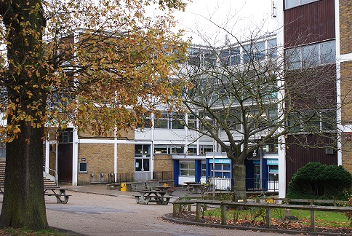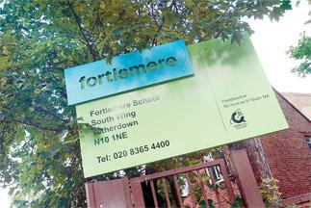

INSERT PICTURE OF YAKUP’S OFFICE

We build our robots here in the (What the fuck is it called) room. Our team members come during break, lunch, free periods and after school to work on our robots resulting in a constant work flow. Often the robot you see in the morning will be completely different from the one that sits there in the evening.

Fortismere School is a high achieving, mixed, foundation secondary school in Muswell Hill, North London. The 2017-18 season is our 3rd season of vex and 2nd season of VEX EDR. In our first ever season of vex in the Vex IQ Bankshot challenge we managed to qualify for the world finals in Kentucky however were unable to attend due to funding issues. In our second year, last season, we started our first two Vex EDR teams and once again had great success managing to secure second place for skills in all the UK and having large success in the UK nationals making it to the quarter finals.

Meet the Staff

# Murat Yakup Lead Mentor/ Head of Enterprise

# Image result for empty profile picture

Somebody write something plz

# John Doe Mentor/ Music teacher

# Image result for empty profile picture

For whoever comes with us to a comp