IRIS

Submitted in partial fulfillment of the requirements for the degree of

Bachelor of Technology

in

Computer Science and Engineering

by

MANIT BISHT

25BCE2441

Under the guidance of

Dr. Jaffino

SENSE
VIT Vellore



Abstract
Iris is a compact AI companion which combines animated facial expressions, face tracking, and voice interaction. An ESP32-CAM module captures images and microphone input, while a local computer performs vision and speech processing. The device displays responsive eyes and a mouth on a small TFT display. It includes bounded buffering, communication recovery, and diagnostic tools. Separate camera, Wi-Fi, and display checks. Although complete audio operation, response time, power consumption, and user experience still require physical evaluation.

Introduction
Voice-only assistants provide limited visual feedback about their activity. Iris addresses this limitation through animated eyes and expressions that give an insight about listening, thinking, and speaking states. It is wall-mounted and thus uses screen animation instead of mechanical eyes.
The main challenge is coordinating camera capture, audio, communication, and display updates on limited embedded hardware. Iris assigns heavy AI workloads to a local computer and keeps sensing and rendering on the device.
The objectives are to track face position, provide clear interaction states, support local voice processing, and limit stale data. The hardware costs roughly ₹1,500. Excluding the host equipment which should also be considered.

Literature Review
Admoni and Scassellati [1] distinguish technical gaze implementation from its effects on people. This distinction matters because successful face tracking does not establish perceived eye contact or engagement.
Jung et al [2] found improved gaze judgments using an additional visual cue with virtual humans on a flat display. Their findings motivate directional feedback, but require separate validation on Iris’s miniature screen.
Andrist et al [3] showed that appropriately timed gaze aversion supported perceived thoughtfulness and conversational floor management. Their robot’s head movements differ from Iris’s pupil animation.
Yates et al [4] distinguish information freshness from throughput. This motivates limiting waiting frames, although freshness alone does not demonstrate better interaction.
Together, these studies support evaluating Iris through directional clarity, state interpretation, and response timing.

Proposed Methodology
The hardware comprises an AI-Thinker ESP32-CAM, OV3660 camera, 128×160 ST7735S TFT, INMP441 microphone, and optional MAX98357A speaker output. A Python host runs OpenCV, Whisper speech recognition, Ollama language-model processing, and Coqui speech synthesis.

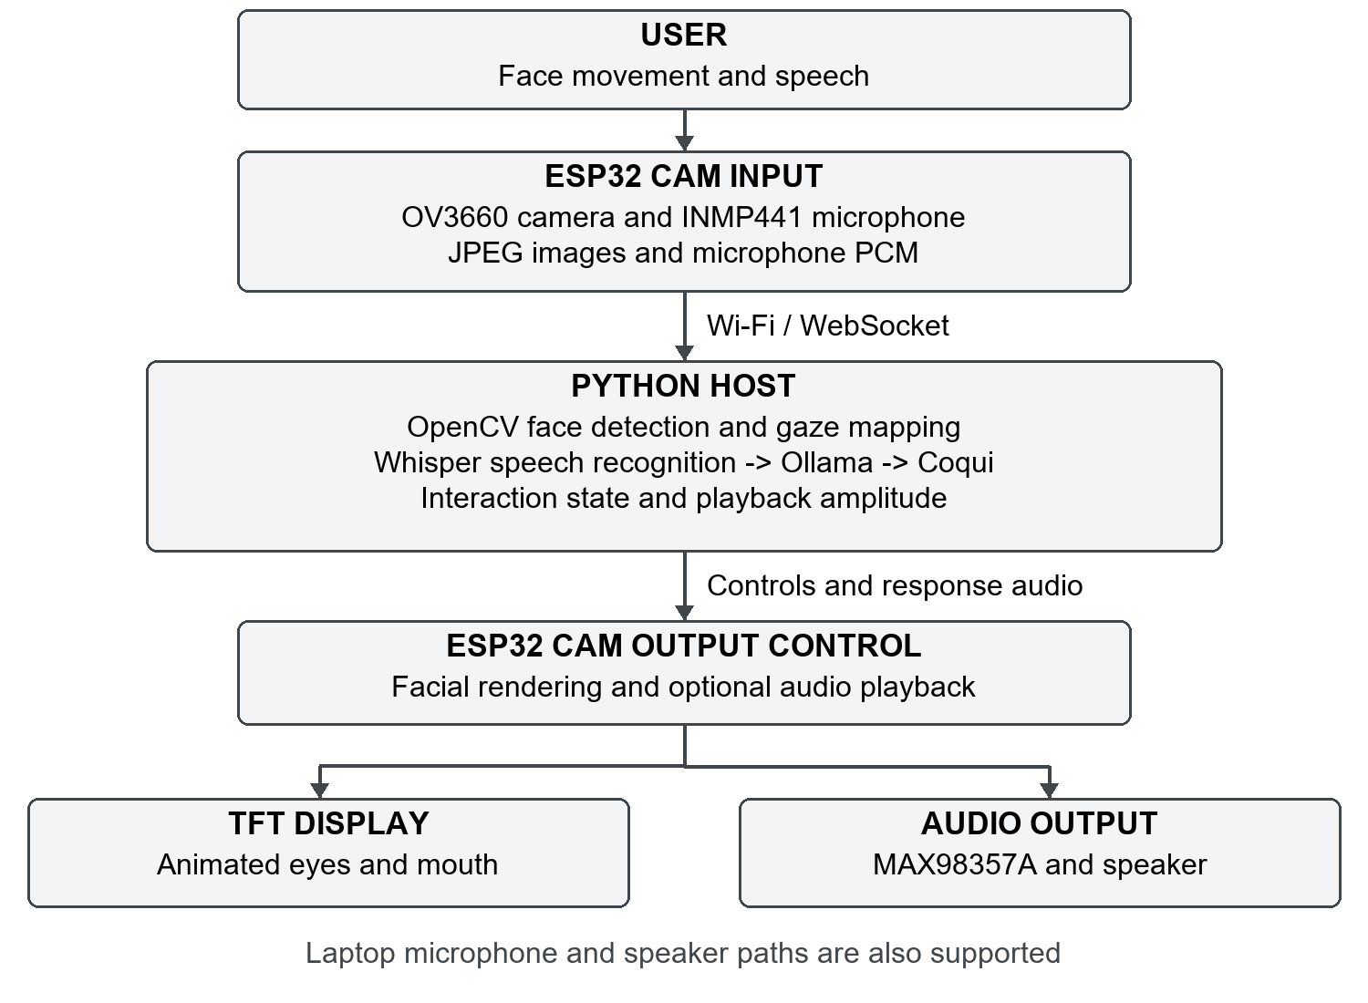
The host selects the largest detected face and maps its center into gaze coordinates between −1 and +1. Horizontal mirroring corrects the orientation. Exponential smoothing reduces abrupt pupil movement. This estimates face position.
Facial states include sleeping, idle, listening, thinking, talking, and excited. Mouth movement follows outgoing audio amplitude. The voice pipeline detects utterance boundaries, transcribes speech, generates a reply, and synthesizes playback. Half-duplex capture reduces feedback during responses.
Camera scheduling permits up to 12.5 FPS without enabled microphone capture and 4 FPS during enabled device microphone capture. Display updates target approximately 30 FPS. Frame acknowledgements and bounded queues aim to reduce backlog. These are configured limits, not measured performance guarantees.

Experimental Results
Item | Documented status
Camera | Worked successfully
Wi-Fi | Connection separately verified
TFT | Standalone color test successful
Replacement microphone and device playback | Complete physical verification pending
End-to-end latency, power, and cost | Not measured or audited

Calculated mono PCM16 audio at 16 kHz requires 32,000 payload bytes per second. A full 128×160 RGB565 image contains 40,960 bytes; ideal transfer at the configured 27 MHz SPI rate takes about 12.14 ms before overhead. These calculations are not benchmark results.
Criterion | Static face | Mechanical face | Iris
Responsive direction | Requires added tracking | Actuator-controlled | Face driven pupils
Facial movement | Fixed or scripted pixels | Physical mechanisms | Animated pixels
Main trade-off | Limited responsive cues | Assembly and calibration | Host and network dependency

This is an architectural comparison of the device. Future testing should compare static, scripted, and responsive faces under identical conditions. Measurements should include visible response delay, audio gaps, gaze interpretation, and state recognition.

Conclusion
Iris integrates embedded sensing, animated feedback, and host-based AI into a compact companion prototype. Its architecture supports further experimentation with expressive interfaces. Physical audio validation, workload benchmarks, complete cost accounting, and participant studies are needed before claiming reliable deployment or improved engagement.

References
[1] Admoni and Scassellati. “Social Eye Gaze in Human-Robot Interaction: A Review.” 2017. DOI.
[2] Jung, Kum, and Lee. “Breaking the Mona Lisa Effect.” 2023. Paper.
[3] Andrist et al. “Conversational Gaze Aversion for Humanlike Robots.” 2014. DOI.
[4] Yates et al. “Age of Information: An Introduction and Survey.” 2021. DOI.

