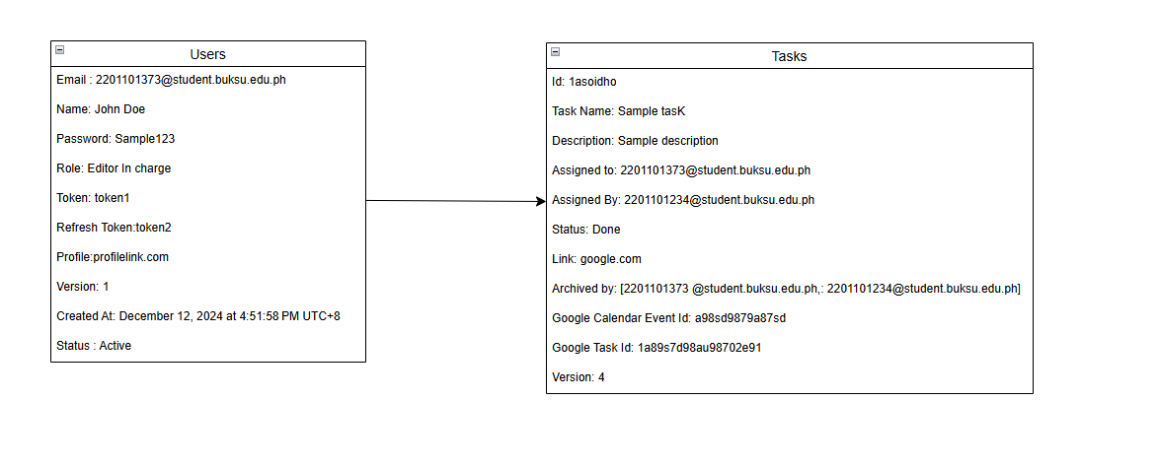

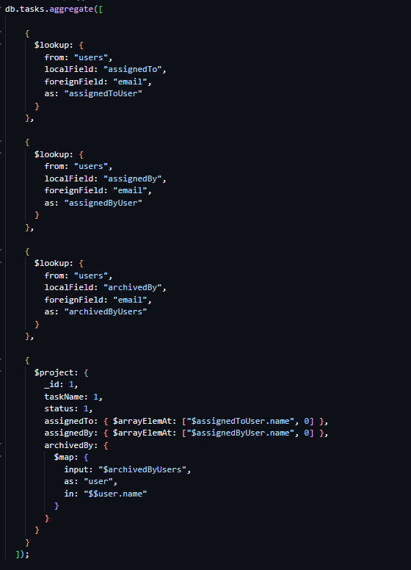

Figure x illustrates the database schema for the Tasks and Users collections in the system. The schema is designed to manage and aggregate task-related activities based on user details. The Tasks collection is linked to the Users collection through the user email field, enabling the system to associate tasks with specific users for efficient tracking and assignment.

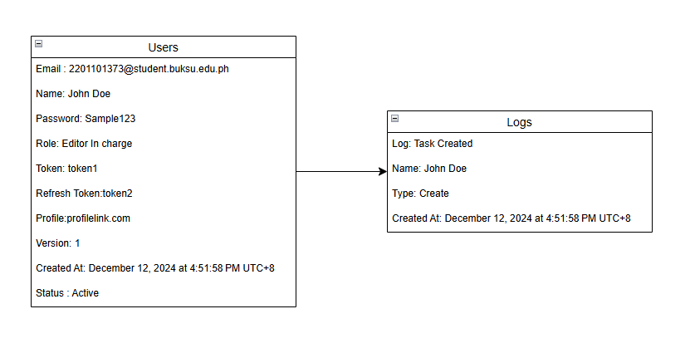

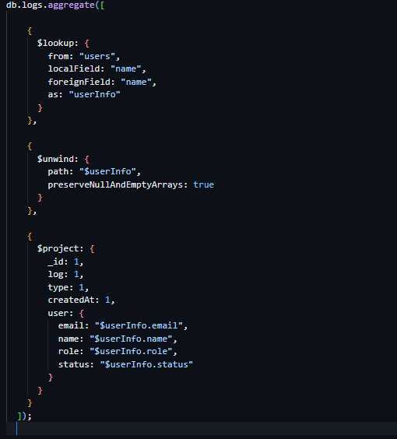

Figure x presents the database schema for the Logs and Users collections. The Logs collection references the user's name field to record and track system actions performed by each user. This relationship ensures that the system can maintain a comprehensive activity log for accountability and auditing purposes.