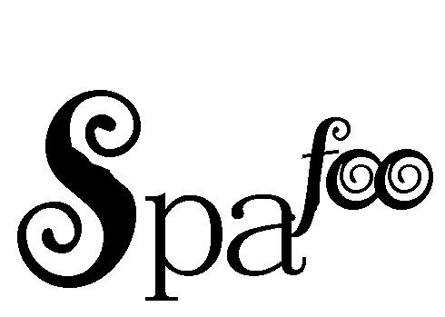

**On Site hair and body services from your phone!**