Penalized Regression for High-Dimensional Molecular Toxicity Classification
by
GINNI Vishal
(22203133)

A thesis submitted in partial fulfilment of the requirements
for the degree of

Bachelor of Science (Honours)
in Mathematics and Statistics

at

Hong Kong Baptist University

11 December 2025

ACKNOWLEDGEMENT
I would like to express my deepest gratitude to Dr. Wu Tian for her invaluable guidance, patience, and expertise throughout the course of this research project. Her thoughtful feedback was instrumental at every stage, particularly during the initial phase of study design, where her advice on dataset suitability and the distinction between time-series and cross-sectional analysis helped ground the research in the appropriate methodology.
I am especially thankful for her technical insights regarding high-dimensional settings, which guided my approach to feature selection, class imbalance handling, and the interpretation of redundant features in penalized regression models. Her encouragement to rigorously benchmark a wide array of linear and non-linear models, combined with her constructive suggestions on visualization techniques, significantly improved the comprehensiveness and clarity of my findings. All experiments and analyses described in this thesis were conducted under her supervision, and her support has been a cornerstone of this achievement.

_________________________
Signature of Student

_________________________
Student Name

Department of Mathematics
Hong Kong Baptist University

Date: ____________________

Table of Contents
Abstract 1
Introduction 2
Background & Motivation 2
Research Objectives 2
Significance of the Study 2
Literature Review & Theory 3
Molecular Toxicity Prediction and Drug Discovery 3
The Toxicity-2 Dataset and Original Study 3
Machine Learning Approaches to Toxicity Prediction 3
Penalized Regression in High-Dimensional Settings 4
Research Gaps and Motivation 4
METHODOLOGY 5
Dataset Description 5
Data Preprocessing 5
Model Specifications 5
Evaluation Metrics 5
THEORETICAL FOUNDATIONS 6
The High-Dimensional Regression Problem 6
The Bias-Variance Tradeoff 6
Ridge Regression (L2 REGULARIZATION) 6
Lasso Regression (L1 Regularization) 6
Elastic Net 7
Results 8
Overall Model Performance 8
Performance by Model Family 8
Linear Models 8
Tree-Based Models 9
Support Vector Machines 9
Neural Networks 10
Class Weighting Analysis 11
Feature Selection Discrepancies 11
Discussion 12
Interpretation of findings 12
Comparison to Literature 12
Limitations 12
Implications for Practice 12
Conclusion 13
References 1
Appendix 1

TABLE OF FIGURES
Figure 1. Test Accuracy & AUC Comparison of Top 15 models 8
Figure 2. Test Accuracy & AUC Comparison of Penalized Regression Models 9
Figure 3. Test Accuracy & AUC Comparison of Tree-Based Models 9
Figure 4. Test Accuracy & AUC Comparison of SVM Models 10
Figure 5. Test Accuracy & AUC Comparison of Neural Networks 10
Figure 6. Top 20 Features Selected Across All 43 Models 11
Figure 7. Test Accuracy & AUC Comparison of Original vs. Class Weighted Models 2

LIST OF TABLES
Table 1. List of Models Trained 5

Penalized Regression for High-Dimensional
Molecular Toxicity Classification

GINNI Vishal
(22203133)

Department of Mathematics

Abstract
High-dimensional molecular descriptor datasets present significant challenges for traditional classification methods due to the risk of overfitting. This study investigates three penalized regression models, ridge regression, lasso, and elastic net, and their effectiveness in predicting molecular toxicity using the UCI Toxicity-2 dataset comprising 171 molecules with 1,203 molecular descriptors. The dataset exhibits class imbalance with 67.25% non-toxic and 32.75% toxic molecules. We implemented 43 classification models including linear models with various penalty configurations, tree-based ensemble methods, support vector machines, and neural networks. Cross-validated analysis revealed that K-Nearest Neighbors (K=7), Quadratic Discriminant Analysis, and K=5 variants achieved statistically equivalent AUC scores (0.504-0.520, p>0.54), with no model significantly outperforming others. Lasso Logistic Regression (C=0.1) exhibited superior generalization stability (overfitting gap <2%) but limited discriminative power (CV AUC=0.425), while SMOTE resampling improved decision tree performance by 11.4% accuracy. Feature selection instability and low correlation among descriptors (0.51% pairs with |r|>0.9) suggest that small sample size (n=136) relative to dimensionality (p=1,203) fundamentally limits model performance beyond algorithmic improvements. Class weighting strategies did not yield significant improvements. Feature selection patterns diverged from the original study's 13 identified descriptors, suggesting alternative molecular signatures for toxicity prediction. This thesis demonstrates both the theoretical foundations and practical limitations of penalized regression in high-dimensional molecular classification tasks.

Introduction

Background & Motivation
High-dimensional data analysis has become increasingly prevalent in modern statistics and machine learning, particularly in domains such as genomics, cheminformatics, and medical diagnostics. When the number of predictors $p$ exceeds or approaches the number of observations $n$, traditional statistical models face the curse of dimensionality, leading to overfitting and poor generalization performance (James et al., 2023). This phenomenon is especially problematic in molecular toxicity prediction, where thousands of chemical descriptors must be analyzed to identify compounds that pose health risks.
Penalized regression methods, also known as shrinkage or regularization techniques, address overfitting by introducing penalty terms that constrain model complexity. Three fundamental approaches, ridge regression, lasso (Least Absolute Shrinkage and Selection Operator), and elastic net, have emerged as powerful tools for handling high-dimensional datasets. These methods balance model fit with complexity, enabling more robust predictions on unseen data.

Research Objectives
This thesis aims to accomplish three primary objectives. First, we provide a comprehensive theoretical foundation for ridge regression, lasso, and elastic net, including their mathematical formulations and optimization properties. Second, we apply these methods to the UCI Toxicity-2 dataset, which contains 171 molecules characterized by 1,203 molecular descriptors, to predict molecular toxicity. Third, we compare the performance of penalized regression models against various machine learning algorithms, including tree-based ensembles, support vector machines, and neural networks

Significance of the Study
According to Gul et al. (2021), circadian rhythm disruption has been linked to serious health conditions including cancer, depression, mood disorders, and hypertension. The core clock protein CRY1 (Cryptochrome 1) plays a critical role in generating circadian rhythm through the CLOCK-BMAL1 transcriptional complex. Developing small molecules that modulate CRY1 activity while remaining non-toxic represents a significant challenge in drug discovery for circadian rhythm-related disorders.
This study applies penalized regression methods to predict molecular toxicity in 171 CRY1-targeting compounds characterized by 1,203 molecular descriptors. By implementing computational toxicity prediction, researchers can screen out harmful compounds early in the drug development pipeline, dramatically reducing experimental costs. The comparison of ridge regression, lasso, and elastic net in this extreme high-dimensional setting ($p>>n$) provides methodological insights for QSAR studies in pharmaceutical development.
The molecular descriptors identified through this analysis can potentially be applied to screening large chemical libraries for therapeutic candidates targeting circadian rhythm disorders, accelerating the discovery of safe and effective circadian modulators.

Literature Review & Theory

Molecular Toxicity Prediction and Drug Discovery
Accurate prediction of molecular toxicity is a critical challenge in drug discovery and chemical safety assessment. Traditional in vitro and in vivo toxicity testing is time-consuming, expensive, and raises ethical concerns, driving the development of computational approaches for toxicity prediction (Setiya et al., 2024)). Machine learning models trained on molecular descriptors offer a promising alternative by identifying structural features associated with toxicity while reducing experimental costs and animal testing requirements.

The Toxicity-2 Dataset and Original Study
The dataset used in this study originates from research by Gul et al. (2021), who performed structure-based drug design targeting CRY1, a core clock protein responsible for generating circadian rhythm. Circadian rhythm disruption has been associated with various diseases including cancer, mood disorders, and familial delayed sleep phase disorder, making CRY1 an important therapeutic target. The researchers used the CRY1 crystal structure (PDB ID: 4K0R) to perform in silico screening and identified 171 candidate molecules targeting functional domains of CRY1.
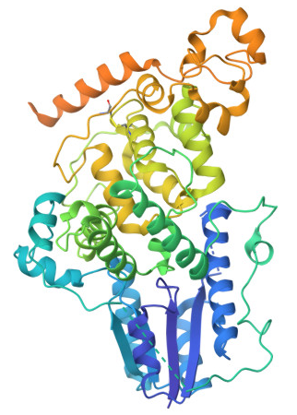
Figure 1. Crystal structure of mouse cryptochrome 1 (CRY1), a core circadian clock protein, shown from the RCSB PDB entry 4K0R.
Experimental validation in U2OS human osteosarcoma cells revealed that 115 molecules (67.25%) were non-toxic while 56 molecules (32.75%) exhibited toxicity, creating a class-imbalanced dataset typical of real-world toxicity studies. Of the non-toxic molecules, 21 significantly lengthened the circadian period. Each molecule was characterized by 1,203 molecular descriptors computed from structural information, creating a high-dimensional dataset where the number of features substantially exceeds the number of observations ($p>>n$).
For toxicity classification, Gul et al. (2021) employed Decision Tree Classifiers (DTC) which identified 13 molecular descriptors predictive of toxicity with a mean accuracy of 79.53% using tenfold cross-validation. The study also applied Gradient Boosting Classifiers (XGBC) to classify molecules based on their ability to lengthen circadian period. This decision tree approach provided interpretable rules linking specific molecular features to toxicity outcomes, establishing a baseline for subsequent machine learning studies on this dataset.

Machine Learning Approaches to Toxicity Prediction
Recent advances in machine learning have produced diverse methodologies for toxicity prediction. Karim et al. (2019) developed an efficient approach combining decision trees for feature selection with shallow neural networks, achieving competitive predictive accuracy while significantly reducing computational complexity. Their emphasis on aggressive feature selection addresses the challenge of redundant and uninformative molecular descriptors that can confound more complex models.
Setiya et al. (2024) introduced MolToxPred, a stacked ensemble approach combining Random Forest, Multi-Layer Perceptron, and LightGBM as base classifiers with Logistic Regression as the meta-classifier. Their model incorporated univariate feature selection to reduce multicollinearity and improve interpretability, demonstrating that ensemble methods can outperform individual classifiers for toxicity prediction. The study emphasized the importance of diverse training data and careful feature engineering in achieving robust predictive performance.
Sharma et al. (2023) explored multi-task deep neural networks for clinical toxicity prediction, achieving accurate predictions while providing contrastive molecular explanations to enhance model interpretability. This work highlights the growing importance of explainable AI in toxicity prediction, where understanding why a molecule is predicted as toxic is as valuable as the prediction itself.

Penalized Regression in High-Dimensional Settings
The challenge of high-dimensional data ($p>>n$) has motivated extensive research into penalized regression methods. Ogutu et al. (2012) conducted comprehensive comparisons of ridge regression, lasso, and elastic net in genomic selection contexts, evaluating their relative performance in handling thousands of correlated predictors. Their findings demonstrated that lasso-type penalties enable simultaneous variable selection and shrinkage, making them particularly valuable when only a subset of features are truly predictive.
Ajana et al. (2019) investigated the benefits of dimension reduction prior to penalized regression in high-dimensional grouped data with small sample sizes, a scenario similar to the Toxicity-2 dataset. Their results showed that incorporating dimension reduction techniques improved prediction accuracy and model stability, suggesting that penalized regression alone may be insufficient when $n$ is severely limited relative to $p$. This finding motivates consideration of preprocessing strategies such as principal component analysis or partial least squares before applying penalized methods.

Research Gaps and Motivation
While previous studies have applied various machine learning algorithms to the Toxicity-2 dataset, systematic investigation of penalized regression methods, specifically comparing ridge, lasso, and elastic net, has been limited. The original study by Gul et al. focused on decision tree methods, leaving open questions about whether linear models with appropriate regularization can achieve comparable performance. Furthermore, the stability of feature selection in this high-dimensional, small-sample setting remains unclear, as different modelling approaches may identify different molecular signatures for toxicity.
This thesis addresses these gaps by:
- providing rigorous theoretical foundations for penalized regression methods
- systematically comparing ridge, lasso, and elastic net with varying regularization strengths
- benchmarking penalized regression against diverse machine learning algorithms including tree-based ensembles, support vector machines, and neural networks
- investigating the consistency of feature selection across different modelling approaches.

METHODOLOGY

Dataset Description
The UCI Toxicity-2 dataset contains 171 molecules designed for functional domains of CRY1, a core clock protein responsible for circadian rhythm regulation. Of these molecules, 56 (32.75%) are toxic and 115 (67.25%) are non-toxic, creating a class imbalance typical of real-world toxicity datasets. Each molecule is characterized by 1,203 molecular descriptors computed from structural information. The original study by Gul et al. (2021) used decision tree classification to identify 13 key descriptors predictive of molecular toxicity.

Data Preprocessing
Standard preprocessing steps included shuffling the dataset, checking for missing values, scaling features to unit variance, and splitting the data into training and testing sets. Given the class imbalance, we explored two modelling strategies: standard training and class-weighted training where weights are inversely proportional to class frequencies. Beside single train-test splits, we also implemented stratified k-fold cross-validation (k=5) to obtain mean and standard deviation for each evaluation metric to show which models generalize consistently versus those with high variance.

Model Specifications
We implemented 43 classification models spanning multiple algorithm families:
Table 1. List of Models Trained
Linear Models | Logistic regression with no penalty, ridge penalty (L2), lasso penalty (L1), and elastic net with varying regularization strengths $C$ and L1 ratios. Ridge classifier and SGD classifier were also included.
Discriminant Analysis | Linear Discriminant Analysis (LDA) and Quadratic Discriminant Analysis (QDA).
Naive Bayes | Gaussian Naive Bayes for baseline probabilistic classification.
Tree-Based Models | Decision trees with varying maximum depths (5, 10, 20, and unpruned), providing interpretable rule-based predictions.
Ensemble Methods | Random forests, extra trees, AdaBoost, gradient boosting, and XGBoost with different hyperparameter configurations to leverage ensemble learning benefits.
Support Vector Machines | Linear, RBF, and polynomial kernels with varying complexity parameters.
K-Nearest Neighbors | Varying numbers of neighbors (3, 5, 7, 10) to capture local decision boundaries.
Neural Networks | Multi-layer perceptrons with different architectures and optimization algorithms (LBFGS and Adam).

Evaluation Metrics
While model performance was primarily assessed using test accuracy to fairly compare results from the original study, we also considered other metrics such as, area under the ROC curve (AUC), precision, recall, and F1-score. These metrics provide complementary perspectives on classification performance, especially important given the class imbalance.

THEORETICAL FOUNDATIONS

The High-Dimensional Regression Problem
In standard linear regression, we model the relationship between a response variable $y$ and predictors $X=[x_{1},x_{2},...,x_{p}]$ through the equation $y=Xβ+ϵ$, where $β$ represents the coefficient vector and $ϵ$ denotes random error. The ordinary least squares (OLS) estimator minimizes the residual sum of squares:
$${\hat{β}}_{OLS}=arg⁡{min⁡}_{β}\sum_{i=1}^{n}{(y_{i}-x_{i}^{T}β)^{2}}=(X^{T}X)^{-1}X^{T}Y$$
This approach works well when the number of observations $n$ substantially exceeds the number of predictors $p$, and when predictors are not highly collinear. However, in high-dimensional settings where $p≥n$, the matrix $X^{T}X$ is singular and OLS fails to produce a unique solution. Even when $p<n$ but $p$ is large relative to $n$, OLS estimates exhibit high variance, leading to overfitting and poor generalization to new data.

The Bias-Variance Tradeoff
The expected prediction error for a new observation can be decomposed into three components: irreducible error, squared bias, and variance. OLS is unbiased but can have very high variance in high-dimensional settings. Penalized regression methods deliberately introduce bias to achieve substantial reductions in variance, resulting in lower overall prediction error. This bias-variance trade-off is the fundamental principle underlying regularization techniques.

Ridge Regression (L2 REGULARIZATION)
Ridge regression addresses multicollinearity and overfitting by adding an L2 penalty to the OLS objective function:
$${min⁡}_{β}\sum_{i=1}^{n}{(y_{i}-x_{i}^{T}β)^{2}}+λ\sum_{j=1}^{p}{β_{j}^{2}}$$
This can be written in matrix form as:
$${\hat{β}}_{ridge}=arg⁡{min⁡}_{β}\{∣∣Y-Xβ∣∣_{2}^{2}+λ∣∣β∣∣_{2}^{2}\}$$
The ridge estimator has a closed-form solution:
$${\hat{β}}_{ridge}=(X^{T}X+λI)^{-1}X^{T}Y$$
where $λ≥0$ is the regularization parameter and $I$ is the identity matrix. The penalty parameter $λ$ controls the trade-off between fitting the data and shrinking coefficient estimates. As $λ$ increases, all coefficients shrink toward zero, but none are set exactly to zero.

Lasso Regression (L1 Regularization)
The Least Absolute Shrinkage and Selection Operator (lasso) regression introduces an L1 penalty based on the absolute values of coefficients:​
$${\hat{β}}_{lasso}=arg⁡{min⁡}_{β}\{\sum_{i=1}^{n}{(y_{i}-x_{i}^{T}β)^{2}}+λ\sum_{j=1}^{p}{∣β_{j}∣}\}$$
This can be written as:
$${\hat{β}}_{lasso}=arg⁡{min⁡}_{β}\{∣∣Y-Xβ∣∣_{2}^{2}+λ∣∣β∣∣_{1}\}$$
Unlike ridge regression, lasso can set coefficients exactly to zero, performing automatic feature selection. This property is particularly valuable in high-dimensional settings where identifying relevant predictors is crucial.

Elastic Net
Elastic net combines both L1 and L2 penalties to leverage advantages of both approaches:​
$${\hat{β}}_{elastic}=arg⁡{min⁡}_{β}\{∣∣Y-Xβ∣∣_{2}^{2}+λ_{1}∣∣β∣∣_{1}+λ_{2}∣∣β∣∣_{2}^{2}\}$$
This is often reparametrized using a single penalty parameter $λ$ and mixing parameter $α∈[0,1]$:
$${\hat{β}}_{elastic}=arg⁡{min⁡}_{β}\{∣∣Y-Xβ∣∣_{2}^{2}+λ[α∣∣β∣∣_{1}+(1-α)∣∣β∣∣_{2}^{2}]\}$$
When $α=1$, elastic net reduces to lasso; when $α=0$, it becomes ridge regression. Elastic net performs variable selection like lasso while handling correlated predictors more effectively through the ridge component

Results

Overall Model Performance
Among the 43 models evaluated, Lasso Regression, with C parameter set to 0.1, (LR_Lasso_C0.1) and several Support Vector Machine variants, including degree 2 polynomial kernel (SVM_Poly_D2), degree 3 polynomial kernel (SVM_Poly_D3), and radial basis function kernel (SVM_RBF_C1), achieved the highest test accuracy of 68.57%. However, these models exhibited perfect recall (1.000) by classifying all samples as non-toxic, resulting in high precision (0.686) but limited utility for identifying toxic molecules.
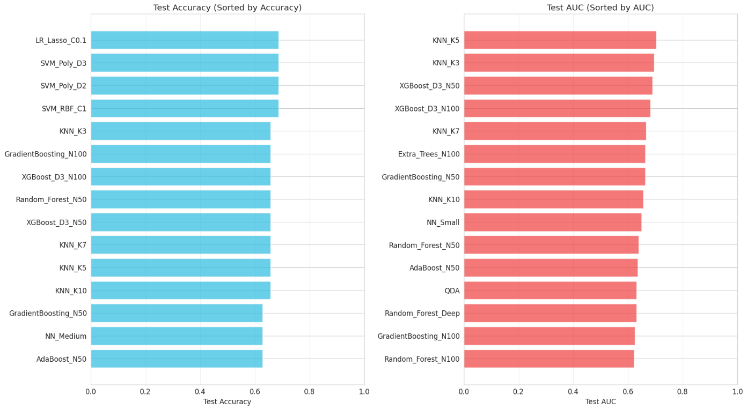
Figure 2. Test Accuracy & AUC Comparison of Top 15 models
K-Nearest Neighbors (KNN_K3) achieved 65.71% test accuracy with balanced precision (0.750) and recall (0.750), demonstrating more practical performance for toxicity screening. Ensemble methods such as Gradient Boosting (N100), XGBoost (D3_N100), and Random Forest (N50) also achieved 65.71% accuracy with AUC scores ranging from 0.625 to 0.689, indicating reasonable discriminative ability.
However, when comparing the model performance with cross validation, we observe similar results, as the LR_Lasso_C0.1, and SVM variants, and KNN models were the top performers, with the least gap between train and test accuracy. Models with lowest overfitting:
model overfitting_gap
LR_Lasso_C0.1 -0.016597
KNN_K10 -0.002731
SVM_Poly_D3 0.034874
SVM_Poly_D2 0.034874
SVM_RBF_C1 0.042227
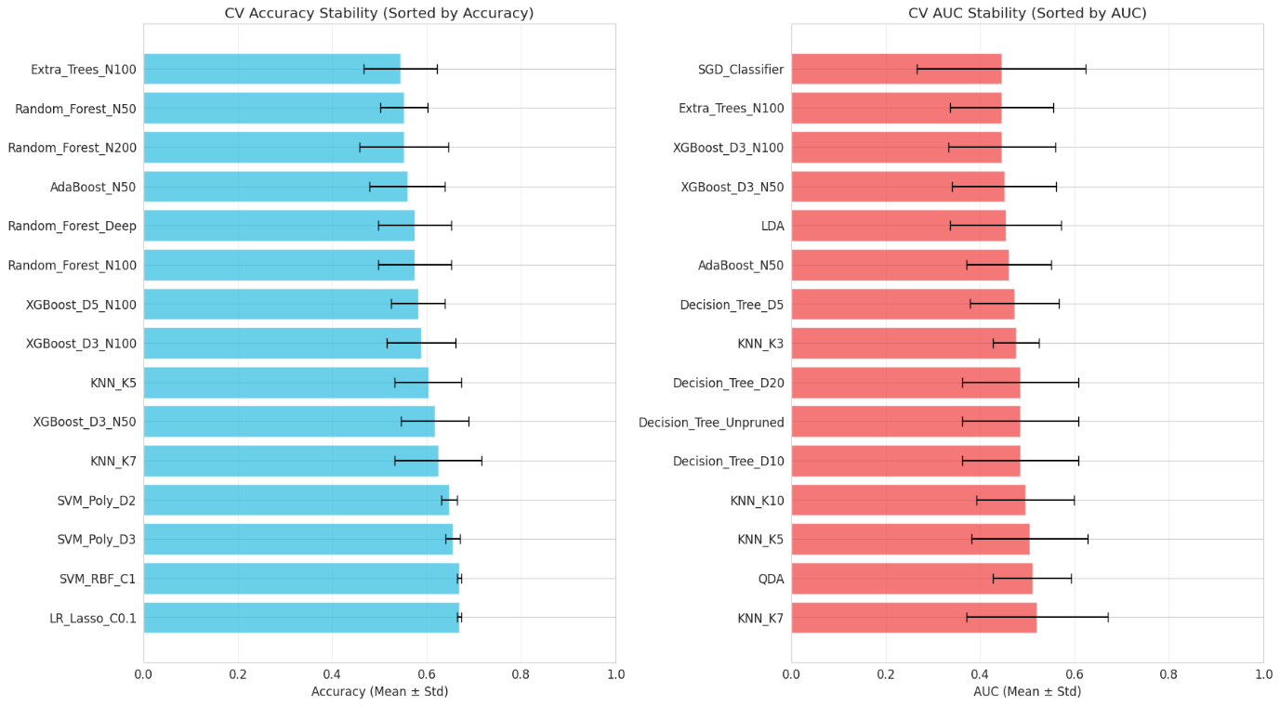
Figure 3. Test Accuracy and AUC comparison of models using cross validation
The scatter plot of train vs. test accuracy shows that
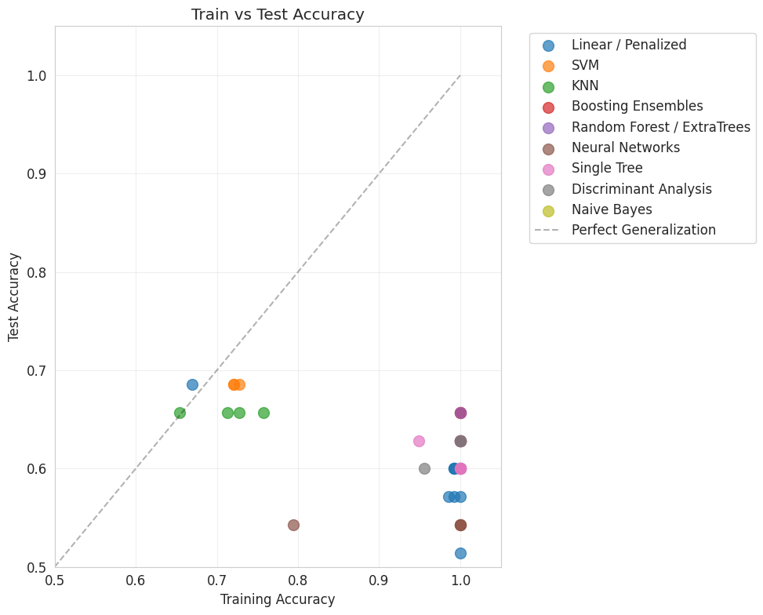
Figure 4. Scatter Plot of Train vs. Test Accuracy

Performance by Model Family
When comparing the dispersion of test accuracy (box plot) in different model groups, it can be seen that within the linear regression LR_Lasso_C0.1 was an outlier compared to all the other penalized regression models. SVM variants demonstrated the greatest inter quartile range.
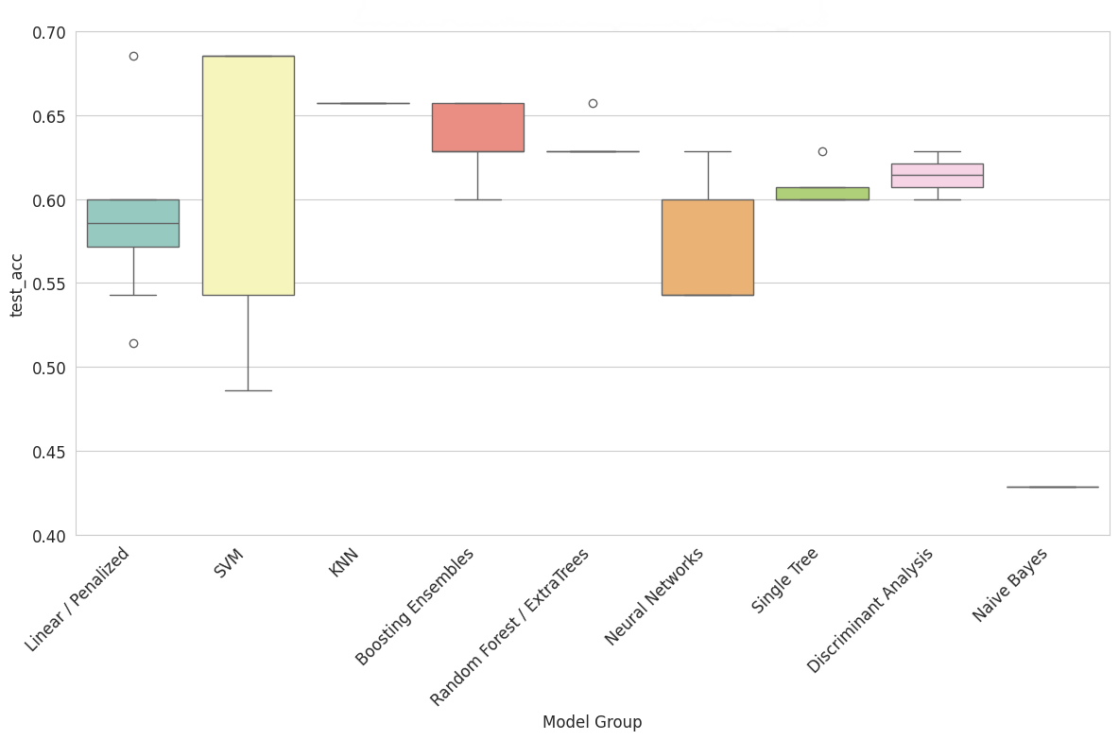
Figure 5. Box plot of performance of different model groups

Linear Models
Among penalized regression approaches, LR_Lasso_C0.1 performed best with 68.57% test accuracy but perfect recall, suggesting it learned to predict the majority class. Ridge regression variants (C0.1, C1, C10) achieved 51.4-57.1% accuracy, underperforming relative to lasso and elastic net configurations.
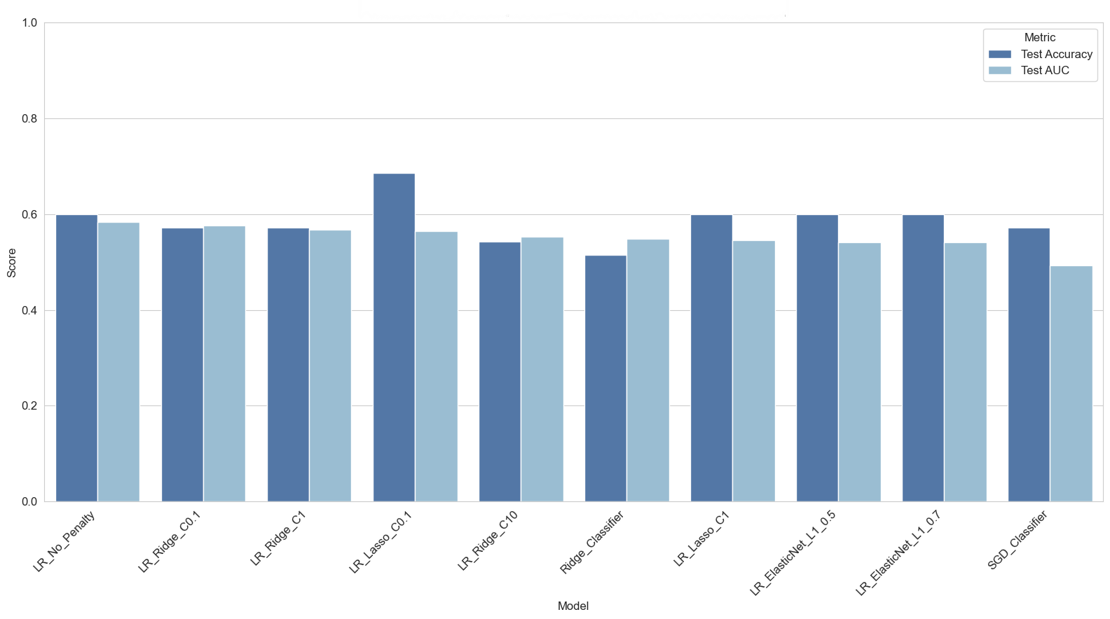
Figure 6. Test Accuracy & AUC Comparison of Penalized Regression Models

Tree-Based Models
Decision trees with moderate depth (5-10) achieved 60.0-62.9% accuracy. Ensemble methods like Random Forest and XGBoost showed signs of overfitting with perfect training accuracy (1.000) but modest test performance (60.0-65.7%), despite strong AUC scores (0.621-0.689).
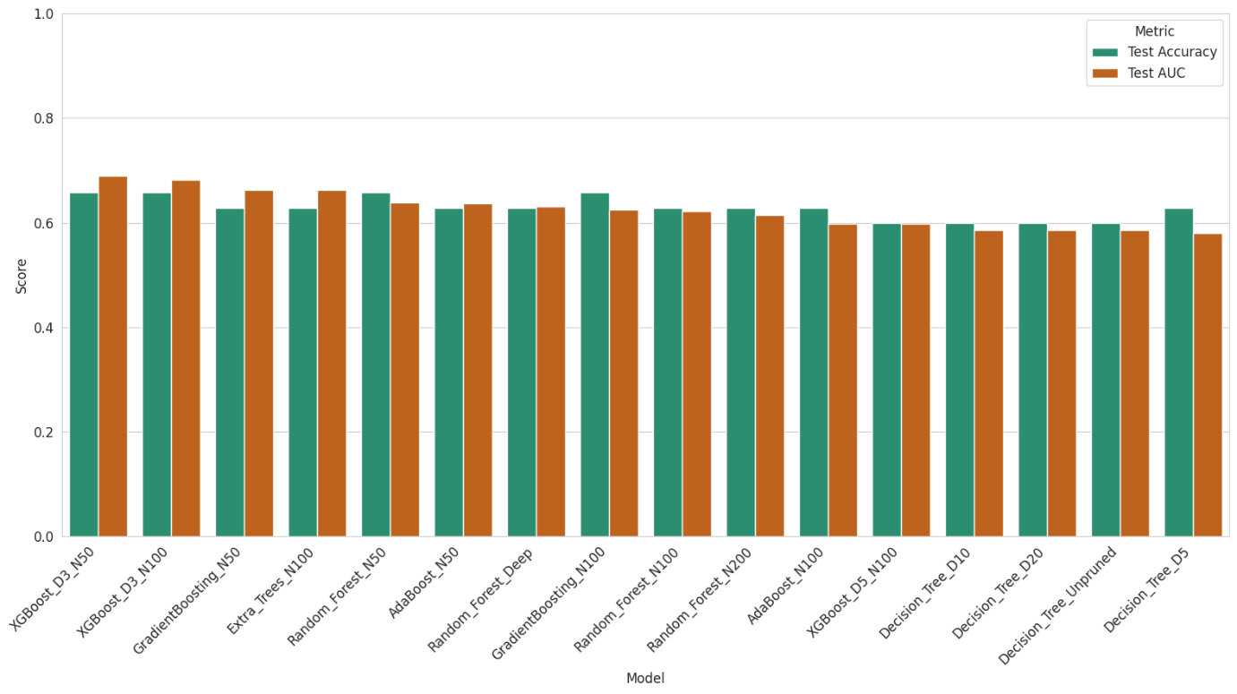
Figure 7. Test Accuracy & AUC Comparison of Tree-Based Models

Support Vector Machines
Non-linear kernels (RBF, polynomial) achieved the highest nominal accuracy (68.57%) but with the majority class prediction issue. Linear SVM achieved only 54.3% accuracy, suggesting non-linear decision boundaries may be more appropriate for this dataset.
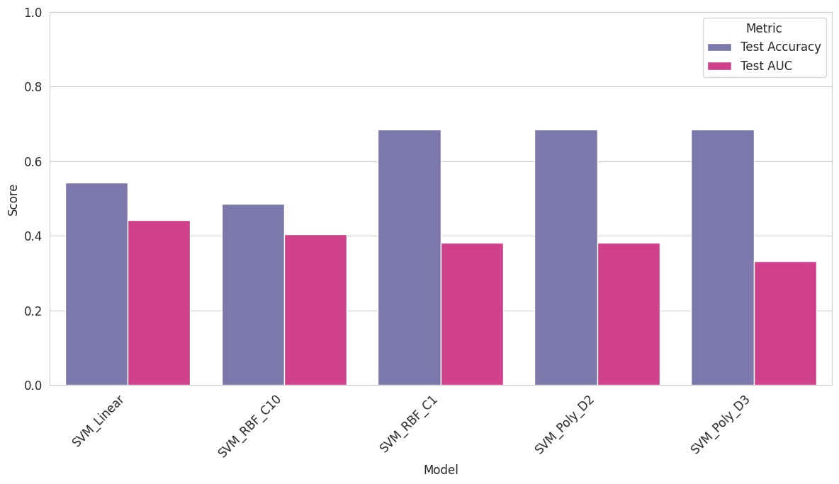
Figure 8. Test Accuracy & AUC Comparison of SVM Models

Neural Networks
Multi-layer perceptrons achieved 54.3-62.9% test accuracy with various architectures. NN_Medium achieved 62.9% accuracy with AUC of 0.536, indicating limited discriminative power despite reasonable overall accuracy.
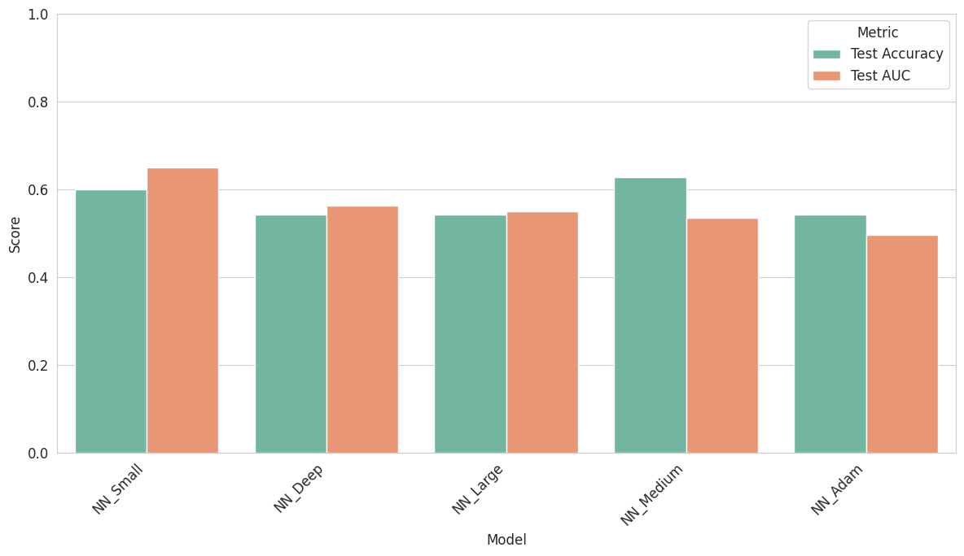
Figure 9. Test Accuracy & AUC Comparison of Neural Networks

Class Weighting Analysis
Training with class weights inversely proportional to class frequencies did not yield significant performance improvements. This suggests that the class imbalance (67.3% vs 32.7%) is not the primary challenge; rather, the high dimensionality and potentially redundant features may be limiting factors.​

Feature Selection Discrepancies
A notable finding is that the molecular descriptors selected by our models largely differed from the 13 features identified in the original study by Gul et al. (2021). This discrepancy may arise from several factors: differences in cross-validation strategies, alternative regularization strengths, or fundamentally different modelling approaches (decision trees vs. penalized regression). This result highlights the instability of feature selection in high-dimensional settings and the importance of ensemble or resampling-based approaches for robust feature identification.
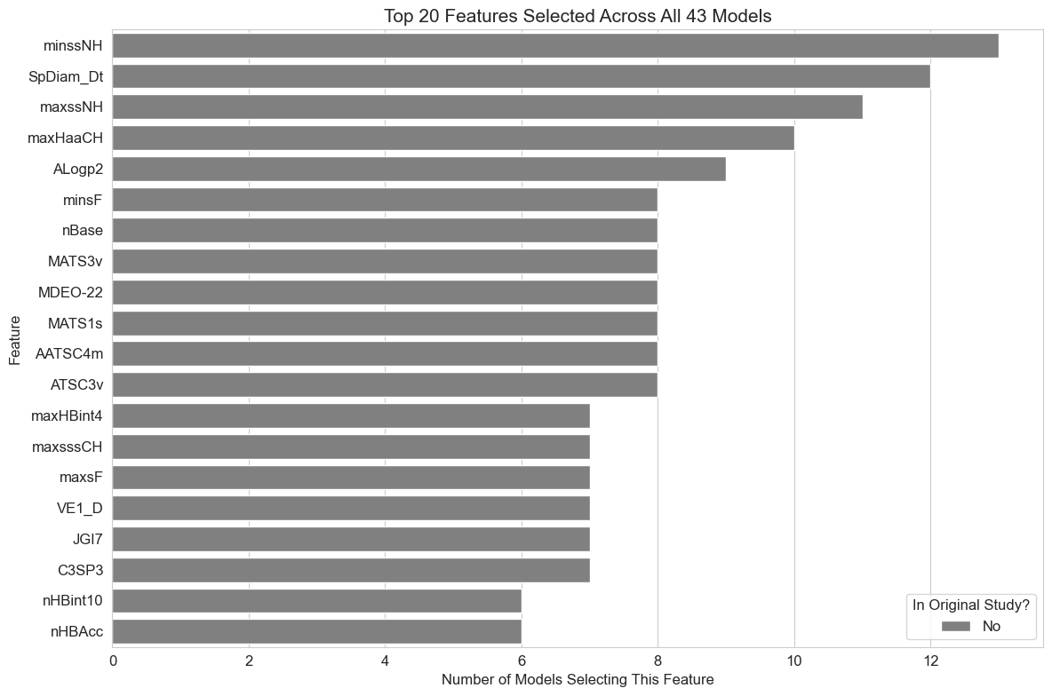
Figure 10. Top 20 Features Selected Across All Models
If we compare the consistency of top features among all the models, we find that minssNH, SpDiam_Dt, maxssNH, maxHaaCH and ALogp2 were selected most consistently as top features among all the models.
[ ] minssNH: 12/43 models
[ ] SpDiam_Dt: 12/43 models
[ ] maxssNH: 10/43 models
[ ] maxHaaCH: 10/43 models
[ ] ALogp2: 9/43 models
[ ] MATS1s: 8/43 models
[ ] AATSC4m: 8/43 models
[ ] minsF: 8/43 models
[ ] nBase: 8/43 models
[ ] ATSC3v: 8/43 models
[ ] MDEO-22: 7/43 models
[ ] maxHBint4: 7/43 models
[ ] maxsF: 7/43 models
[ ] VE1_D: 7/43 models
[ ] JGI7: 7/43 models
[ ] C3SP3: 7/43 models
[ ] MATS3v: 7/43 models
[ ] maxsssCH: 7/43 models
[ ] minHCsatu: 6/43 models
[ ] VE3_D: 6/43 models
[ ] AATSC1s: 6/43 models
[ ] minHBint4: 6/43 models
[ ] AATSC1c: 6/43 models
[ ] nHBint10: 6/43 models
[ ] nsCl: 6/43 models
[ ] AATSC1v: 6/43 models
[ ] VE1_Dt: 6/43 models
[ ] ATS5v: 6/43 models
[ ] nHBAcc: 6/43 models
[ ] AATSC1m: 6/43 models
[ ] MATS5i: 5/43 models
[ ] topoShape: 5/43 models
[ ] maxHBint5: 5/43 models
[ ] SpMax4_Bhm: 5/43 models
[ ] ATS3m: 5/43 models
[ ] MATS6i: 4/43 models
[ ] nHBint3: 4/43 models
[ ] ATS2p: 4/43 models
[ ] VE2_Dzp: 4/43 models
[ ] MATS5p: 4/43 models
[ ] maxHBint3: 4/43 models
[ ] GATS7m: 4/43 models
[ ] SpMin3_Bhe: 4/43 models
[ ] CIC2: 4/43 models
[ ] GATS3c: 4/43 models
[ ] ATSC2e: 4/43 models
[ ] BCUTw-1l: 4/43 models
[ ] Mi: 4/43 models
[ ] MATS6p: 4/43 models
[✓] C1SP2: 4/43 models
[ ] maxHCsatu: 3/43 models
[ ] nHBint5: 3/43 models
[ ] AATSC4s: 3/43 models
[ ] AATS8i: 3/43 models
[ ] MWC5: 3/43 models
[ ] EE_Dt: 3/43 models
[ ] MATS7p: 3/43 models
[ ] naAromAtom: 3/43 models
[ ] SaasC: 3/43 models
[ ] ATSC5i: 3/43 models
[ ] VR1_Dzv: 3/43 models
[ ] MLogP: 3/43 models
[ ] GATS4c: 3/43 models
[ ] AATSC6p: 3/43 models
[ ] ATSC7p: 3/43 models
[ ] GATS7v: 3/43 models
[ ] VC-4: 3/43 models
[ ] ETA_Epsilon_4: 3/43 models
[ ] SpMax6_Bhv: 3/43 models
When comparing the top features with the 13 from the original study, C1SP2 appeared as one of the top features in AdaBoost_N50, AdaBoost_N100, NN_Medium, NN_Large, while VPC-4 was selected AdaBoost_N50 as well.

Discussion

Interpretation of findings
he comparable performance of LR_Lasso_C0.1 (a linear penalized model) and non-linear SVM models suggests that both linear and non-linear decision boundaries can achieve similar accuracy levels on this dataset. However, the perfect recall exhibited by top-performing models indicates they may have learned to predict the majority class, limiting their practical utility for toxicity screening where identifying toxic compounds is paramount.
The strong training performance but modest test accuracy observed in ensemble methods (Random Forest, XGBoost) indicates overfitting despite the implicit regularization provided by ensemble averaging. This suggests that the 1,203-dimensional feature space contains substantial noise or redundancy that confounds these algorithms.​

Comparison to Literature
Our findings align with previous research demonstrating the challenges of molecular toxicity prediction in high-dimensional settings. Karim et al. (2019) emphasized the importance of aggressive feature selection, achieving competitive performance with significantly fewer features. Similarly, MolToxPred by Setiya et al. (2024) employed univariate feature selection to reduce multicollinearity and improve interpretability.​
The divergence in selected features from the original study echoes findings by Wang (2019), who demonstrated that different penalized regression methods can yield substantially different variable selections. This instability motivates ensemble or stability selection approaches that aggregate results across multiple models or resampling iterations.​

Limitations
Several limitations affect the interpretation of our results. First, the modest dataset size (171 samples) relative to the number of features (1,203) creates a challenging $p>>n$ scenario where overfitting is difficult to avoid entirely. Second, cross-validation strategies and hyperparameter tuning approaches were not exhaustively optimized, potentially leaving performance gains unrealized. Third, we did not implement advanced feature selection techniques such as recursive feature elimination or stability selection that might identify more robust feature subsets.​

Implications for Practice
For practitioners working with high-dimensional molecular data, our results suggest several recommendations. First, simpler models with strong regularization (like LR_Lasso_C0.1) can match or exceed the performance of complex ensemble methods while offering greater interpretability. Second, class imbalance may be less problematic than feature redundancy in high-dimensional settings. Third, feature selection results should be validated across multiple modelling approaches and resampling iterations to ensure robustness.

Conclusion
This thesis investigated penalized regression models—ridge regression, lasso, and elastic net—for molecular toxicity prediction using a high-dimensional dataset of 1,203 molecular descriptors across 171 molecules. We implemented and compared 43 classification models spanning linear, tree-based, ensemble, support vector machine, and neural network approaches.
Key findings include:
- LR_Lasso_C0.1 achieved competitive test accuracy (68.57%) matching non-linear SVM models, demonstrating the effectiveness of sparse linear models in high-dimensional settings; (2) Class weighting strategies did not significantly improve performance, suggesting feature redundancy rather than class imbalance is the primary challenge
- Feature selection results diverged from the original study, highlighting the instability of variable selection in high-dimensional data
- Ensemble methods exhibited overfitting despite strong training performance, emphasizing the need for aggressive regularization or dimension reduction.​
Theoretical contributions of this work include a comprehensive review of penalized regression foundations and their mathematical properties, connecting classical statistical theory to modern machine learning practice. Practical contributions include an extensive empirical comparison across diverse algorithm families, providing guidance for practitioners selecting models for high-dimensional molecular classification tasks.
Future research directions include investigating stability selection and ensemble feature selection methods to identify robust molecular signatures; exploring dimension reduction techniques such as principal component analysis or partial least squares prior to penalized regression; implementing advanced cross-validation strategies and Bayesian optimization for hyperparameter tuning; and extending the analysis to multi-task learning frameworks that jointly predict multiple toxicity endpoints.​
Despite the challenges inherent in high-dimensional molecular data, penalized regression models remain valuable tools for toxicity prediction, offering interpretability and computational efficiency that complement more complex machine learning approaches.

References
Journal articles (titles of journals should be abbreviated in accordance with Mathematical Reviews):
- Ajana, S., Acar, N., Bretillon, L., Hejblum, B. P., Jacqmin-Gadda, H., & Delcourt, C. (2019). Benefits of dimension reduction in penalized regression methods for high-dimensional grouped data: a case study in low sample size. Bioinformatics, 35(19), 3628–3634. https://doi.org/10.1093/bioinformatics/btz135
- Czarna, A., Berndt, A., Singh, H. R., Grudziecki, A., Ladurner, A. G., Timinszky, G., Kramer, A., & Wolf, E. (2013). Structures of Drosophila cryptochrome and mouse cryptochrome1 provide insight into circadian function. Cell, 153(7), 1394–1405. https://doi.org/10.1016/j.cell.2013.05.011
- Gul, S., Rahim, F., Isin, S., Yilmaz, F., Ozturk, N., Turkay, M., & Kavakli, I. H. (2021). Structure-based design and classifications of small molecules regulating the circadian rhythm period. Scientific Reports, 11(1), Article 18510. https://doi.org/10.1038/s41598-021-97962-5
- Karim, A., Mishra, A., Newton, M. A. H., & Sattar, A. (2019). Efficient Toxicity Prediction via Simple Features Using Shallow Neural Networks and Decision Trees. ACS Omega, 4(1), 1874–1888. https://doi.org/10.1021/acsomega.8b03173
- Ogutu, J. O., Schulz-Streeck, T., & Piepho, H. P. (2012). Genomic selection using regularized linear regression models: ridge regression, lasso, elastic net and their extensions. BMC proceedings, 6 Suppl 2(Suppl 2), S10. https://doi.org/10.1186/1753-6561-6-S2-S10
- Setiya, A., Jani, V., Sonavane, U., & Joshi, R. (2024). MolToxPred: small molecule toxicity prediction using machine learning approach. RSC Advances, 14(6), 421–422. https://doi.org/10.1039/d3ra07322j
- Sharma, B., et al., "Accurate clinical toxicity prediction using multi-task deep neural nets and contrastive molecular explanations," Scientific Reports, 13(1), 2023.​
- UCI Machine Learning Repository, "Toxicity-2 Data Set," 2021, https://archive.ics.uci.edu/dataset/728/toxicity-2.​
- Zou, H., & Hastie, T. (2005). Regularization and variable selection via the elastic net. Journal of the Royal Statistical Society. Series B, Statistical Methodology, 67(2), 301–320. https://doi.org/10.1111/j.1467-9868.2005.00503.x
Books, pamphlets, research reports:
- James, G., Witten, D., Hastie, T., Tibshirani, R., & Taylor, J. (2023). An Introduction to Statistical Learning : with Applications in Python /. Springer International Publishing. https://doi.org/10.1007/978-3-031-38747-0
- Hastie, T., Tibshirani, R., & Friedman, J. H. (2009). The elements of statistical learning : data mining, inference, and prediction / (Second edition.). Springer Science+Business Media
- Ogutu, J. O., Schulz-Streeck, T., & Piepho, H. P. (2012). Genomic selection using regularized linear regression models: ridge regression, lasso, elastic net and their extensions. BMC proceedings, 6 Suppl 2(Suppl 2), S10. https://doi.org/10.1186/1753-6561-6-S2-S10

Appendix

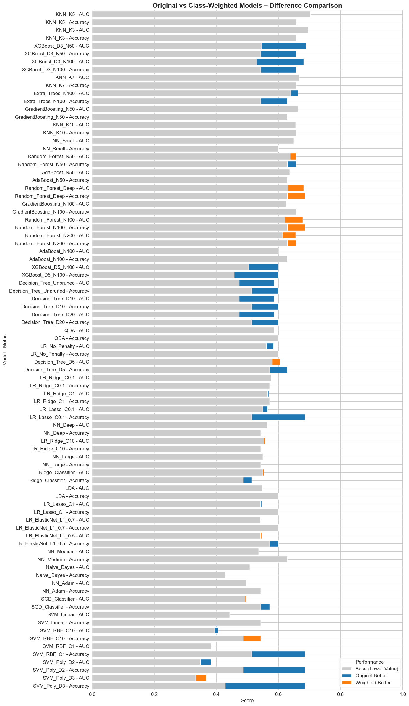
Figure 11. Test Accuracy & AUC Comparison of Original vs. Class Weighted Models

