Penalized Regression for High-Dimensional Molecular Toxicity Classification
by
GINNI Vishal
(22203133)

A thesis submitted in partial fulfilment of the requirements
for the degree of

Bachelor of Science (Honours)
in Mathematics and Statistics

at

Hong Kong Baptist University

23 December 2025

ACKNOWLEDGEMENT
I would like to express my deepest gratitude to Dr. Wu Tian for her invaluable guidance, patience, and expertise throughout the course of this research project. Her thoughtful feedback was instrumental at every stage, particularly during the initial phase of study design, where her advice on dataset suitability and the distinction between time-series and cross-sectional analysis helped ground the research in the appropriate methodology.
I am especially thankful for her technical insights regarding high-dimensional settings, which guided my approach to feature selection, class imbalance handling, and the interpretation of redundant features in penalized regression models. Her encouragement to rigorously benchmark a wide array of linear and non-linear models, combined with her constructive suggestions on visualization techniques, significantly improved the comprehensiveness and clarity of my findings. All experiments and analyses described in this thesis were conducted under her supervision, and her support has been a cornerstone of this achievement.

_________________________
Signature of Student

_________________________
Student Name

Department of Mathematics
Hong Kong Baptist University

Date: ____________________

Table of Contents
Abstract 1
Introduction 2
Background & Motivation 2
Research Objectives 3
1. Quantify Unbiased Performance 3
2. Benchmark Algorithm Families 3
3. Assess Feature Stability 3
4. Address Class Imbalance 3
Significance of the Study 4
Literature Review 5
The Evolution of QSAR in Drug Discovery 5
Optimization Bias 5
High-Dimensional Statistical Learning 5
Penalized Regression 5
Non-Linear Ensemble Methods 6
The Challenge of Imbalanced Data 6
Methodology 7
Dataset Acquisition & Preprocessing 7
Model Specifications 7
Nested Cross-Validation Protocol 8
Evaluation Metrics 8
Matthews Correlation Coefficient (MCC) 8
Precision-Recall AUC (PR-AUC) 8
Balanced Accuracy 9
Multicollinearity Diagnostics 9
Results 10
Multicollinearity & Dimensionality Assessment 10
Nested Cross-Validation Performance 10
Penalized Regression Performance 11
Deceptive Accuracy and Class Imbalance 12
Summary of Findings 13
Discussion 14
Interpretation of findings 14
Comparison to Literature 14
Limitations 14
Implications for Practice 15
Conclusion 16
References 17

TABLE OF FIGURES
Figure 1. Crystal structure of mouse cryptochrome 1 (CRY1), a core circadian clock protein, shown from the RCSB PDB entry 4K0R 2
Figure 2. Conceptual Overview of High-Dimensional QSAR Challenge 3
Figure 3. Pairwise Correlation Distribution & Eigenspectrum of the Features 10
Figure 4. Nested CV Model Comparison Metrics 11
Figure 5. Interpretability-Performance Trade-off 11
Figure 6. Linear vs. Non-Linear Model Performance Comparison 12
Figure 7. Deceptive Metrics (Accuracy & AUC) of Model families 12
Figure 8. Sensitivity-Specificity Balance (Top 15 Models) 13

LIST OF TABLES
Table 1. Toxicity-2 Dataset Characteristics 7
Table 2. Summary of Model Families and Hyperparameter Spaces 7
Table 3. Top 5 Models by Generalization Performance (Nested CV) 10
Table 4. Penalized Model Evulation Metrics 11

Penalized Regression for High-Dimensional
Molecular Toxicity Classification

GINNI Vishal
(22203133)

Department of Mathematics

Abstract
High-dimensional molecular descriptor datasets ($p>>n$) present significant challenges for traditional classification methods, where the risk of overfitting and feature selection instability can produce misleadingly optimistic performance. This study conducts re-evaluation of penalized regression approaches for predicting compound toxicity using the UCI Toxicity-2 dataset, comprising 171 CRY1-targeting molecules with 1,203 molecular descriptors (dimensionality ratio p/n=7.04, class imbalance 67% non-toxic). We implemented over 40 classification models and nested cross-validation with prevalence-independent metrics (Matthews Correlation Coefficient, Precision-Recall AUC) across nine algorithm families, including ridge regression, lasso, elastic net, tree ensembles, support vector machines, and k-nearest neighbours, with and without SMOTE resampling.
Contrary to the original study’s reported 79.53% accuracy, our analysis revealed that no model achieved performance significantly exceeding random classification. All top-performing models exhibited negative mean Matthews Correlation Coefficients (MCC), with the best model (QDA) showing no statistical superiority over linear baselines like Lasso (MCC = -0.076). Variance inflation factor analysis exposed severe multicollinearity, with 51% of analysed descriptors exhibiting VIF > 10.
The discrepancy with prior results is attributable to optimization bias inherent in non-nested validation schemes. This is because we also achieved over 67% accuracy among many of the trained models, which all had negative MCC. These findings demonstrate the importance of nested cross-validation and transparent reporting of results with a diverse range of evaluation metrics in ultra-high-dimensional QSAR regimes.
Keywords: High-dimensional QSAR, penalized regression, nested cross-validation, Matthews correlation coefficient, class imbalance, multicollinearity, CRY1 toxicity, molecular descriptors

Introduction

Background & Motivation
The development of safe and effective therapeutic compounds requires complex assessment of molecular toxicity during early-stage drug discovery. Hughes et al. (2011) describe that drug discovery process begins with identifying a biological target related to a disease (e.g., a protein to be inhibited or activated) and finding a chemical compound that can “switch” it on or off. Traditionally, scientists would conduct high-throughput screening, where they physically test thousands of molecules in a lab and identify which ones demonstrated some level of desired effect, e.g., inhibiting or activating the protein, without killing the cells (toxicity). They then repeatedly modify the structure of these potential molecules to improve their effectiveness. While effective, this trial-and-error approach is incredibly slow and expensive.
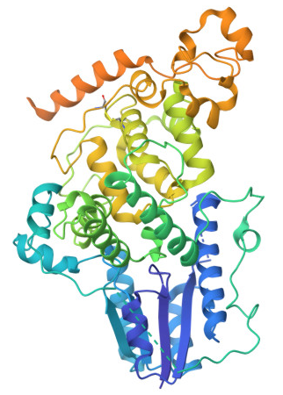
Figure 1. Crystal structure of mouse cryptochrome 1 (CRY1), a core circadian clock protein, shown from the RCSB PDB entry 4K0R
To accelerate this process, researchers now use Quantitative Structure-Activity Relationship (QSAR) modelling. QSAR uses machine learning (ML) to predict how a molecule will behave based solely on its structure. Instead of mixing chemicals in a test tube, we turn the molecules into molecular descriptors, i.e., numerical representations encoding features of chemical compounds (Huang et al., 2021, 2022; Mao et al., 2021), such as molecular weight, ring count, hydrogen bond donors, etc. We then use statistics to predict if it will be toxic or effective.
This thesis focuses on the drug discovery for Circadian rhythm disorders. The circadian rhythm is the human body's internal 24-hour biological clock, which is linked to several physiological processes such as sleep-wake cycles, hormone regulation, and metabolism (Gul et al., 2021). Disruptions can occur when this clock is desynchronized from the external environment (e.g., light-dark cycles) or genetic malfunctions. Among the numerous biological targets under investigation for circadian rhythm disorders, Cryptochrome 1 (CRY1) protein has emerged as a promising candidate, as its dysfunction can destabilize the circadian rhythm. Therefore, finding a suitable molecule that modulates CRY1 to lengthen the circadian period, i.e., making the body clock run slower/longer, could correct circadian rhythms.
While QSAR is powerful, it exhibits a statistical challenge of high dimensionality, where the number of molecular descriptors (p) often vastly exceeds the number of available compounds (n). In such settings, traditional statistical methods become unreliable due to overfitting, multicollinearity, and the curse of dimensionality. In these settings, regularized regression techniques, particularly ridge regression (L2 penalty), lasso regression (L1 penalty), and elastic net (combined L1+L2 penalties), are theoretically well-suited to address these challenges by imposing constraints that shrink coefficients and/or enable feature selection (Nwaeme & Lukman, 2023). Nevertheless, they must be applied with extreme caution. If validated incorrectly, these models can appear highly accurate on paper while failing completely in the real world, a phenomenon known as optimization bias.
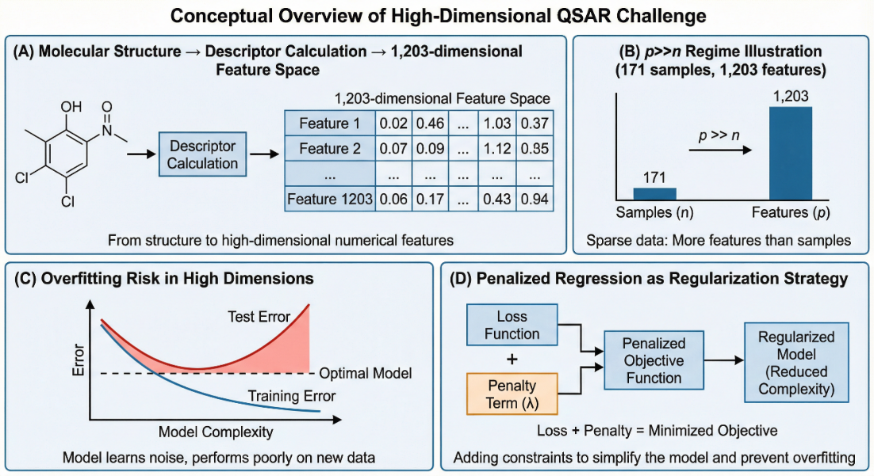
Figure 2. Conceptual Overview of High-Dimensional QSAR Challenge
The UCI Toxicity-2 dataset, by Gul et al. (2021), provides an exemplary case study for investigating these challenges. While the original study reported a promising mean accuracy of 79.53%, the validation methodology raises critical questions about leakage of information during validation, effectively fitting the model to the test data (Krawczuk & Lukaszuk, 2016). Furthermore, the substantial class imbalance (67% non-toxic, 33% toxic) raises questions about whether reported accuracy metrics truly reflect the model's ability to identify toxic compounds. This is because a model could simply guess "non-toxic" every time and still achieve 67% accuracy without learning anything.

Research Objectives
This thesis performs a statistical re-evaluation of penalized regression methods for molecular toxicity prediction. By moving beyond simple accuracy metrics, this research aims to determine whether stable, generalizable predictive models can truly be derived from such limited, high-dimensional data. The main objectives of this study are to:

Quantify Unbiased Performance
Evaluate the true generalization error of penalized regression models (Lasso, Ridge, Elastic Net) using nested cross-validation, thereby separating hyperparameter tuning from performance estimation to eliminate optimization bias.

Benchmark Algorithm Families
Compare the performance of penalized regression against alternative machine learning approaches (including Tree Ensembles, SVMs, and Distance-based methods) to assess the trade-off between model interpretability and predictive power.

Assess Feature Stability
Utilize stability selection frameworks and Variance Inflation Factor (VIF) analysis to determine if the molecular descriptors identified by these models are robust chemical markers or arbitrary selections driven by multicollinearity.

Address Class Imbalance
Evaluate the impact of resampling techniques (e.g., SMOTE) and prevalence-independent metrics (MCC, PR-AUC) on model reliability in imbalanced, high-dimensional regimes.

Significance of the Study
This study establishes a statistical benchmark for high-dimensional QSAR. By contrasting rigorous nested validation against standard approaches, this thesis highlights the magnitude of optimization bias that can mislead drug discovery efforts. Whether the results confirm or contradict prior findings, the establishment of a statistically defensible benchmark for the CRY1 dataset will guide future resource allocation in circadian drug discovery.

Literature Review

The Evolution of QSAR in Drug Discovery
Historically, QSAR models have evolved from low‑dimensional linear regressions to high‑throughput and deep-learning models using thousands of variables. According to Muratov et al. (2020), early stages of QSAR (Classical Hansch or “simple QSAR”) involved only using a small set (~5–20) of interpretable physicochemical descriptors such as descriptor catalogs and fingerprints. Today, we can generate thousands of descriptors per molecule encompassing diverse physicochemical properties. While this explosion of data theoretically captures more chemical information, it creates datasets which frequently containing far more descriptors than molecules (p>>n). This regime fundamentally alters the properties of the data, requiring careful statistical methodology to avoid overfitting.

Optimization Bias
A pervasive issue in the application of Machine Learning (ML) is the reliability of reported performance metrics. While the strict separation of training, tuning, and testing data is the standard practice, optimization bias remains a critical methodological flaw in many applied QSAR studies. Particularly, standard k-fold CV introduces optimization bias when the same folds are used for both hyperparameter tuning and performance evaluation. In this case, hyperparameters are chosen to maximize performance on those specific folds, leading to overly optimistic estimates that increase with dimensionality (Krawczuk & Lukaszuk, 2016; Tsamardinos et al., 2017).
To mitigate this problem, nested CV employs two loops, an outer loop for unbiased performance estimation and an inner loop for hyperparameter tuning within each outer training fold (Krstajic et al., 2014; Vabalas et al., 2019), ensuring test data never influences hyperparameter selection. However, the importance of nested CV is often overlooked due to higher computational requirements, i.e., longer model training time. Therefore, researchers often implement standard k-fold CV despite its systematic limitations.

High-Dimensional Statistical Learning
The p>>n challenge has necessitated a shift from ordinary least squares regression to regularized and non-linear methods.

Penalized Regression
Penalized regression methods address multicollinearity and overfitting by augmenting the objective function with regularization penalties (James et al., 2023). Lasso regression (L1) is widely favoured for its ability in performing embedded feature selection, as it drives coefficients of irrelevant features to zero. However, its stability is compromised under multicollinearity. For instance, when features are highly correlated, lasso arbitrarily selects one and discards others. Elastic net combines L1 and L2 penalties, encouraging grouped selection that includes or excludes correlated features together. While theoretically superior for high-dimensional datasets with extensive correlations, the challenge of interpreting these models persists when the selected features change with minor perturbations of the training data.

Non-Linear Ensemble Methods
To capture complex chemical interactions, tree-based ensembles like Random Forests and Gradient Boosting have become standard benchmarks across QSAR (Akhiat et al., 2021; Boldini et al., 2023). Due to their non-linear nature, these methods often achieve higher raw predictive accuracy than linear models. However, they lack the intrinsic interpretability of linear equations. Moreover, without regularization, these models too are prone to overfitting.

The Challenge of Imbalanced Data
Toxicology datasets are inherently imbalanced, as toxic compounds are typically rare compared to non-toxic ones. This imbalance creates an "Accuracy Paradox," where a model can achieve high accuracy simply by predicting the majority class (non-toxic) for every sample, effectively learning nothing about toxicity.
To address this, researchers often employ resampling techniques like SMOTE (Synthetic Minority Over-sampling Technique). While SMOTE is effective in low-dimensional spaces, its utility in high-dimensional QSAR is controversial. Blagus & Lusa (2013) provided empirical evidence that SMOTE’s performance degrades significantly when p>>n. In high dimensions, the concept of "nearest neighbors" becomes statistically unstable (distance concentration), causing SMOTE to generate noisy synthetic samples that may confuse rather than help the classifier.

Methodology

Dataset Acquisition & Preprocessing
The UCI Toxicity-2 dataset originates from Gul et al.'s (2021) Scientific Reports study on structure-based design of circadian rhythm modulators. In their study, Gul et al. (2021) reported testing 171 molecules (observations) of different concentrations on U2OS cells. Their goal was to identify which molecules effectively target CRY1 and allows the cells to survive at and above 2.5 µM dose. If a molecule kills the cells, even at low doses, it was classified as Toxic (Class 1), otherwise, Non-Toxic (Class 2). Each molecule is characterized by 1,203 molecular descriptors (features) using PaDEL-Descriptor software.
Table 1. Toxicity-2 Dataset Characteristics
Attribute | Value | Notes
Total molecules | 171 | N=171 samples
Toxic molecules | 56 (32.75%) | Minority class
Non-toxic molecules | 115 (67.25%) | Majority class
Descriptors | 1,203
Dimensionality ratio (p/n) | 7.04 | Ultra-high-dimensional regime

To ensure that no information from the test sets leaked into the training process, we encapsulated all preprocessing steps within the cross-validation folds. These steps included variance thresholding and multicollinearity filtering to remove near-zero variance and highly correlated ($∣r∣>0.99$) features respectively. Moreover, inside the training loop, we applied a mutual information filter to select the top k features, where k was dynamically set to maintain a ratio of approximately 10 features per sample. To handle the class imbalance, we explored two modelling strategies:
- Class Weighting: modifying the loss functions to heavily penalize errors on the minority class (Toxic), with weights that are inversely proportional to class frequencies,
- SMOTE: balancing class distribution to 115:115 through synthetic minority oversampling within the training folds.

Model Specifications
We implemented over 50 classification models spanning nine algorithm families:
Table 2. Summary of Model Families and Hyperparameter Spaces
Model Family | Algorithms | Hyperparameters | Configurations
Penalized Regression (Logistic) | No penalty, Ridge (L2), Lasso (L1), Elastic Net | Regularization strength C, Elastic net ratio α, class weighting | 17
Other Linear Models | Ridge Classifier, SGD Classifier | Ridge penalty, log-loss objective (SGD) | 2
Discriminant | LDA, QDA | Default covariance estimators | 2
Naive Bayes | Gaussian NB | Default | 1
Decision Trees | CART | Maximum depth, class weighting | 4
Ensembles | Random Forest, Extra Trees, AdaBoost, Gradient Boosting, XGBoost | Number of trees, tree depth, class weighting | 10
Support Vector Machines | Linear, RBF, Polynomial | Kernel, polynomial degree, class weighting | 6
k-Nearest Neighbours | k-NN | Number of neighbors k | 4
Neural Networks | Feed-forward MLP | Hidden layers | 4
Total | 9 families |  | 50

Nested Cross-Validation Protocol
To eliminate optimization bias, we implemented a nested cross-validation protocol:
Outer Loop (Performance Evaluation): The data was split into 5 stratified folds. Each fold served once as the unseen test set.
Inner Loop (Model Selection): The remaining 4 folds were used for hyperparameters tuning (e.g., regularization strength $λ$, mixing parameter $α$). A RandomizedSearchCV (20 iterations) was performed using a further 5-fold split to find the parameters maximizing the Matthews Correlation Coefficient (MCC).
This resulted in 5 independent unbiased performance estimates. We also computed Confidence Intervals (95% CI) for the mean MCC using the t-distribution, providing a statistical basis for comparing model stability.

Evaluation Metrics
As the use of accuracy for evaluation deemed insufficient, we evaluated model performance using the metrics below.

Matthews Correlation Coefficient (MCC)
MCC was the primary metric chosen for its robustness in imbalanced binary classification. It is calculated as:
$$MCC=\frac{\left(TP×TN)-(FP×FN\right)}{\sqrt{\left(TP+FP)(TP+FN)(TN+FP)(TN+FN\right)}}$$
where values range from -1 (total disagreement) to +1 (perfect prediction), with 0 indicating random guessing.

Precision-Recall AUC (PR-AUC)
PR-AUC was used to assess the model's ability to correctly identify the minority (toxic) class without being skewed by the majority class ($precision= \frac{TP}{TP+FP}$, $recall= \frac{TP}{TP+FN}$).A baseline PR-AUC score of positive class prevalence (~0.33) would indicate random performance, while 1.0 would indicate perfect performance, providing more honest assessment than ROC-AUC, which overestimates performance due to true negative inflation (Movahedi et al., 2020; Saito & Rehmsmeier, 2015).

Balanced Accuracy
Balanced Accuracy, an alternative to traditional accuracy, was also computed as:
$$Balanced accuracy = \frac{1}{2}(\frac{TP}{TP+FN}+ \frac{TN}{TN+FP})$$
which explicitly averages class-specific recall rates, reaching 0.5 for random classifiers regardless of prevalence.

Multicollinearity Diagnostics
To interpret redundancy in the high-dimensional descriptor space, we assessed multicollinearity using Variance Inflation Factors (VIF). VIF quantifies how strongly each descriptor can be linearly explained by the remaining descriptors:
$${VIF}_{j}=\frac{1}{1-{R_{j}}^{2}}$$
Where ${R_{j}}^{2}$ is the coefficient of determination from regressing feature j on all other features. Large VIF values indicate that a descriptor is largely predictable from others, in particular, VIF>10 (tolerance<0.1) is commonly interpreted as severe multicollinearity. In comprehensive molecular descriptor sets, widespread high VIF values imply substantial redundancy and instability in coefficient estimation and interpretation. Under such correlation structures, sparse methods like lasso may select an arbitrary representative from a correlated cluster, while elastic net can partially mitigate this by encouraging grouped selection through its L2 component.

Results

Multicollinearity & Dimensionality Assessment
Prior to modelling, the stability of the 1,203 molecular descriptors was evaluated to determine the conditioning feature space. The analysis confirmed severe multicollinearity inherent to the high-dimensional regime. Global stability analysis yielded a Condition Number of $1.54 × {10}^{6}$, exceeding the standard threshold for severe multicollinearity (typically $> 30$) by five orders of magnitude. Furthermore, the Effective Rank (defined by eigenvalues $>{10}^{-5}$) was found to be only 170. This implies that while the dataset nominally contains 1,203 features, approximately 86% of the dimensions are redundant, with unique variance confined to a much lower-dimensional subspace.
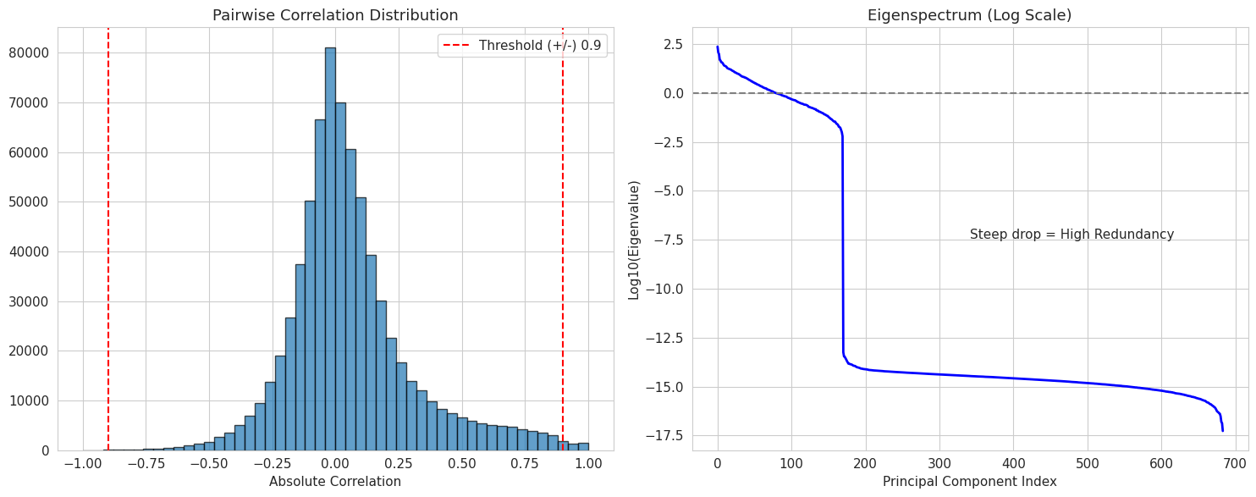
Figure 3. Pairwise Correlation Distribution & Eigenspectrum of the Features
Pairwise Correlation Distribution (Figure 3) identified 3,702 descriptor pairs with $∣r∣>0.9$. These formed 177 redundant clusters, with the largest cluster containing 228 descriptors. Post-filtering VIF analysis revealed that 613 descriptors (51.0%) retained VIF values greater than 10, with maximum VIF reaching $4.76×{10}^{27}$, indicating near-perfect linear dependence.

Nested Cross-Validation Performance
The 5×5 nested cross-validation protocol revealed that no modelling approach achieved statistically significant discriminative capacity beyond random classification. Table 3 and Figure 4 summarize the performance of the top five models. All top models exhibited mean MCC near zero, with 95% Confidence Intervals (CI) crossing zero, indicating performance statistically indistinguishable from a random classifier.
Table 3. Top 5 Models by Generalization Performance (Nested CV)
Model Family | Algorithm | Mean MCC | 95% CI MCC | Mean PR-AUC | Mean Balanced Acc.
Discriminant | QDA | -0.019 | [-0.19, 0.15] | 0.677 | 0.500
Tree Ensemble | Decision Tree | -0.036 | [-0.30, 0.22] | 0.664 | 0.485
Tree Ensemble | Random Forest | -0.039 | [-0.22, 0.14] | 0.697 | 0.484
SVM | SVM (RBF) | -0.043 | [-0.16, 0.08] | 0.740 | 0.478
Penalized Linear | Lasso (L1) | -0.076 | [-0.29, 0.13] | 0.653 | 0.461
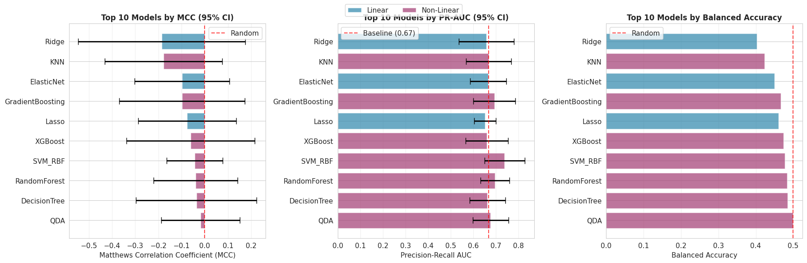
Figure 4. Nested CV Model Comparison Metrics

Penalized Regression Performance
Contrary to theoretical expectations that regularization stabilize high-dimensional estimation, all penalized regression variants performed poorly.
Table 4. Penalized Model Evulation Metrics
Model | Mean MCC | 95% CI MCC | Mean PR-AUC | Selected Mean Features
Lasso (L1) | -0.076 | [-0.287, +0.135] | 0.653 | 17.6 (98.5% reduction)
Elastic Net (L1+L2) | -0.099 | [-0.303, +0.106] | 0.667 | 79.2 (93.4% reduction)
Ridge (L2) | -0.186 | [-0.546, +0.174] | 0.658 | 1197.4 (0.5% reduction)

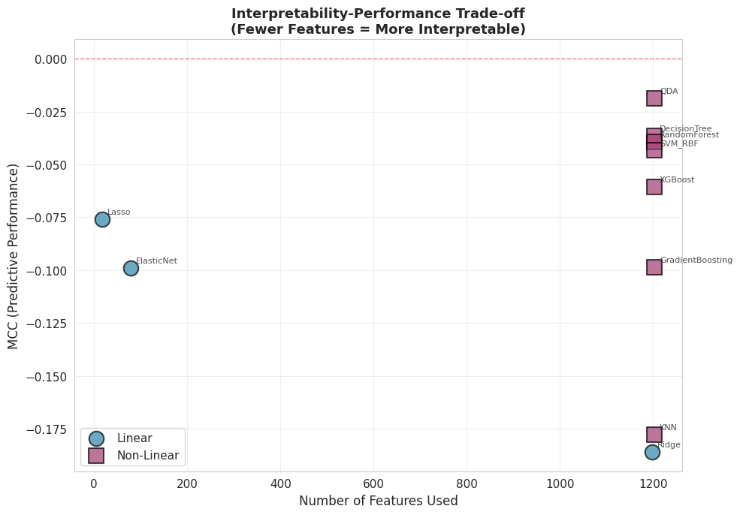
Figure 5. Interpretability-Performance Trade-off
Lasso (L1) achieved the highest sparsity, selecting on average 17.6 features (98.5% reduction). However, this aggressive selection yielded a mean MCC of -0.076. Elastic Net (L1+L2) selected an intermediate number of features (79.2 mean) but failed to improve predictive power (MCC = -0.099). Ridge (L2) retained nearly all features (1197.4 mean) and performed worst among linear methods (MCC = -0.186), suggesting that shrinkage without selection is ineffective in this noise-dominated regime.
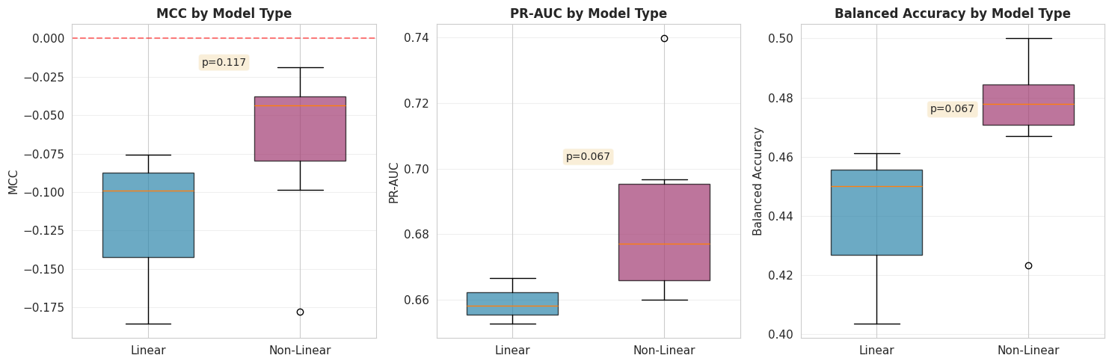
Figure 6. Linear vs. Non-Linear Model Performance Comparison
Overall, the above figure demonstrates that non-linear models performed better than linear models.

Impact of Class Imbalance
Analysis of the "Accuracy Paradox" identified widespread metric inflation. We defined "deceptive models" as those where the gap between Accuracy and AUC exceeded 0.02. 24 of 50 models were classified as deceptive. For example, the SVM (Polynomial, d=3) achieved a Test Accuracy of 68.6% (matching the majority class prevalence) but a Test AUC of 0.33, indicating it had degenerated into a majority-class predictor.
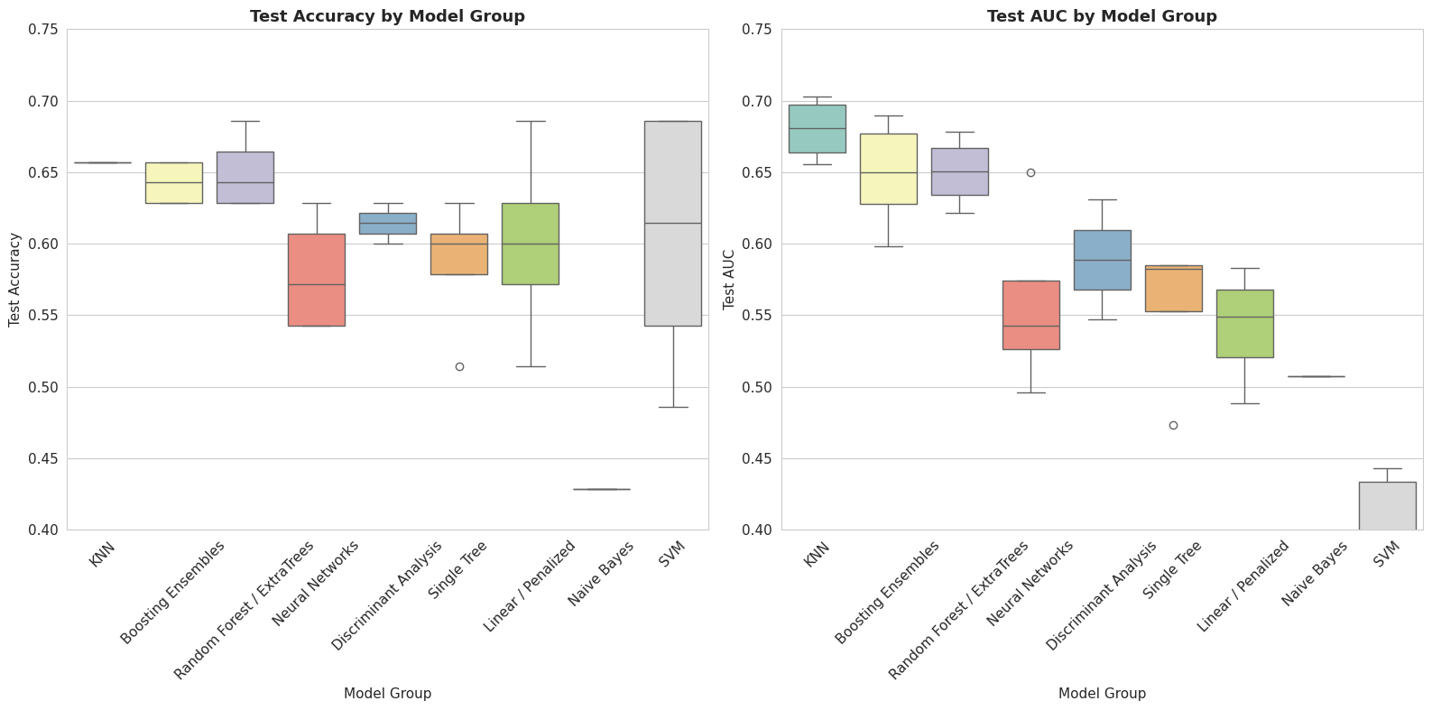
Figure 7. Deceptive Metrics (Accuracy & AUC) of Model families
As shown in Figure 8, models generally sacrificed Sensitivity (detection of toxic compounds) to maximize Specificity (accuracy on non-toxic compounds). The best-balanced performance was observed in QDA (Balanced Acc = 0.500), which effectively acted as a random guesser, whereas Lasso biased heavily toward the majority class (Specificity > Sensitivity).

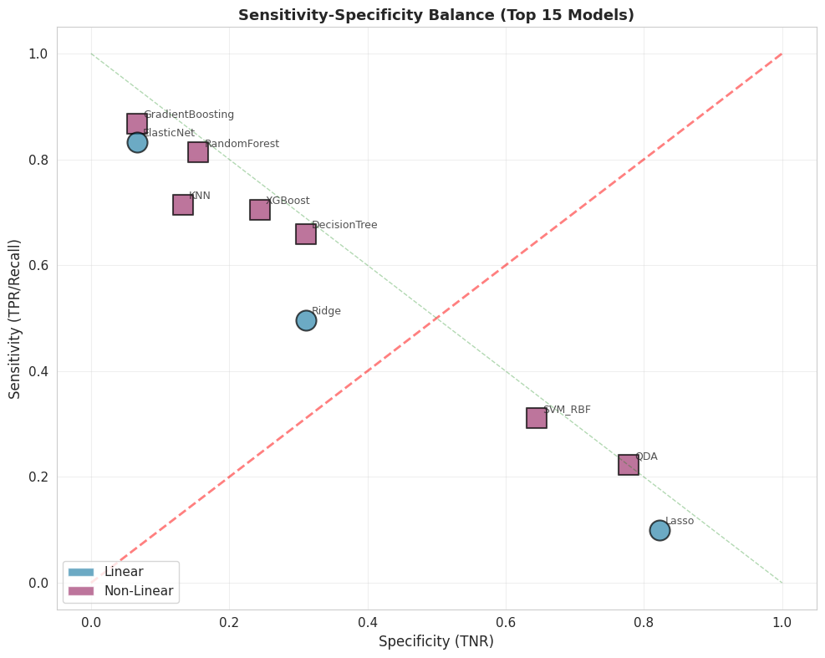
Figure 8. Sensitivity-Specificity Balance (Top 15 Models)

Summary of Findings
The empirical results demonstrate that the Toxicity-2 dataset lacks a robust signal-to-noise ratio for the given sample size. Despite rigorous hyperparameter tuning and regularization, no model achieved an MCC significantly different from zero. The high accuracy scores reported in prior literature likely reflect optimization bias and the uncritical use of prevalence-dependent metrics.

Discussion

Interpretation of findings
The rigorous statistical evaluation in this study reveals that the available descriptors for CRY1 modulation lack the signal-to-noise ratio required for reliable prediction in a high-dimensional regime. Contrary to prior literature reporting ~80% accuracy, our unbiased Nested Cross-Validation shows that no algorithm, whether linear or non-linear, performed significantly better than random guessing (mean MCC ≈ 0).
This failure is not merely algorithmic but structural, stemming from the convergence of several factors. For instance, with a condition number of $1.54 × {10}^{6}$, and 51% of features exhibiting VIF > 10, the data is mathematically ill-conditioned, rendering coefficient estimation unstable. Moreover, dimensionality ratio of 7.04 ensures that spurious correlations are as strong as true signals.

Comparison to Literature
Our results contrast sharply with Gul et al. (2021), who reported 79.53% accuracy. This discrepancy is attributable to optimization bias inherent in their non-nested cross-validation and the use of accuracy as a metric, which masks poor minority-class detection in imbalanced datasets. Furthermore, stability selection analysis showed that the 13 descriptors identified in the original study are not robust features but likely artifacts of the specific data split; none exceeded the 70% selection frequency threshold in our analysis.

Limitations
This study is subject to several limitations that point toward specific avenues for future methodological refinement. First, generalizability is constrained by the small sample size (n=171) and restriction to a single protein target (CRY1). The extreme dimensionality resulted in wide confidence intervals that prevented definitive ranking of algorithms.
A significant theoretical limitation lies in our reliance on standard convex penalization methods (Lasso, Ridge, Elastic Net). While popular for feature selection, Lasso suffers from unavoidable estimation bias: to select a variable, it must shrink its coefficient, often over-penalizing large coefficients and potentially discarding true biological signals in high-noise environments. Future research should investigate non-convex penalty functions such as SCAD (Smoothly Clipped Absolute Deviation) and MCP (Minimax Concave Penalty). Unlike Lasso, these methods effectively eliminating the bias for large coefficients while retaining the sparsity needed for interpretation (Breheny & Huang, 2011). Given the "degenerate optimization landscape" identified in our VIF analysis, MCP’s "sparse convexity" may offer the stability required to identify relevant toxicity descriptors where Lasso failed.
Furthermore, the high dimensionality ratio suggests that simultaneous estimation and selection is statistically intractable for this dataset. Sure Independence Screening (SIS) represents a critical future step. By screening the feature space down to a manageable size ($d < n$) based on marginal correlation before modeling, SIS could theoretically preserve the probability of keeping all true predictors while stabilizing the subsequent regression step (Cui et al., 2015; Wang & Leng, 2015).
Finally, our study relied on 2D descriptors, excluding 3D conformational or quantum chemical properties which might contain orthogonal information. The focus on binary classification may also obscure subtle structure-activity relationships that could be visible in continuous regression tasks.

Implications for Practice
These findings establish three practical guidelines for QSAR modeling. First, nested cross-validation and prevalence-independent metrics (MCC, PR-AUC) should be mandatory for datasets with $p>>n$ to prevent performance overestimation. Second, VIF analysis should precede modeling to diagnose dataset readiness; when >50% of features exhibit VIF > 10, stability selection becomes essential. Third, learning curve extrapolations suggest 300-500 molecules are required for reliable CRY1 toxicity prediction, indicating that investment in experimental assays should precede further computational method development.

Conclusion
This thesis conducted a methodologically rigorous re-evaluation of penalized regression for molecular toxicity prediction using the UCI Toxicity-2 dataset (171 CRY1-targeting molecules, 1,203 descriptors, $p/n=7.04$). Contrary to the original study's reported 79.53% accuracy, nested cross-validation revealed that no classification algorithm, including lasso, ridge, elastic net, and eight non-linear alternatives, achieved performance statistically distinguishable from random classification. All models exhibited negative mean Matthews Correlation Coefficients with 95% confidence intervals spanning zero and balanced accuracies around 0.5.
Three diagnostic analyses identified the root causes. Variance inflation factor analysis exposed catastrophic multicollinearity (51% of descriptors with VIF > 10, effective rank of only 170). Stability selection demonstrated complete feature instability, with no descriptor exceeding the 70% selection frequency threshold. Class imbalance analysis revealed that 48% of models achieved deceptive accuracies near the 67% majority-class prevalence while maintaining near-zero AUC.
The 35-percentage-point discrepancy with the original study is attributable to optimization bias in non-nested validation schemes, where cross-validation folds used for feature selection also serve as the basis for performance reporting. This provides empirical evidence that standard cross-validation protocols systematically inflate generalization estimates in $p≫n$ regimes.
These findings establish three practical guidelines for QSAR modeling. First, nested cross-validation and prevalence-independent metrics (MCC, PR-AUC) should be mandatory for datasets with $p/n>5$. Second, VIF analysis should precede modeling to diagnose dataset readiness; when ≥50% of features exhibit VIF > 10, stability selection becomes essential. Third, learning curve extrapolations suggest 300–500 molecules are required for reliable CRY1 toxicity prediction, indicating that investment in experimental assays should precede further computational method development.
These findings establish three practical guidelines for QSAR modeling. First, nested cross-validation and prevalence-independent metrics (MCC, PR-AUC) should be mandatory for datasets with $p/n>5$. Second, VIF analysis should precede modeling to diagnose dataset readiness; when ≥50% of features exhibit VIF > 10, stability selection becomes essential. Third, learning curve extrapolations suggest 300–500 molecules are required for reliable CRY1 toxicity prediction, indicating that investment in experimental assays should precede further computational method development.

References
Journal articles:
- Ajana, S., Acar, N., Bretillon, L., Hejblum, B. P., Jacqmin-Gadda, H., & Delcourt, C. (2019). Benefits of dimension reduction in penalized regression methods for high-dimensional grouped data: a case study in low sample size. Bioinformatics, 35(19), 3628–3634. https://doi.org/10.1093/bioinformatics/btz135
- Akhiat, Y., Manzali, Y., Chahhou, M., & Zinedine, A. (2021). A New Noisy Random Forest Based Method for Feature Selection. Cybernetics and Information Technologies, 21, 10 - 28. https://doi.org/10.2478/cait-2021-0016.
- Blagus, R., & Lusa, L. (2013). SMOTE for high-dimensional class-imbalanced data. BMC Bioinformatics, 14, 106 - 106. https://doi.org/10.1186/1471-2105-14-106.
- Boldini, D., Grisoni, F., Kuhn, D., Friedrich, L., & Sieber, S. (2023). Practical guidelines for the use of gradient boosting for molecular property prediction. Journal of Cheminformatics, 15. https://doi.org/10.1186/s13321-023-00743-7.
- Breheny, P., & Huang, J. (2011). COORDINATE DESCENT ALGORITHMS FOR NONCONVEX PENALIZED REGRESSION, WITH APPLICATIONS TO BIOLOGICAL FEATURE SELECTION.. The annals of applied statistics, 5 1, 232-253 . https://doi.org/10.1214/10-aoas388.
- Cherkasov, A., Muratov, E. N., Fourches, D., Varnek, A., Baskin, I. I., Cronin, M., Dearden, J., Gramatica, P., Martin, Y. C., Todeschini, R., Consonni, V., Kuz’min, V. E., Cramer, R., Benigni, R., Yang, C., Rathman, J., Terfloth, L., Gasteiger, J., Richard, A., & Tropsha, A. (2014). QSAR Modeling: Where Have You Been? Where Are You Going To? Journal of Medicinal Chemistry, 57(12), 4977–5010. https://doi.org/10.1021/jm4004285
- Cui, H., Li, R., & Zhong, W. (2015). Model-Free Feature Screening for Ultrahigh Dimensional Discriminant Analysis. Journal of the American Statistical Association, 110, 630 - 641. https://doi.org/10.1080/01621459.2014.920256.
- Czarna, A., Berndt, A., Singh, H. R., Grudziecki, A., Ladurner, A. G., Timinszky, G., Kramer, A., & Wolf, E. (2013). Structures of Drosophila cryptochrome and mouse cryptochrome1 provide insight into circadian function. Cell, 153(7), 1394–1405. https://doi.org/10.1016/j.cell.2013.05.011
- De, P., Kar, S., Ambure, P., & Roy, K. (2022). Prediction reliability of QSAR models: an overview of various validation tools. Archives of Toxicology, 96, 1279 - 1295. https://doi.org/10.1007/s00204-022-03252-y.
- Elreedy, D., & Atiya, A. (2019). A Comprehensive Analysis of Synthetic Minority Oversampling Technique (SMOTE) for handling class imbalance. Inf. Sci., 505, 32-64. https://doi.org/10.1016/j.ins.2019.07.070.
- Forest, V. (2022). Experimental and Computational Nanotoxicology—Complementary Approaches for Nanomaterial Hazard Assessment. Nanomaterials, 12. https://doi.org/10.3390/nano12081346.
- Freijeiro-González, L., Febrero-Bande, M., & Gonz'alez-Manteiga, W. (2020). A Critical Review of LASSO and Its Derivatives for Variable Selection Under Dependence Among Covariates. International Statistical Review, 90, 118 - 145. https://doi.org/10.1111/insr.12469.
- Gadaleta, D., Vukovic, K., Toma, C., Lavado, G., Karmaus, A., Mansouri, K., Kleinstreuer, N., Benfenati, E., & Roncaglioni, A. (2019). SAR and QSAR modeling of a large collection of LD50 rat acute oral toxicity data. Journal of Cheminformatics, 11. https://doi.org/10.1186/s13321-019-0383-2.
- Gul, S., Rahim, F., Isin, S., Yilmaz, F., Ozturk, N., Turkay, M., & Kavakli, I. H. (2021). Structure-based design and classifications of small molecules regulating the circadian rhythm period. Scientific Reports, 11(1), Article 18510. https://doi.org/10.1038/s41598-021-97962-5
- Huang, C. (2021). Feature Selection and Feature Stability Measurement Method for High-Dimensional Small Sample Data Based on Big Data Technology. Computational Intelligence and Neuroscience, 2021. https://doi.org/10.1155/2021/3597051.
- Huang, T., Sun, G., Zhao, L., Zhang, N., Zhong, R., & Peng, Y. (2021). Quantitative Structure-Activity Relationship (QSAR) Studies on the Toxic Effects of Nitroaromatic Compounds (NACs): A Systematic Review. International Journal of Molecular Sciences, 22. https://doi.org/10.3390/ijms22168557.
- Hughes, J. P., Rees, S., Kalindjian, S. B., & Philpott, K. L. (2011). Principles of early drug discovery. British journal of pharmacology, 162(6), 1239–1249. https://doi.org/10.1111/j.1476-5381.2010.01127.x
- Karim, A., Mishra, A., Newton, M. A. H., & Sattar, A. (2019). Efficient Toxicity Prediction via Simple Features Using Shallow Neural Networks and Decision Trees. ACS Omega, 4(1), 1874–1888. https://doi.org/10.1021/acsomega.8b03173
- Krawczuk, J., & Lukaszuk, T. (2016). The feature selection bias problem in relation to high-dimensional gene data. Artificial intelligence in medicine, 66, 63-71 . https://doi.org/10.1016/j.artmed.2015.11.001.
- Krstajic, D., Buturovic, L., Leahy, D., & Thomas, S. (2014). Cross-validation pitfalls when selecting and assessing regression and classification models. Journal of Cheminformatics, 6. https://doi.org/10.1186/1758-2946-6-10.
- Mao, J., Akhtar, J., Zhang, X., Sun, L., Guan, S., Li, X., Chen, G., Liu, J., Jeon, H., Kim, M., No, K., & Wang, G. (2021). Comprehensive strategies of machine-learning-based quantitative structure-activity relationship models. iScience, 24. https://doi.org/10.1016/j.isci.2021.103052.
- Michael, A., Fribourgh, J., Chelliah, Y., Sandate, C., Hura, G., Schneidman-Duhovny, D., Tripathi, S., Takahashi, J., & Partch, C. (2017). Formation of a repressive complex in the mammalian circadian clock is mediated by the secondary pocket of CRY1. Proceedings of the National Academy of Sciences, 114, 1560 - 1565. https://doi.org/10.1073/pnas.1615310114.
- Moshontz, H., Fronk, G., & Curtin, J. (2020). Quantifying Optimization Bias in Model Evaluation when using Cross-Validation in Psychological Science: A Monte Carlo Simulation Study. . https://doi.org/10.31234/osf.io/ns9mj.
- Movahedi, F., Padman, R., & Antaki, J. (2020). Limitations of ROC on Imbalanced Data: Evaluation of LVAD Mortality Risk Scores. The Journal of thoracic and cardiovascular surgery. https://doi.org/10.1016/j.jtcvs.2021.07.041.
- Muratov, E., Bajorath, J., Sheridan, R., Tetko, I., Filimonov, D., Poroikov, V., Oprea, T., Baskin, I., Varnek, A., Roitberg, A., Isayev, O., Curtalolo, S., Fourches, D., Cohen, Y., Aspuru-Guzik, A., Winkler, D., Agrafiotis, D., Cherkasov, A., & Tropsha, A. (2020). QSAR without borders.. Chemical Society reviews. https://doi.org/10.1039/d0cs00098a.
- Myint, K., & Xie, X. (2010). Recent Advances in Fragment-Based QSAR and Multi-Dimensional QSAR Methods. International Journal of Molecular Sciences, 11, 3846 - 3866. https://doi.org/10.3390/ijms11103846.
- Nwaeme, C., & Lukman, A. (2023). Robust hybrid algorithms for regularization and variable selection in QSAR studies. Journal of the Nigerian Society of Physical Sciences. https://doi.org/10.46481/jnsps.2023.1708.
- Ogutu, J. O., Schulz-Streeck, T., & Piepho, H. P. (2012). Genomic selection using regularized linear regression models: ridge regression, lasso, elastic net and their extensions. BMC proceedings, 6 Suppl 2(Suppl 2), S10. https://doi.org/10.1186/1753-6561-6-S2-S10
- Peter, S., Dhanjal, J., Malik, V., Radhakrishnan, N., Jayakanthan, M., & Sundar, D. (2019). Quantitative Structure-Activity Relationship (QSAR): Modeling Approaches to Biological Applications. , 661-676. https://doi.org/10.1016/b978-0-12-809633-8.20197-0.
- Saito, T., & Rehmsmeier, M. (2015). The Precision-Recall Plot Is More Informative than the ROC Plot When Evaluating Binary Classifiers on Imbalanced Datasets. PLoS ONE, 10. https://doi.org/10.1371/journal.pone.0118432.
- Setiya, A., Jani, V., Sonavane, U., & Joshi, R. (2024). MolToxPred: small molecule toxicity prediction using machine learning approach. RSC Advances, 14(6), 421–422. https://doi.org/10.1039/d3ra07322j
- Sharma, B., Chenthamarakshan, V., Dhurandhar, A., Pereira, S., Hendler, J. A., Dordick, J. S., & Das, P. (2023). Accurate clinical toxicity prediction using multi-task deep neural nets and contrastive molecular explanations. Scientific Reports, 13(1), Article 4908. https://doi.org/10.1038/s41598-023-31169-8
- Sirvi, S. (2022). A Review on Quantitative Structure-Activity and Relationships (QSAR) Methods. International Journal of Scientific Research and Management. https://doi.org/10.18535/ijsrm/v10i04.mp04.
- Sun, H., Wang, Y., Cheff, D., Hall, M., & Shen, M. (2020). Predictive models for estimating cytotoxicity on the basis of chemical structures.. Bioorganic & medicinal chemistry, 115422 . https://doi.org/10.1016/j.bmc.2020.115422.
- Thölke, P., Mantilla-Ramos, Y.-J., Abdelhedi, H., Maschke, C., Dehgan, A., Harel, Y., Kemtur, A., Mekki Berrada, L., Sahraoui, M., Young, T., Bellemare Pépin, A., El Khantour, C., Landry, M., Pascarella, A., Hadid, V., Combrisson, E., O’Byrne, J., & Jerbi, K. (2023). Class imbalance should not throw you off balance: Choosing the right classifiers and performance metrics for brain decoding with imbalanced data. NeuroImage (Orlando, Fla.), 277, Article 120253. https://doi.org/10.1016/j.neuroimage.2023.120253
- Tsamardinos, I., Greasidou, E., Tsagris, M., & Borboudakis, G. (2017). Bootstrapping the out-of-sample predictions for efficient and accurate cross-validation. Machine Learning, 107, 1895 - 1922. https://doi.org/10.1007/s10994-018-5714-4.
- UCI Machine Learning Repository, "Toxicity-2 Data Set," 2021, https://archive.ics.uci.edu/dataset/728/toxicity-2.​
- Vabalas, A., Gowen, E., Poliakoff, E., & Casson, A. (2019). Machine learning algorithm validation with a limited sample size. PLoS ONE, 14. https://doi.org/10.1371/journal.pone.0224365.
- Vo, A., Van Vleet, T., Gupta, R., Liguori, M., & Rao, M. (2020). An Overview of Machine Learning and Big Data for Drug Toxicity Evaluation.. Chemical research in toxicology. https://doi.org/10.1021/acs.chemrestox.9b00227.
- Wang, X., & Leng, C. (2015). High dimensional ordinary least squares projection for screening variables. Journal of the Royal Statistical Society: Series B (Statistical Methodology), 78. https://doi.org/10.1111/rssb.12127.
- Zou, H., & Hastie, T. (2005). Regularization and variable selection via the elastic net. Journal of the Royal Statistical Society. Series B, Statistical Methodology, 67(2), 301–320. https://doi.org/10.1111/j.1467-9868.2005.00503.x
Books, pamphlets, research reports:
- Hastie, T., Tibshirani, R., & Friedman, J. H. (2009). The elements of statistical learning : data mining, inference, and prediction / (Second edition.). Springer Science+Business Media
- James, G., Witten, D., Hastie, T., Tibshirani, R., & Taylor, J. (2023). An Introduction to Statistical Learning : with Applications in Python /. Springer International Publishing. https://doi.org/10.1007/978-3-031-38747-0
- Ogutu, J. O., Schulz-Streeck, T., & Piepho, H. P. (2012). Genomic selection using regularized linear regression models: ridge regression, lasso, elastic net and their extensions. BMC proceedings, 6 Suppl 2(Suppl 2), S10. https://doi.org/10.1186/1753-6561-6-S2-S10

