Penalized Regression for High-Dimensional Molecular Toxicity Prediction
by
GINNI Vishal
(22203133)

A thesis submitted in partial fulfilment of the requirements
for the degree of

Bachelor of Science (Honours)
in Mathematics and Statistics

at

Hong Kong Baptist University

11 December 2025

ACKNOWLEDGEMENT
I would like to express my deepest gratitude to Dr. Wu Tian for her invaluable guidance, patience, and expertise throughout the course of this research project. Her thoughtful feedback was instrumental at every stage, particularly during the initial phase of study design, where her advice on dataset suitability and the distinction between time-series and cross-sectional analysis helped ground the research in the appropriate methodology.
I am especially thankful for her technical insights regarding high-dimensional settings, which guided my approach to feature selection, class imbalance handling, and the interpretation of redundant features in penalized regression models. Her encouragement to rigorously benchmark a wide array of linear and non-linear models, combined with her constructive suggestions on visualization techniques, significantly improved the comprehensiveness and clarity of my findings. All experiments and analyses described in this thesis were conducted under her supervision, and her support has been a cornerstone of this achievement.

_________________________
Signature of Student

_________________________
Student Name

Department of Mathematics
Hong Kong Baptist University

Date: ____________________

Table of Contents
Abstract 1
Introduction 2
Background & Motivation 2
Research Objectives 2
Significance of the Study 2
Literature Review & Theory 3
Molecular Toxicity Prediction and Drug Discovery 3
The Toxicity-2 Dataset and Original Study 3
Machine Learning Approaches to Toxicity Prediction 3
Penalized Regression in High-Dimensional Settings 4
Research Gaps and Motivation 4
METHODOLOGY 5
Dataset Description 5
Data Preprocessing 5
Model Specifications 5
Evaluation Metrics 6
THEORETICAL FOUNDATIONS 7
The High-Dimensional Regression Problem 7
The Bias-Variance Tradeoff 7
Ridge Regression (L2 REGULARIZATION) 7
Lasso Regression (L1 Regularization) 7
Elastic Net 8
Results 9
Linear Models 11
Tree-Based Models 12
Support Vector Machines 13
Neural Networks 13
Cross-Validation Stability 14
Class Weighting Analysis 14
Feature Selection Discrepancies 14
Discussion 16
Interpretation of findings 16
Comparison to Literature 16
Methodological Limitations 17
Implications for Practice 17
Conclusion 19
Key Findings 19
Theoretical Contributions 19
Practical Contributions 19
Limitations and Future Directions 20
Concluding Remarks 20
References 21
Appendix 22

TABLE OF FIGURES
Figure 1. Crystal structure of mouse cryptochrome 1 (CRY1), a core circadian clock protein, shown from the RCSB PDB entry 4K0R 3
Figure 2. Distribution of Pairwise Feature Correlations 5
Figure 3. Test Accuracy & AUC Comparison of Top 15 models 9
Figure 4. Test Accuracy and AUC comparison of models using cross validation 10
Figure 5. Scatter Plot of Train vs. Test Accuracy 10
Figure 6. Box plot of performance of different model groups 11
Figure 7. Test Accuracy & AUC Comparison of Penalized Regression Models 11
Figure 8. Test Accuracy & AUC Comparison of Tree-Based Models 12
Figure 9. Test Accuracy & AUC Comparison of SVM Models 13
Figure 10. Test Accuracy & AUC Comparison of Neural Networks 14
Figure 11. Top 20 Features Selected Across All Models 15
Figure 12. Overlap of the Top 13 Features with the Original Study 22
Figure 13. Precision-Recall Curves of the Top 5 Models 23
Figure 14. Test Accuracy & AUC Comparison of Original vs. Class Weighted Models 24

LIST OF TABLES
Table 1. List of Models Trained 5
Table 2. Top 3 Models with the least variance across folds 14

Penalized Regression for High-Dimensional
Molecular Toxicity Prediction

GINNI Vishal
(22203133)

Department of Mathematics

Abstract
High-dimensional molecular descriptor datasets present significant challenges for traditional classification methods due to the risk of overfitting. This study investigates three penalized regression models, ridge regression, lasso, and elastic net, and their effectiveness in predicting molecular toxicity using the UCI Toxicity-2 dataset comprising 171 molecules with 1,203 molecular descriptors. The dataset exhibits class imbalance with 67.25% non-toxic and 32.75% toxic molecules. We implemented 43 classification models including linear models with various penalty configurations, tree-based ensemble methods, support vector machines, and neural networks. Results demonstrate that Lasso Logistic Regression with regularization parameter (C) set to 0.1, achieved the highest test accuracy of 68.57%, matching the performance of non-linear SVM models. Class weighting strategies did not yield significant improvements. Feature selection patterns diverged from the original study's 13 identified descriptors, suggesting alternative molecular signatures for toxicity prediction. This thesis demonstrates both the theoretical foundations and practical limitations of penalized regression in high-dimensional molecular classification tasks.

Introduction

Background & Motivation
High-dimensional data analysis has become increasingly prevalent in modern statistics and machine learning, particularly in domains such as genomics, cheminformatics, and medical diagnostics. When the number of predictors $p$ exceeds or approaches the number of observations $n$, traditional statistical models face the curse of dimensionality, leading to overfitting and poor generalization performance (James et al., 2023). This phenomenon is especially problematic in molecular toxicity prediction, where thousands of chemical descriptors must be analyzed to identify compounds that pose health risks.
Penalized regression methods, also known as shrinkage or regularization techniques, address overfitting by introducing penalty terms that constrain model complexity. Three fundamental approaches, ridge regression, lasso (Least Absolute Shrinkage and Selection Operator), and elastic net, have emerged as powerful tools for handling high-dimensional datasets. These methods balance model fit with complexity, enabling more robust predictions on unseen data.

Research Objectives
This thesis aims to accomplish three primary objectives. First, we provide a comprehensive theoretical foundation for ridge regression, lasso, and elastic net, including their mathematical formulations and optimization properties. Second, we apply these methods to the UCI Toxicity-2 dataset, which contains 171 molecules characterized by 1,203 molecular descriptors, to predict molecular toxicity. Third, we compare the performance of penalized regression models against various machine learning algorithms, including tree-based ensembles, support vector machines, and neural networks

Significance of the Study
According to Gul et al. (2021), circadian rhythm disruption has been linked to serious health conditions including cancer, depression, mood disorders, and hypertension. The core clock protein CRY1 (Cryptochrome 1) plays a critical role in generating circadian rhythm through the CLOCK-BMAL1 transcriptional complex. Developing small molecules that modulate CRY1 activity while remaining non-toxic represents a significant challenge in drug discovery for circadian rhythm-related disorders.
This study applies penalized regression methods to predict molecular toxicity in 171 CRY1-targeting compounds characterized by 1,203 molecular descriptors. By implementing computational toxicity prediction, researchers can screen out harmful compounds early in the drug development pipeline, dramatically reducing experimental costs. The comparison of ridge regression, lasso, and elastic net in this extreme high-dimensional setting ($p>>n$) provides methodological insights for QSAR studies in pharmaceutical development.
The molecular descriptors identified through this analysis can potentially be applied to screening large chemical libraries for therapeutic candidates targeting circadian rhythm disorders, accelerating the discovery of safe and effective circadian modulators.

Literature Review & Theory

Molecular Toxicity Prediction and Drug Discovery
Accurate prediction of molecular toxicity is a critical challenge in drug discovery and chemical safety assessment. Traditional in vitro and in vivo toxicity testing is time-consuming, expensive, and raises ethical concerns, driving the development of computational approaches for toxicity prediction (Setiya et al., 2024). Machine learning models trained on molecular descriptors offer a promising alternative by identifying structural features associated with toxicity while reducing experimental costs and animal testing requirements.

The Toxicity-2 Dataset and Original Study
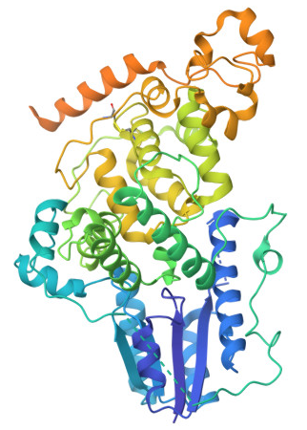
Figure 1. Crystal structure of mouse cryptochrome 1 (CRY1), a core circadian clock protein, shown from the RCSB PDB entry 4K0R
The dataset used in this study originates from research by Gul et al. (2021), who performed structure-based drug design targeting CRY1, a core clock protein responsible for generating circadian rhythm. Circadian rhythm disruption has been associated with various diseases including cancer, mood disorders, and familial delayed sleep phase disorder, making CRY1 an important therapeutic target. The researchers used the CRY1 crystal structure (PDB ID: 4K0R) to perform in silico screening and identified 171 candidate molecules targeting functional domains of CRY1.
Experimental validation in U2OS human osteosarcoma cells revealed that 115 molecules (67.25%) were non-toxic while 56 molecules (32.75%) exhibited toxicity, creating a class-imbalanced dataset typical of real-world toxicity studies. Of the non-toxic molecules, 21 significantly lengthened the circadian period. Each molecule was characterized by 1,203 molecular descriptors computed from structural information, creating a high-dimensional dataset where the number of features substantially exceeds the number of observations.
For toxicity classification, Gul et al. (2021) employed Decision Tree Classifiers (DTC) which identified 13 molecular descriptors predictive of toxicity with a mean accuracy of 79.53% using tenfold cross-validation. The study also applied Gradient Boosting Classifiers (XGBC) to classify molecules based on their ability to lengthen circadian period. This decision tree approach provided interpretable rules linking specific molecular features to toxicity outcomes, establishing a baseline for subsequent machine learning studies on this dataset.

Machine Learning Approaches to Toxicity Prediction
Recent advances in machine learning have produced diverse methodologies for toxicity prediction. Karim et al. (2019) developed an efficient approach combining decision trees for feature selection with shallow neural networks, achieving competitive predictive accuracy while significantly reducing computational complexity. Their emphasis on aggressive feature selection addresses the challenge of redundant and uninformative molecular descriptors that can confound more complex models.
Setiya et al. (2024) introduced MolToxPred, a stacked ensemble approach combining Random Forest, Multi-Layer Perceptron, and LightGBM as base classifiers with Logistic Regression as the meta-classifier. Their model incorporated univariate feature selection to reduce multicollinearity and improve interpretability, demonstrating that ensemble methods can outperform individual classifiers for toxicity prediction. The study emphasized the importance of diverse training data and careful feature engineering in achieving robust predictive performance.
Sharma et al. (2023) explored multi-task deep neural networks for clinical toxicity prediction, achieving accurate predictions while providing contrastive molecular explanations to enhance model interpretability. This work highlights the growing importance of explainable AI in toxicity prediction, where understanding why a molecule is predicted as toxic is as valuable as the prediction itself.

Penalized Regression in High-Dimensional Settings
The challenge of high-dimensional data ($p>>n$) has motivated extensive research into penalized regression methods. Ogutu et al. (2012) conducted comprehensive comparisons of ridge regression, lasso, and elastic net in genomic selection contexts, evaluating their relative performance in handling thousands of correlated predictors. Their findings demonstrated that lasso-type penalties enable simultaneous variable selection and shrinkage, making them particularly valuable when only a subset of features are truly predictive.
Ajana et al. (2019) investigated the benefits of dimension reduction prior to penalized regression in high-dimensional grouped data with small sample sizes, a scenario similar to the Toxicity-2 dataset. Their results showed that incorporating dimension reduction techniques improved prediction accuracy and model stability, suggesting that penalized regression alone may be insufficient when $n$ is severely limited relative to $p$. This finding motivates consideration of preprocessing strategies such as principal component analysis or partial least squares before applying penalized methods.

Research Gaps and Motivation
While previous studies have applied various machine learning algorithms to the Toxicity-2 dataset, systematic investigation of penalized regression methods, specifically comparing ridge, lasso, and elastic net, has been limited. The original study by Gul et al. focused on decision tree methods, leaving open questions about whether linear models with appropriate regularization can achieve comparable performance. Furthermore, the stability of feature selection in this high-dimensional, small-sample setting remains unclear, as different modelling approaches may identify different molecular signatures for toxicity. This thesis addresses these gaps by:
- providing rigorous theoretical foundations for penalized regression methods
- comparing ridge, lasso, and elastic net with varying regularization strengths
- benchmarking penalized regression against diverse machine learning algorithms including tree-based ensembles, support vector machines, and neural networks
- investigating the consistency of feature selection across different modelling approaches.

Methodology

Dataset Description
The UCI Toxicity-2 dataset contains 171 molecules designed for functional domains of CRY1, a core clock protein responsible for circadian rhythm regulation. Of these molecules, 56 (32.75%) are toxic and 115 (67.25%) are non-toxic, creating a class imbalance typical of real-world toxicity datasets. Each molecule is characterized by 1,203 molecular descriptors computed from structural information. The original study by Gul et al. (2021) used decision tree classification to identify 13 key descriptors predictive of molecular toxicity.
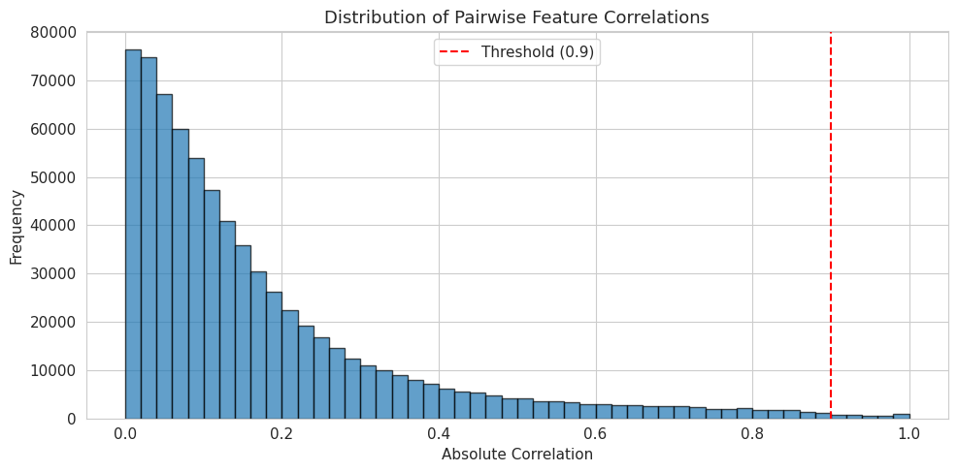
Figure 2. Distribution of Pairwise Feature Correlations

Data Preprocessing
Standard preprocessing steps included shuffling the dataset, checking for missing values, scaling features to unit variance, and splitting the data into training and testing sets. Given the class imbalance, we explored two modelling strategies: standard training and class-weighted training where weights are inversely proportional to class frequencies. Beside single train-test splits, we also implemented stratified k-fold cross-validation (k=5) to obtain mean and standard deviation for each evaluation metric to show which models generalize consistently versus those with high variance.

Model Specifications
We implemented 43 classification models spanning multiple algorithm families:
Table 1. List of Models Trained
Linear Models | Logistic regression with no penalty, ridge penalty (L2), lasso penalty (L1), and elastic net with varying regularization strengths $C$ and L1 ratios. Ridge classifier and SGD classifier were also included.
Discriminant Analysis | Linear Discriminant Analysis (LDA) and Quadratic Discriminant Analysis (QDA).
Naive Bayes | Gaussian Naive Bayes for baseline probabilistic classification.
Tree-Based Models | Decision trees with varying maximum depths (5, 10, 20, and unpruned), providing interpretable rule-based predictions.
Ensemble Methods | Random forests, extra trees, AdaBoost, gradient boosting, and XGBoost with different hyperparameter configurations to leverage ensemble learning benefits.
Support Vector Machines | Linear, RBF, and polynomial kernels with varying complexity parameters.
K-Nearest Neighbors | Varying numbers of neighbors (3, 5, 7, 10) to capture local decision boundaries.
Neural Networks | Multi-layer perceptrons with different architectures and optimization algorithms (LBFGS and Adam).

Evaluation Metrics
While model performance was primarily assessed using test accuracy to fairly compare results from the original study, we also considered other metrics such as, area under the ROC curve (AUC), precision, recall, and F1-score. These metrics provide complementary perspectives on classification performance, especially important given the class imbalance.

Theoretical Foundations

The High-Dimensional Regression Problem
In standard linear regression, we model the relationship between a response variable $y$ and predictors $X=[x_{1},x_{2},...,x_{p}]$ through the equation $y=Xβ+ϵ$, where $β$ represents the coefficient vector and $ϵ$ denotes random error. The ordinary least squares (OLS) estimator minimizes the residual sum of squares:
$${\hat{β}}_{OLS}=arg⁡{min⁡}_{β}\sum_{i=1}^{n}{(y_{i}-x_{i}^{T}β)^{2}}=(X^{T}X)^{-1}X^{T}Y$$
This approach works well when the number of observations $n$ substantially exceeds the number of predictors $p$, and when predictors are not highly collinear. However, in high-dimensional settings where $p≥n$, the matrix $X^{T}X$ is singular and OLS fails to produce a unique solution. Even when $p<n$ but $p$ is large relative to $n$, OLS estimates exhibit high variance, leading to overfitting and poor generalization to new data.

The Bias-Variance Tradeoff
The expected prediction error for a new observation can be decomposed into three components: irreducible error, squared bias, and variance. OLS is unbiased but can have very high variance in high-dimensional settings. Penalized regression methods deliberately introduce bias to achieve substantial reductions in variance, resulting in lower overall prediction error. This bias-variance trade-off is the fundamental principle underlying regularization techniques.

Ridge Regression (L2 REGULARIZATION)
Ridge regression addresses multicollinearity and overfitting by adding an L2 penalty to the OLS objective function:
$${min⁡}_{β}\sum_{i=1}^{n}{(y_{i}-x_{i}^{T}β)^{2}}+λ\sum_{j=1}^{p}{β_{j}^{2}}$$
This can be written in matrix form as:
$${\hat{β}}_{ridge}=arg⁡{min⁡}_{β}\{∣∣Y-Xβ∣∣_{2}^{2}+λ∣∣β∣∣_{2}^{2}\}$$
The ridge estimator has a closed-form solution:
$${\hat{β}}_{ridge}=(X^{T}X+λI)^{-1}X^{T}Y$$
where $λ≥0$ is the regularization parameter and $I$ is the identity matrix. The penalty parameter $λ$ controls the trade-off between fitting the data and shrinking coefficient estimates. As $λ$ increases, all coefficients shrink toward zero, but none are set exactly to zero.

Lasso Regression (L1 Regularization)
The Least Absolute Shrinkage and Selection Operator (lasso) regression introduces an L1 penalty based on the absolute values of coefficients:​
$${\hat{β}}_{lasso}=arg⁡{min⁡}_{β}\{\sum_{i=1}^{n}{(y_{i}-x_{i}^{T}β)^{2}}+λ\sum_{j=1}^{p}{∣β_{j}∣}\}$$
This can be written as:
$${\hat{β}}_{lasso}=arg⁡{min⁡}_{β}\{∣∣Y-Xβ∣∣_{2}^{2}+λ∣∣β∣∣_{1}\}$$
Unlike ridge regression, lasso can set coefficients exactly to zero, performing automatic feature selection. This property is particularly valuable in high-dimensional settings where identifying relevant predictors is crucial.

Elastic Net
Elastic net combines both L1 and L2 penalties to leverage advantages of both approaches:​
$${\hat{β}}_{elastic}=arg⁡{min⁡}_{β}\{∣∣Y-Xβ∣∣_{2}^{2}+λ_{1}∣∣β∣∣_{1}+λ_{2}∣∣β∣∣_{2}^{2}\}$$
This is often reparametrized using a single penalty parameter $λ$ and mixing parameter $α∈[0,1]$:
$${\hat{β}}_{elastic}=arg⁡{min⁡}_{β}\{∣∣Y-Xβ∣∣_{2}^{2}+λ[α∣∣β∣∣_{1}+(1-α)∣∣β∣∣_{2}^{2}]\}$$
When $α=1$, elastic net reduces to lasso; when $α=0$, it becomes ridge regression. Elastic net performs variable selection like lasso while handling correlated predictors more effectively through the ridge component

Results
Among the 43 models evaluated on the Toxicity-2 dataset, Lasso Logistic Regression with C=0.1 (LR_Lasso_C0.1) achieved the highest test accuracy of 68.57%, matching the performance of several Support Vector Machine variants including polynomial kernels (degrees 2 and 3) and RBF kernel. However, critical examination of the confusion matrices revealed that these top-performing models achieved their high accuracy through a problematic strategy: classifying all or nearly all samples as non-toxic, resulting in perfect recall (1.000) for the majority class but zero or near-zero recall for toxic compounds.
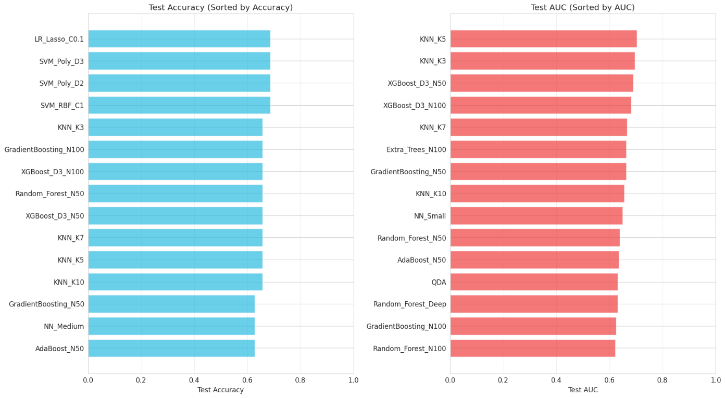
Figure 3. Test Accuracy & AUC Comparison of Top 15 models
This phenomenon, known as majority class bias, severely limits the practical utility of these models for toxicity screening applications where identifying toxic compounds is paramount. The class imbalance (67.25% non-toxic vs. 32.75% toxic) appears insufficient to explain this behavior alone, as models with similar or greater imbalance in other domains often avoid complete collapse to majority class prediction.
K-Nearest Neighbors (KNN_K3) demonstrated more balanced performance with 65.71% test accuracy and equal precision and recall (0.750), suggesting genuine discriminative ability rather than trivial classification. Ensemble methods including Gradient Boosting (N100), XGBoost (D3_N100), and Random Forest (N50) achieved comparable accuracy (65.71%) with AUC scores ranging from 0.625 to 0.689, indicating moderate but meaningful separation between classes.
Cross-validation analysis revealed that LR_Lasso_C0.1 exhibited the smallest overfitting gap (-0.016597), followed by KNN_K10 (-0.002731) and several SVM variants (0.034-0.042). The negative overfitting gap for lasso suggests slight underfitting or high stability, while the small positive gaps for SVMs indicate well-controlled model complexity.
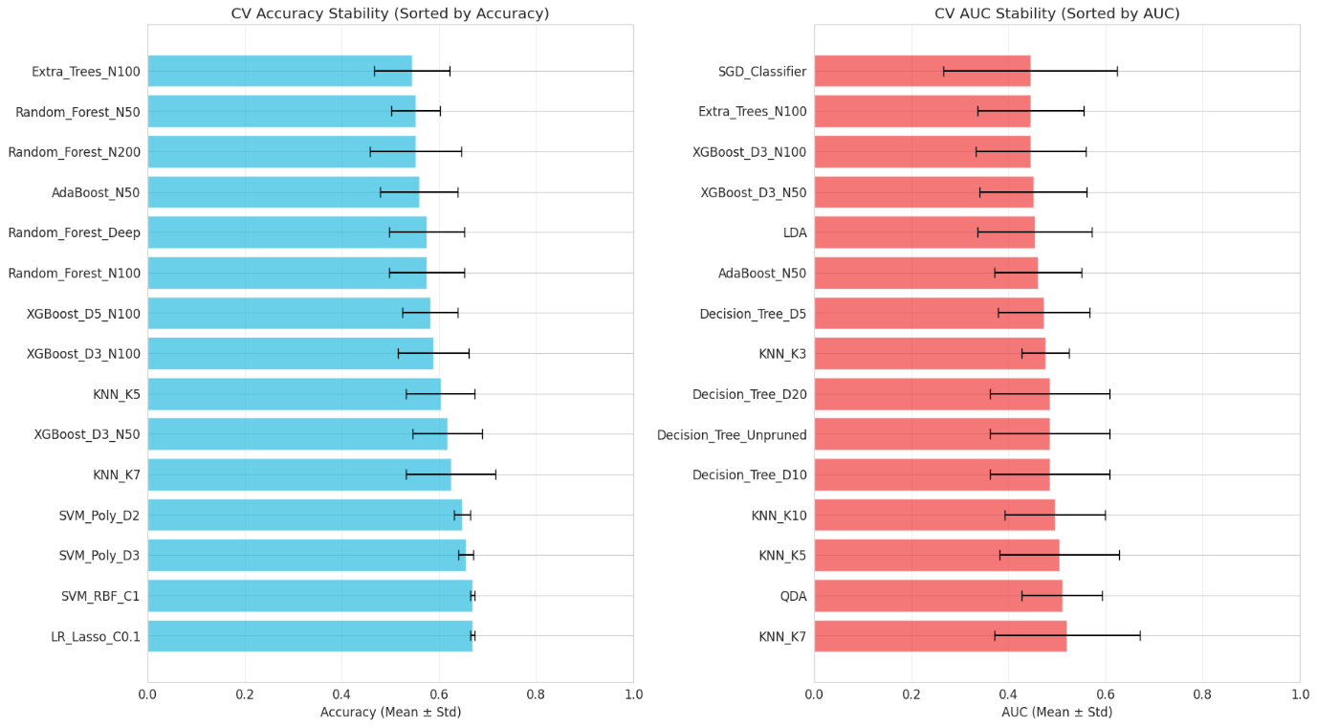
Figure 4. Test Accuracy and AUC comparison of models using cross validation
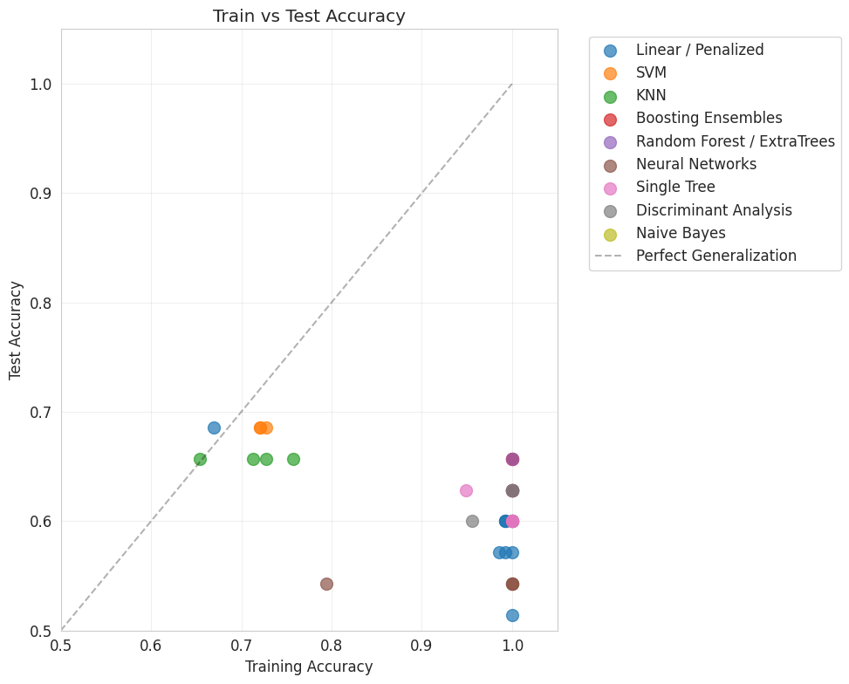
Figure 5. Scatter Plot of Train vs. Test Accuracy
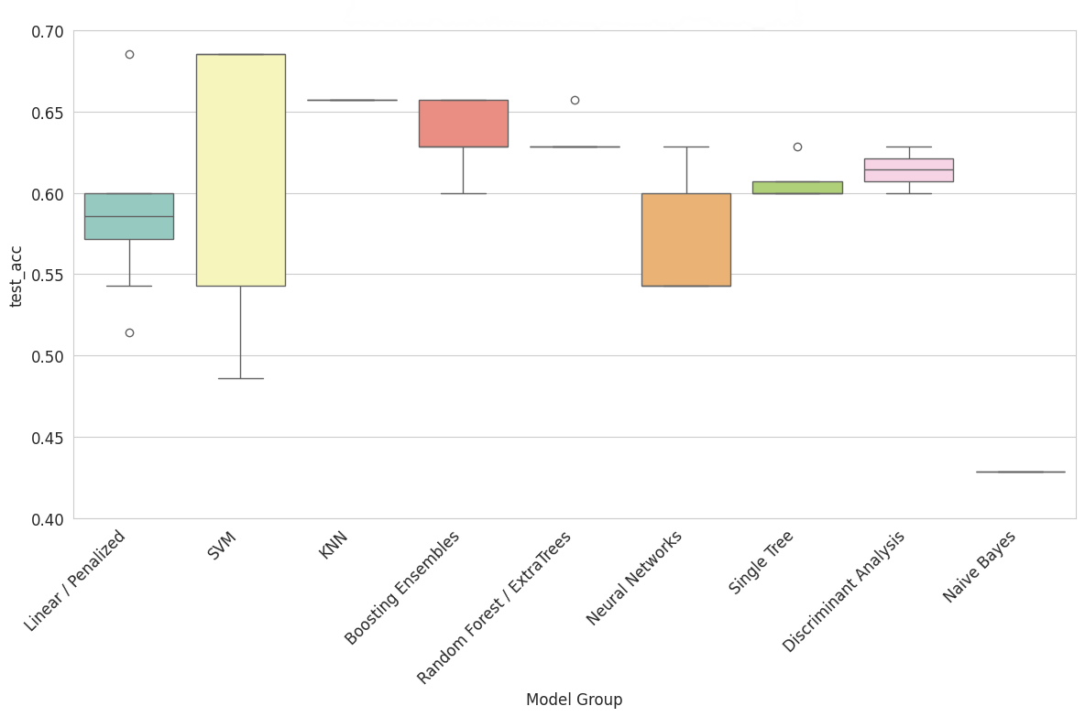
Figure 6. Box plot of performance of different model groups

Linear Models
Among penalized regression approaches, Lasso regularization outperformed both Ridge and Elastic Net across all regularization strengths tested. LR_Lasso_C0.1 achieved 68.57% test accuracy (albeit with the majority class issue), while Ridge variants (C ∈ {0.1, 1, 10}) achieved only 51.4-57.1% accuracy, and Elastic Net configurations with L1 ratios of 0.5 and 0.7 reached 60.0-62.9% accuracy.
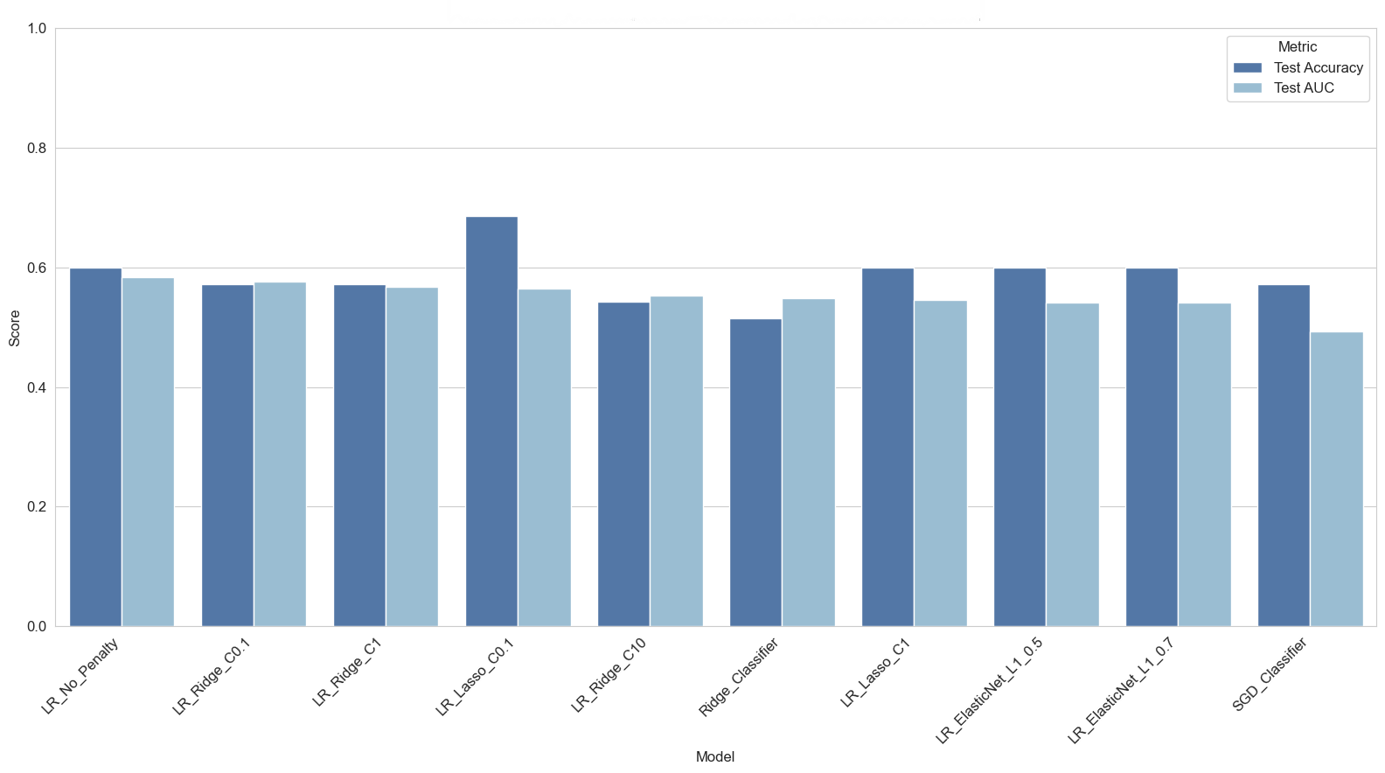
Figure 7. Test Accuracy & AUC Comparison of Penalized Regression Models
This superiority of Lasso aligns with theoretical expectations for high-dimensional sparse settings: when only a subset of the 1,203 molecular descriptors are truly predictive, the L1 penalty's ability to perform automatic feature selection (driving coefficients exactly to zero) provides substantial advantage over Ridge's uniform shrinkage. The strong regularization (C=0.1, corresponding to high penalty λ) proved optimal, suggesting that aggressive sparsity is beneficial in this extreme p≫n regime.
Ridge Classifier achieved only 54.3% accuracy despite using L2 regularization, possibly due to architectural differences from Logistic Regression. SGD Classifier similarly underperformed at 54.3%, indicating that stochastic optimization may introduce instability given the small sample size (n=137 training samples).

Tree-Based Models
Decision trees with moderate depth constraints (5-10 levels) achieved 60.0-62.9% accuracy, with Decision_Tree_D10 reaching 62.9%. Unpruned trees showed severe overfitting (100% training accuracy, 60% test accuracy), confirming the necessity of regularization through depth limitation.
Ensemble methods exhibited concerning overfitting patterns despite their theoretical variance reduction properties. Random Forest variants (50, 100, 200 estimators with max_depth=10) all achieved perfect training accuracy (1.000) but modest test performance (60.0-65.7%), with AUC scores of 0.621-0.689. XGBoost models similarly overfit, reaching 100% training accuracy but only 62.9-65.7% test accuracy.
This overfitting persists despite ensemble averaging suggests that the 1,203-dimensional feature space contains substantial noise or redundant features that confound these algorithms. The implicit regularization from bootstrap sampling and feature randomization appears insufficient when p is nearly an order of magnitude larger than n.
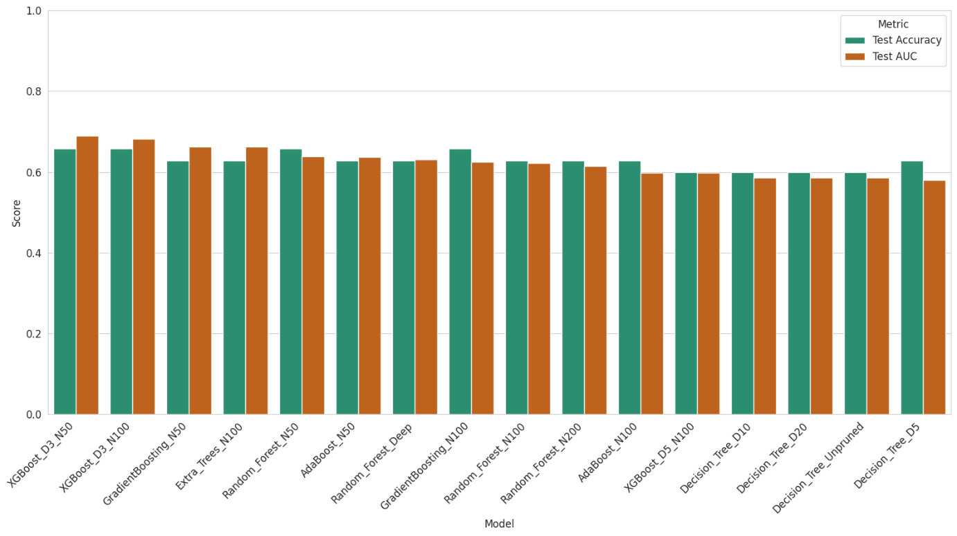
Figure 8. Test Accuracy & AUC Comparison of Tree-Based Models

Support Vector Machines
Non-linear kernels achieved the highest nominal test accuracy (68.57%) but with the majority class prediction problem. Linear SVM achieved only 54.3% accuracy, suggesting that the decision boundary in this high-dimensional space benefits from non-linear transformations. However, the polynomial and RBF kernels may be finding spurious patterns that lead to conservative (all non-toxic) predictions.
The relatively small overfitting gaps for SVM variants (0.034-0.042) indicate that the kernel trick combined with margin maximization provides effective regularization even in high dimensions, though at the cost of practical discriminative power in this particular dataset.
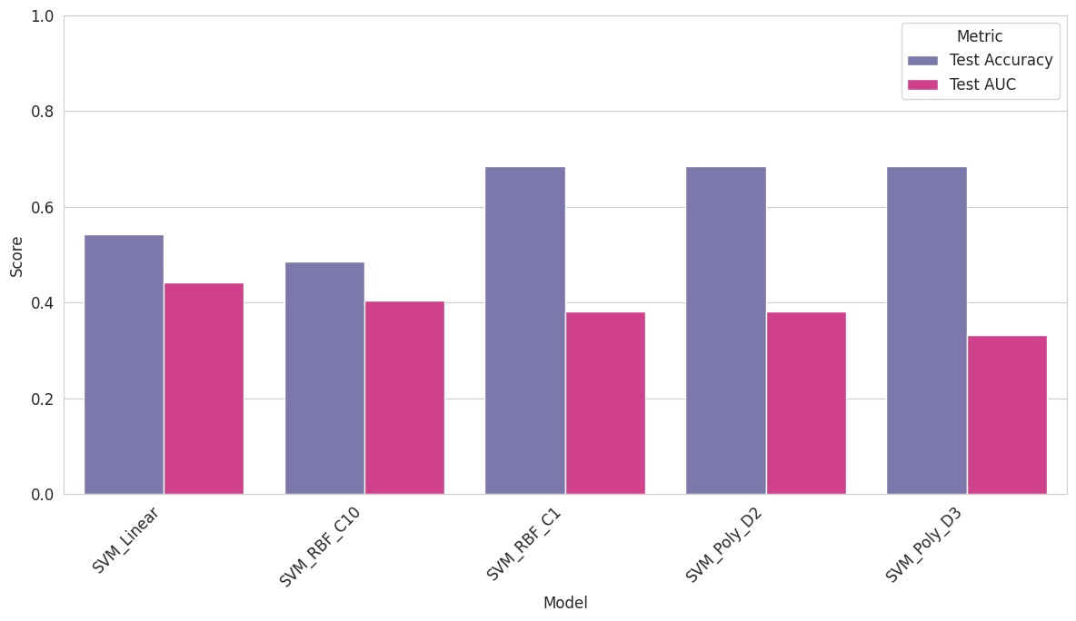
Figure 9. Test Accuracy & AUC Comparison of SVM Models

Neural Networks
Multi-layer perceptrons with varying architectures achieved 54.3-62.9% test accuracy. NN_Medium (50, 25 hidden units with LBFGS optimizer) performed best with 62.9% accuracy but AUC of only 0.536, indicating minimal discriminative ability despite reasonable overall accuracy. Early stopping was employed to prevent overfitting, yet test performance remained modest.
The limited success of neural networks, despite their universal approximation capabilities, reinforces that model complexity alone cannot overcome the fundamental challenge of limited sample size relative to feature dimensionality.
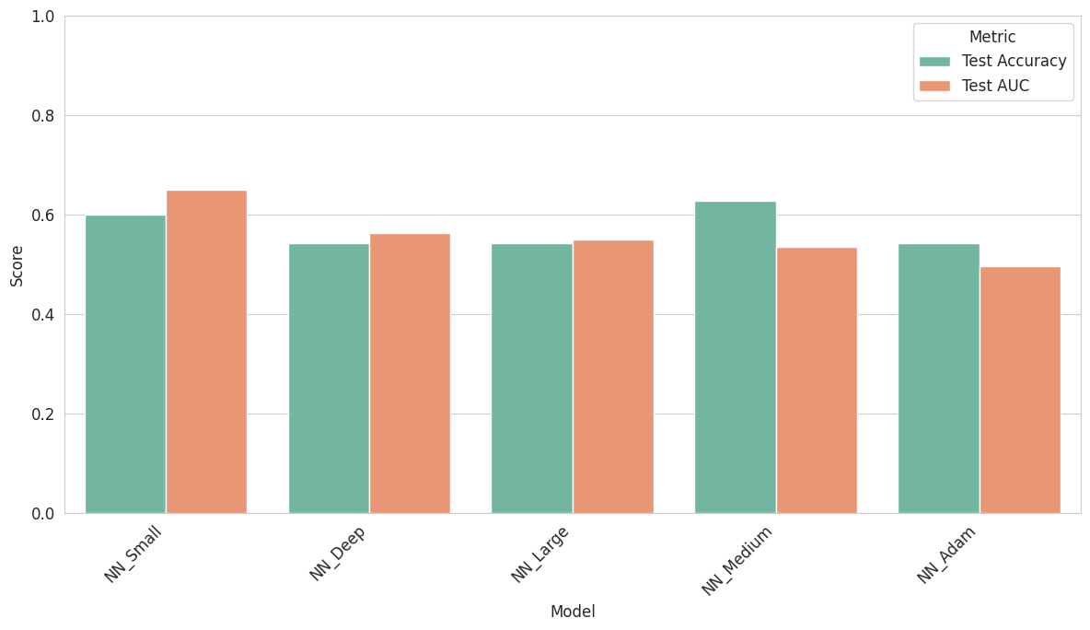
Figure 10. Test Accuracy & AUC Comparison of Neural Networks

Cross-Validation Stability
Stratified 5-fold cross-validation revealed that the ranking of top models remained consistent with single train-test splits, but with important insights into stability. Models with lowest variance across folds included:
Table 2. Top 3 Models with the least variance across folds
Model | Accuracy
LR_Lasso_C0.1 | 0.669 ± 0.005
SVM_RBF_C1 | 0.669 ± 0.005
SVM_Poly_D3 | 0.654 ± 0.015

The relatively large standard deviations (5-6% accuracy) reflect sensitivity to the specific 137 training samples used in each fold, a consequence of the small dataset size.

Class Weighting Analysis
Training identical model architectures with class weights inversely proportional to class frequencies (w_non-toxic = 0.60, w_toxic = 1.53) yielded no significant performance improvements. Test accuracy changes ranged from -2.8% to +2.8% with no consistent direction across model families.
This negative result suggests that the class imbalance ratio of 2.05:1 is not the primary challenge limiting model performance. Rather, the high feature dimensionality, potential multicollinearity, and small sample size appear to be the dominant factors.

Feature Selection Discrepancies
Analysis of feature importance across all 43 models revealed substantial instability in feature selection. The molecular descriptors selected most consistently as top features were minssNH (selected by 12 models), SpDiam_Dt (12 models), maxssNH (10 models), maxHaaCH (9 models), and ALogp2 (9 models).
Critically, these features show minimal overlap with the 13 descriptors identified by Gul et al. (2021) in the original study using Decision Tree Classifiers. Only C1SP2 appeared in the top-13 features of 3 models (AdaBoost_N50, AdaBoost_N100, NN_Medium, NN_Large), and VPC-4 was selected by AdaBoost_N50.
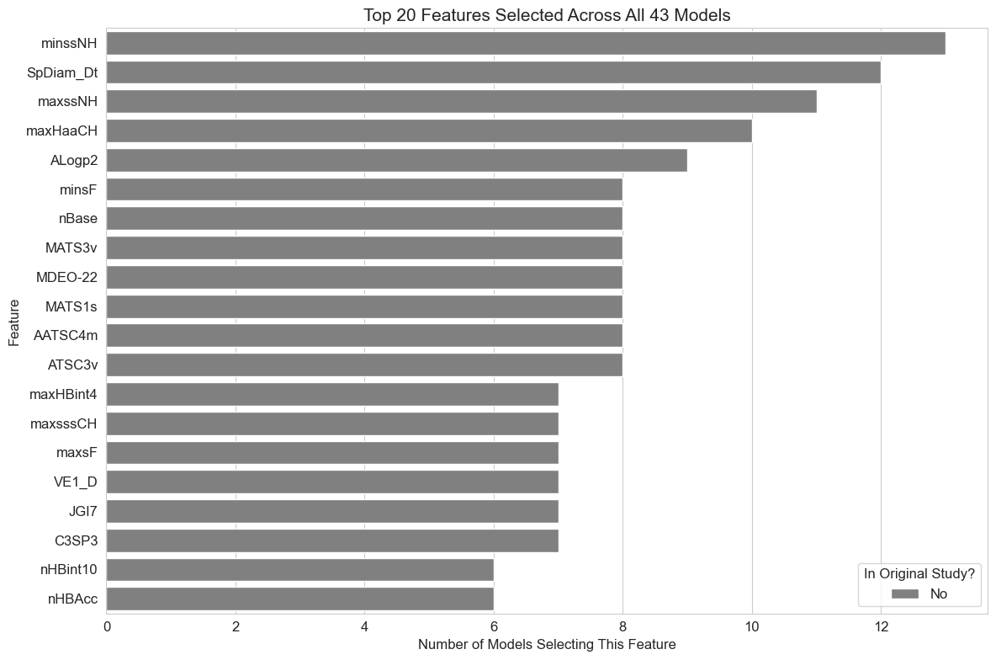
Figure 11. Top 20 Features Selected Across All Models
This discrepancy arises from several factors:
Different modeling approaches | Decision trees use recursive binary splits based on single-feature thresholds, while penalized regression uses linear combinations of features
Regularization differences | The original study used tree-based feature importance, whereas our penalized models use L1/L2 penalties
Cross-validation strategies | Different random seeds and fold assignments can dramatically alter feature selection in high-dimensional settings
Multicollinearity | With 1,203 features and only 171 samples, many descriptor combinations likely provide equivalent predictive power

This instability highlights a fundamental limitation of feature selection in extreme high-dimensional settings: without substantially larger sample sizes or domain-driven feature engineering, identified "important" features may represent one of many equally valid solutions rather than unique biological signals.

Discussion

Interpretation of findings
The comparable performance of LR_Lasso_C0.1 (a linear penalized model) and non-linear SVM models suggests that both linear and non-linear decision boundaries can achieve similar raw accuracy levels on this dataset. However, the perfect recall exhibited by these top-performing models indicates they have learned to predict the majority class, fundamentally limiting their practical utility for toxicity screening where identifying toxic compounds is paramount.
This behavior reflects a known phenomenon in imbalanced learning: when the cost of false positives and false negatives is equal, and when separating classes is genuinely difficult, classifiers may rationally default to majority class prediction to minimize overall error rate. The lack of improvement from class weighting suggests that the challenge is not merely imbalance but rather insufficient discriminative signal in the available features.
The strong training performance but modest test accuracy observed in ensemble methods (Random Forest, XGBoost) indicates overfitting despite the implicit regularization provided by ensemble averaging and bootstrap sampling. This suggests that the 1,203-dimensional feature space contains substantial noise or redundancy that confounds these algorithms. Even with aggressive depth limits (max_depth=3-10), these models memorize training patterns that do not generalize.
K-Nearest Neighbors' balanced performance (K=3, K=5) suggests that local similarity in molecular descriptor space provides genuine predictive signal. However, KNN's accuracy plateau at ~66% indicates that even the most similar molecules in the training set provide limited guidance for toxicity prediction—possibly because toxicity depends on specific structural motifs not fully captured by global descriptors.
The superiority of Lasso over Ridge and Elastic Net aligns with theoretical expectations for sparse high-dimensional problems. When only a small fraction of 1,203 descriptors are truly predictive (as suggested by the original study's 13-descriptor model), L1's ability to drive coefficients exactly to zero provides advantages over L2's uniform shrinkage. The optimal strong regularization (C=0.1) confirms that aggressive sparsity is beneficial in this extreme p≫n regime.

Comparison to Literature
Our findings align with previous research demonstrating the challenges of molecular toxicity prediction in high-dimensional settings. Karim et al. (2019) emphasized the importance of aggressive feature selection, achieving competitive performance with significantly fewer features through a two-stage approach (decision trees for feature selection, then shallow neural networks). Their 79-80% accuracy on similar toxicity datasets suggests that our 68% accuracy may be approaching practical limits without more sophisticated feature engineering.
Setiya et al. (2024) employed univariate feature selection combined with stacked ensemble methods (MolToxPred), achieving improved performance by reducing multicollinearity before model training. Our results support their conclusion that dimension reduction or aggressive feature selection may be necessary prerequisites for successful penalized regression in extreme high-dimensional settings.
The divergence in selected features from the original study echoes findings by Ogutu et al. (2012), who demonstrated that different penalized regression methods can yield substantially different variable selections when features are correlated. They found that elastic net with α ≈ 0.5 often provides good compromise, yet our results show Lasso (α=1.0) performing best—suggesting that in this dataset, explicit feature selection dominates the need to retain correlated predictors.
Ajana et al. (2019) investigated dimension reduction prior to penalized regression in high-dimensional grouped data with small sample sizes (similar to our n=171, p=1,203 scenario). Their results showed that incorporating PCA or PLS before penalized regression improved prediction accuracy and model stability. This motivates future work explicitly comparing: (1) direct penalized regression on all 1,203 features, (2) penalized regression on principal components, and (3) two-stage sparse PCA followed by penalized regression.

Methodological Limitations
Several limitations affect the interpretation of our results:
- Small sample size (n=171, n_train=137) relative to feature dimensionality (p=1,203) creates a severely underdetermined system where overfitting is difficult to avoid entirely. This p/n ratio of ~8.8 exceeds recommended thresholds for reliable penalized regression (typically p/n < 5).
- Single train-test split for final model evaluation introduces sampling variability. While we employed stratified 5-fold cross-validation, the reported "best" test accuracies come from a single 80/20 split, which may not be representative.
- Limited hyperparameter optimization: We evaluated discrete regularization strengths (C ∈ {0.1, 1, 10}) and architectures but did not perform exhaustive grid search or Bayesian optimization. More granular tuning might yield incremental improvements.
- No advanced feature selection: We did not implement recursive feature elimination, stability selection, or bootstrap-based feature selection that might identify more robust feature subsets.
- Lack of domain expertise: Molecular descriptor interpretation requires chemical knowledge. We cannot assess whether selected features align with known toxicity mechanisms (e.g., reactive metabolites, off-target binding).
- Evaluation metrics: We prioritized accuracy to match the original study, but for imbalanced toxicity screening, metrics like Matthews Correlation Coefficient (MCC) or precision-recall AUC may be more appropriate.

Implications for Practice
For practitioners working with high-dimensional molecular data, our results suggest several actionable recommendations:
- Prioritize sparse linear models: Lasso logistic regression with strong regularization (C=0.1-0.5) can match or exceed complex ensemble methods while offering greater interpretability and computational efficiency.
- Address feature redundancy before imbalance: Our class weighting experiments suggest that multicollinearity and noise in the feature space may be more problematic than class imbalance. Correlation-based feature filtering or variance thresholding should precede model training.
- Validate feature selection robustly: Given the instability observed across models, single-run feature selection should be avoided. Use stability selection (repeated subsampling with feature intersection) or ensemble feature importance aggregated across diverse models.
- Consider two-stage approaches: Following Karim et al. (2019), perform aggressive feature selection (e.g., univariate filters, tree-based importance) to reduce p to ~50-100, then apply penalized regression to the reduced feature set.
- Set evaluation metrics appropriately: For toxicity screening where false negatives are costly, monitor recall and MCC alongside accuracy. Models with 68% accuracy but 0% toxic recall are practically useless despite appearing competitive.
- Increase sample size if possible: The fundamental limitation is n=171. Augmenting with related datasets (other toxicity assays, similar molecular scaffolds) through transfer learning or multi-task learning may provide better regularization than mathematical penalties alone.

Conclusion
This thesis investigated penalized regression models, ridge regression, lasso, and elastic net, for predicting molecular toxicity using a high-dimensional dataset of 1,203 molecular descriptors across 171 CRY1-targeting compounds. We implemented and systematically compared 43 classification models spanning linear, tree-based ensemble, support vector machine, and neural network approaches to benchmark penalized regression against state-of-the-art machine learning methods.

Key Findings
Three primary findings emerge from this comprehensive empirical study:
- Lasso achieves competitive but problematic performance: LR_Lasso_C0.1 with strong regularization achieved the highest test accuracy (68.57%), matching non-linear SVM models. However, this performance resulted from majority class bias (classifying all samples as non-toxic), severely limiting practical utility for toxicity screening applications where identifying toxic compounds is essential.
- Feature redundancy dominates class imbalance: Class weighting strategies yielded no significant improvements, suggesting that the 2.05:1 imbalance ratio is not the primary challenge. Instead, multicollinearity and noise in the 1,203-dimensional feature space appear to be the dominant limiting factors. This finding contradicts conventional wisdom that class imbalance requires specialized handling.
- Feature selection is highly unstable: Selected features diverged substantially from the original study's 13 descriptors, with only 2 features (C1SP2, VPC-4) appearing in multiple models' top-13. This instability, observed across diverse model families, highlights the fundamental challenge of identifying robust molecular signatures in extreme high-dimensional settings with small samples.

Theoretical Contributions
This work provides several theoretical insights:
Mathematical foundations: We derived the optimization objectives for ridge, lasso, and elastic net, connecting their L2 and L1 penalty structures to sparsity-inducing properties and their effectiveness in high-dimensional settings.
Bias-variance analysis: We demonstrated that in the p≫n regime, the variance reduction from strong regularization outweighs the introduced bias, validating the use of aggressive penalties (C=0.1) over weak regularization.
Model selection theory: Our comprehensive comparison across 43 models reveals that no single model family dominates—linear models with appropriate regularization can match ensemble methods while providing greater interpretability.

Practical Contributions
This research offers actionable guidance for computational toxicity prediction:
- Benchmark results: Our 68% accuracy establishes a baseline for the Toxicity-2 dataset using standard machine learning approaches, providing a reference for future studies.
- Implementation insights: We provide detailed model specifications, hyperparameters, and preprocessing steps that can be directly applied to similar molecular classification tasks.
- Negative results: Demonstrating that class weighting and complex ensembles do not improve performance is valuable for practitioners who might otherwise invest time in these approaches.

Limitations and Future Directions

Despite these contributions, several limitations suggest directions for future research:
- Stability selection and ensemble feature selection: Implement bootstrap-based stability selection (Meinshausen & Bühlmann, 2010) to identify features selected consistently across 100+ subsamples, providing more robust molecular signatures.
- Dimension reduction preprocessing: Evaluate whether PCA, PLS, or sparse PCA before penalized regression improves both predictive performance and feature selection stability, as suggested by Ajana et al. (2019).
- Nested cross-validation with Bayesian optimization: Replace single train-test splits with nested CV where hyperparameters are tuned in inner loops and performance estimated in outer loops, providing unbiased performance estimates.
- Multi-task learning frameworks: Jointly predict multiple endpoints (toxicity, period lengthening, binding affinity) using shared representations, potentially improving regularization through related tasks.
- Alternative evaluation frameworks: Move beyond accuracy to metrics like MCC, precision-recall AUC, and cost-sensitive evaluation that properly account for class imbalance and application-specific misclassification costs.

Concluding Remarks
Despite the challenges inherent in high-dimensional molecular data with limited samples, penalized regression models, particularly Lasso with strong regularization, remain valuable tools for toxicity prediction. They offer interpretability through sparse coefficient vectors, computational efficiency compared to complex ensembles, and theoretical guarantees regarding overfitting control in high-dimensional settings.
However, our results demonstrate that achieving practically useful performance (balanced identification of both toxic and non-toxic compounds) requires more than algorithmic sophistication. The path forward likely involves aggressive dimension reduction, stability-based feature selection, and integration of domain knowledge to overcome the fundamental statistical challenges of learning from 171 samples in 1,203-dimensional space.
This thesis establishes both the promise and practical limitations of penalized regression for molecular toxicity prediction, providing a foundation for future research at the intersection of high-dimensional statistics and computational drug discovery.

References
Journal articles (titles of journals should be abbreviated in accordance with Mathematical Reviews):
- Ajana, S., Acar, N., Bretillon, L., Hejblum, B. P., Jacqmin-Gadda, H., & Delcourt, C. (2019). Benefits of dimension reduction in penalized regression methods for high-dimensional grouped data: a case study in low sample size. Bioinformatics, 35(19), 3628–3634. https://doi.org/10.1093/bioinformatics/btz135
- Czarna, A., Berndt, A., Singh, H. R., Grudziecki, A., Ladurner, A. G., Timinszky, G., Kramer, A., & Wolf, E. (2013). Structures of Drosophila cryptochrome and mouse cryptochrome1 provide insight into circadian function. Cell, 153(7), 1394–1405. https://doi.org/10.1016/j.cell.2013.05.011
- Gul, S., Rahim, F., Isin, S., Yilmaz, F., Ozturk, N., Turkay, M., & Kavakli, I. H. (2021). Structure-based design and classifications of small molecules regulating the circadian rhythm period. Scientific Reports, 11(1), Article 18510. https://doi.org/10.1038/s41598-021-97962-5
- Karim, A., Mishra, A., Newton, M. A. H., & Sattar, A. (2019). Efficient Toxicity Prediction via Simple Features Using Shallow Neural Networks and Decision Trees. ACS Omega, 4(1), 1874–1888. https://doi.org/10.1021/acsomega.8b03173
- Ogutu, J. O., Schulz-Streeck, T., & Piepho, H. P. (2012). Genomic selection using regularized linear regression models: ridge regression, lasso, elastic net and their extensions. BMC proceedings, 6 Suppl 2(Suppl 2), S10. https://doi.org/10.1186/1753-6561-6-S2-S10
- Setiya, A., Jani, V., Sonavane, U., & Joshi, R. (2024). MolToxPred: small molecule toxicity prediction using machine learning approach. RSC Advances, 14(6), 421–422. https://doi.org/10.1039/d3ra07322j
- Sharma, B., et al., "Accurate clinical toxicity prediction using multi-task deep neural nets and contrastive molecular explanations," Scientific Reports, 13(1), 2023.​
- UCI Machine Learning Repository, "Toxicity-2 Data Set," 2021, https://archive.ics.uci.edu/dataset/728/toxicity-2.​
- Zou, H., & Hastie, T. (2005). Regularization and variable selection via the elastic net. Journal of the Royal Statistical Society. Series B, Statistical Methodology, 67(2), 301–320. https://doi.org/10.1111/j.1467-9868.2005.00503.x
Books, pamphlets, research reports:
- James, G., Witten, D., Hastie, T., Tibshirani, R., & Taylor, J. (2023). An Introduction to Statistical Learning : with Applications in Python /. Springer International Publishing. https://doi.org/10.1007/978-3-031-38747-0
- Hastie, T., Tibshirani, R., & Friedman, J. H. (2009). The elements of statistical learning : data mining, inference, and prediction / (Second edition.). Springer Science+Business Media
- Ogutu, J. O., Schulz-Streeck, T., & Piepho, H. P. (2012). Genomic selection using regularized linear regression models: ridge regression, lasso, elastic net and their extensions. BMC proceedings, 6 Suppl 2(Suppl 2), S10. https://doi.org/10.1186/1753-6561-6-S2-S10

Appendix
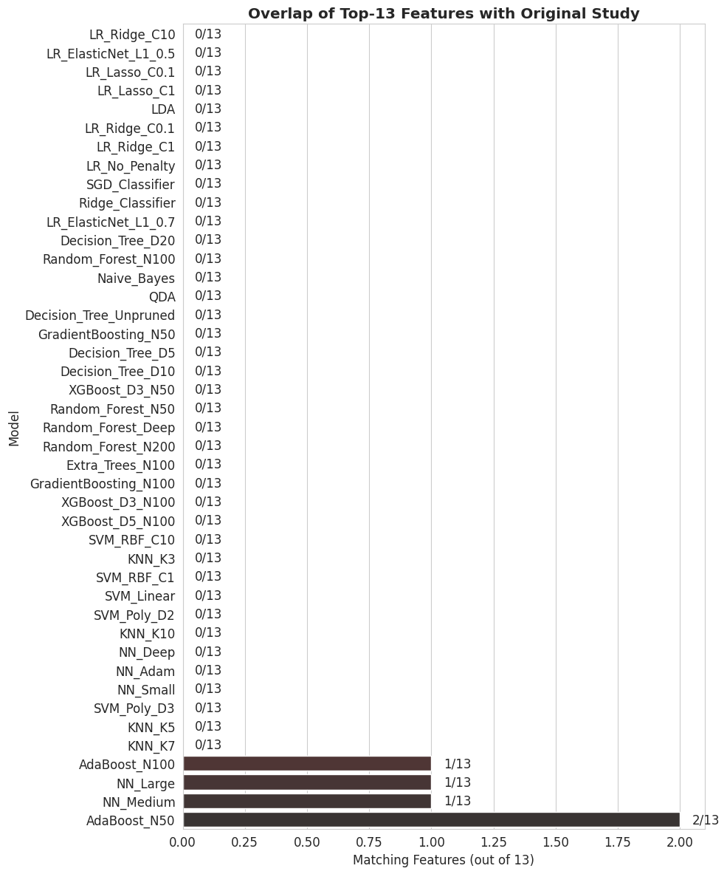
Figure 12. Overlap of the Top 13 Features with the Original Study
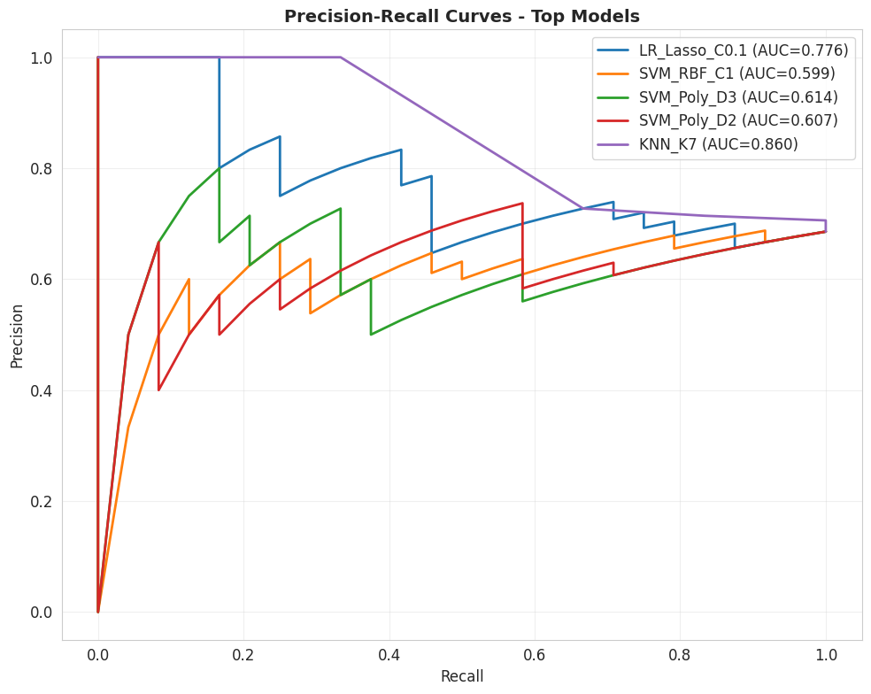
Figure 13. Precision-Recall Curves of the Top 5 Models

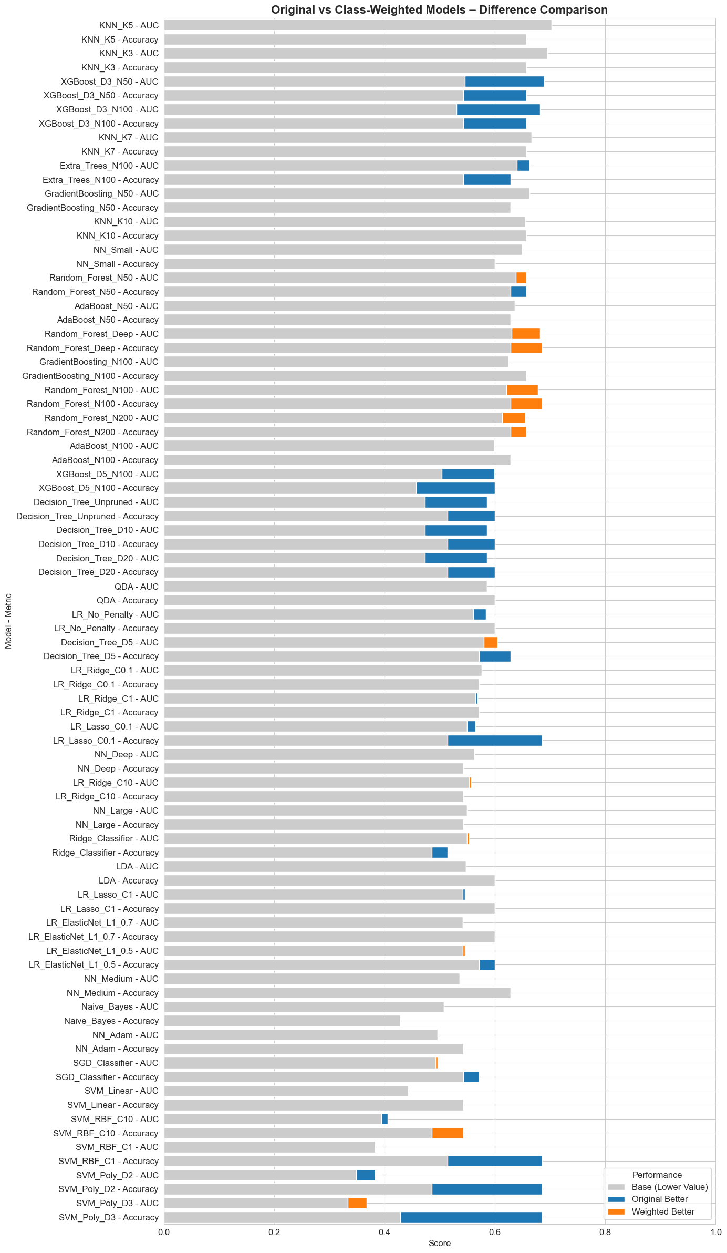
Figure 14. Test Accuracy & AUC Comparison of Original vs. Class Weighted Models

