# D-триггер

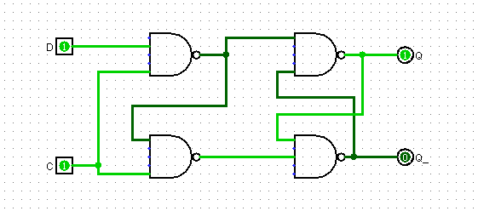

## Логическая таблица:

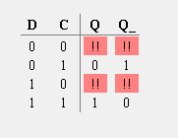

# Т-триггер

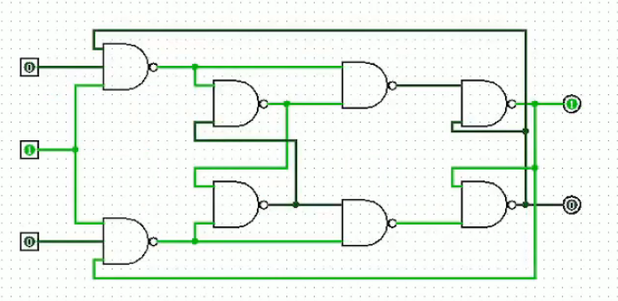

## Логическая таблица

|  |  |  |
| --- | --- | --- |
| T | Q | Q_ |
| 0 | 1 | 1 |
| 0 | 0 | 0 |
| 1 | 1 | 0 |
| 1 | 0 | 1 |

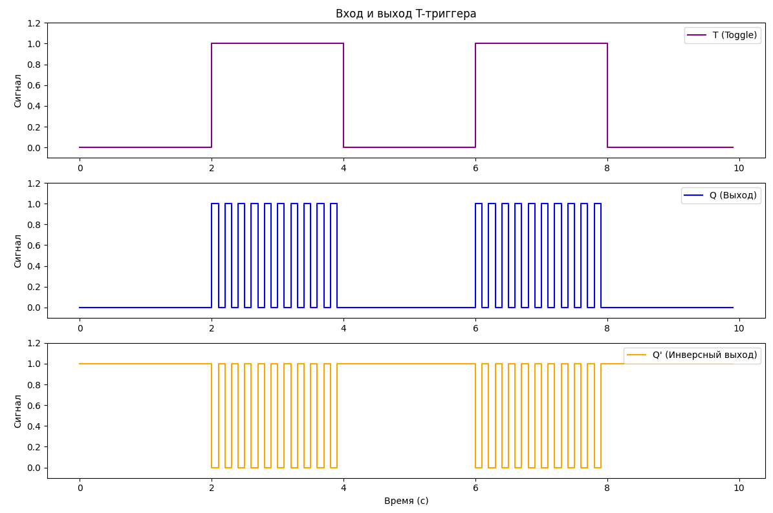

# JK триггер

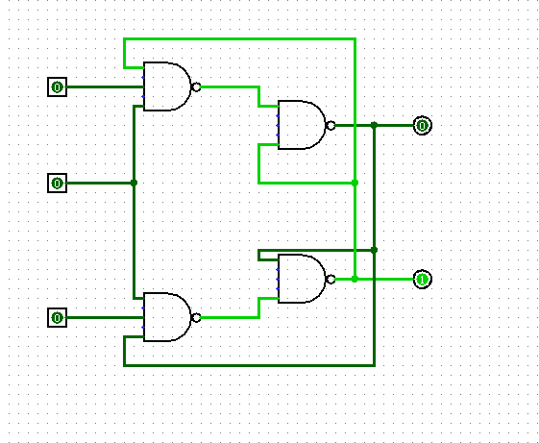

## Таблица истинности

|  |  |  |  |  |
| --- | --- | --- | --- | --- |
| C | J | K | Q_ | Q |
| 0 |  | 0 | 0 | 0 |
| 0 |  | 1 | 1 | 1 |
| 1 | 0 | 0 | 0 | 0 |
| 1 | 0 | 1 | 1 | 1 |
| 1 | 0 |  |  | 1 |
| 1 | 1 |  |  | 0 |
| 1 | 1 | 0 | 0 | 1 |
| 1 | 1 | 1 | 1 | 0 |

