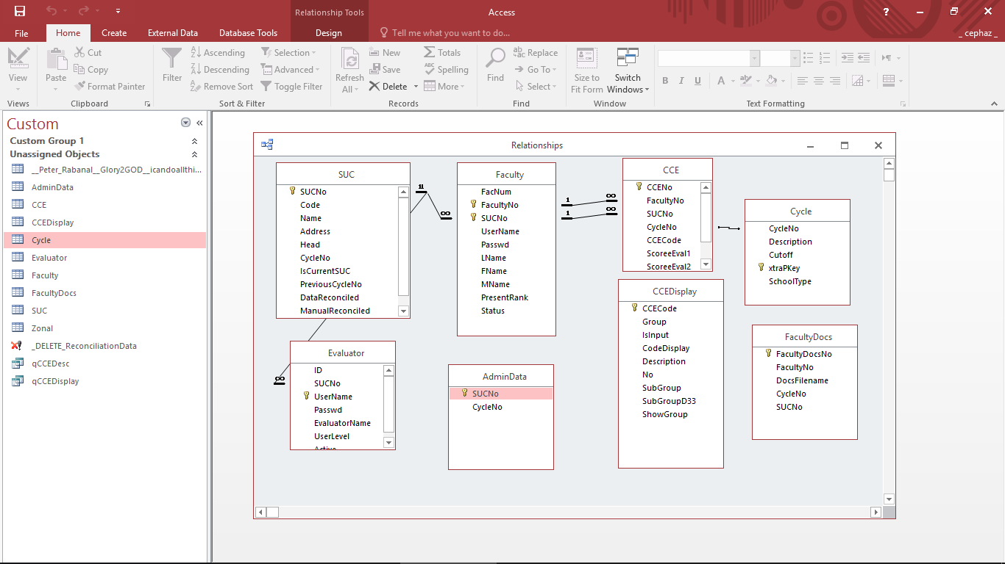  
Faculty USER will login using **FACULTY**-> Username & Passwd

Evlauator USER will login using **EVALUATOR** -> UserName & Passwd

*Kindly make a table for Admin Details

*if Faculty is new then create faculty data by admin // Just get the

FacultyDocs table stores info regarding PDF uploads

*FAcultyNo are set upon login by the Faculty

*CycleNo(Get from Cycle Table) & SUCNo(get from SUC table) are set at admin by choosing from a comboboxes and then Stored at ADMINDATA table as the currentCyle for the SUC

ADMINDATA table will only have onerow

**To be exported in CSV: CCE, Faculty & AdminData**

Evaluation Page

This could be generated from

CCEDisplay table is used for displaying the categories.

*qCCEDisplay Query/View includes the previously encoded score  
 IsInput field indicates if data will be inputted in this category.

1. Evaluator Level 1 will not display Score2 and can enter/update Score1
2. Evaluator Level 2 will display Score1 as Readonly and can enter/update Score2

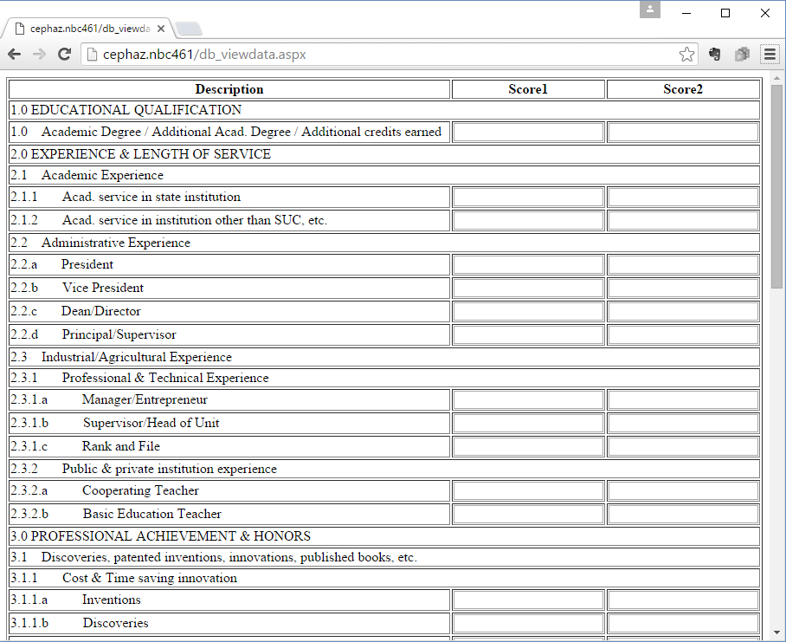

Desktop App for reference

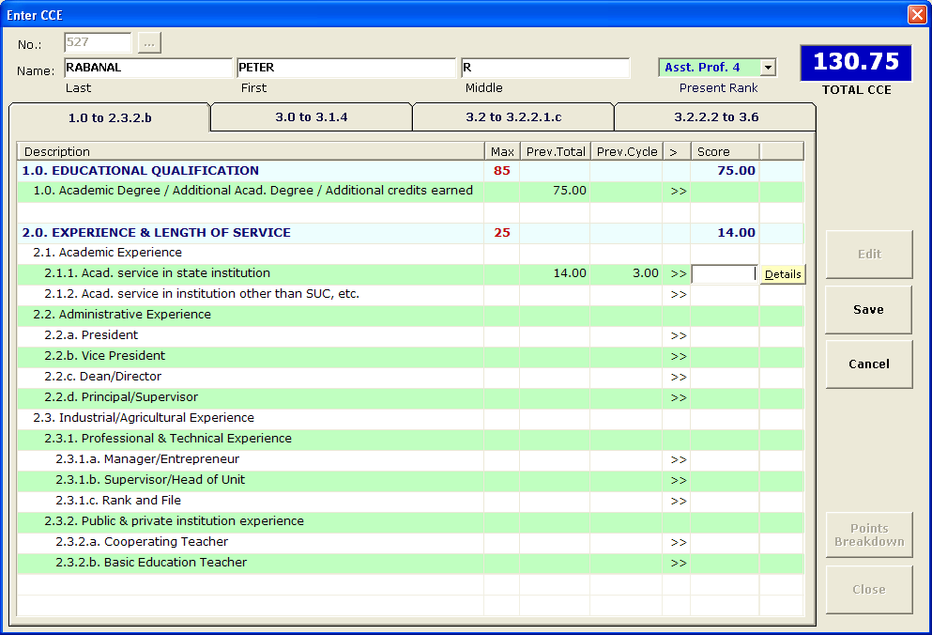

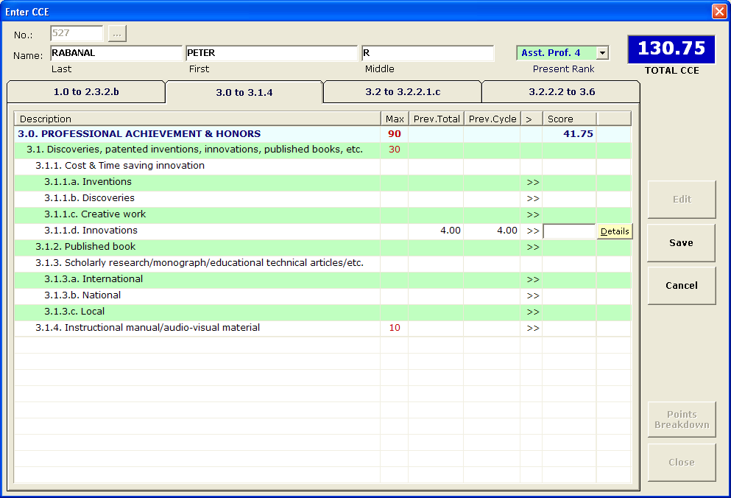

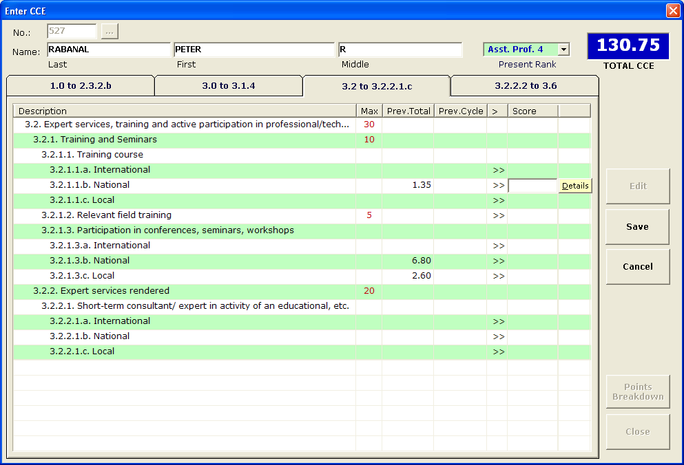

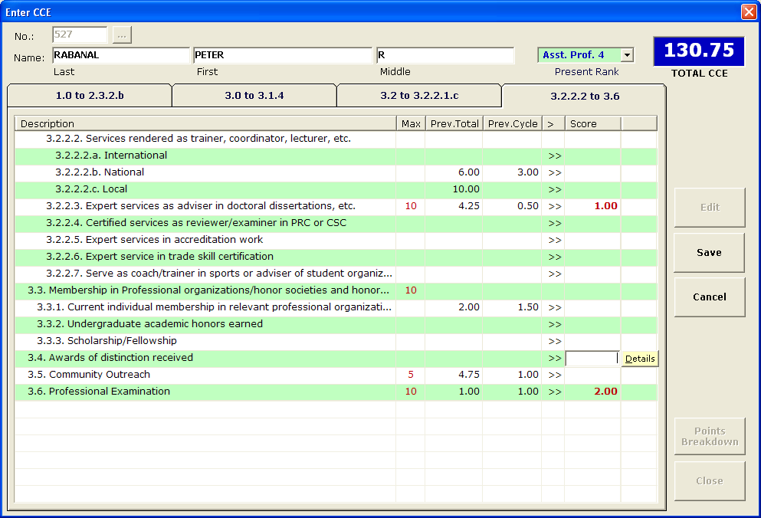

\***Prev.Total , Prev.Cycle** and **Details** will not be needed in the web app. **>>** indicates that INPUT(IsInput in database) can be accepted.