How to create a swf file with OpenLaszlo

- Download the openLaszlo server (4.3) and install it (rif. http://forum.openlaszlo.org)
- Download Laszlo IDE for Eclipse and install it.
- Configure the Eclipse for to connect to the server (Window| Preferences):
- 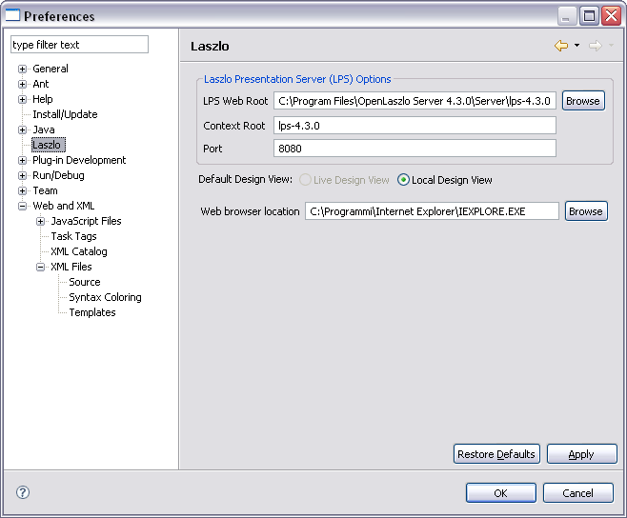

- Create a new Laszlo project :
- 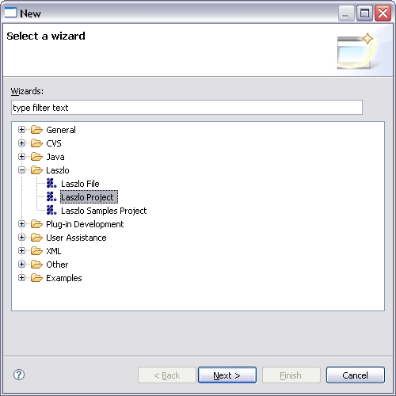

- Define its properties:

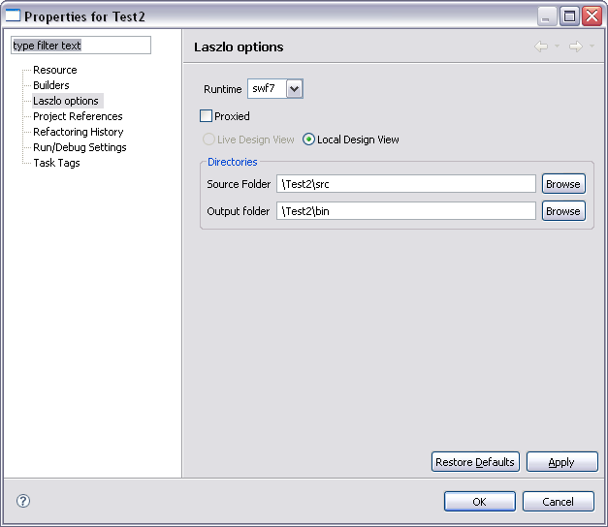

- Create a new Laszlo File ():
- 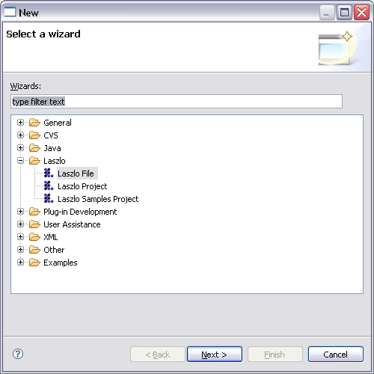
- It create a .lzx file that when it will be deployed it creates the relative .swf file.
- Write lzx code ; specify if you want debug with directive
<canvas debug="true" width="100%" height="100%">
- Create a run configuration:
- 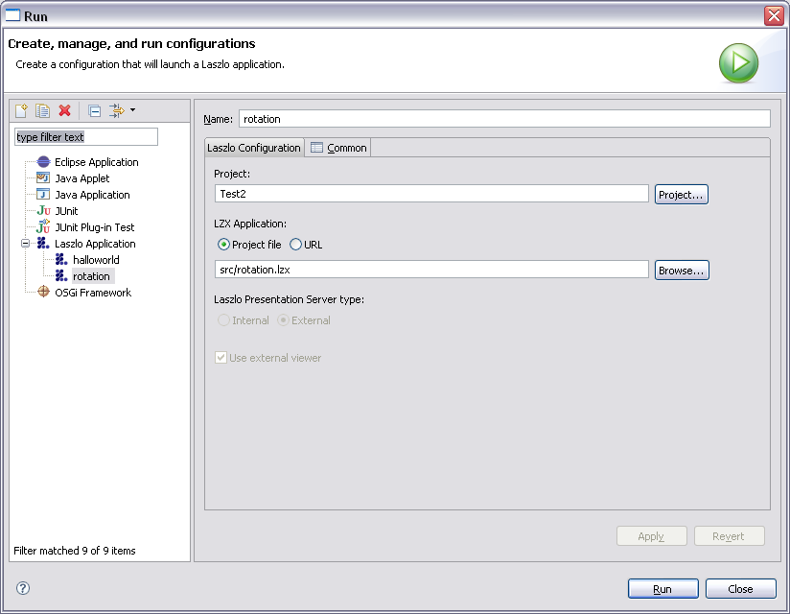
- 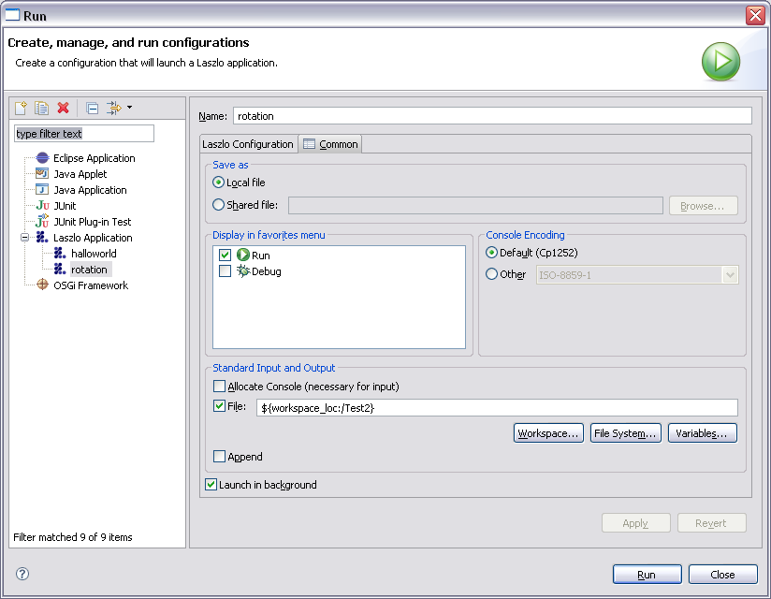
- Run the lzx file.
- When it’s ok… deploy it and create the swf file clicking on ‘SOLO’ button:
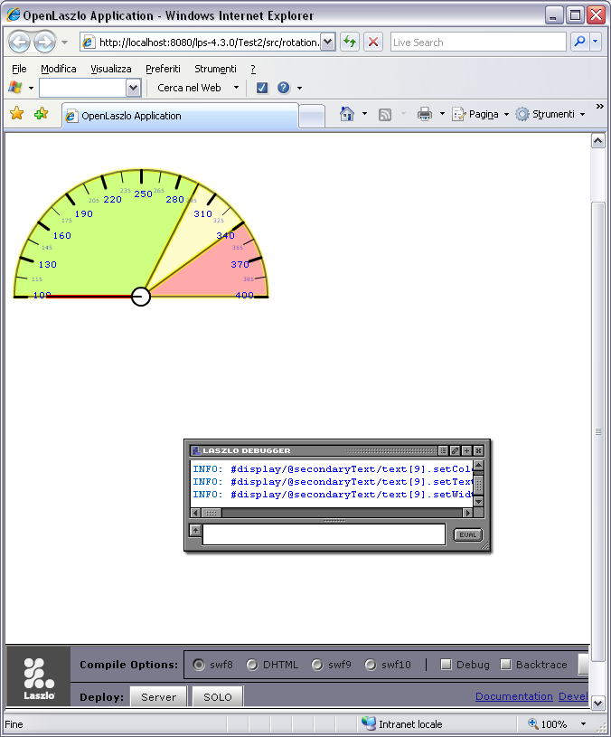

- 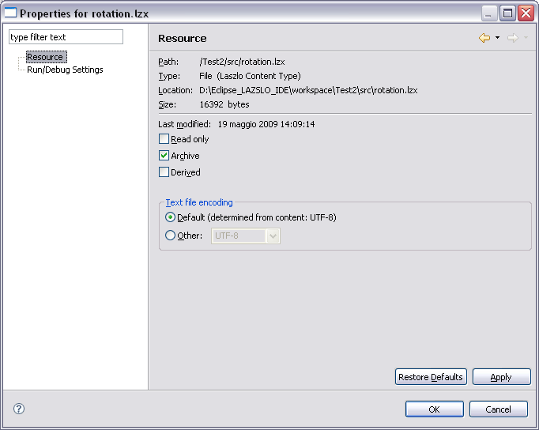
- then click on continue button:
- 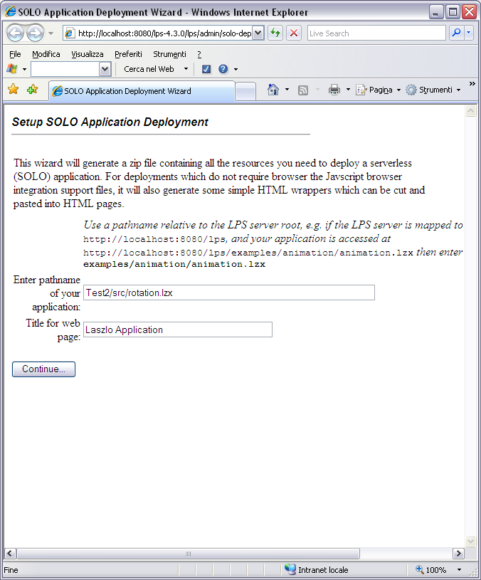
- Again..
- 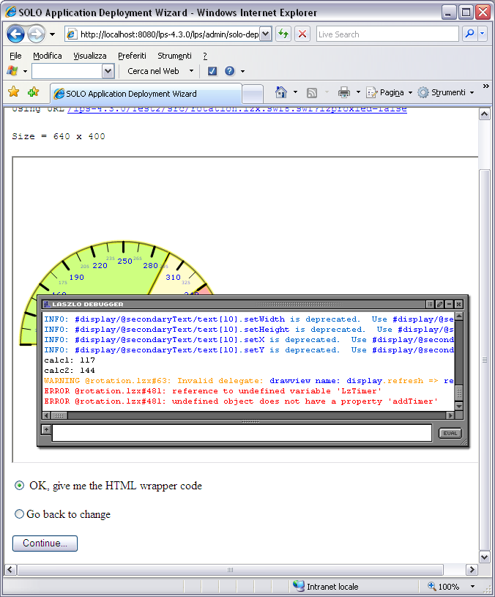
- At the last it give a link for download a package with lzx and swf file:
- 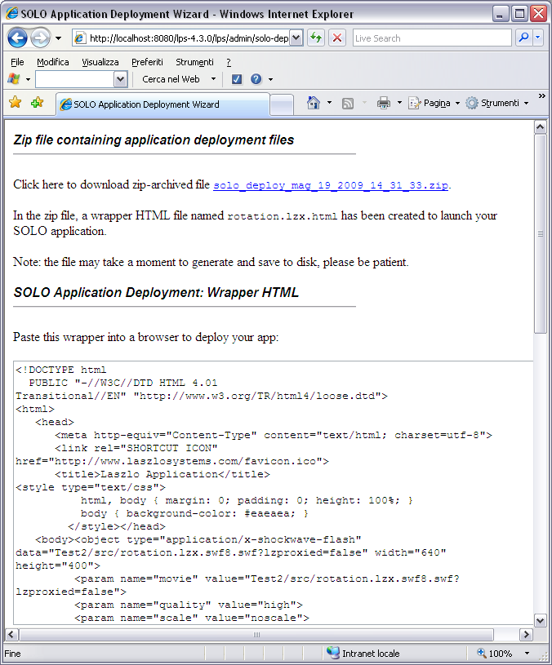

It’s possible to change the original source of laszlo files (lzx files).

