**ANGIOGAME**

Hardware and Software Specifications

Russell Short & Jacob Culley

**Introduction**:

This document serves to outline ANGIOGAME hardware and software specifications. This product is an application on an Android device, so much of the information that you may find on a similar document may be lacking. This is a piece of software that can be used on many different devices, so storage space must be conserved so that it can run on more devices. As for the software, most software we will utilize are tools to help us develop this app rather than additional software required to run it. Android supplies us with all we need to have an executable game on the device.

**Hardware:**

Android-powered device:

* Varying amount of Storage and Memory, as well as device features and limitations

**Software:**

Android Studio

* IDE made for programming android applications
* Allows for a virtual Android Device to using for testing

Blender

* Software used to make 3D models to be used in the game

Unity3D

* Tool used to render game objects and environments

**Database References:** *(speculatory)*

Player Records

* Game saves, score history, inventory, player data, etc.

NPC Information

* Location, script location, inventory, etc

World Location Information

* Position in the game, with links to other positions

Achievements

* Saved to be attributed on the Google Play Store

Extra Content

* Downloadable extras to the game

Settings Information

* Any adjustments made to the app by the player must be saved here

**Other Notes:**

User Interface

* ANGIOGAME will implement a simple and familiar UI for the users
* Starting with a basic menu system where players can either choose to start the game, where the player selects to either begin a new adventure, or continue a previous adventure. The player can also choose to see the achievements that they have completed or go straight to the settings and modify many of the game's features and settings.

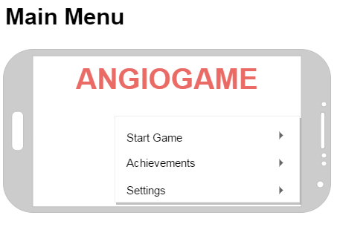

* Each crew member will appear in the upper left corner of the interface, with their portrait and overall skill level found within the center of their representative circle. Green and light yellow represents each of the crew members overall physical condition and mental condition, respectively. With the crew members names appearing at the bottom of the circle.
* There will be a drop down box on the right hand side of the interface for quick and easy access to your currently tracked missions.
* Along with a mission list, you will have the objective tracker found toward the upper center of the interface which tells you the relative direction and distance to the first tracked mission.
* Near the bottom of the interface you will find information about your current enemy such as their overall health and energy statistics.
* Found in the middle area of the interface, the player's ship along with the any enemies the player has encountered.
* The interface will also show which enemy is the current target with four arrows surrounding the enemy.

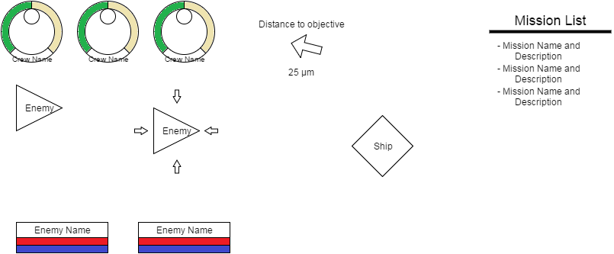

Art Style

* More focus on anatomic accuracy before any creative liberties

Game Mechanics

* Similar to a three dimensional free roaming role player game

Replayability

* Our goal is to allow added content to the game to simulate different scenarios to the human body, to build around this, we must implement a way for the added content to be included easily