Museum Buddy: A Multilingual Generative AI Chatbot for Museum Ticketing and Analytics
Spandana K G*, Misba Ain*, M Priyanka*, Afroj Alam, Jeevitha V K
School of Computer Science and Engineering, School of Information Science
Presidency University, Bengaluru, Karnataka
spandanakg61@gmail.com, misbaain134@gmail.com, mpriyanka.27173@gmail.com, afroj.alam@presidencyuniversity.in, jeevitha.vk@presidencyuniversity.in

Abstract— In​‍​‌‍​‍‌​‍​‌‍​‍‌ large part to the above scenario, digital gateways to culture get tougher for visitors to be there, as the ticketing websites based on forms seem to function like a wall, and the lack of linguistic diversity only worsens the situation. We present a new concept of the web platform named "Museum Buddy" in this document, which is created primarily to solve the accessibility problem. We offer a conversational, intuitive, and multilingual chat environment that replaces the user experience with static traditional forms of a website. The system is basically a current full-stack architecture with a Next.js (React) frontend and a generative AI backend that runs on Google's Genkit framework and the Gemini model.
Our​‍​‌‍​‍‌​‍​‌‍​‍‌ hybrid two-mode chat system is one of the major breakthroughs, which can distinguish simple questions from a more formal, structured, and guided booking process in a very natural way. Besides English, the app also supports six major Indian languages (Hindi, Bengali, Tamil, Telugu, Kannada), can locally generate digital tickets with QR codes, and has a live analytics dashboard for museum staff. This project is a demonstration of a practical and speedy method of infusing large language models (LLMs) to devise user-friendly apps that aim to uplift the accessibility level, engage visitors more deeply and furnish operational insights that are of great value to the cultural ​‍​‌‍​‍‌​‍​‌‍​‍‌sector.

Keywords: Generative AI, Chatbot, Conversational AI, Next.js, React, Genkit, Google Gemini, Museum Ticketing, Multilingual, Web Application, Human-Computer Interaction

  - Introduction
Though​‍​‌‍​‍‌​‍​‌‍​‍‌ museums and cultural centers remain very much relevant in the digital era, they appear to be somewhat slower to move online. In fact, the public can only access these institutions through their websites, which is somewhat paradoxical. The digital ways that lead to the direct contact with the institutions such as ticketing portals and information pages—are usually far from being accessible or ​‍​‌‍​‍‌​‍​‌‍​‍‌user-friendly. There still lacks much progress in many of these digital systems to a degree that they almost unavoidably inherit, if not are designed intentionally, burdensome and forgettable user interactions through ill-designed, template-like interfaces, usually with a low level of understanding of the target-group.
The issue of digital divide has a language barrier accomplice in the absence of multilingual support and this problem is quite challenging for non-native speakers. India, as a country of multiple cultural and linguistic traditions, is impacted by this virtual chasm in such a way that it can unconsciously close the door to would-be visitors thus creating unnecessary hurdles between people and their cultural heritage.
The swift and far-reaching development of generative AI with a special focus on Large Language Models (LLMs) can be seen as a game-changer that can lead to the obsolescence of those historically low-performing interfaces. Presently, we can devise models that not only recognize human spoken language but also respond accordingly in a very natural human language fashion, hence, the turning point from “filling out a form” to “having a conversation” is quite evident. “Museum Buddy” is our response to this challenge, an enterprise through which we desire to invent the least manipulative and more user-friendly, guiding-like, comprehensive, end-to-end museum ticketing experience.
Above all, we were after accessibility in a people-centric manner as the very foundation of our system besides the technical aspect. Our breakthrough was to conceive a novel conversation agent which has two separate functioning modes: (i) an open, knowledge-based mode giving answers to frequently asked questions, and (ii) a closed, guided mode for the booking process. With the help of Google’s Genkit framework, our platform is capable of delivering correct, context-sensitive replies in seven languages, English being one language and the other six major Indian languages being Hindi, Bengali, Tamil, Telugu, and Kannada, respectively.
The key points for this paper are:
- - The conversational AI architecture of a hybrid, dual-mode model. This model cleverly balances the use of natural language by an LLM for answering queries with the procedural dependability of a state machine for carrying out critical transactions.
- - An on-the-ground example of utilizing Genkit and the Gemini model for advanced multilingual intent recognition and “grounded” response generation. The approach provides localized data contexts to ensure that all information given is accurate.
- - The full-stack development of a Next.js web application that allows perfect, end-to-end booking flow i.e. from the user’s first question to the issuing of a portable digital ticket (JPG/PDF carrying a verifiable QR code).
- - The design of a live data visualizing platform for museum employees that draws up the core of sales metrics so that the managers obtain a fast, efficient, and easy-to-understand overview of their daily business.
This manuscript is organized in such a way that follows: The second section reviews the present condition of digital ticketing and conversational AI and the third one describes our method and system layout. The fourth section depicts the system performance through user scenarios, the fifth section is about the concluding remarks, and the last one offers insightful research paths for the ​‍​‌‍​‍‌​‍​‌‍​‍‌future.
  - Literature Survey
“Museum Buddy” is a research endeavor merging two fields.

Digital Ticketing Systems
An investigation into the existing digital ticketing environment shows that the present digital ticketing space is one that is largely dominated by platforms that have been designed for transactional efficiency as their sole purpose. The efficiency of those platforms in selling tickets in large numbers is quite high but the price to pay for user experience is a drop as almost all user experiences are built around rigid, static forms. Users have to go through a series of predetermined steps of drop-down menus and calendars, which are linear. While​‍​‌‍​‍‌​‍​‌‍​‍‌ this method is quite efficient, it lacks a personal touch and could be a confusion source for users, mainly if they are non-digitally proficient individuals. The “one-size-fits-all” model referred to does not provide for clarization in the text (e.g., “Are you open on Mondays?” or “Is parking available?”). The problem at this point is that it almost always results in situations where users decide to quit the checkout process in order to find the needed information elsewhere, thus causing dissatisfaction and lost ​‍​‌‍​‍‌​‍​‌‍​‍‌conversions.

Conversational AI in Customer Service
Conversational​‍​‌‍​‍‌​‍​‌‍​‍‌ AI, meanwhile, has evolved from simple rule-based bots to complex agents powered by LLMs, which are basically used in ecommerce and customer support. The main failure point in this area, however, is the “conversational handoff.” A chatbot can explain the features of a product very well but when it comes to the purchase, the user is usually given a link to a traditional, static form. As a result, the user experience becomes disjointed and unpleasant, and the conversational illusion gets broken. “Museum Buddy” is trying to bridge the gap by providing a single comprehensive conversational interface that not only understands the questions but also, without any trouble, completes the booking thus giving a seamless, end-to-end user ​‍​‌‍​‍‌​‍​‌‍​‍‌journey.

1.3. Proposed Methodology
The​‍​‌‍​‍‌​‍​‌‍​‍‌ 'Museum Buddy' application is built on a modern, full-stack JavaScript. Such a method entails different parts for the front end, which includes user interface (presentation and state), and the backend AI logic (computation and intelligence) thus, the system is scalable, maintainable, and the user experience will be responsive. The system is designed as a hybrid model that leverages the advantages of generative AI, while also being able to fall back on a deterministic state machine for ​‍​‌‍​‍‌​‍​‌‍​‍‌stability.

Dataset Used
The "dataset" for this work is not a usual fixed file, but the multi-modal, curated pieces of information given to both the AI and the frontend. The "living dataset" that they talk about here has basically two forms:

AI Context Data: The content of src/ai/flows/faq flow.ts is a JSON object that has lists of states, museums in those states, and available time slots. The data is very carefully changed into local languages such as English, Hindi, Bengali, Tamil, Telugu, and Kannada. This "grounding" data is interactively fetched from the AI's prompt, which helps it to be a source of multilingual, museum-facts-based, and language-diverse answers.

Frontend Translation Data: There is a corresponding JSON file in src/components/chat/chatinterface.tsx which holds all the static UI strings (for instance, button labels, prompts, helper text) that have been localized into the same languages. The current language is found out from a URL query parameter (e.g., ?lang=hi), which is used by both the React frontend and the Genkit backend to select the proper set of strings and context. This way, the user gets a completely immersive and localized ​‍​‌‍​‍‌​‍​‌‍​‍‌experience.

Model Development
The system's core intellect is basically a Genkit "flow" which is defined in src/ai/flows/faq-flow.ts. This "model" flow is not a single AI creation but rather an orchestrated AI process. It relies on Google's gemini-2.0-flash model whose configuration is in src/ai/genkit.ts.
The "production" of this model was basically prompt engineering done all the way, resulting in a prompt template so powerful that it basically serves as the instruction manual for the AI to do two most operations directly dependent on the user ​‍​‌‍​‍‌​‍​‌‍​‍‌query:
- Grounded FAQ Answering: The prompt teaches the model to produce its answer only by the provided multilingual JSON context. If the question is related to the museum, the answer must be formulated based solely on the data given in the context. This is a crucial step that hinders the model from "hallucinating" wrong opening hours or locations and thus increases factual reliability. When general knowledge questions are asked, the model can use its base training.
- Intent Recognition: One of the important points in the prompt for the model is to identify the user's intent and return the corresponding JSON key. The model determines the user's intent as ANSWER if the user asks a general question of the system. If the user wants to book a ticket (e.g., "I want to buy a ticket" or "Book two tickets for Kolkata"), the intent will be SWITCH_TO_BOOKING.
The flow here is the main backend endpoint for all natural language queries. It returns a structured JSON object with the answer and the intent to the frontend, which decides the next ​‍​‌‍​‍‌​‍​‌‍​‍‌step.

Digital Twin Integration
Our work here entails a different Digital Twin notion than usual. Usually, a Digital Twin indicates a detailed, physics-based, high-fidelity simulation, but here the project essentially conceptualizes and utilizes the most important equivalent: a well-developed client-side state machine which is the "digital twin" of the user's real-world booking journey. The chatinterface.tsx React component handles this.
The architecturally divergent state machine "twin", which through the Chat Step type diligently depicts the user's journey of the complicated, multifaceted, multi-step booking operation is the significant factor behind our project's system reliability. The AI which is to say the state machine not the AI is in control of the booking flow has been given primary control by the state machine.
- It assures the booking procedure to be dependable and deterministic. Necessary information (like date, time, and quantity) is obtained in a very precise, logical manner thus the risk of an LLM misunderstanding or skipping a step that is critical is eliminated.
- It gives a detailed model of the user’s “order” at any time. The​‍​‌‍​‍‌​‍​‌‍​‍‌ order state object is being developed step-by-step as the user moves through the different stages and thus it is the one single, unambiguous source of truth.
As an intelligent "receptionist," the AI understands the user's SWITCH_TO_BOOKING intent. The user is reliably guided from select_state to ticket_issued once the intent is identified, as the frontend switches to "Booking Mode" and the React state machine takes over.

Visualization and Deployment
The system is structured to deliver benefits to both the users and the museum staff through a specially designed analytics dashboard.
- Visualization: The /dashboard page which is implemented in dashboard/page.tsx, shows a real-time (currently simulated) snapshot of key figures. With the help of the recharts library, it renders a BarChart for “Tickets Sold Per Day” and a table for “Most Popular Shows.” This visualization layer delivers direct, immediate, and thus, quite effective, insights into sales trends and exhibition popularity.
- Deployment: The app is set up for serverless cloud platforms of the latest generation. The presence of an apphosting.yaml file points to the fact that the deployment is designed to be on Firebase App Hosting, which is responsible for backend provisioning, scaling that is done automatically, and integration with other ​‍​‌‍​‍‌​‍​‌‍​‍‌cloud services.
  - Experimental Result
We​‍​‌‍​‍‌​‍​‌‍​‍‌ demonstrate three common user scenarios as experimental test cases for the core functionality of the application in order to confirm the system's human-centric design and the efficiency of the hybrid AI-state machine ​‍​‌‍​‍‌​‍​‌‍​‍‌model.

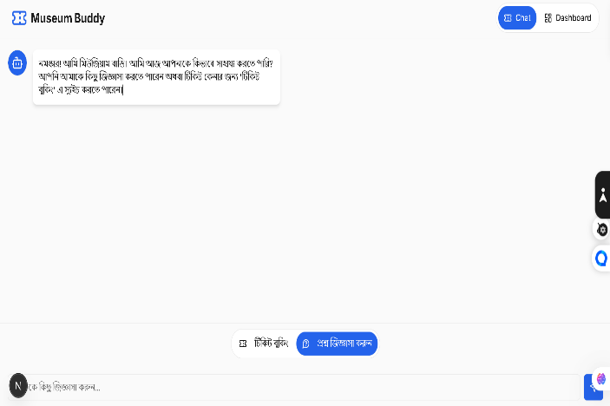

Figure 1.1. Example of the multilingual FAQ mode.

Scenario A:
FAQs in a Local Language: A person from West Bengal accessed the website and from the home page chose the option ‘বাংলা’ (Bengali). The whole chat window appeared in Bengali. The user, not knowing the store hours, wrote “কখন খ োলা?” (When are you open?). The question is directed to the Genkit flow with lang: 'bn'. The AI, by employing the Bengali-specific context data, identifies the question and formulates a very natural Bengali response enumerating the time slots available (e.g., “সকাল ১০:০০, দপু ুর ১২:০০...”), thus giving an instant and very useful reply (Fig. ​‍​‌‍​‍‌​‍​‌‍​‍‌1)

Scenario B:
Guided Ticket Booking: A user needed a ticket and so, decided to click on the 'Ticket Booking' button, which in turn started the state machine.
1) Buttons for states appeared on the chat screen. The user selected 'Telangana'
2) buttons for museums in Telangana appeared on the chat. The user selected 'Salar Jung Museum, Hyderabad'
3) The user chose the 'General Admission' experience.
4) The entire <Calendar /> component is rendered. The user chooses a date.
5) The user selects “2:00 PM” by clicking on the available
time slot buttons
6) An interactive quantity selector is shown on the screen.
The user chooses 2 Adult, 1 Child.
7) A Ticket Summary component
with the entire order and cost is displayed. The user clicks 'Proceed to Payment'.
8) A (simulated) Payment Dialog modal comes into the user's view. The user "pays".
9) The chat shows a confirmation in the end, and the
Digital Ticket component along with QR code and download options is rendered​‍​‌‍​‍‌​(Fig. 2).
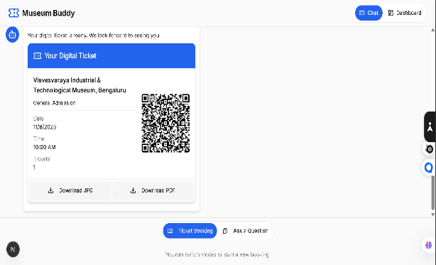
Figure 1.2. Final digital ticket generated in-browser.

Scenario C:
Admin View: A museum administrator logs in and navigates to the /dashboard page. They are presented with a real-time analytics dashboard (Fig. 3). They can immediately see the “Tickets Sold Per Day” bar chart and identify that Saturday is the peak day, and the “Most Popular Shows” table clearly indicates that the “Special Exhibition: 'Cosmos'” is driving the most sales. This demonstrates the system’s ability to provide actionable operational insights.

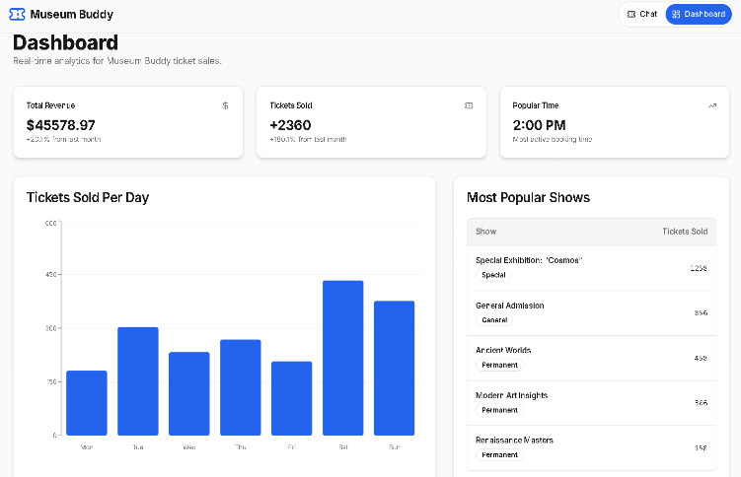

Figure 1.3. Real-time analytics dashboard.
1.5. Summary/Conclusion
“Museum​‍​‌‍​‍‌​‍​‌‍​‍‌ Buddy” is a prime example of how the careful consideration of generative AI combined with a contemporary web stack can result in a museum ticketing system that is dramatically more user-friendly, accessible, and multilingual. The system is designed to provide a seamless user experience that is both powerful and easy to navigate, thus effectively removing the usual obstacles to cultural access, by means of a hybrid solution that fuses the capabilities of Genkit and Gemini for natural language understanding with the
react state machine control of a structure.
Such a dual strategy makes the best use of the advantages of each model: the inherently flexible conversational AI to handle user queries and the state-driven flow to carry out transactions in a more reliable and consistent manner. The undertaking serves as a proof-of-concept that such a system can be designed and implemented, furthermore, it offers a substantially more human-centric way of interacting with technology as opposed to the impersonal, form-based interfaces which are prevalent ​‍​‌‍​‍‌​‍​‌‍​‍‌nowadays.
References:
[1] Vercel, “Next.js: The React Framework for the Web, “https://nextjs.org/, Accessed: Nov 5, 2025.
[2] M. Zuckerberg, J. Walke, et al., “React: A JavaScript library for building user interfaces,” https://react.dev/, Accessed: Nov 5, 2025.
[3] Google, “Genkit: An open source framework for building
generative AI applications,” https://firebase.google.com/docs/genkit, Accessed: Nov 5, 2025.
[4] Google AI, “Gemini: A family of generative AI models,” https://deepmind.google/technologies/gemini/, Accessed: Nov 5,2025.
[5] A. Wathan, et al., “Tailwind CSS: A utility-first CSS framework, “https://tailwindcss.com/, Accessed: Nov 5, 2025.
[6] shadcn, “shadcn/ui: Beautifully designed components builtwith Radix UI and Tailwind CSS,” https://ui.shadcn.com/, Accessed: Nov 5, 2025

