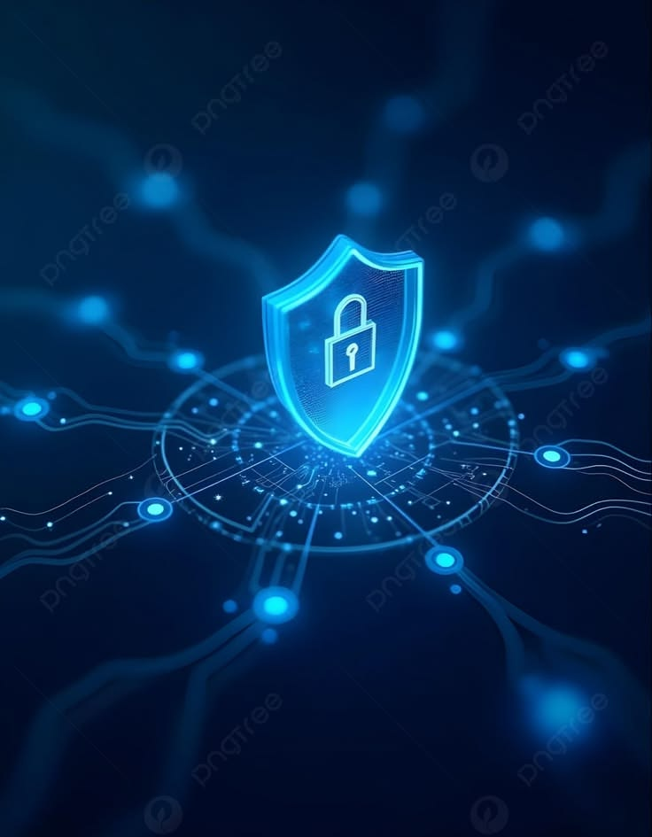

Jawadil, Alsamhel J. | BSIT-4A | IAS2

ISO 27001 Controls Implementation – Login System
This document explains how each required ISO 27001 security control is implemented in the authentication system to ensure secure, reliable, and compliant user login operations.

1. Unique user accounts
Each user is assigned a unique identifier (user_id) and username to prevent account duplication and ensure individual accountability.

2. Strong password requirements
Passwords must meet complexity rules (minimum length, mix of characters). This is enforced using validation patterns before account creation or update.

3. Secure password hashing
Passwords are never stored in plain text. They are hashed using secure algorithms such as bcrypt / Argon2 / PBKDF2 before being saved in the database.

4. Multi-Factor Authentication (MFA)
Users are required to verify identity using an additional factor such as OTP (email/SMS/app) during login.

5. HTTPS/TLS encryption
All communication between client and server is secured using HTTPS/TLS, ensuring data encryption in transit.

6. Failed login attempt limits
Accounts are temporarily locked or delayed after multiple failed login attempts to prevent brute-force attacks.

7. Login audit logging
All login attempts (successful or failed) are recorded in audit logs for monitoring and forensic analysis.

8. Generic error messages
Error messages like “Invalid username or password” are used instead of specifying which field is incorrect to prevent information leakage.

9. Session timeout
User sessions automatically expire after a period of inactivity to prevent unauthorized access from idle sessions.

10. Secure session identifiers
Sessions are managed using secure, random session IDs or tokens stored safely in cookies.

11. Session hijacking protection
Cookies are protected using HttpOnly, Secure, and SameSite flags, and CSRF tokens are used to prevent session theft.

12. Password change requirement
Users are required to update passwords periodically or after suspicious activity detection.

13. Secure password recovery
Password reset uses secure token-based recovery links sent via verified email or phone.

14. Least privilege access
Users are assigned roles (e.g., admin, user) with only the minimum permissions required for their function.

15. Audit log protection
Audit logs are protected from unauthorized access and modification using restricted permissions.

16. SQL Injection protection
Database queries use prepared statements or parameterized queries to prevent SQL injection attacks.

17. XSS protection
User inputs are sanitized and escaped to prevent Cross-Site Scripting (XSS) attacks.

18. CSRF protection
CSRF tokens are implemented to ensure that requests come from authenticated and trusted sources.

19. Brute-force attack protection
Rate limiting is applied to login endpoints to restrict repeated login attempts in a short time.

20. Authentication data security
Sensitive authentication data is encrypted and hashed to ensure confidentiality and integrity.

21. Suspicious login notifications
Users receive alerts (email/SMS/app notifications) when login activity is detected from new devices or locations.

22. Security testing
Regular penetration testing and vulnerability scanning are conducted to identify and fix security weaknesses.

23. Access control policies
Strict authentication and authorization policies define who can access specific resources and actions within the system.

Summary
The system integrates ISO 27001 controls across authentication, session management, encryption, access control, and monitoring. These implementations collectively ensure confidentiality, integrity, and availability of user accounts and system data.

