# Backend Internship Assignment – Solution Report

## Candidate Name: Spandan Bhattarai Date: 2025-07-25 Role: Backend Intern Tech Stack: Python (Flask), SQLite, Postman

# Assignment Overview

The test consisted of two tasks:

1. Design and implement RESTful blog APIs with CRUD capabilities.
2. Write a function to find a pair in an array that sums to a given target.

# Task 1: Blog API Development

### Each blog should contain:

### title (string)

### description (string)

### category (string; one per blog)

## API Endpoints Implemented

|  |  |  |
| --- | --- | --- |
| Endpoint | Method | Description |
| /blogs | GET | Get all blogs |
| /blogs/<id> | GET | Get a blog by its ID |
| /blogs | POST | Create a new blog |
| /blogs/<id> | PUT | Update an existing blog |

## Code Snippet: Flask App

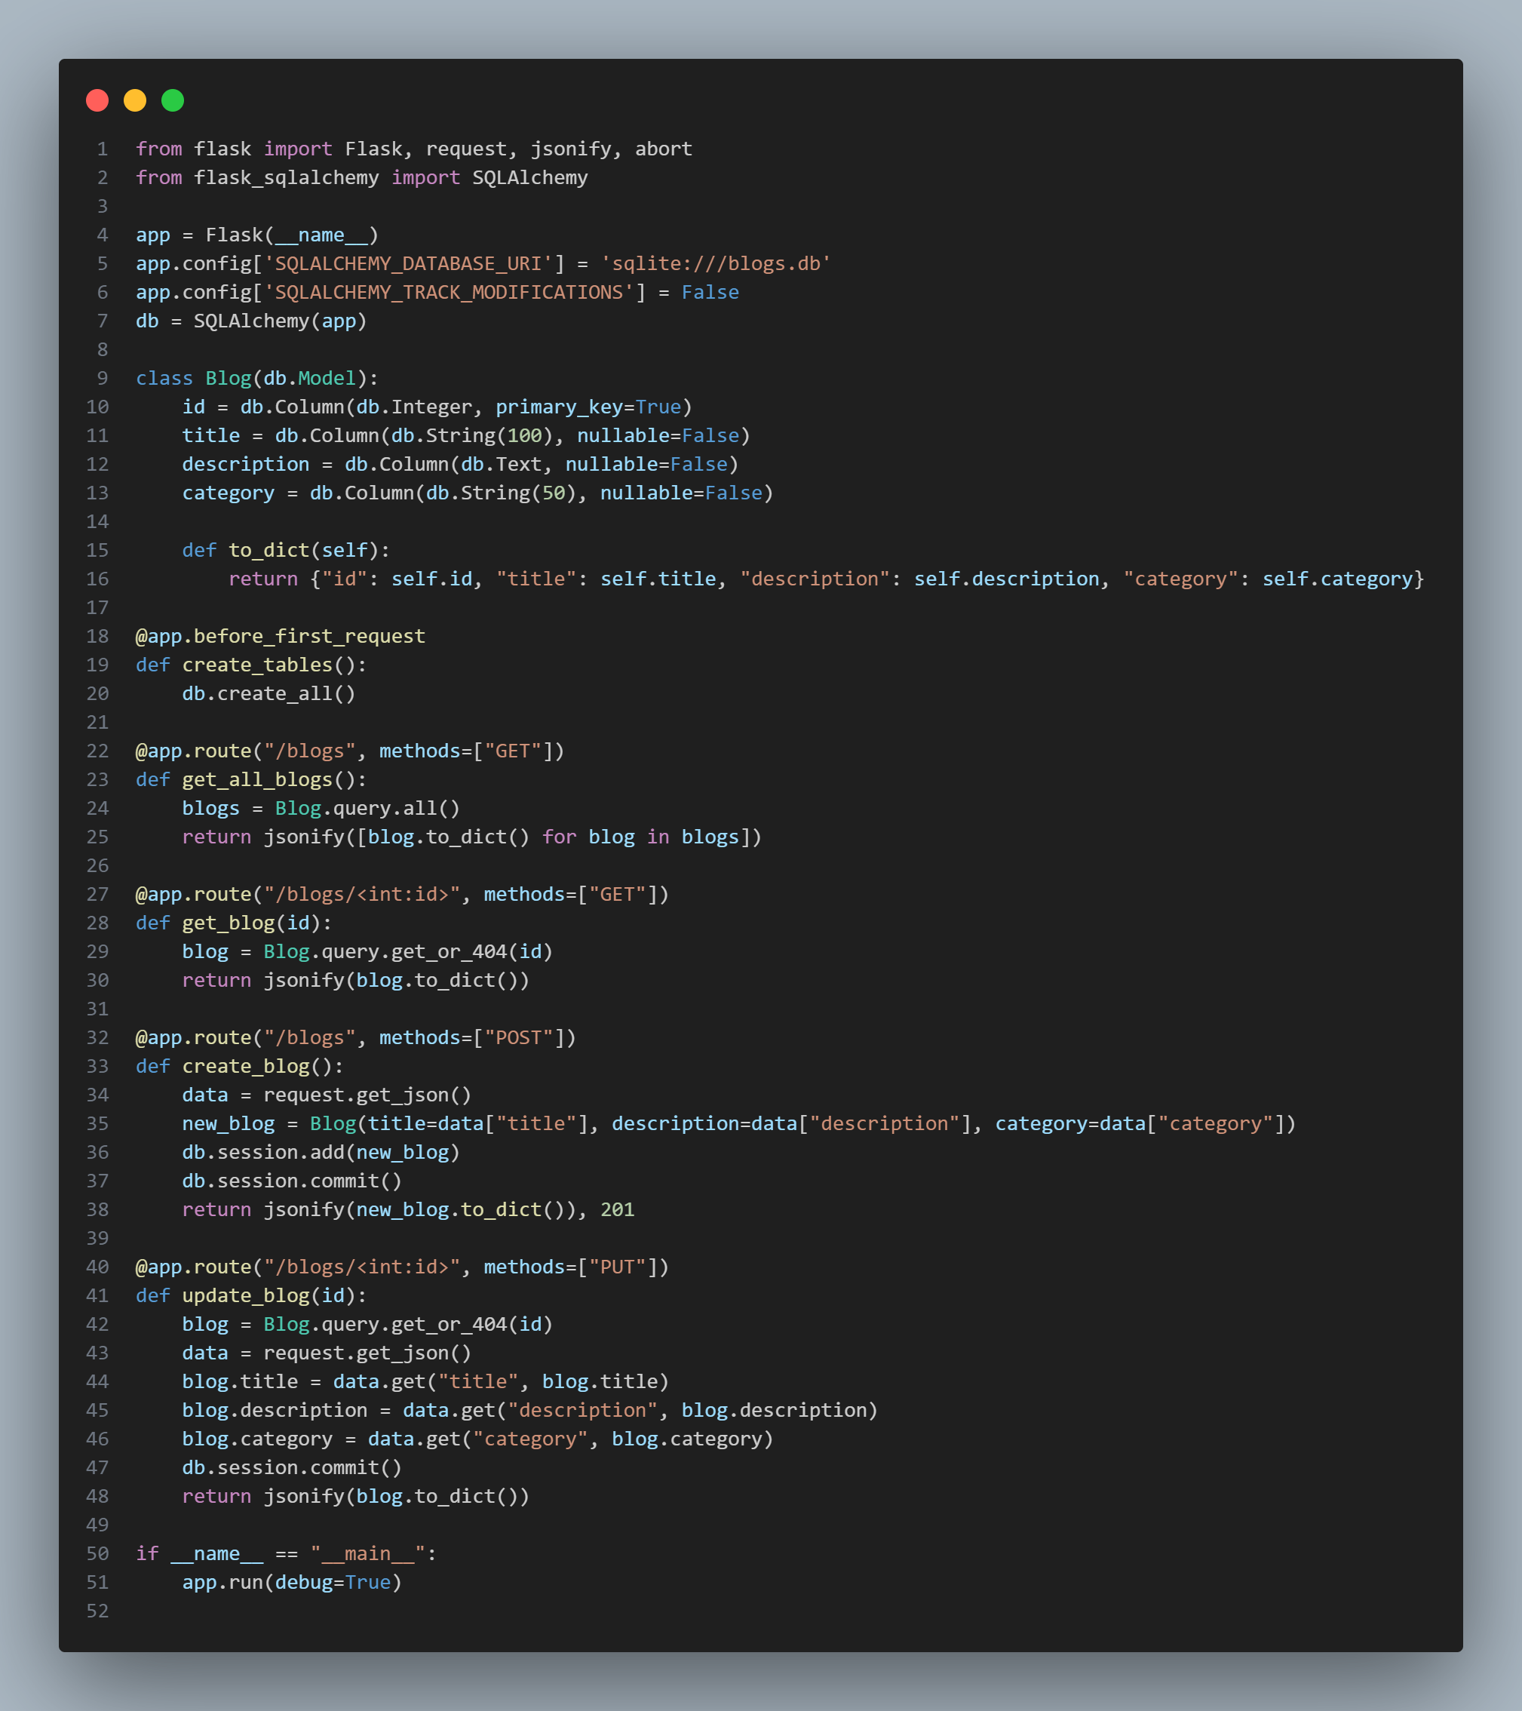

Example POST Request Body (Postman)

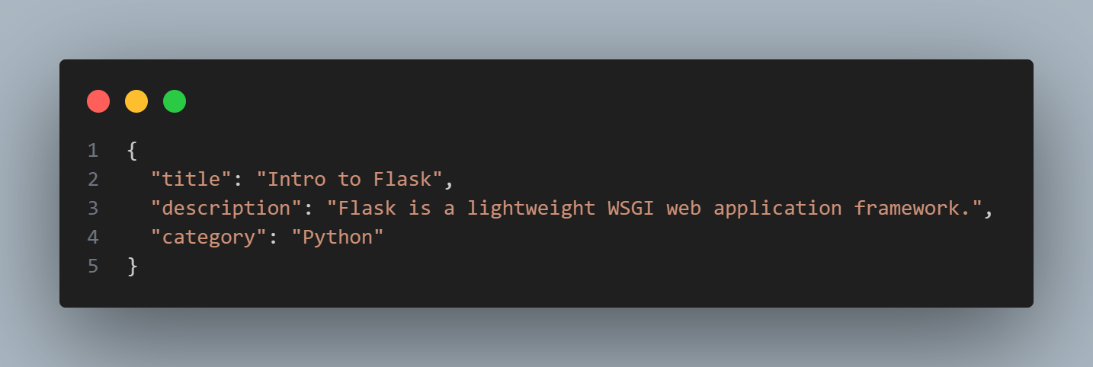

# Task 2: Find Pair with Given Sum

## Problem Statement

Given an unsorted list of integers and a target sum, find whether a pair exists that adds up to the target.

### Optimized Approach

### Time complexity: O(n) using a hash set().

### Avoids nested loops by storing seen values and checking complements.

## Code Implementation

### Example Inputs and Outputs

