**Practical No. 1. Write a program to demonstrate the use of AWT Components.**

**Exercise 1: Develop a program using Label to display message “Welcome to Java”.**

**Program:**

import java.awt.*;

import java.applet.*;

public class pract1_ex1 extends Applet

{ public void init()

{

Label l = new Label("Welcome to Java."); add(l);

} }

**Output:**

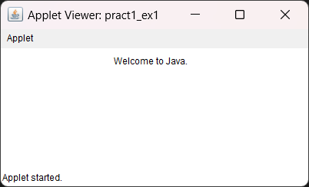

**2. Develop a program to select multiple languages known as user (Marathi, Hindi, English, Sanskrit).**

**Program:**

import java.awt.*;

import java.applet.*;

/*

<applet code=pract1_ex2.class width=400 height=400>

</applet>

*/

public class pract1_ex2 extends Applet

{public void init()

    {Choice c =  new Choice();

    c.add("Marathi");

    c.add("Hindi");

    c.add("English");

    c.add("Sanskrit");

    add(c);

    }  }

**Output:**

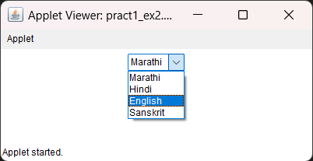

**3. Write a program to create three Buttons with Caption OK, RESET, and CANCEL.**

**Program:**

import java.applet.*;

import java.awt.*;

/*<applet code=pract1_ex3.class width=300 height=200>

</applet>

*/

public class pract1_ex3 extends Applet

{public void init()

   {Button b1,b2,b3;

    b1 = new Button("OK");

    add(b1);

    b2 = new Button("RESET");

    add(b2);

    b3 = new Button("CANCEL");

    add(b3);}}

**Output:**

