SUPERSET ID: 8016983
NAME: SPANDAN POLLEY

WEEK-1 ADVANCED SQL HANDSON
(Stored Procedure)

Exercise 1: Create a Stored Procedure
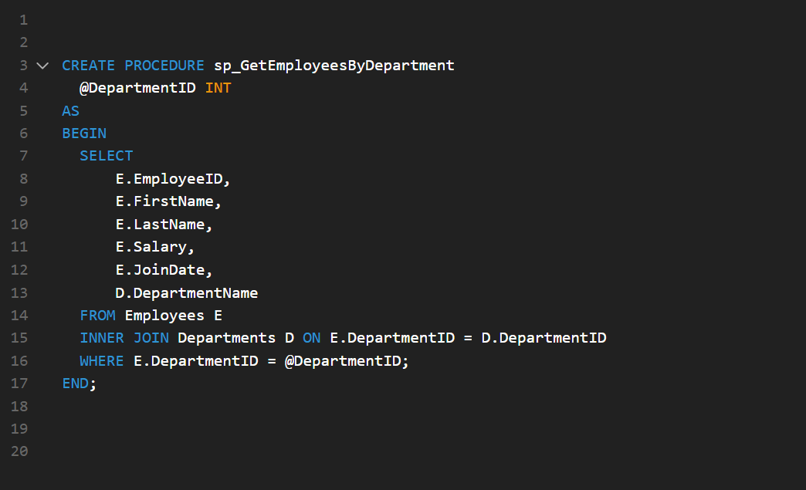

Exercise 5: Return Data from a stored Procedure:
