SuperSet Id-8016983
Name:SPANDAN POLLEY

WEEK1
DATA STRUCTURES AND ALGORITHM

Exercise 2: E-commerce Platform Search Function

Explanation of Big O Notation
Big O notation is a mathematical notation used to describe the performance or efficiency of an algorithm as the size of the input data increases. It represents the growth rate of an algorithm's time or space requirements and helps compare different algorithms independent of hardware or implementation details.
Best Case Scenario (Minimum Time Required)
Search Operation:
The best case occurs when the target element is found immediately, usually at the first position being checked. In this situation, the search requires the fewest possible comparisons and executes in the shortest amount of time.
Average Case Scenario (Typical Performance)
Search Operation:
The average case represents the expected performance of the search algorithm over all possible input arrangements. Typically, the target element is found after examining a moderate portion of the dataset, resulting in an average number of comparisons.
Worst Case Scenario (Maximum Time Required)
Search Operation:
The worst case occurs when the target element is located at the last position or is not present in the dataset at all. In this case, the algorithm must examine every element, leading to the maximum number of comparisons and the highest execution time.

CODE:
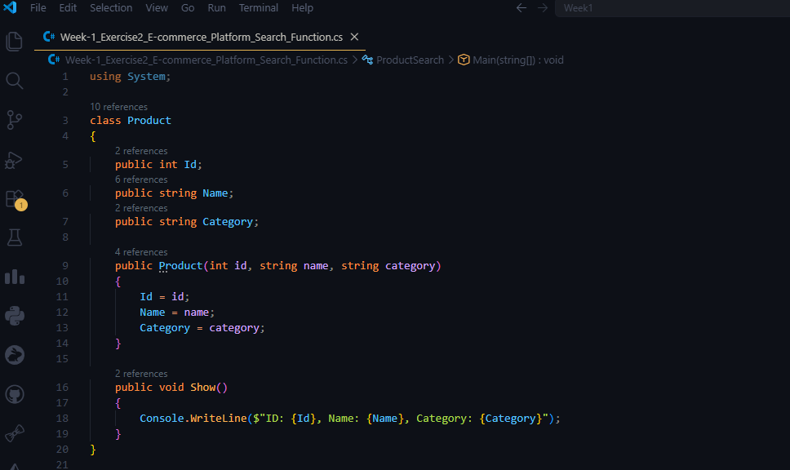
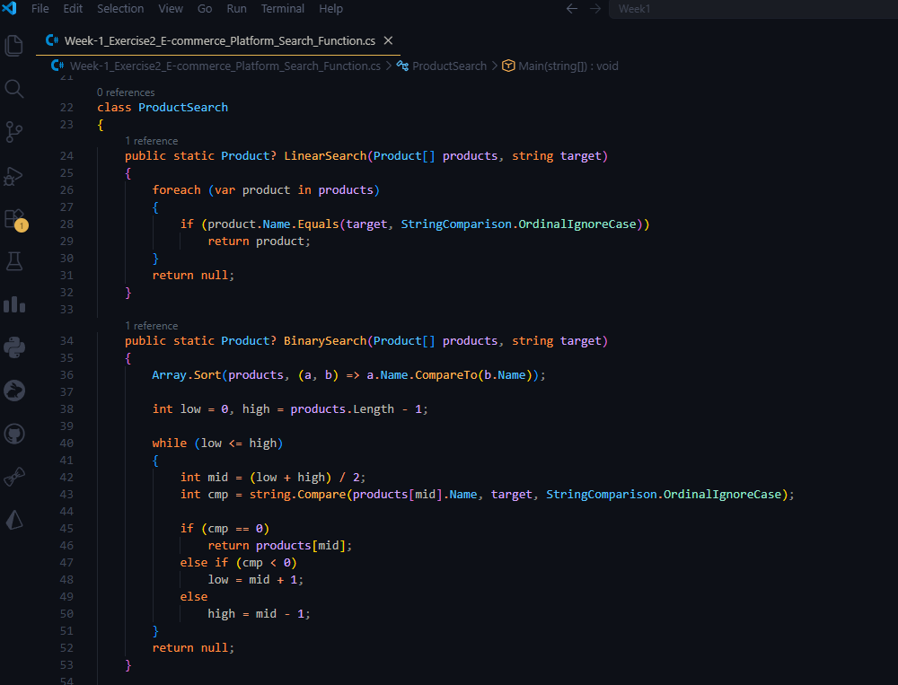
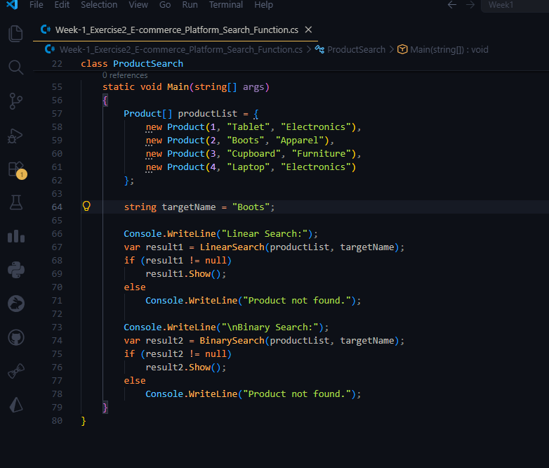
Output:
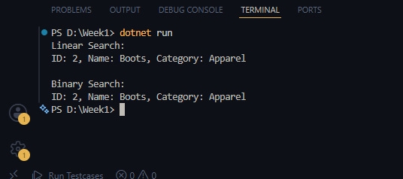
Analysis:
Linear Search
- Time Complexity: O(n)
- Searches elements one by one until the target is found.
- Does not require the data to be sorted.
- Best suited for small datasets or when maintaining sorted order is impractical.
Binary Search
- Time Complexity: O(log n)
- Repeatedly divides the search space into two halves.
- Requires the data to be sorted before searching.
- Highly efficient for large datasets due to its logarithmic time complexity.

Exercise 7: Financial Forecasting
Recursion is a programming technique where a function solves a problem by calling itself to break the problem into smaller, more manageable sub-problems. By dividing the task into simpler versions of itself, recursion often leads to cleaner and more concise code, particularly for tasks involving repetitive operations or nested structures.

CODE:
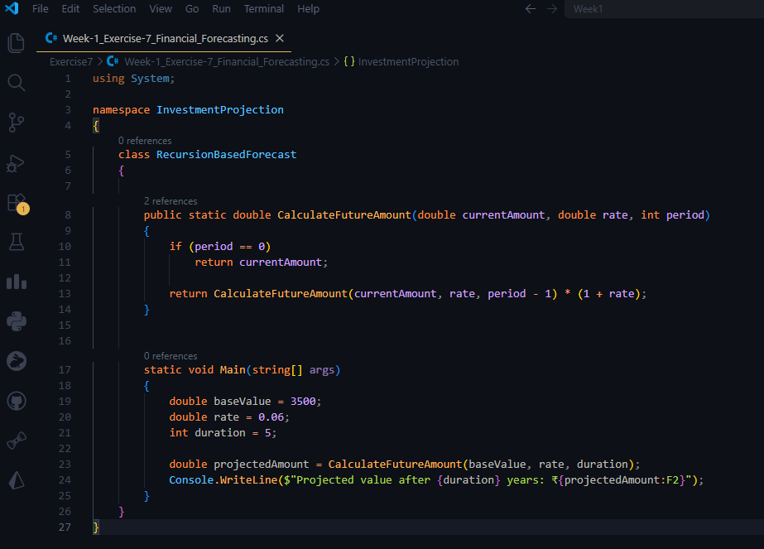

Output:

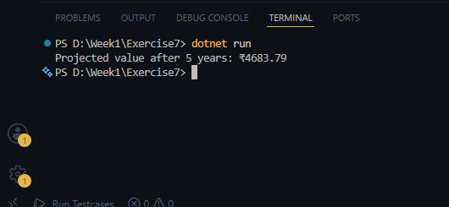

-> The algorithm has a linear time complexity of O(n), as it makes one recursive call for each year in the calculation.
-> Optimization Strategy:
• Recursion creates additional function call overhead and uses extra stack memory for each recursive call.
• We can enhance performance by:
- Rewriting the solution using an iterative (loop-based) approach, which eliminates recursive call overhead and reduces space complexity.

- Using the compound interest formula directly:
Future Value = Current Amount × (1 + Rate) ^ Period
This computes the result efficiently without recursion.

