SUPERSET-ID: 8016983
NAME: SPANDAN POLLEY
WEEK- 1 Moq Hands On

TASK-1:
- IMailSender.cs
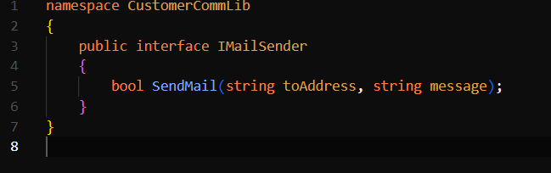

- MailSender.cs
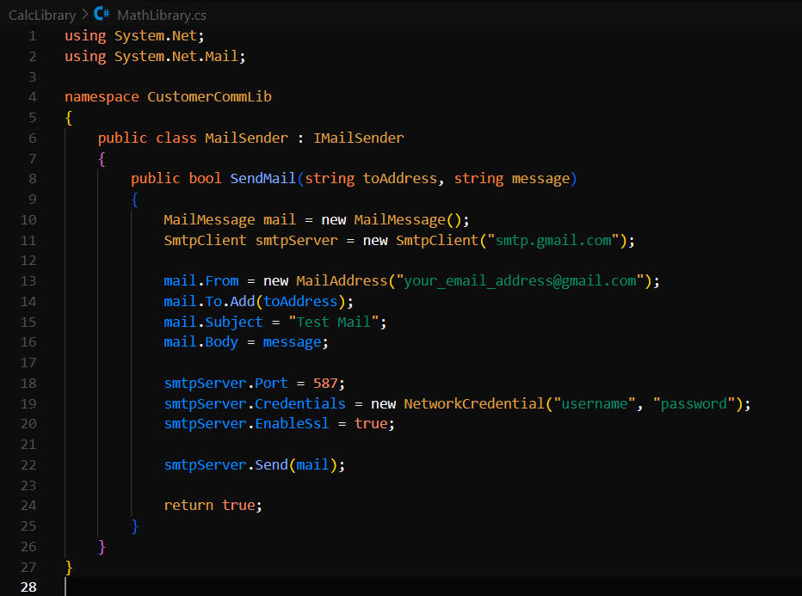
- CustomerCom.cs
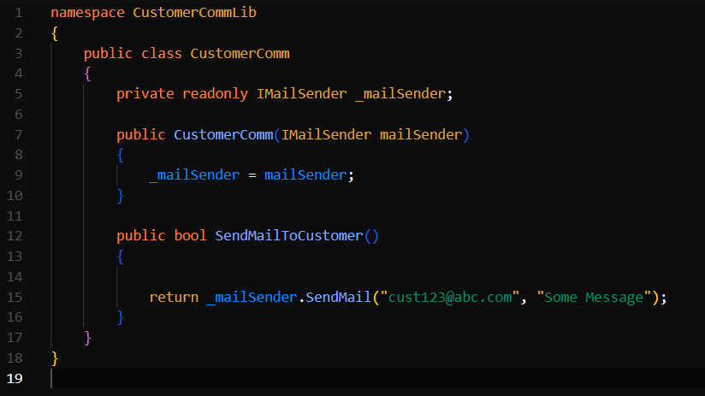

TASK- 2:
- CustomerCommTests.cs
