Superset-Id: 8016983
Name: SPANDAN POLLEY

WEEK- 2 ENTITY FRAMEWORK CORE 8.0 HANDSON

Lab 1: Understanding ORM with a Retail Inventory System

Step-1) What is ORM ? Explain how ORM maps C# classes to database tables? What are the benefits of ORM?
Answer:
ORM is a development technique that enables coders to work with databases using language-specific objects instead of writing direct SQL queries.
-Each class in C# is equivalent to a database table.
-The attributes (properties) of the class represent the table's fields.
-A class object symbolizes a single record in the database.

-Productivity: Minimizes repetitive SQL code.
-Maintainability: Code-first methodology makes updates simpler.
- Abstraction: LINQ queries replace manual SQL writing.

Step-2) Difference between EF Core and EF Framework
Answer:
Feature: Platform:-
EF Core: Compatible with multiple platforms (.NET Core)
EF Framework: Limited to Windows (.NET Framework)
Feature:Speed:-
EF Core: Leaner and offers better speed
EF Framework: Stable but bulkier
Feature:Capabilities:-
EF Core: Offers modern features like async, LINQ, compiled models
EF Framework: Lacks several updated functionalities
Feature:Best Fit For:-
EF Core: New apps, especially for cloud or cross-platform
EF Framework: Old systems, typically for enterprises

Step-3) What are the new features of EF Core 8.0?
Answer:
JSON Support: Allows use of JSON fields in SQL Server.
Precompiled Models: Helps boost app launch time and runtime performance.
Interceptors: Lets you tap into DB actions for custom code.
Mass Updates: Enhanced handling of bulk operations like insert/update/delete.

Step-4) Create a .NET Console App
Answer:

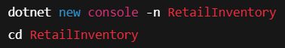

Step-5) Install EF Core Packages:

Answers:

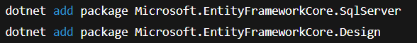

Lab 2: Setting Up the Database Context for a Retail Store

Step-1) Create Models:

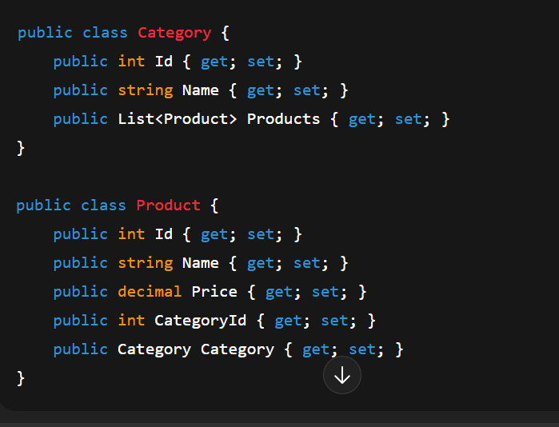

Step- 2. Create AppDbContext:

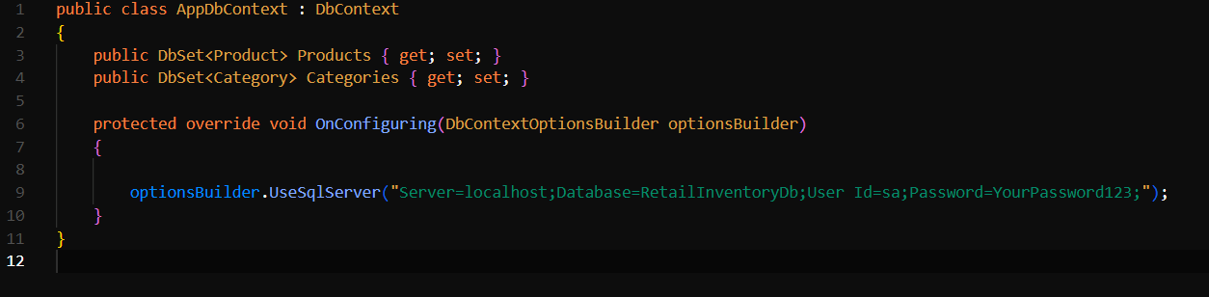

Step-3. Add Connection String in appsettings.json (optional for ASP.NET Core).

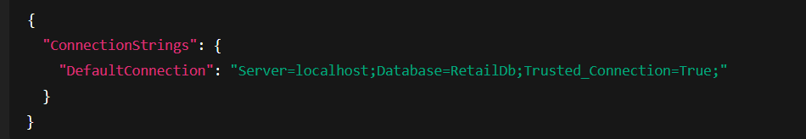

Lab 3: Using EF Core CLI to Create and Apply Migrations

Step-1 Install EF Core CLI



Step-2:Create Initial Migration

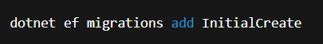

Step-3: Apply Migration to Create Database:

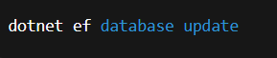

Lab 4: Inserting Initial Data into the Database

Step-1. Insert Data in Program.cs:

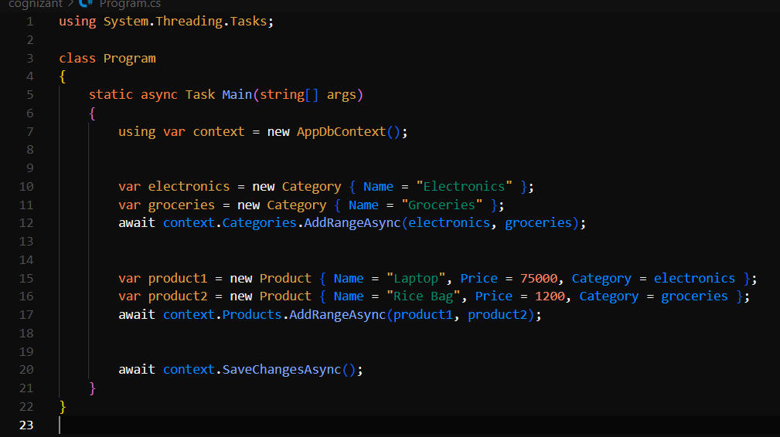

Step- 2. Run the App:

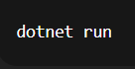

Step-3: Verify in SQL Server:

Products Table:

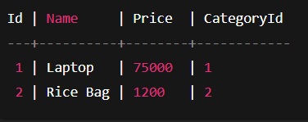

Categories Table:

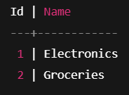

Lab 5: Retrieving Data from the Database

Step-1. Retrieve All Products:

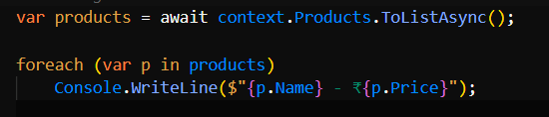

Step-2: Find by ID:

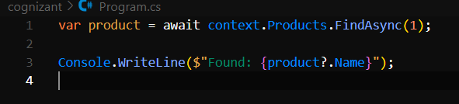

Step-3: FirstOrDefault with Condition:

