Superset-Id: 8016983
Name: SPANDAN POLLEY

WEEK-3 WEB API HANDSON
- WebApi_Handson.docx

1) Explain the concept of RESTful web service, Web API & Microservice
Answer:
- RESTful Web Service is an architectural style based on stateless communication and resource representation.
- Web API allows communication between client and server over HTTP using standard verbs (GET, POST, etc.).
- Microservice is a small, independently deployable service that performs a specific business function.

2) What are the Features of REST Architecture?
Answer:
-Representational State Transfer (REST): Resource-based design
-Stateless: Each request from client to server must contain all information
-Messages: Generally exchanged via HTTP in JSON or XML

3) Concept of Microservice
Answer:
Microservice architecture is a design approach where a large application is built as a suite of small, independent services, each focused on a specific business capability. These services communicate with each other via APIs, usually over HTTP (REST) or messaging queues.

Key Concepts of Microservices:
- Independent Deployment: Each microservice can be deployed and updated independently without affecting others.
-Single Responsibility: Each service is designed to perform one business function (e.g., user service, payment service).
-Technology Agnostic: Different microservices can be developed using different programming languages and frameworks.
-Decentralized Data Management: Each microservice manages its own database (no shared schema).
-Lightweight Communication: Services typically use REST APIs or messaging (RabbitMQ, Kafka) to interact.
-Scalability: Individual services can be scaled independently based on demand.
-Resilience: Failure in one service does not necessarily bring down the whole system.
- Difference between WebService & WebAPI, Not restricted to send XML as response
Answer:
 | Aspect | WebService (SOAP-based) |  |  | WebAPI (RESTful)
 | Response Format | Restricted to XML only |  |  | Not restricted — supports JSON, XML, plain text, HTML, etc.
 | Flexibility | Fixed to SOAP envelope using XML |  |  | Flexible — returns data based on client’s Accept header
 | Modern Usage | Less preferred for modern web or mobile apps (which use JSON) |  |  | Preferred for modern applications due to JSON-first approach
Serialization |  |  | Requires strict XML schema (XSD/WSDL) | Easily serializes/deserializes POCOs to/from JSON/XML

5)Explain what is HttpRequest & HttpResponse
Answer:
-HttpRequest: A message sent by the client to request data or perform an action (includes headers, URL, method, and body).
-HttpResponse: The server's reply to the request, including a status code, headers, and possibly a response body (like JSON or HTML).

6) List the types of Action Verbs
Answer:
HTTP Verb | Purpose | Typical Use Case
HttpGet | Retrieve data from the server | Fetch list of products, user profile, etc.
HttpPost | Send new data to the server | Create a new record (e.g., new order)
HttpPut | Update existing data | Modify an existing item entirely
HttpDelete | Delete a specific resource | Remove a user, delete an item from cart

7) List the types of HttpStatusCodes used in WebAPI
Status Code | Name | Meaning
200 | OK | The request was successful.
400 | BadRequest | The request is malformed or contains invalid data.
401 | Unauthorized | The request lacks valid authentication credentials.
500 | InternalServerError | An unexpected error occurred on the server.
Answer:
9)Demonstrate creation of a simple WebAPI - With Read, Write actions
Answer:
Steps:
1) Create a New Project:
In Visual Studio or CLI:
dotnet new webapi -n SampleApi
2)Create a Model:
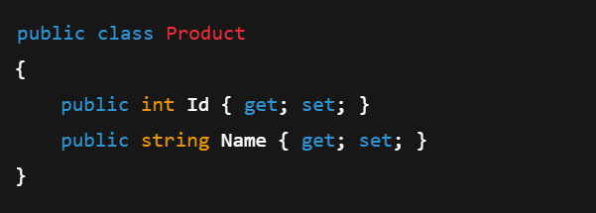
Create a Controller
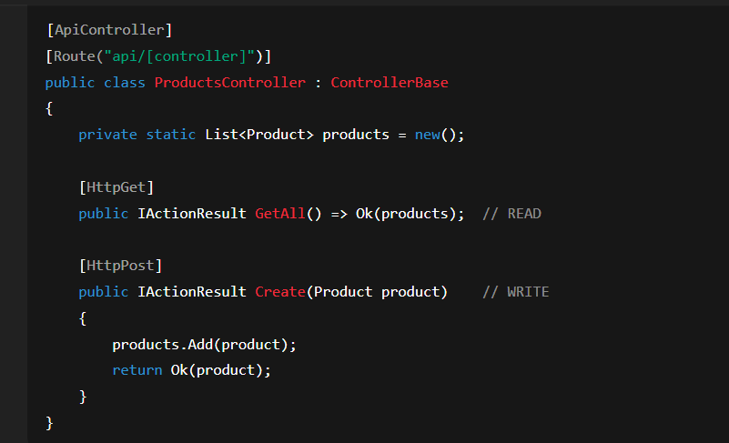
- Run and Test using Swagger UI or Postman.
Component | Description
Controller | Inherits from ControllerBase or ApiController
Route | Defined using [Route("api/[controller]")] attribute
Action Methods | Decorated with action verbs like [HttpGet], [HttpPost], etc.
Model | Class representing data (e.g., Product, User)

10) Explain the types of Configuration files of WebAPI
Answer:
1. Startup.cs (for .NET Core): Acts as the entry point for app configuration.
Contains two main methods:

- ConfigureServices(IServiceCollection services) – Used for dependency injection (DI).

- Configure(IApplicationBuilder app, ...) – Used to set up middleware (like routing, CORS, etc.).
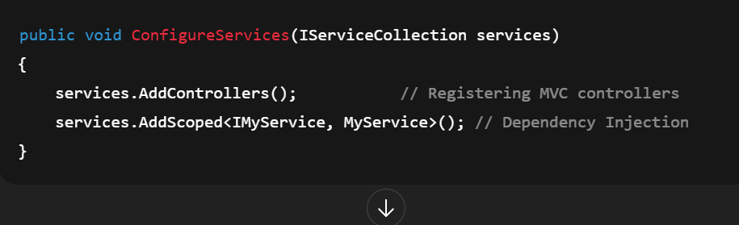
2)appSettings.json:
-Used to store application settings, like connection strings, keys, and custom configure values.

-Replaces traditional web.config in .NET Core.
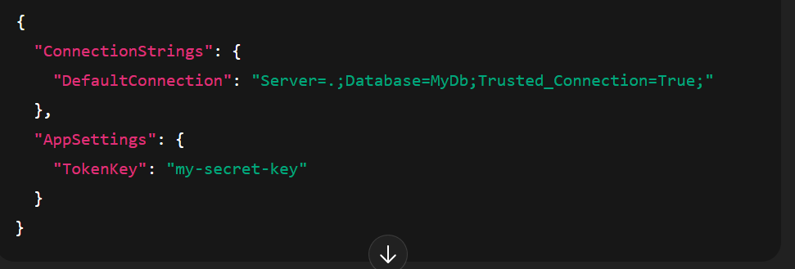

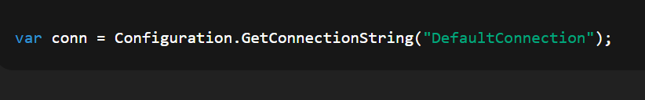
3. launchSettings.json:

- Used only in development to configure how the app starts (e.g., ports, environment).

- Contains profiles for IIS Express, Kestrel, etc.
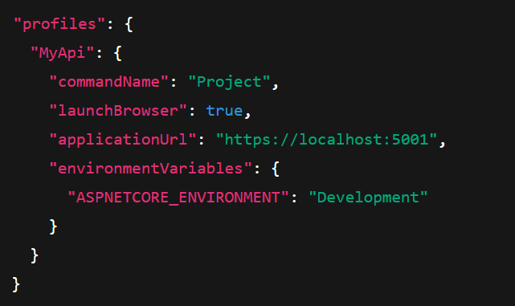4. Route.config (in .NET Framework 4.5)

-A separate configure file for defining custom routing rules in Web Forms or legacy APIs.
-Defines how URLs map to handlers/controllers.

5) WebAPI.config / Web.config (in .NET Framework 4.5)

-Contains all major configurations:
-Routing (in WebApiConfig.cs)
-Dependency injection
-Handler and filter registrations
- Connection strings and app settings (within web.config XML)

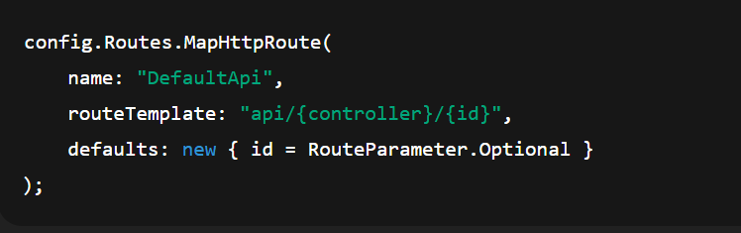

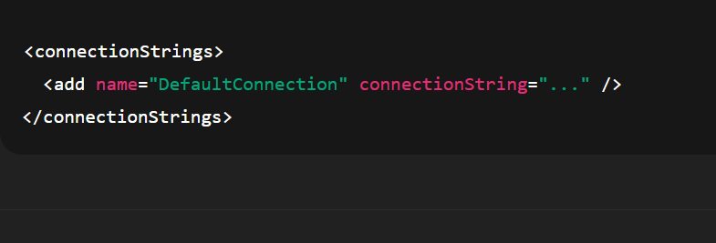

1)First Web Api using .Net core

Steps:
1. Create project in Visual Studio using Web API template
2. Auto-generated `WeatherForecastController` with GET method
3. Run project and open Swagger
Code:
using Microsoft.AspNetCore.Mvc;
namespace WebApiDemo.Controllers

[ApiController]
[Route("api/[controller]")]
public class ValuesController : ControllerBase
{
[HttpGet]
public ActionResult<IEnumerable<string>> Get()
{
return new string[] { "value1", "value2" };
}

[HttpGet("{id}")]
public ActionResult<string> Get(int id)
{
return "value";
}

[HttpPost]
public void Post([FromBody] string value)
{
}

[HttpPut("{id}")]
public void Put(int id, [FromBody] string value)
{
}
[HttpDelete("{id}")]
public void Delete(int id)
{
}
}
}
Output:
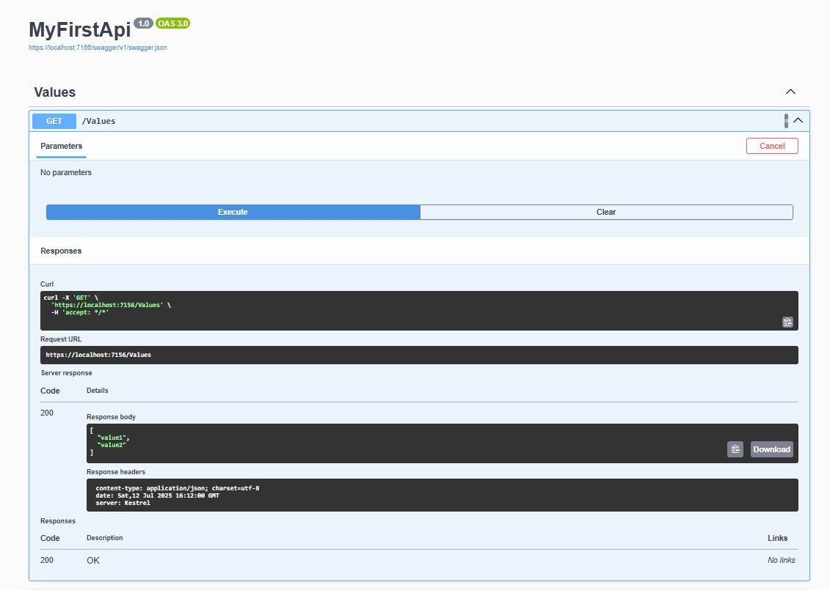
2.WebApi_Handson.docx

2)Swagger Integration & Postman
Program.cs
using Microsoft.OpenApi.Models;
var builder = WebApplication.CreateBuilder(args);
// Add services
builder.Services.AddControllers();
builder.Services.AddEndpointsApiExplorer();
builder.Services.AddCors(options =>
{
options.AddPolicy("AllowAll", policy =>
{
policy.AllowAnyOrigin()
.AllowAnyHeader()
.AllowAnyMethod();
});
});

builder.Services.AddSwaggerGen(c =>
{
c.SwaggerDoc("v1", new OpenApiInfo
{
Title = "Swagger Demo",
Version = "v1",
Description = "Basic Web API with Swagger",
Contact = new OpenApiContact
{
Name = "Your Name",
Email = "your@email.com",
Url = new Uri("https://example.com")
},
License = new OpenApiLicense
{
Name = "MIT",
Url = new Uri("https://example.com/license")
}
});
});

var app = builder.Build();

// Configure middleware
if (app.Environment.IsDevelopment())
{
app.UseSwagger();
app.UseSwaggerUI(c =>
{
c.SwaggerEndpoint("/swagger/v1/swagger.json", "Swagger Demo");

});
}

app.UseHttpsRedirection();
app.UseAuthorization();
app.MapControllers();
app.Run();
ValuesController.cs:
using Microsoft.AspNetCore.Mvc;
namespace WebApiDemo.Controllers
{
[ApiController]
[Route("api/[controller]")]
public class ValuesController : ControllerBase
{
[HttpGet]
public ActionResult<IEnumerable<string>> Get()
{
return new string[] { "Aryan", "Zoie" };
}

[HttpGet("{id}")]
public ActionResult<string> Get(int id)
{
return "value";
}

[HttpPost]
public void Post([FromBody] string value)
{
}

[HttpPut("{id}")]
public void Put(int id, [FromBody] string value)
{
}

[HttpDelete("{id}")]
public void Delete(int id)
{
}
}
}
launchSettings.json:
{
"$schema": "http://json.schemastore.org/launchsettings.json",
"iisSettings": {
"windowsAuthentication": false,
"anonymousAuthentication": true,
"iisExpress": {
"applicationUrl": "http://localhost:10522",
"sslPort": 44388
}
},
"profiles": {
"http": {
"commandName": "Project",
"dotnetRunMessages": true,
"launchBrowser": true,
"launchUrl": "swagger",
"applicationUrl": "http://localhost:5167",
"environmentVariables": {
"ASPNETCORE_ENVIRONMENT": "Development"
}
},
"https": {
"commandName": "Project",
"dotnetRunMessages": true,
"launchBrowser": true,
"launchUrl": "swagger",
"applicationUrl": "https://localhost:7145;http://localhost:5167",
"environmentVariables": {
"ASPNETCORE_ENVIRONMENT": "Development"
}
},
"IIS Express": {
"commandName": "IISExpress",
"launchBrowser": true,
"launchUrl": "swagger",
"environmentVariables": {
"ASPNETCORE_ENVIRONMENT": "Development"
}
}
}
}
Postman Output:
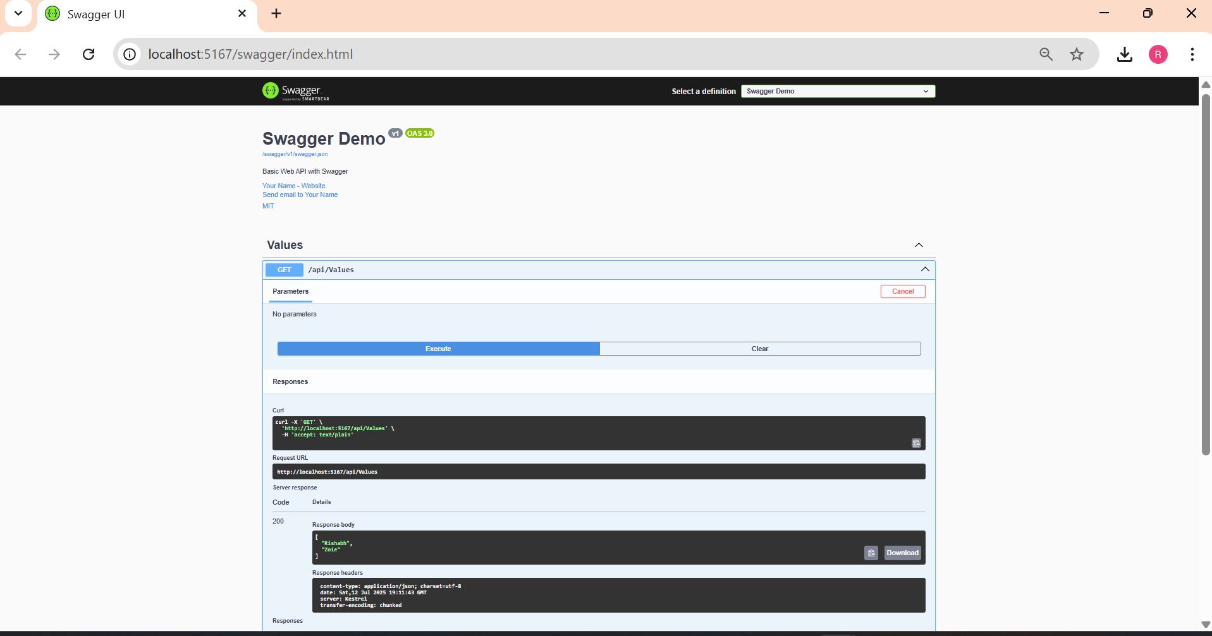
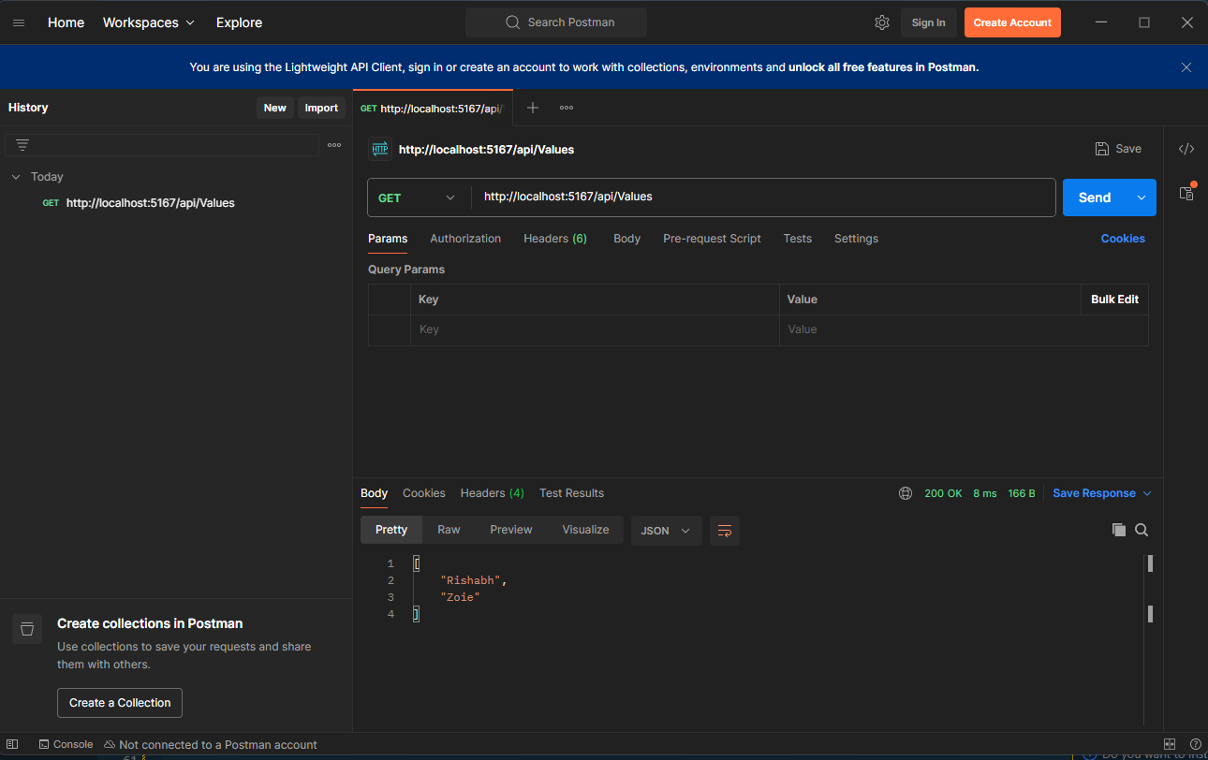
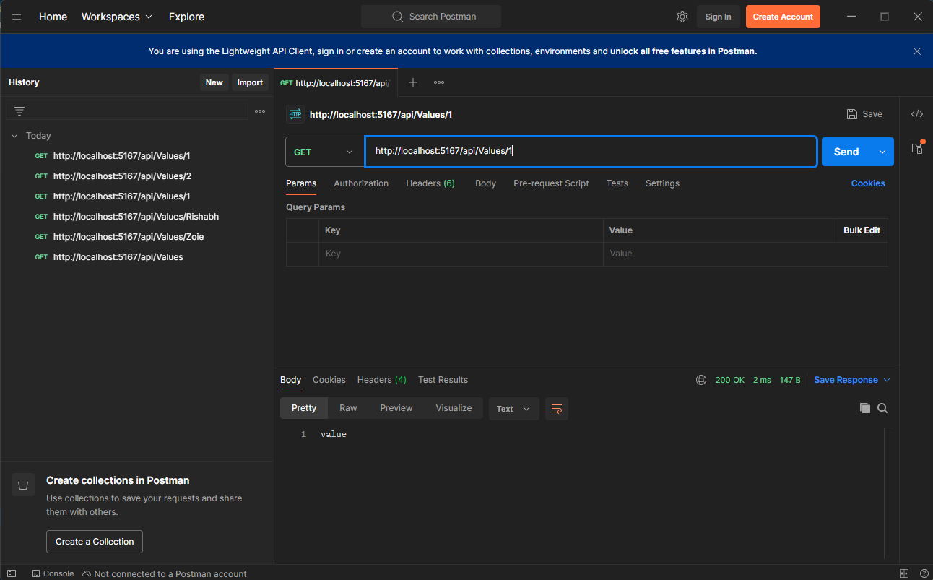
3.WebApi_Handson.docx

- Custom Models & Filters

EmployeeController.cs:
using Microsoft.AspNetCore.Mvc;
using WebApiDemo.Models;

namespace WebApiDemo.Controllers
{
[ApiController]
[Route("api/[controller]")]
public class EmployeeController : ControllerBase
{
private static List<Employee> _employees = GetStandardEmployeeList();

private static List<Employee> GetStandardEmployeeList()
{
return new List<Employee>
{
new Employee
{
Id = 1,
Name = "Alice",
Salary = 50000,
Permanent = true,
Department = new Department { Id = 1, Name = "HR" },
Skills = new List<Skill>
{
new Skill { Id = 1, Name = "Communication" },
new Skill { Id = 2, Name = "Recruitment" }
},
DateOfBirth = new DateTime(1990, 1, 1)
}
};
}

[HttpGet]
[ProducesResponseType(typeof(List<Employee>), 200)]
public ActionResult<List<Employee>> Get()
{
return Ok(_employees);
}

[HttpGet("standard")]
public ActionResult<List<Employee>> GetStandard()
{
return Ok(GetStandardEmployeeList());
}

[HttpPost]
public IActionResult Post([FromBody] Employee emp)
{
_employees.Add(emp);
return CreatedAtAction(nameof(Get), new { id = emp.Id }, emp);
}

[HttpPut("{id}")]
public IActionResult Put(int id, [FromBody] Employee emp)
{
var existing = _employees.FirstOrDefault(e => e.Id == id);
if (existing == null) return NotFound();
return NoContent();
}
}
}
Program.cs:
using Microsoft.OpenApi.Models;

var builder = WebApplication.CreateBuilder(args);

builder.Services.AddControllers(options =>
{
options.Filters.Add<CustomExceptionFilter>();
});

builder.Services.AddEndpointsApiExplorer();
builder.Services.AddCors(options =>
{
options.AddPolicy("AllowAll", policy =>
{
policy.AllowAnyOrigin()
.AllowAnyHeader()
.AllowAnyMethod();
});
});

builder.Services.AddSwaggerGen(c =>
{
c.SwaggerDoc("v1", new OpenApiInfo
{
Title = "Swagger Demo",
Version = "v1",
Description = "Basic Web API with Swagger",
Contact = new OpenApiContact
{
Name = "Your Name",
Email = "your@email.com",
Url = new Uri("https://example.com")
},
License = new OpenApiLicense
{
Name = "MIT",
Url = new Uri("https://example.com/license")
}
});
});
builder.Services.AddScoped<CustomAuthFilter>();

var app = builder.Build();

if (app.Environment.IsDevelopment())
{
app.UseSwagger();
app.UseSwaggerUI(c =>
{
c.SwaggerEndpoint("/swagger/v1/swagger.json", "Swagger Demo");
});
}

app.UseHttpsRedirection();
app.UseAuthorization();
app.MapControllers();
app.Run();
ValueController.cs:
using Microsoft.AspNetCore.Mvc;
namespace WebApiDemo.Controllers
{
[ApiController]
[Route("api/[controller]")]
public class ValuesController : ControllerBase
{
[HttpGet]
public ActionResult<IEnumerable<string>> Get()
{
return new string[] { "Rishabh", "Zoie" };
}

[HttpGet("{id}")]
public ActionResult<string> Get(int id)
{
return "value";
}

[HttpPost]
public void Post([FromBody] string value)
{
}

[HttpPut("{id}")]
public void Put(int id, [FromBody] string value)
{
}

[HttpDelete("{id}")]
public void Delete(int id)
{
}
[HttpGet("throw")]
public IActionResult ThrowException()
{
throw new Exception("Test exception");
}

}
}
Output:
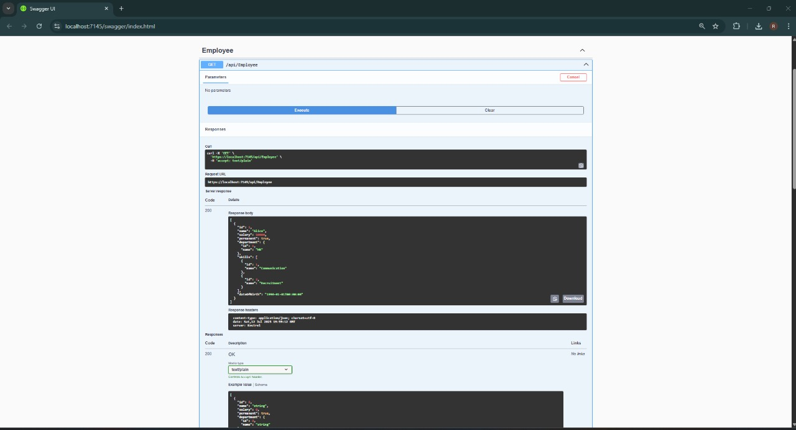

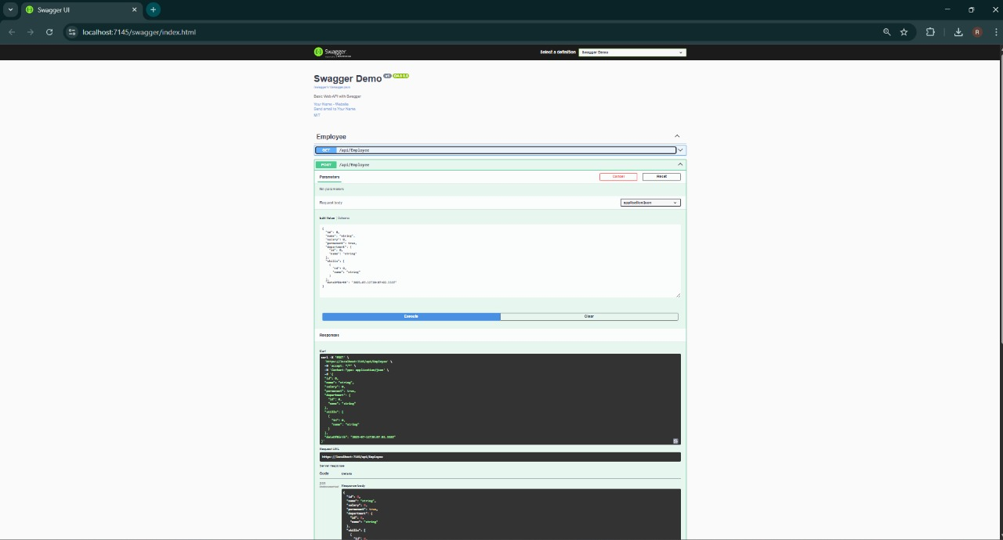

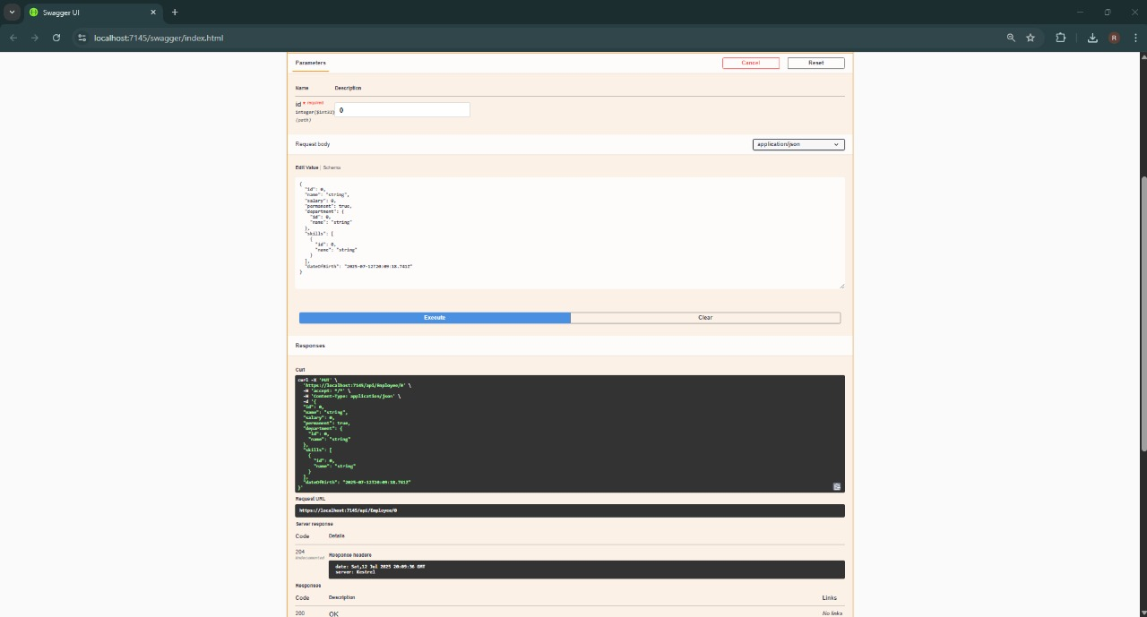

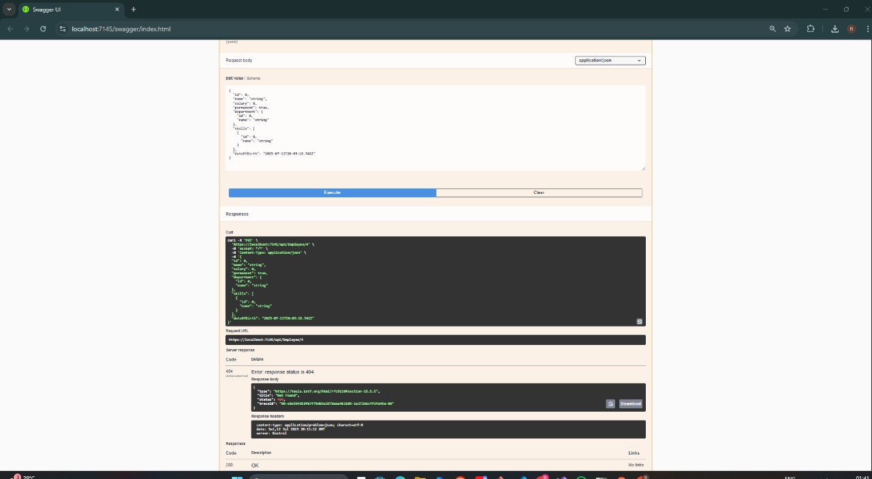

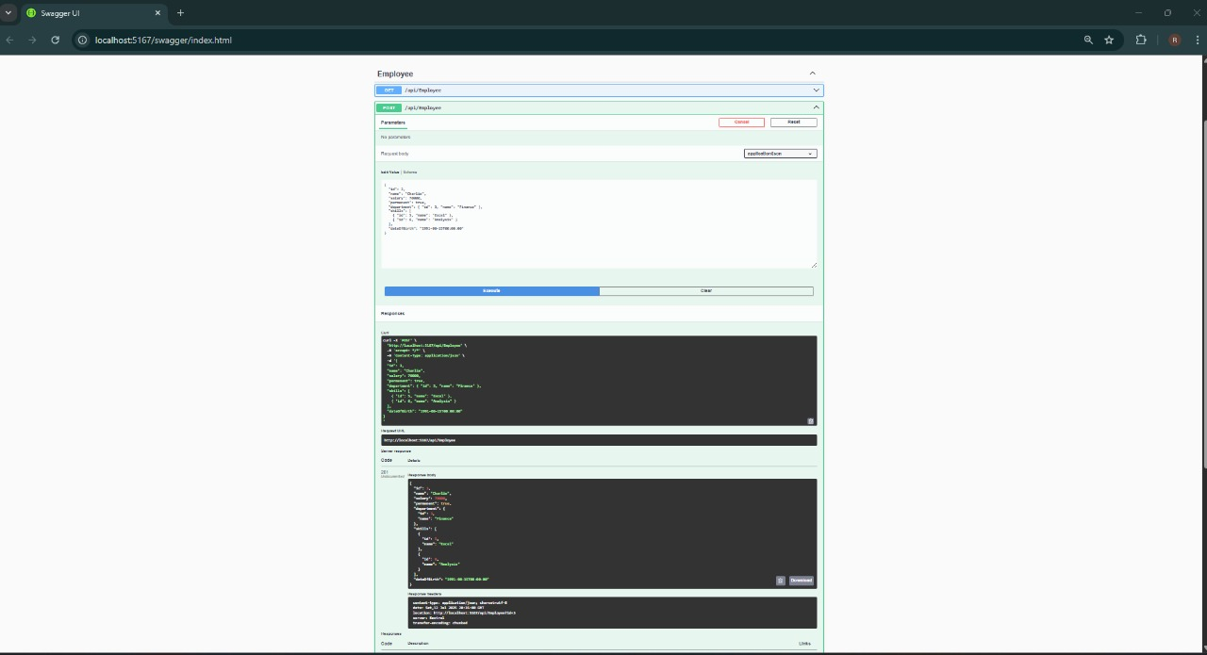

4.WebApi_Handson.docx

3)CRUD Operations

EmployeeController.cs:
using Microsoft.AspNetCore.Mvc;
using WebApiDemo.Models;

namespace WebApiDemo.Controllers
{
[ApiController]
[Route("api/[controller]")]
public class EmployeeController : ControllerBase
{
private static List<Employee> _employees = GetStandardEmployeeList();

private static List<Employee> GetStandardEmployeeList()
{
return new List<Employee>
{
new Employee
{
Id = 1,
Name = "Alice",
Salary = 50000,
Permanent = true,
Department = new Department { Id = 1, Name = "HR" },
Skills = new List<Skill>
{
new Skill { Id = 1, Name = "Communication" },
new Skill { Id = 2, Name = "Recruitment" }
},
DateOfBirth = new DateTime(1990, 1, 1)
}
};
}

[HttpGet]
[ProducesResponseType(typeof(List<Employee>), 200)]
public ActionResult<List<Employee>> Get()
{
return Ok(_employees);
}

[HttpGet("standard")]
public ActionResult<List<Employee>> GetStandard()
{
return Ok(GetStandardEmployeeList());
}

[HttpPost]
public IActionResult Post([FromBody] Employee emp)
{
_employees.Add(emp);
return CreatedAtAction(nameof(Get), new { id = emp.Id }, emp);
}

[HttpPut("{id}")]
public ActionResult<Employee> Put(int id, [FromBody] Employee emp)
{
if (id <= 0)
return BadRequest("Invalid employee id");

var existing = _employees.FirstOrDefault(e => e.Id == id);
if (existing == null)
return BadRequest("Invalid employee id");

existing.Name = emp.Name;
existing.Salary = emp.Salary;
existing.Permanent = emp.Permanent;
existing.Department = emp.Department;
existing.Skills = emp.Skills;
existing.DateOfBirth = emp.DateOfBirth;

return Ok(existing);
}

}
}
Program.cs:
using Microsoft.OpenApi.Models;

var builder = WebApplication.CreateBuilder(args);

builder.Services.AddControllers(options =>
{
options.Filters.Add<CustomExceptionFilter>();
});

builder.Services.AddEndpointsApiExplorer();
builder.Services.AddCors(options =>
{
options.AddPolicy("AllowAll", policy =>
{
policy.AllowAnyOrigin()
.AllowAnyHeader()
.AllowAnyMethod();
});
});

builder.Services.AddSwaggerGen(c =>
{
c.SwaggerDoc("v1", new OpenApiInfo
{
Title = "Swagger Demo",
Version = "v1",
Description = "Basic Web API with Swagger",
Contact = new OpenApiContact
{
Name = "...",
Email = "yyyy@email.com",
Url = new Uri("https://example.com")
},
License = new OpenApiLicense
{
Name = "MIT",
Url = new Uri("https://example.com/license")
}
});
});
builder.Services.AddScoped<CustomAuthFilter>();

var app = builder.Build();

if (app.Environment.IsDevelopment())
{
app.UseSwagger();
app.UseSwaggerUI(c =>
{
c.SwaggerEndpoint("/swagger/v1/swagger.json", "Swagger Demo");
});
}

app.UseHttpsRedirection();
app.UseAuthorization();
app.MapControllers();
app.Run();
Output:

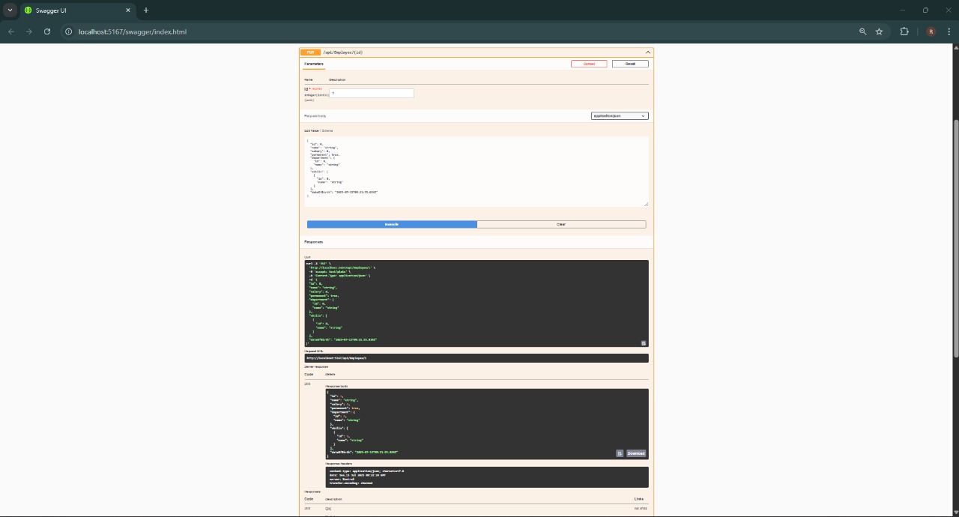
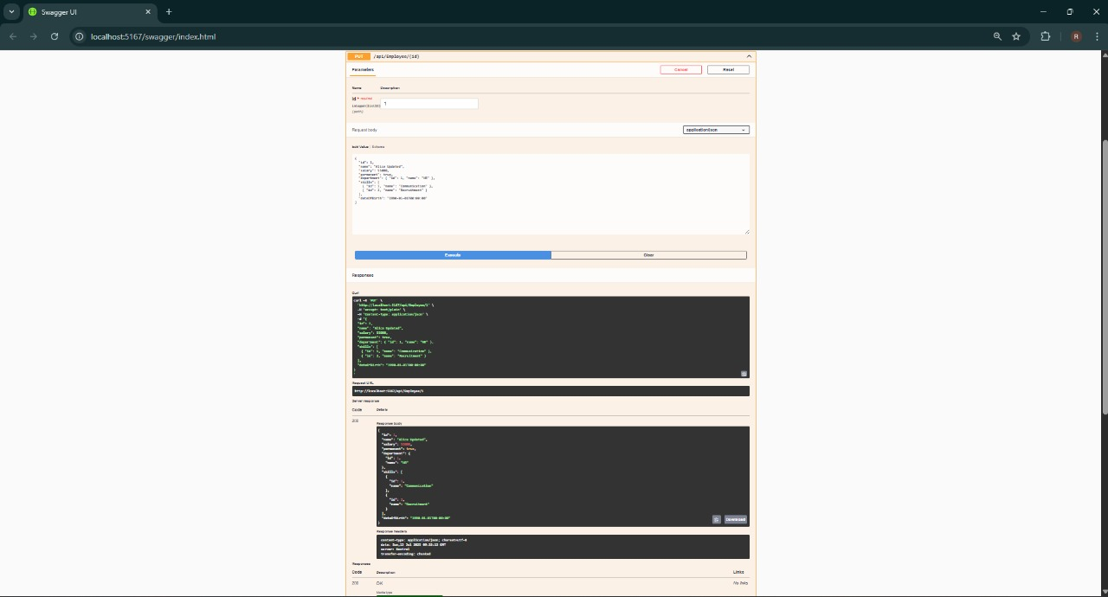
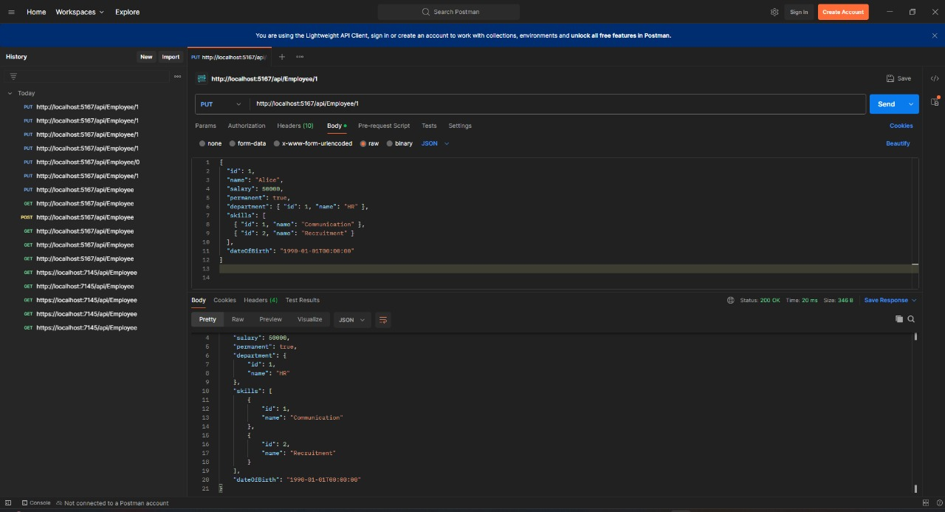
5.WebApi_Handson.docx
4)JWT Authentication & Role-Based Access
AuthController.cs:
using Microsoft.AspNetCore.Authorization;
using Microsoft.AspNetCore.Mvc;
using Microsoft.IdentityModel.Tokens;
using System.IdentityModel.Tokens.Jwt;
using System.Security.Claims;
using System.Text;

namespace WebApiDemo.Controllers
{
[Route("api/[controller]")]
[ApiController]
[AllowAnonymous]
public class AuthController : ControllerBase
{
[HttpGet("token")]
public IActionResult GetToken()
{
var securityKey = new SymmetricSecurityKey(Encoding.UTF8.GetBytes("mysuperdupersecretkey1234567890abcd"));
var credentials = new SigningCredentials(securityKey, SecurityAlgorithms.HmacSha256);

var claims = new[]
{
new Claim(ClaimTypes.Role, "Admin"),
new Claim("UserId", "1")
};

var token = new JwtSecurityToken(
issuer: "mySystem",
audience: "myUsers",
claims: claims,
expires: DateTime.Now.AddMinutes(2),
signingCredentials: credentials);

return Ok(new { token = new JwtSecurityTokenHandler().WriteToken(token) });
}
}
}
EmployeeController.cs:
using Microsoft.AspNetCore.Authorization;
using Microsoft.AspNetCore.Mvc;
using WebApiDemo.Models;

namespace WebApiDemo.Controllers
{
[Authorize(Roles = "Admin,POC")]
[ApiController]
[Route("api/[controller]")]
public class EmployeeController : ControllerBase
{
private static List<Employee> _employees = new List<Employee>
{
new Employee
{
Id = 1,
Name = "Alice",
Salary = 50000,
Permanent = true,
Department = new Department { Id = 1, Name = "HR" },
Skills = new List<Skill>
{
new Skill { Id = 1, Name = "Communication" },
new Skill { Id = 2, Name = "Recruitment" }
},
DateOfBirth = new DateTime(1990, 1, 1)
}
};

[HttpGet]
public ActionResult<List<Employee>> Get() => Ok(_employees);

[HttpPost]
public IActionResult Post([FromBody] Employee emp)
{
_employees.Add(emp);
return CreatedAtAction(nameof(Get), new { id = emp.Id }, emp);
}

[HttpPut("{id}")]
public ActionResult<Employee> Put(int id, [FromBody] Employee emp)
{
if (id <= 0) return BadRequest("Invalid employee id");

var existing = _employees.FirstOrDefault(e => e.Id == id);
if (existing == null) return BadRequest("Invalid employee id");

existing.Name = emp.Name;
existing.Salary = emp.Salary;
existing.Permanent = emp.Permanent;
existing.Department = emp.Department;
existing.Skills = emp.Skills;
existing.DateOfBirth = emp.DateOfBirth;

return Ok(existing);
}
}
}
Program.cs:
using Microsoft.AspNetCore.Authentication.JwtBearer;
using Microsoft.IdentityModel.Tokens;
using Microsoft.OpenApi.Models;
using System.Text;

var builder = WebApplication.CreateBuilder(args);

string securityKey = "mysuperdupersecretkey1234567890abcd";
var symmetricSecurityKey = new SymmetricSecurityKey(Encoding.UTF8.GetBytes(securityKey));

builder.Services.AddAuthentication(options =>
{
options.DefaultAuthenticateScheme = JwtBearerDefaults.AuthenticationScheme;
options.DefaultChallengeScheme = JwtBearerDefaults.AuthenticationScheme;
}).AddJwtBearer(options =>
{
options.TokenValidationParameters = new TokenValidationParameters
{
ValidateIssuer = true,
ValidateAudience = true,
ValidateLifetime = true,
ValidateIssuerSigningKey = true,
ValidIssuer = "mySystem",
ValidAudience = "myUsers",
IssuerSigningKey = symmetricSecurityKey
};
});

builder.Services.AddControllers();
builder.Services.AddCors(options =>
{
options.AddPolicy("AllowAll", policy =>
policy.AllowAnyOrigin().AllowAnyMethod().AllowAnyHeader());
});

builder.Services.AddEndpointsApiExplorer();
builder.Services.AddSwaggerGen(c =>
{
c.SwaggerDoc("v1", new OpenApiInfo { Title = "JWT Demo", Version = "v1" });
});

var app = builder.Build();

app.UseHttpsRedirection();
app.UseCors("AllowAll");
app.UseAuthentication();
app.UseAuthorization();

if (app.Environment.IsDevelopment())
{
app.UseSwagger();
app.UseSwaggerUI();
}

app.MapControllers();
app.Run();
Output:
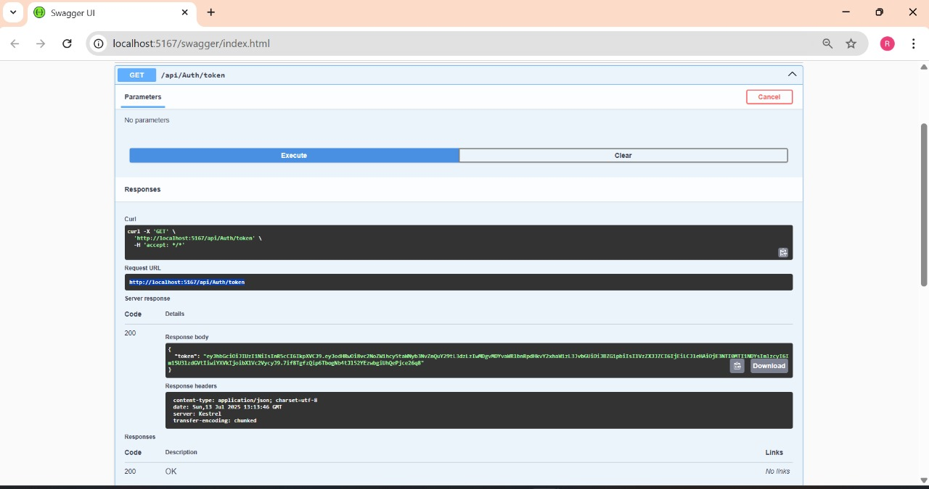
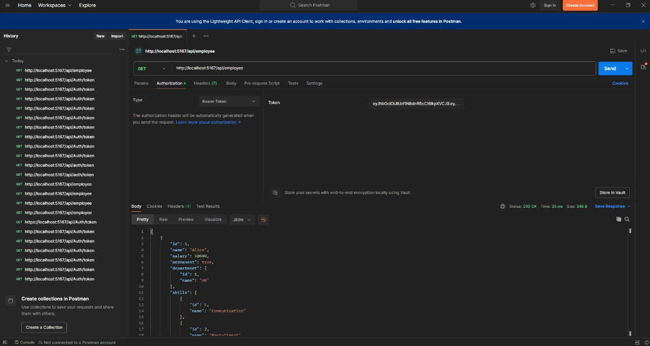

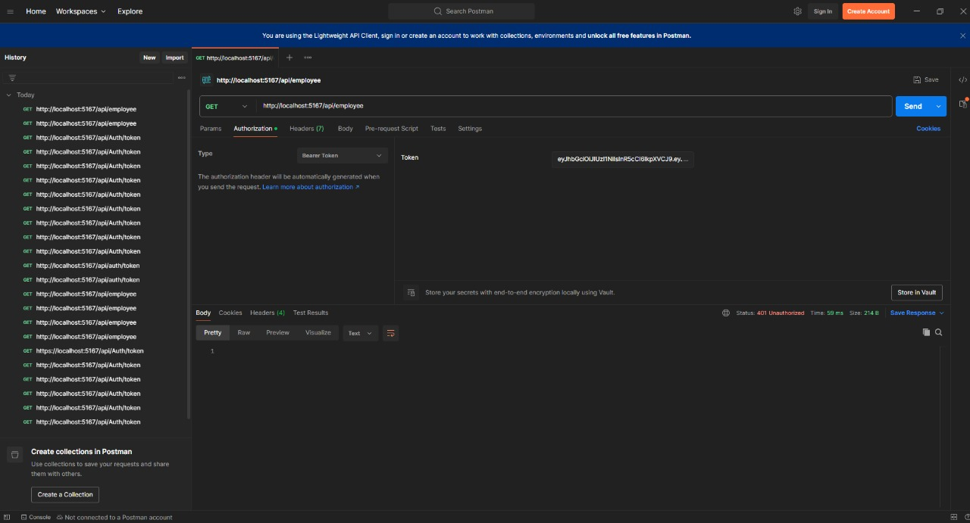
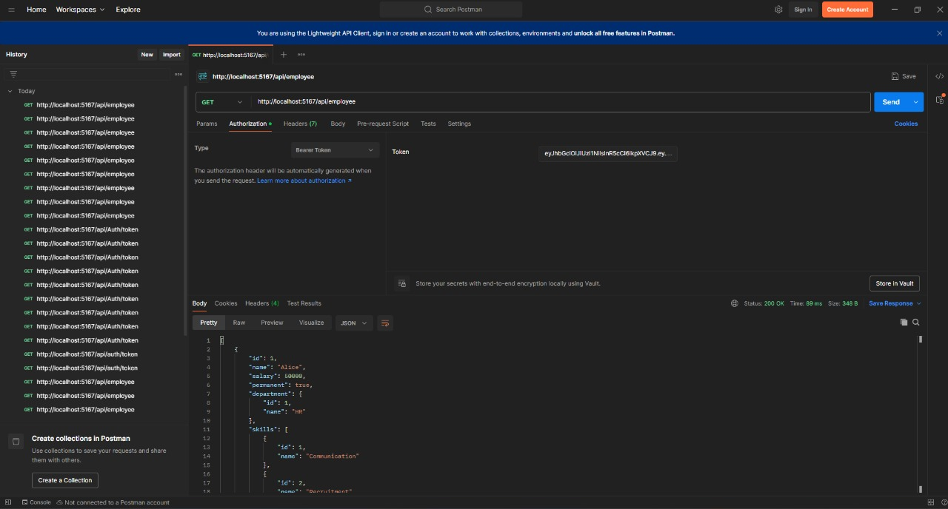
6.WebApi_Handson.docx
6. Kafka Integration with C#

- Create a Chat Application which uses Kafka as a streaming platform and consume the chat messages in the command prompt.
Answer:
Steps:
1) Install Kafka and Zookeeper (Windows):
a)Start Zookeeper:
zookeeper-server-start.bat ..\..\config\zookeeper.properties
b)Start Kafka Broker:
kafka-server-start.bat ..\..\config\server.properties
2) Create a Topic:
kafka-topics.bat --create --topic chat-topic --bootstrap-server localhost:9092 --partitions 1 --replication-factor 1
3) Producer Application (Console App):
a)Create a C# console app.
b) Install NuGet:
Confluent.Kafka
c)Write producer logic:

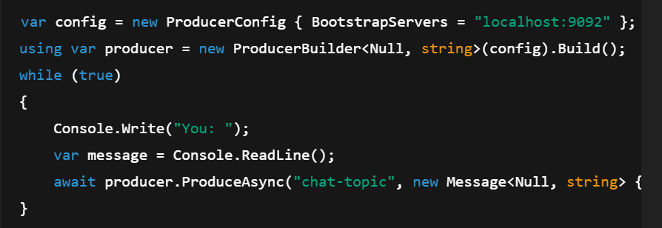
Consumer Application (Console App):
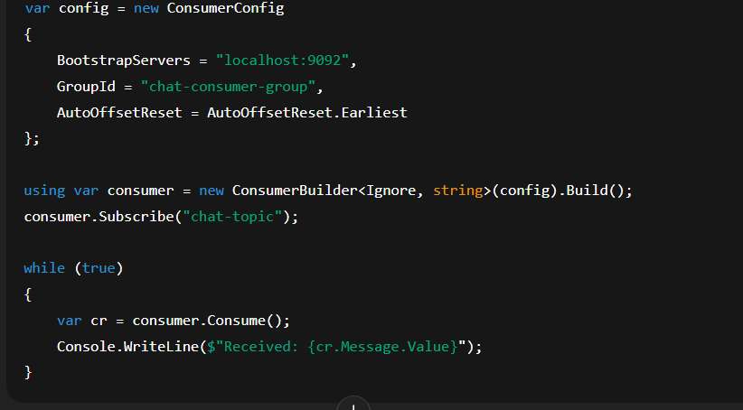
- Create a Chat Application using C# Windows Application using Kafka and consume the message in different client applications.
Answer:
Steps:
1)Setup Windows Forms App:
a) Create a new C# Windows Forms App (.NET).
b) Install Confluent.Kafka via NuGet.
2)Design the UI:
a) TextBox for message input
b)ListBox/TextArea for displaying messages
c)Button to send messages
3)Producer Logic (On Button Click):
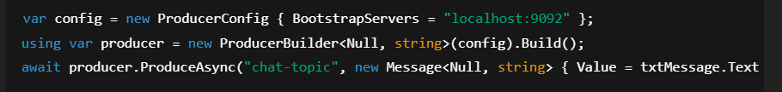
4)Consumer Logic (Background Task):
