DATA BASE STRUCTURE

PERSONAL TABLE

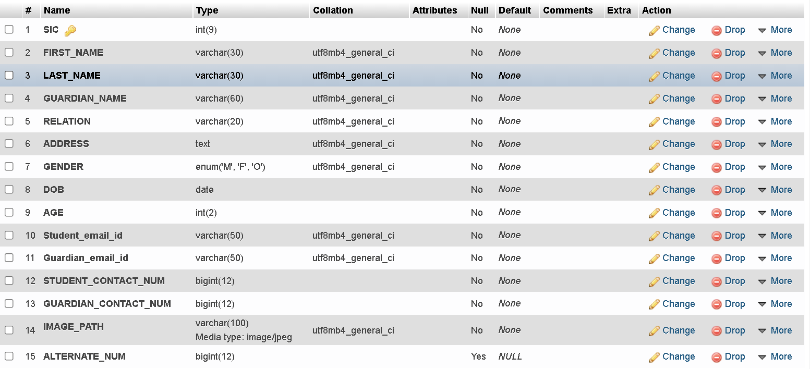
ACADEMICS TABLE
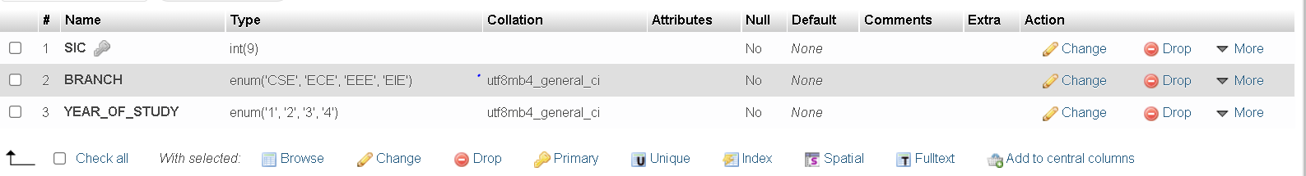
FACILITY MASTER TABLE
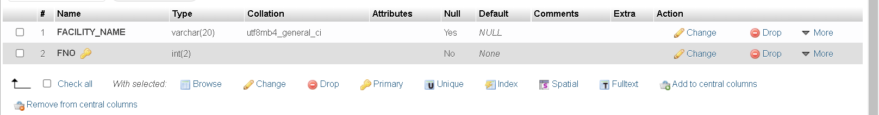

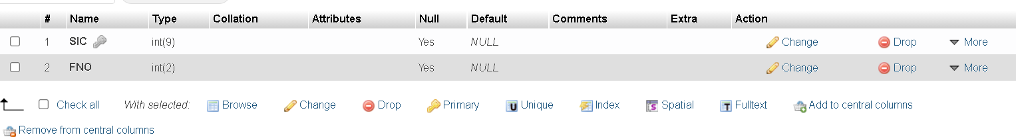
FACILITY TABLE

LOG IN DETAILS TABLE
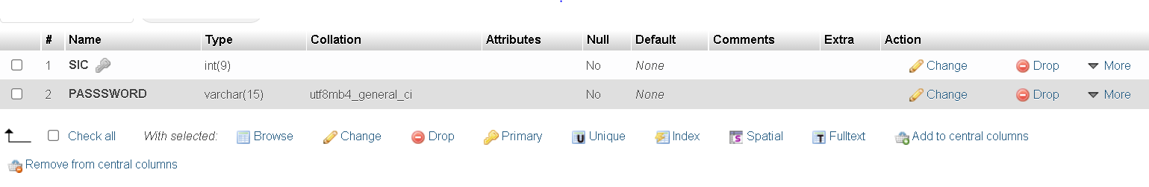

1. Personal table stores the personal details of the student which has SIC as its primary key.
That means no student can have the same SIC.

2. Log in details table stores the SIC of the student and the password to access the account during log in. SIC column is a foreign key referred to from the SIC of the Personal table.

3. Academic table stores all the academic details of the student with SIC as the foreign key referred to from the SIC of the Personal table.
4. Facility master is a table which stores all the facilities’ name that are provided along with their unique id (FNO) which is a primary key to the table. If more facilities are added later on, simply add them to the table and no more changes are required to be done.

5. Facility table stores the details of the facilities that are being availed by the student . The details are being stored with the help of SIC which is a foreign key referred to from the SIC of the personal table and the Facility number as derived from the facility master table. Like if bus is availed by the student, then get the unique id of BUS facility from the facility master table and insert that value in the facility table along with the Sic of that particular student.

