Chapter 1
INTRODUCTION

1.1 About Data Science and Machine Learning
Data Science is an interdisciplinary field that uses scientific methods, algorithms, and systems to extract knowledge and insights from structured and unstructured data. It combines aspects of statistics, mathematics, and computer science to analyze large volumes of data and uncover hidden patterns that can drive decision-making. Machine Learning, a subset of Data Science, enables systems to learn patterns from data and make predictions or decisions without being explicitly programmed. Instead of following static instructions, ML models improve their performance as they are exposed to more data over time. A data science project leverages statistical analysis, data preprocessing, and predictive modeling to solve real-world business problems through data-driven insights. In the context of real estate, these techniques help transform raw housing data into meaningful predictions that benefit both consumers and industry professionals.

1.2 Working with Regression Models
Regression is a supervised machine learning technique used for predicting continuous numerical values. It is particularly suited for problems where the outcome we want to predict is a quantity, such as price, temperature, or sales. In house price prediction, regression models analyze historical housing data to identify relationships between property features and sale price. The model learns how different factors contribute to the final price by studying thousands of past transactions. Popular algorithms include Linear Regression, Decision Trees, Random Forest, and XGBoost. Each of these algorithms has its own way of capturing linear or non-linear relationships in the data. These models are trained on features like area, location, number of bedrooms, and age of property to predict the market value. The accuracy of the prediction depends heavily on the quality of these features and how well they represent the real-world scenario. Libraries such as Scikit-learn, Pandas, and NumPy provide powerful tools for building, evaluating, and deploying robust regression models, making the development process efficient and reliable.

1.3 Purpose
The house price prediction system is developed to assist buyers, sellers, and real estate professionals in estimating the fair market value of a property. Determining the right price for a house is often challenging due to fluctuating market conditions and the large number of factors involved. The system allows users to input property details and obtain an accurate price prediction, helping them make informed decisions and understand price trends based on various factors. For buyers, it ensures they do not overpay for a property. For sellers, it helps in setting a competitive and realistic asking price. For real estate agents, it serves as a quick reference tool to support their valuations and build trust with clients. Ultimately, the purpose is to bring transparency and data-backed confidence into real estate transactions.

1.4 Scope
It is mainly designed to predict the prices of residential properties using historical housing datasets. The focus is on residential houses and apartments since they form the majority of real estate transactions and have consistent data available for analysis. The system will consider key attributes such as location, square footage, number of bedrooms and bathrooms, amenities, and year built. These are the most influential factors that buyers and sellers typically look at while evaluating a property. The scope covers data collection, preprocessing, model training, evaluation, and deployment through a user-friendly interface. While the initial version is limited to residential properties in a specific region, the framework is designed in a way that it can be extended to other cities or property types in the future. The project does not cover commercial real estate or rental price prediction in its current scope.

1.5 Overall Description
Our project on house price prediction is mainly helpful for users to estimate the price of a house before buying or selling. In a market where prices can vary significantly even within the same locality, having a reliable estimate reduces uncertainty and supports better financial planning. The description of each feature’s impact on price is analyzed using feature importance, so that the user can understand which factors drive property value. This helps users see why a larger area or a prime location leads to a higher price, making the model’s decision process more transparent. By entering details like area, locality, and property type, users can get an instant price estimate without needing deep domain knowledge. The system also provides data visualizations for price trends and comparisons, allowing users to compare how prices change across neighborhoods or with different property sizes. The admin has the authority to update the dataset, retrain the model, and monitor prediction accuracy to ensure the system remains relevant as market conditions change.

The project has been planned using a modular architecture, with centralized storage of the dataset. This ensures that all components of the system can access the same consistent data and that updates can be managed easily. The application for data processing and model training has been planned using Python. Data preprocessing and model development are done using Pandas, Scikit-learn, and Matplotlib libraries. The user interface for accepting inputs and displaying predictions has been designed using Streamlit, which allows for quick interaction and clear presentation of results to the end user.

Chapter 2
DETAILS OF INDUSTRY

COMPANY DETAILS:
Name: QSpiders Campus Connect - Rajajinagar
Address: #159, 3rd Floor, Amarjyothi Layout, Chord Road, Near Rajajinagar Metro Station, Rajajinagar, Bangalore - 560010, Karnataka
Contact: +91 99725 77773 / +91 97404 99660
Website: http://www.qspiders.com

ABOUT COMPANY:
QSpiders is a leading software training and testing institute headquartered in Bangalore, established with the vision of bridging the gap between industry requirements and academic curriculum. It is a unit of Test Yantra Software Solutions Pvt. Ltd. and is recognized as one of the world’s largest software testing training organizations. QSpiders Rajajinagar is one of its prominent branches, strategically located near Rajajinagar Metro Station for easy accessibility to students and working professionals.

The company focuses on providing industry-oriented training to engineering graduates and job aspirants in the field of software development and testing. With a strong team of experienced trainers who have real-time industry exposure, QSpiders ensures that students gain practical knowledge along with theoretical concepts. The institute has trained and placed thousands of candidates in top MNCs and startups across India. QSpiders is known for its unique teaching methodology, hands-on practice sessions, and strong placement support system. The Rajajinagar branch maintains the same quality standards and placement track record as other branches, making it a preferred choice for students in West Bangalore. The training environment is designed to simulate real-time IT company culture, helping students adapt quickly once placed.

SERVICES:
QSpiders Rajajinagar offers comprehensive training programs and placement services focused on the IT industry. The key services include:

1. Software Testing Training: Manual Testing, Automation Testing using Selenium, API Testing, Mobile Testing, and Database Testing. The curriculum covers SDLC, STLC, Agile methodology, and defect management tools like JIRA.

2. Development Training: Core Java, Advanced Java, SQL, Web Technologies including HTML, CSS, JavaScript, and frameworks. Full Stack Development training with Java and Python is also provided based on industry demand.

3. Python Training: Python programming for beginners to advanced level, covering data structures, OOPs concepts, and frameworks like Django and Flask for web development.

4. Corporate Training: Customized training programs for companies to upskill their employees in latest technologies and testing tools as per project requirements.

5. Placement Assistance: Dedicated placement team that conducts aptitude training, mock interviews, resume building sessions, and soft skills development. QSpiders has tie-ups with 3000+ companies and conducts regular placement drives at the campus.

6. Internship Programs: Real-time project-based internships for students to gain practical exposure to software development and testing life cycles under the guidance of industry experts.

7. Aptitude & Soft Skills Training: Dedicated sessions on quantitative aptitude, logical reasoning, verbal ability, group discussions, and HR interview preparation to make students job-ready.

8. Online & Offline Batches: Flexible batch timings including weekday, weekend, and fast-track batches for students and working professionals. Online training with live instructor-led sessions is also available.

Chapter 3
CONCEPTS LEARNED

DATA SCIENCE
Data Science is an interdisciplinary field that uses scientific methods, processes, algorithms, and systems to extract knowledge and insights from structured and unstructured data. It unifies statistics, data analysis, machine learning, and domain expertise to understand and analyze actual phenomena with data. The goal of data science is to turn raw data into actionable insights that can drive decision-making and solve complex problems. It is not limited to one technique but rather a combination of tools, principles, and practices applied throughout the data lifecycle.

The data science lifecycle typically includes data collection, data cleaning, exploratory data analysis, feature engineering, modeling, evaluation, and deployment. In the context of house price prediction, data science provides the framework for approaching the problem systematically. It starts by defining the business question — how can we estimate a fair market price for a property — and then gathering relevant housing data from sources like real estate listings, government records, or APIs. Data scientists then explore the data to understand patterns, such as how location impacts price or whether newer houses sell for more.

Data science emphasizes reproducibility and validation. Every step from preprocessing to model selection is documented so results can be verified and improved. It also involves communicating findings through reports and visualizations so non-technical stakeholders like buyers, sellers, and agents can understand the insights. The field draws from mathematics for statistical inference, computer science for algorithm design and data structures, and domain knowledge of real estate to ensure the features used are meaningful.

A key principle in data science is that data is never perfect. There will be missing values, outliers, and biases. Part of the discipline is recognizing these limitations and handling them appropriately so they do not lead to misleading conclusions. In this project, data science guides the entire process: deciding what data to collect, how to clean it, which models to try, how to measure success using metrics like RMSE, and how to present the final predictions in a user-friendly way. It bridges the gap between raw housing data and practical, real-world value for end users.

DATA ANALYSIS
Data Analysis is the process of inspecting, cleaning, transforming, and modeling data to discover useful information, draw conclusions, and support decision-making. It is the first and most crucial step in any data science project because the quality of analysis directly influences the reliability of the final model. The process begins with understanding the structure of the dataset — identifying the number of rows and columns, data types of each feature, and the overall completeness of the data. Analysts check for missing values, duplicate records, and inconsistencies that may have occurred during data collection.

In the context of house price prediction, data analysis involves examining how features like location, square footage, number of bedrooms, year built, and proximity to amenities relate to the sale price. Descriptive statistics such as mean, median, mode, standard deviation, and percentiles are used to summarize the central tendency and spread of numerical features like area and price. For categorical features like property type or locality, frequency counts and mode values help understand the distribution. Outlier detection is another key part, since extremely high or low property prices can skew the model. Techniques like box plots and z-score analysis are applied to identify and handle such anomalies.

Correlation analysis is performed to measure the strength of relationships between independent variables and the target variable. This helps in selecting the most relevant features for the model. Exploratory Data Analysis (EDA) is a major phase where visual and statistical methods are combined to form hypotheses. During EDA, we may discover that houses in certain localities consistently have higher prices, or that price per square foot decreases after a certain area threshold. These insights guide feature engineering, where new variables like age of the house or price per square foot are created to improve model performance. Data analysis ensures that raw, messy data is converted into a clean, structured, and meaningful format. Without thorough analysis, even the most advanced machine learning model will produce misleading results.

MACHINE LEARNING
Machine Learning is a subset of artificial intelligence that enables systems to learn from data and improve their performance on a specific task without being explicitly programmed. Unlike traditional programming where rules are hard-coded, ML algorithms identify patterns and relationships directly from data and use them to make predictions or decisions. The core idea is that the system learns from experience — the more relevant data it processes, the better its predictions become. Machine Learning is broadly categorized into three types: supervised learning, unsupervised learning, and reinforcement learning.

For house price prediction, we use supervised learning because the dataset contains both input features and the corresponding output labels, which is the actual sale price. The algorithm is trained on this historical data, learning the mapping between features like area, location, and number of rooms to the final price. Once trained, the model can predict prices for new houses where the price is unknown. Common supervised learning tasks include regression for continuous outputs like price, and classification for discrete outputs like spam or not spam.

The machine learning workflow involves several stages. First, the problem is defined and data is collected. Then, data is preprocessed and split into training and testing sets. The model is selected based on the problem type — for price prediction, regression models are appropriate. The model is then trained on the training data, where it adjusts its internal parameters to minimize prediction error. After training, the model is evaluated on the test set using performance metrics to check how well it generalizes to unseen data. If performance is poor, techniques like hyperparameter tuning, feature selection, or trying different algorithms are applied.

Machine Learning brings automation and scalability to data analysis. In real estate, it can process thousands of property listings in seconds and provide instant price estimates, which would be impossible manually. It also reduces human bias by relying on data-driven patterns rather than subjective judgment. However, the success of ML depends heavily on data quality, feature relevance, and proper validation. A well-trained model can capture complex non-linear relationships, such as how the impact of location on price changes with property size, which simple rule-based systems cannot.

PANDAS
Pandas is an open-source Python library used for data manipulation and analysis. It is one of the most fundamental tools in the data science ecosystem and is designed to make working with structured data fast, easy, and expressive. Pandas introduces two primary data structures: Series, which is one-dimensional and similar to a column in a table, and DataFrame, which is two-dimensional and resembles a spreadsheet or SQL table. These structures allow for intuitive handling of labeled and relational data.

One of the first uses of Pandas in any project is data ingestion. It can read data from a wide variety of sources including CSV files, Excel sheets, JSON files, and SQL databases using simple commands like `read_csv()` or `read_sql()`. Once loaded, Pandas provides a comprehensive view of the dataset through functions like `.head()`, `.info()`, and `.describe()`, which quickly summarize the shape, data types, and statistical properties of the data.

Data cleaning is where Pandas truly excels. Real-world datasets often contain missing values, incorrect data types, or inconsistent formatting. Pandas offers functions like `.isnull()`, `.fillna()`, `.dropna()`, and `.astype()` to detect and handle these issues efficiently. For the house price prediction dataset, Pandas is used to handle missing values in columns like number of bathrooms or year built, either by imputation or removal, depending on the extent. It also helps in converting categorical text data like locality names into a format suitable for modeling.

Feature engineering and transformation are also performed using Pandas. New columns can be created using arithmetic operations on existing ones, such as calculating the age of a property by subtracting the year built from the current year. Grouping and aggregation functions like `.groupby()` allow us to compute average price per locality or average area by property type, which can reveal important market trends. Filtering and querying data using boolean indexing makes it easy to analyze subsets, for instance, all houses with more than 3 bedrooms in a specific city. Merging and joining datasets is another critical capability. If property features and locality details are stored in separate files, Pandas can merge them using a common key like locality ID. Before feeding data into a machine learning model, Pandas is used to separate features and the target variable, and to encode categorical variables into numerical form using techniques like one-hot encoding.

SCIKIT-LEARN
Scikit-learn is an open-source machine learning library for Python that provides simple and efficient tools for data mining and data analysis. It is built on NumPy, SciPy, and Matplotlib, and has become the standard library for implementing machine learning algorithms in Python. Scikit-learn is designed with a consistent and user-friendly API, where different models share common methods like `.fit()`, `.predict()`, and `.score()`, making it easy to switch between algorithms and experiment.

The library covers almost every stage of the machine learning pipeline. It includes modules for data preprocessing such as `StandardScaler` and `MinMaxScaler` for feature scaling, `LabelEncoder` and `OneHotEncoder` for handling categorical data. In the house price prediction project, these preprocessing tools are essential because features like area and number of bedrooms are on different scales, and models like Linear Regression perform better when features are normalized.

For model building, Scikit-learn offers a vast collection of supervised learning algorithms. For regression tasks, it provides `LinearRegression`, `DecisionTreeRegressor`, `RandomForestRegressor`, and `GradientBoostingRegressor`, among others. Each algorithm can be instantiated, trained on data using the `.fit()` method, and used to make predictions with `.predict()`. This modularity allows us to quickly test multiple models and compare their performance. The library also supports ensemble methods that combine multiple models to improve accuracy and reduce overfitting, which is particularly useful in real estate data where relationships can be complex.

Model selection and evaluation are handled through tools like `train_test_split` to divide data into training and testing sets, and `cross_val_score` for k-fold cross-validation to ensure the model’s performance is stable. Scikit-learn provides a wide range of evaluation metrics specific to regression, including Mean Absolute Error (MAE), Mean Squared Error (MSE), Root Mean Squared Error (RMSE), and R² Score. Hyperparameter tuning is simplified using `GridSearchCV` and `RandomizedSearchCV`, which automatically test different combinations of parameters to find the optimal setup for a model. Pipelines can be created to chain together preprocessing steps and model training into a single object, preventing data leakage and making the workflow more reproducible.

MATPLOTLIB
Matplotlib is a comprehensive library for creating static, animated, and interactive visualizations in Python. It is the oldest and most widely used plotting library in the Python ecosystem and serves as the foundation for many other visualization tools. Matplotlib gives developers fine-grained control over every element of a plot, including figure size, axes, lines, colors, labels, and annotations. This level of control makes it ideal for creating publication-quality figures and for customizing plots to meet specific requirements.

The most basic interface in Matplotlib is `pyplot`, which provides a MATLAB-like plotting framework. With just a few lines of code, users can create line plots, scatter plots, bar charts, histograms, and pie charts. In the context of data analysis for house prices, Matplotlib is first used to understand the distribution of individual variables. A histogram of house prices can reveal whether the data is normally distributed or skewed, which influences the choice of model and preprocessing steps. A bar chart can show the count of houses in each locality, highlighting which areas have the most data.

Scatter plots are particularly important in regression problems because they visualize the relationship between two continuous variables. Plotting area on the x-axis and price on the y-axis can show whether there is a linear trend, and if that trend differs by location. Multiple subplots can be arranged in a single figure to compare distributions or relationships across different categories, such as comparing price distributions for apartments versus independent houses.

Matplotlib is also crucial for model evaluation and diagnostics. After training a regression model, we plot predicted prices against actual prices. In an ideal model, these points should lie close to a 45-degree line. Residual plots, which show the difference between actual and predicted values, help check for patterns that indicate model bias or heteroscedasticity. Learning curves can be plotted to diagnose overfitting or underfitting by showing how training and validation error change with training set size. While Matplotlib requires more code than some higher-level libraries, this level of control ensures every aspect of the visualization can be customized for clarity in reports and presentations.

SEABORN
Seaborn is a Python data visualization library based on Matplotlib that provides a high-level interface for drawing attractive and informative statistical graphics. It was created to address some of the complexities of Matplotlib by offering simpler syntax and better default aesthetics. Seaborn integrates closely with Pandas DataFrames, meaning it can directly plot data using column names without extensive data reshaping. This makes the transition from data analysis to visualization seamless.

One of Seaborn’s key advantages is its built-in support for complex statistical plots. Functions like `pairplot()` automatically create a grid of scatter plots for every pair of numerical variables in the dataset, with histograms on the diagonal. For house price data, a pair plot can instantly reveal how area, bedrooms, bathrooms, and price are interrelated, saving hours of manual plotting. `heatmap()` is used to visualize correlation matrices, where color intensity indicates the strength of correlation between variables. This is critical for feature selection, as highly correlated features can be redundant and variables with high correlation to price are good predictors.

Seaborn excels at categorical data visualization. `boxplot()` shows the distribution of a numerical variable across different categories, such as how house prices vary across different localities or property types. These plots display median, quartiles, and outliers, giving a richer summary than a simple bar chart of means. `countplot()` is used to visualize the frequency of categorical variables, like the number of 1BHK vs 2BHK vs 3BHK properties in the dataset.

Seaborn’s default color palettes and themes are designed to be visually appealing and colorblind-friendly, reducing the need for manual styling. In the house price prediction project, Seaborn is used extensively during EDA to quickly generate insights and after modeling to visualize feature importance and model performance.

TITLE
Chapter 4

SYSTEM DESIGN / METHODOLOGY
4.1 System Architecture
The house price prediction system follows a modular architecture with 4 main layers: Data Layer, Processing Layer, Model Layer, and Presentation Layer.
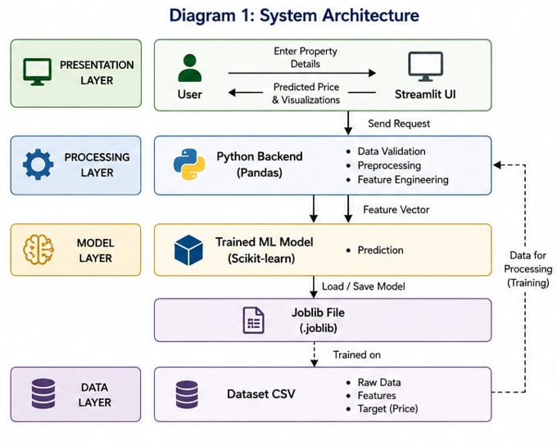

Description:
The user interacts with the Streamlit frontend. Input data is sent to the Python backend where Pandas preprocesses it into the same format used during training. The trained Scikit-learn model loaded from a .joblib file predicts the price. The result is sent back to the UI along with visualizations from Matplotlib/Seaborn.

4.2 Methodology / Workflow
The project was implemented using a standard data science workflow: Problem Definition → Data Collection → Data Preparation → Modeling → Evaluation → Deployment.
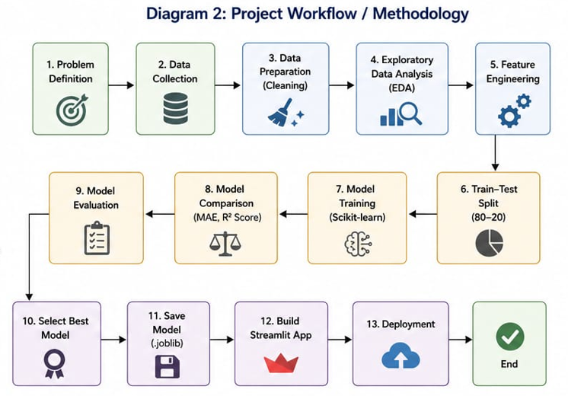

Description:
We first collected housing data and understood the requirements. Pandas was used for cleaning missing values and handling outliers. EDA with Matplotlib and Seaborn revealed key patterns. Features like age of house and location were processed for modeling. Data was split 80-20 for training-testing. Multiple Scikit-learn regression models like Linear Regression and Random Forest were trained with default parameters and compared. The model with highest R² Score and lowest MAE was selected, saved, and integrated into Streamlit for deployment.

4.3 Data Flow Diagram
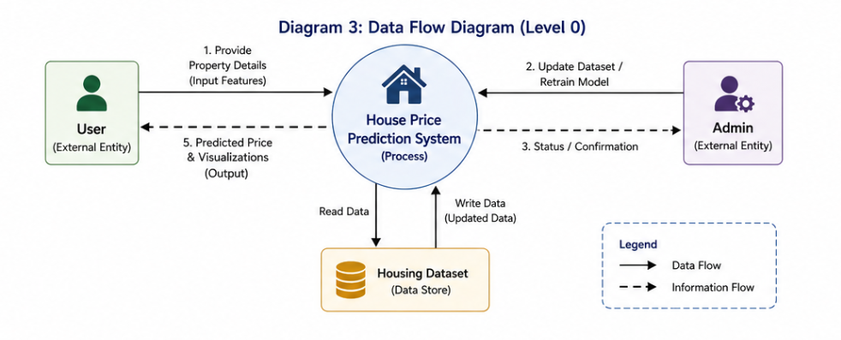
Description:
The user provides input features and receives predicted prices with supporting charts. Admin can update the housing dataset and retrain the model manually to keep predictions current.

4.4 Modules Description
1. Data Collection & Preprocessing Module: Uses Pandas to read CSV, handle null values using median/mode imputation, remove outliers, and apply one-hot encoding to categorical variables.
2. EDA Module: Uses Matplotlib and Seaborn to generate histograms, box plots, heatmaps, and scatter plots for understanding feature distributions and relationships.
3. Model Training Module: Uses Scikit-learn to train regression models like Linear Regression and Random Forest Regressor. Models were compared using MAE and R² Score on the test set.
4. Prediction Module: Loads the saved model and takes user input to return price estimates after applying the same preprocessing steps.
5. UI Module: Built with Streamlit to accept inputs through sliders and dropdowns, display predicted price, and show feature importance and price trend graphs.
6. Admin Module: Allows manual dataset updates and retraining of the model to maintain accuracy.

4.5 Tools and Libraries Used
- Data Science & Machine Learning: Used for overall problem formulation, statistical analysis, and predictive modeling.
- Pandas: Data loading, cleaning, transformation, encoding, and feature engineering.
- Scikit-learn: Model building, train-test split, training regression models, and evaluation using MAE and R² Score.
- Matplotlib: Plotting distributions, actual vs predicted plots, and evaluation graphs.
- Seaborn: Correlation heatmaps, pair plots, and box plots for EDA and outlier detection.
- Streamlit: Frontend deployment for user interaction and result visualization.

Chapter 5
CONCLUSION

5.1 Challenges Faced
During the development of the house price prediction system, several challenges were encountered at different stages of the project. The first major challenge was data collection and quality. Real estate datasets often contain missing values, inconsistent formats, and outliers due to manual entry errors or incomplete listings. Columns like number of bathrooms, year built, and locality had missing or incorrect data that required careful imputation without introducing bias. Identifying and treating extreme outliers in price and area was critical, as a few luxury properties could heavily skew the model.

Another challenge was feature selection and handling categorical variables like location and property type. Since location has a high cardinality with hundreds of unique values, one-hot encoding led to a large number of features, increasing dimensionality and risk of overfitting. Deciding how to group rare localities or use target encoding without data leakage required multiple iterations. Handling multicollinearity was also difficult because features like total area, number of bedrooms, and number of bathrooms are often correlated, which can affect the stability of linear models.

Model selection and tuning presented additional difficulties. Linear Regression gave poor results on non-linear data and was sensitive to outliers, while complex models like Random Forest and XGBoost required extensive hyperparameter tuning to balance accuracy and overfitting. Ensuring the model generalized well was challenging because a high R² score on training data did not always guarantee good predictions on unseen data from a different time period. Integrating the trained model with a Streamlit interface and ensuring real-time prediction with proper input validation for edge cases like negative area or unrealistic year built also posed technical difficulties. Lastly, keeping the model updated with changing market trends was identified as an ongoing challenge, since real estate prices are influenced by economic factors and static models become outdated quickly.

5.2 Learning Outcomes
This project provided extensive hands-on experience across the entire data science lifecycle and strengthened both technical and analytical skills. The first key learning was the importance of data preprocessing and exploratory data analysis. We learned how to use Pandas for cleaning data, handling missing values through mean, median, or mode imputation, and creating new features like age of property and price per square foot that significantly improved model accuracy. Through correlation analysis and visualizations using Matplotlib and Seaborn, we understood how different factors influence house prices, how to detect skewed distributions, and how to identify interactions between variables that are not obvious in raw data.

We gained practical knowledge of Machine Learning concepts by implementing multiple regression algorithms using Scikit-learn. We learned how to split data into training and testing sets to avoid data leakage, apply feature scaling using StandardScaler for distance-based algorithms, and train models like Linear Regression, Decision Tree, Random Forest, and XGBoost. The process of evaluating models using metrics like MAE, MSE, RMSE, and R² Score taught us how to quantify performance and compare algorithms objectively. Hyperparameter tuning using GridSearchCV helped us understand the bias-variance tradeoff and the impact of parameters like `n_estimators` and `max_depth` on model complexity.

On the visualization side, we learned how to use Matplotlib for basic plots and Seaborn for advanced statistical graphics like heatmaps, pair plots, and box plots to communicate findings effectively. On the deployment side, we learned how to build an interactive web application using Streamlit to take user inputs, validate them, and display predictions instantly with supporting charts. This taught us how data science models are converted into usable products for end users. Overall, the project improved our skills in Python, data analysis, model building, result interpretation, and problem-solving. It also developed our ability to approach a real-world problem systematically, document each step, and present technical work to a non-technical audience.

5.3 Conclusion
The House Price Prediction system was successfully developed to estimate the market value of residential properties based on key features like area, location, number of bedrooms, bathrooms, and age of the property. The project demonstrated how data science and machine learning techniques can be applied to solve practical problems in the real estate domain and reduce uncertainty in financial decisions. After thorough data analysis and preprocessing using Pandas, multiple regression models were implemented and compared using Scikit-learn, and the best-performing model was selected based on cross-validation scores and evaluation metrics.

Data visualizations created using Matplotlib and Seaborn played a crucial role in understanding data patterns, validating model assumptions, and explaining feature importance to users. The final model was deployed through a user-friendly Streamlit interface, allowing users to get instant price estimates by entering property details without needing technical knowledge. The system brings transparency to real estate transactions by providing data-driven price predictions, helping buyers avoid overpaying, sellers set competitive prices, and agents support their valuations with evidence.

The project achieved its objective of building an accurate, interpretable, and accessible tool for house price estimation. It also highlighted the importance of clean data, relevant features, proper model validation, and clear communication in building reliable predictive systems. The work confirmed that while no model can predict exact market prices due to human and economic factors, a well-trained system can provide close estimates that serve as a valuable reference point.

5.4 Future Scope
While the current system performs well for residential properties in a specific region, there is significant scope for future enhancement to increase its utility and accuracy. The model can be extended to include more cities and localities by integrating larger and more diverse datasets from multiple real estate portals and government records. Additional features such as proximity to schools, hospitals, metro stations, crime rate, air quality index, and upcoming infrastructure projects can be incorporated to capture external factors that influence price.

The system can be upgraded to predict rental prices along with sale prices, making it useful for tenants, landlords, and investors. In terms of technology, advanced algorithms like LightGBM, CatBoost, or deep learning models can be explored for better handling of non-linear relationships and high-cardinality categorical features. A time series component can be added to analyze and forecast price trends over the next few years, helping users understand if it is the right time to buy or sell.

The user interface can be enhanced with interactive maps to show locality-wise price comparisons, heatmaps of high-demand areas, and filters for budget and amenities. An automated data pipeline can be built to periodically fetch new property listings, retrain the model, and keep predictions updated with current market conditions. Mobile application support and integration with real estate websites through APIs are other potential extensions that would make the tool more accessible. Implementing explainable AI techniques like SHAP or LIME would also help users understand why the model predicted a certain price, increasing trust. These improvements will make the system more robust, scalable, and commercially viable for real-world use.

