**CS5551**

**ADVANCED SOFTWARE ENGINEERING**

**PROJECT INCREMENT-I (PG-10)**

**TITLE:- AUTOPROFILE**

**Submitted By**:

Bhuvana Atluri (Class ID-3)

Venkata Sai Spandana Surapaneni (Class ID -47)

Vepuri Bhargavi (Class ID-52)

Venkata Nagaraj Voonna (Class ID-53)

**Import Existing Services/API**

There are no external API used as of now.

**Detail Design**

**User Stories:**

We have four stories in Iteration1

1. As the developer, I need to develop a user interface for the creation of auto profile application so that users can create their profile
2. As a system, I want to store the input data given by the user into the database so that user access the data when required
3. As a user, I need to add a profile so that I can intimate the caller when I can't attend a call.
4. As a user, I can create multiple profiles with different timings.

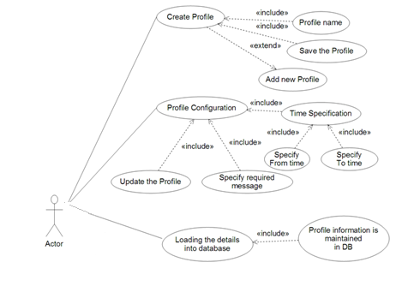

**Description:**

**Creating own Profile module**

In this module we have to create our own custom profile name. It’s purely depends on our requirement. This means we provide the profile name & message as per our requirement and save the profile and further the profile can be displayed in the list format

**Creating SQLite Database module**

In this module we are creating SQLite Database, where Time of the profile and the specified message can be stored in the database. In order to store all the details database is required.

**Configuring Profile**

In this module we create our timings like (To_Time and From_Time) i.e., we create a schedule. For each and every profile To Time and From Time is specified in order to activate the profile. We specify the message as per our requirement this means required message by the user. As per the time specifications only the profile is activated. Inserting time values in to the database and updating the profile is done in this module.

**Sequence Diagrams:**

**For Creating Profile:-**

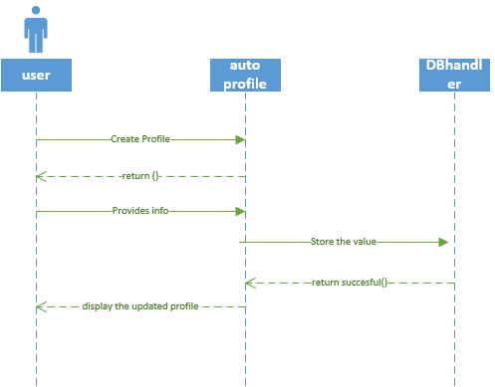

**For Updating Profile:-**

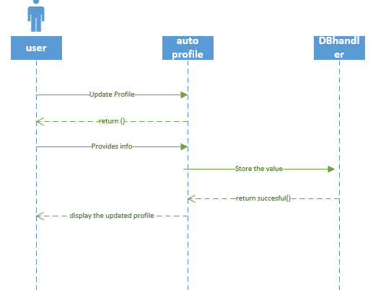

**Class Diagram:**

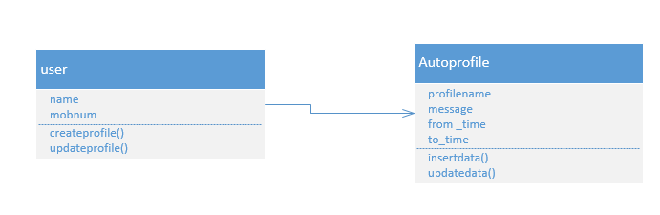**Design of Mobile Client Interface:**

Mobile client interface is an Android application which is a rich client. In the first increment our app consists of 4 different screens. The starting page allows the user to select add profile or activate. A profile page to have the profile name and message to be delivered. Two different time pages to select the to time and from time.

1. In this screen we can add the profile and also update the profile

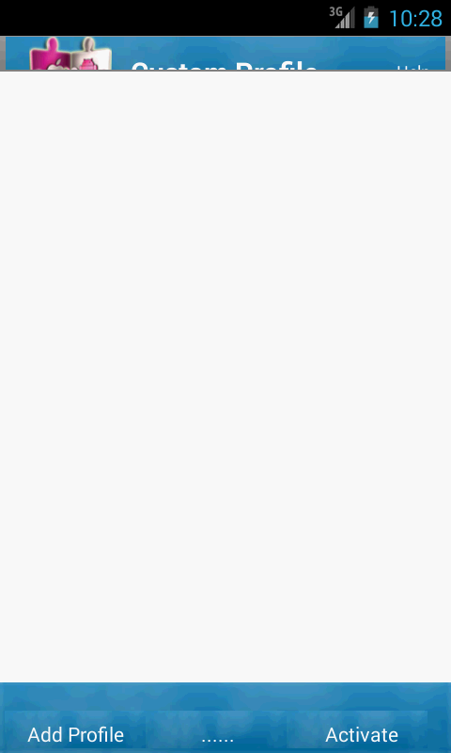

1. Clicking on add profile button a dialog box is displayed on the screen showing profile and message fields.

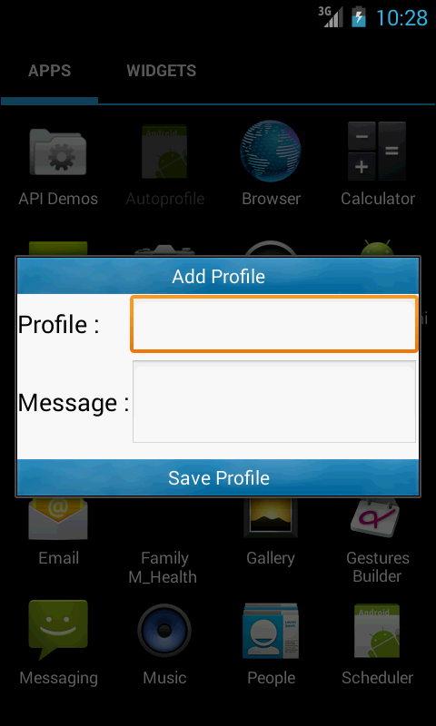

1. We enter and save the profile name and message to be sent to caller.

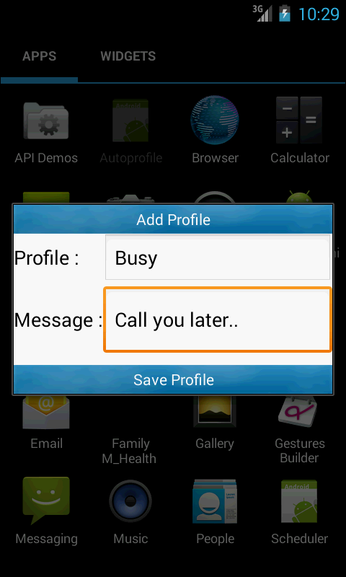

1. The saved profile is displayed on the home screen.

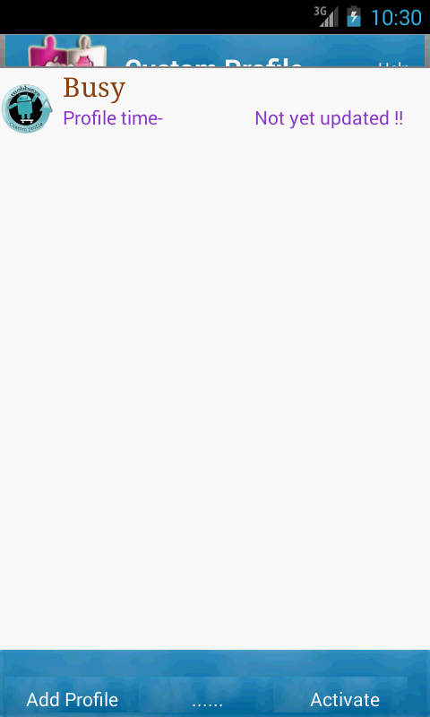

1. When clicked on saved profile a new dialog box is displayed with profile name, from time, to time, modes and message fields along with an update button.

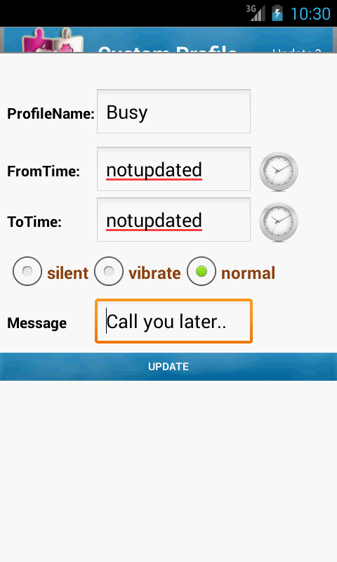

**6.**In this dialog box, we set from time.

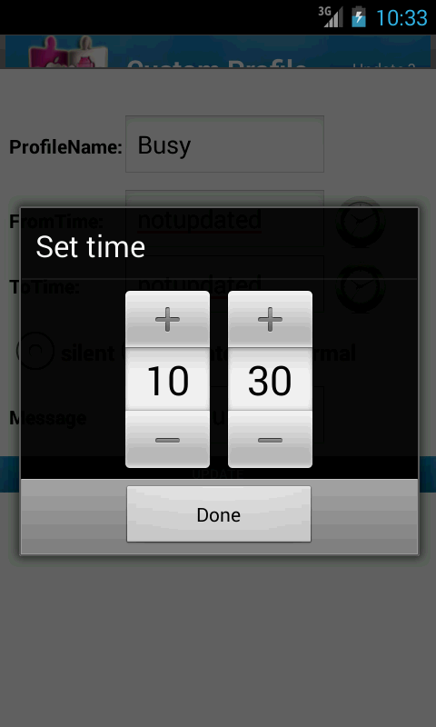

**7.**In this dialogbox, we set to time.

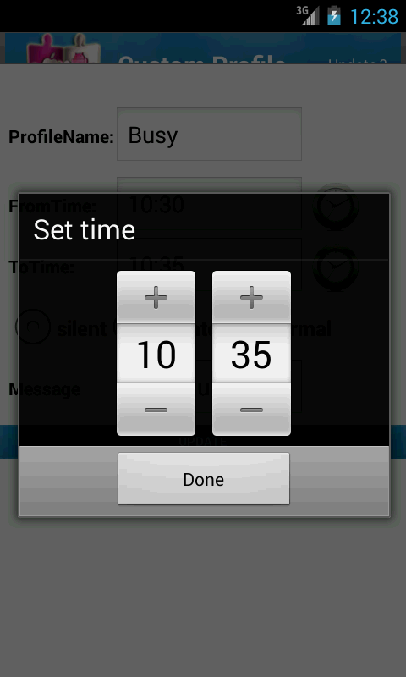

**8.**Profile updated is displayed on the home screen with the updated information

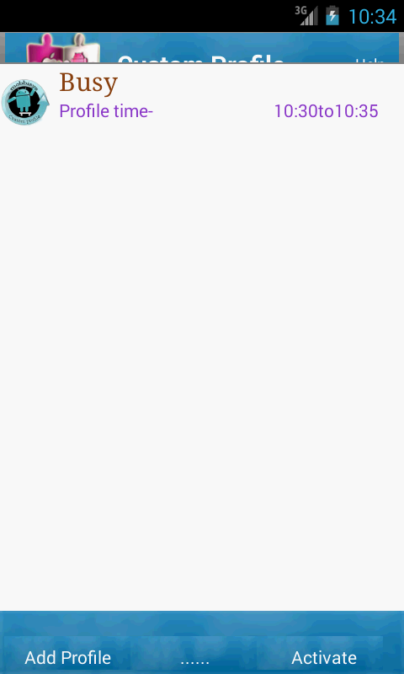

**Scrumdo link:**

<https://www.scrumdo.com/projects/project/plan4/iteration/121763/board>

**Github Link:**

**Implementation status report:**

**Work Completed:**

1. **Description:** As the developer, I need to develop a user interface for the creation of auto profile application so that users can create their profile

Responsibility: Bhuvana

Time Taken: 1 week

Contribution: 100%

1. As a system, I want to store the input data given by the user into the database so that user access the data when required

Responsibility: Bhargavi

Time Taken: 1 week

Contribution: 100%

1. As a user, I need to add a profile so that I can intimate the caller when I can't attend a call.

Responsibility: Spandana

Time Taken: 1 week

Contribution: 100%

1. As a user, I can create multiple profiles with different timings

Responsibility: Nagaraj

Time Taken: 1 week

Contribution: 100%

**Work To be completed:** None

**Issues/Concerns:**

* As we are new to android we faced some problems regarding the database connections.
* We faced build issues.