**CS5551**

**ADVANCED SOFTWARE ENGINEERING**

**PROJECT INCREMENT-II (PG-10)**

**TITLE:- AUTOPROFILE**

**Submitted By**:

Bhuvana Atluri (Class ID-3)

Venkata Sai Spandana Surapaneni (Class ID -47)

Vepuri Bhargavi (Class ID-52)

Venkata Nagaraj Voonna (Class ID-53)

**Import Existing Services/API**

Text to speech: This service is used to convert text to speech format.

**Detail Design**

**User Stories:**

We have four stories in iteration1

1. As a developer, I need to retrieve the input data given by the user from the database so that the application can use the data.
2. As a developer, I need to build a service to broadcast the message to the caller.
3. As a developer, I need to build a service to notify the message is sent or not.
4. As a developer, I need to mention the cases where the application should start working.
5. As a developer, I need to convert the text to speech and broadcast it as a message.

Use case:

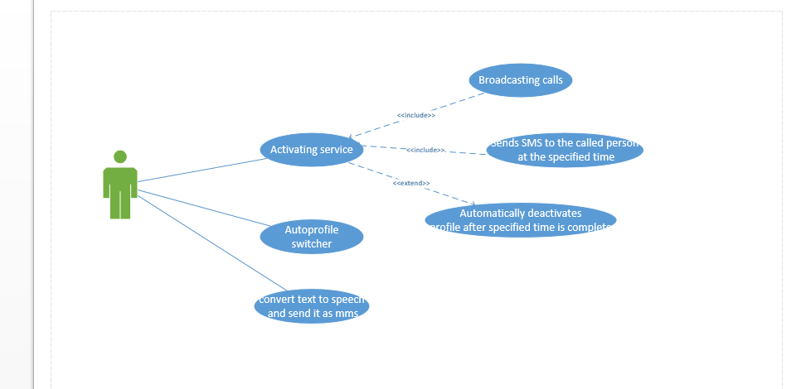

Description:

**Activating Profile Module**

In this module we activate our custom profile. This means we activate one or more of our saved profiles. And there should not exit two profiles at the same time. We are also implementing auto profile switcher, so that multiple profiles can be activated at one particular time. As soon as the profile is activated, the application starts working.

**Activate Service Module**

This module will provide 24*7 services to our custom profile this means activation of the profile is possible at any time. Activating the service means after setting the Timings and specifying message we activate the profile then the service is activated.

**Broad casting call and sending SMS module**

This module plays key role in whole system, it will broadcast the call, and if we have not attended the call it automatically sends the message to concerned call person. And it will notify us that the message is sent and delivered. Here we are also converting the text message in to voice message and sending it in the form of multimedia message.

Sequence Diagrams:

For Profile Activation:-

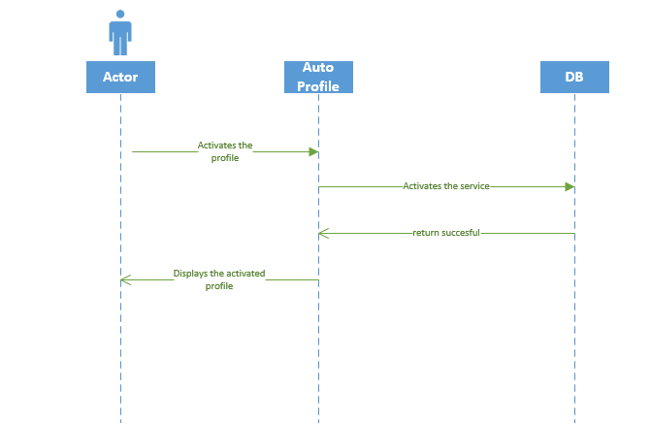

For Activating service and Broadcasting message:-

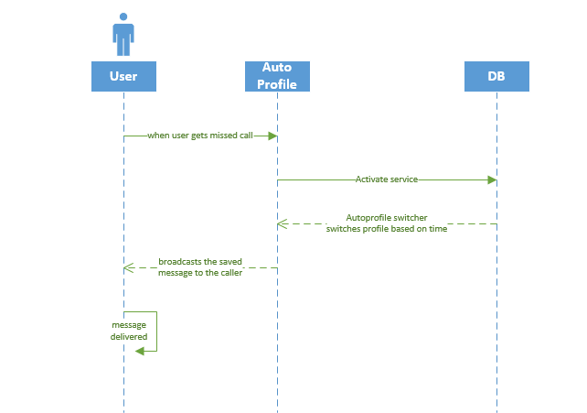

Class Diagram:

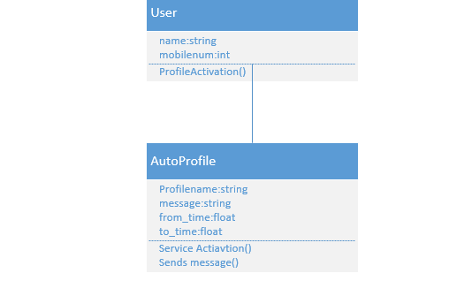

**Design of Mobile Client Interface:**

Mobile client interface is an Android application which is a rich client. In this increment our app consists of 4 different screens. The following are the screenshots of our application:

1. The saved profile is displayed on the home screen.

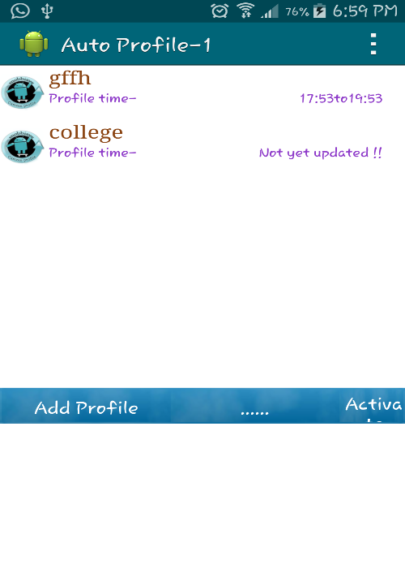

1. The saved profile is activated.

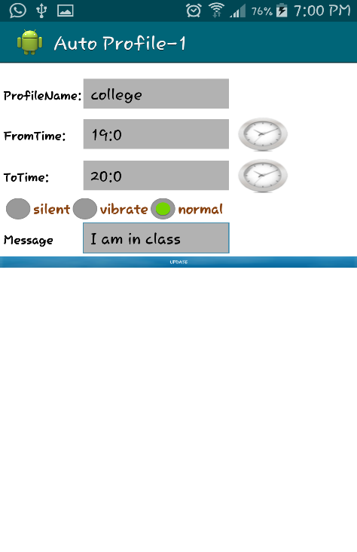

1. Profile updated is displayed on the home screen with the updated information

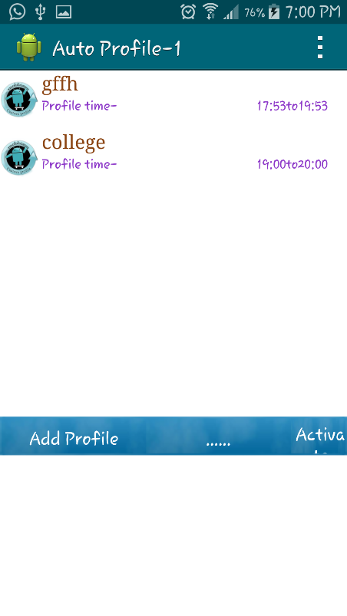

1. When we get a missed call, the service is activated

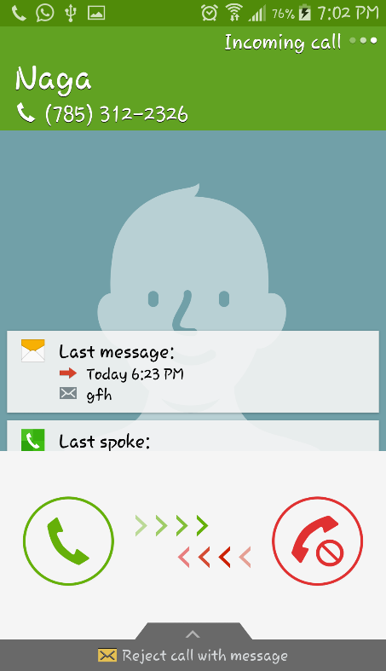 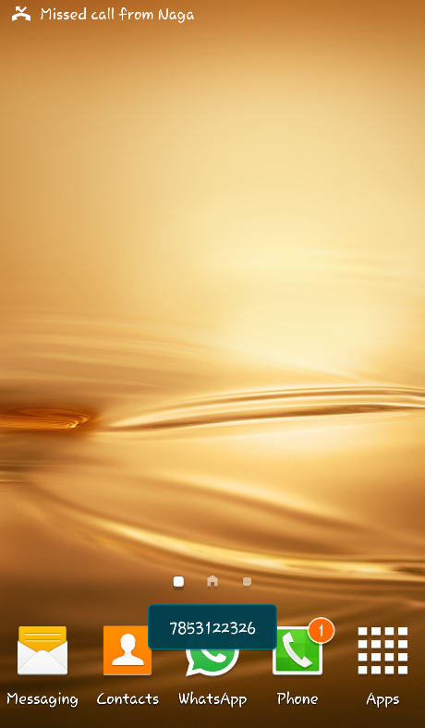

1. Pop will be displayed

 

1. We can view the sent message.

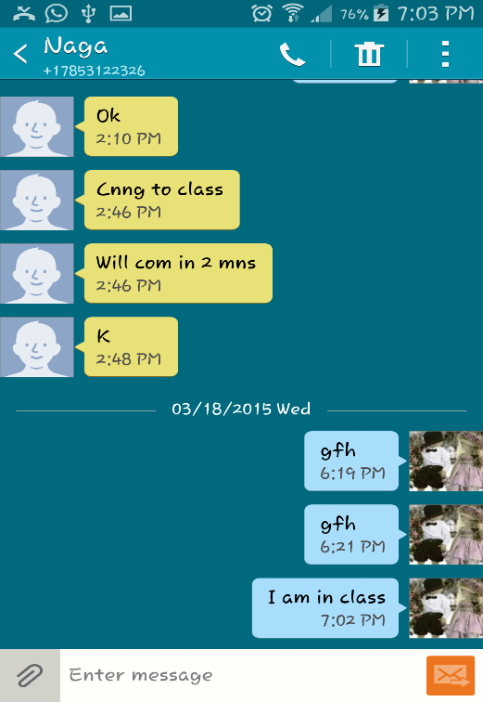

Scrumdo link:

<https://www.scrumdo.com/projects/project/2944/iteration/124768>

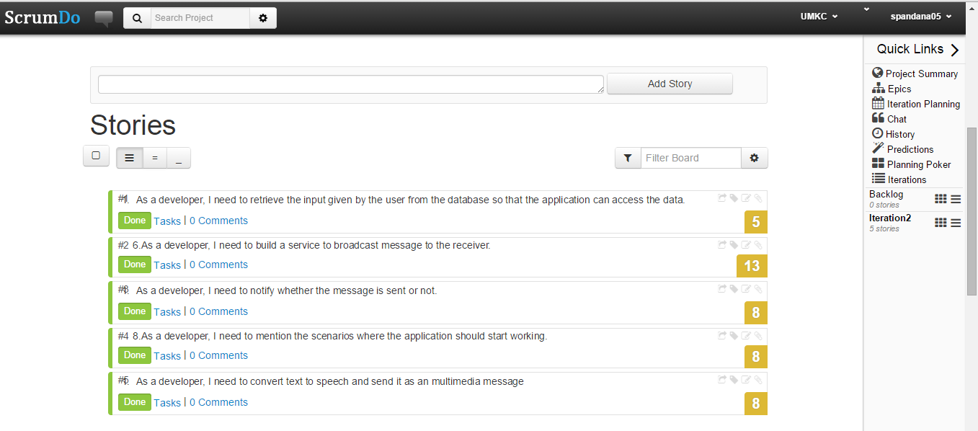

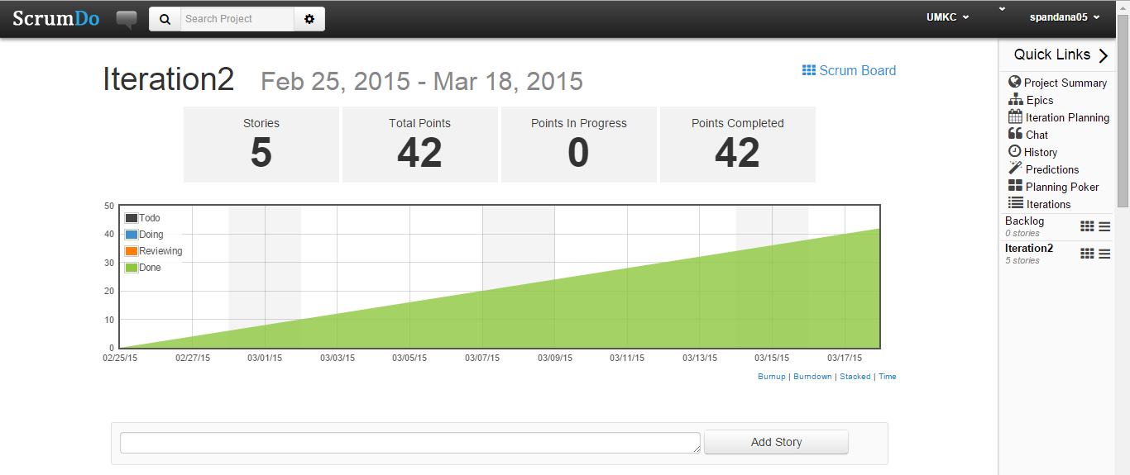

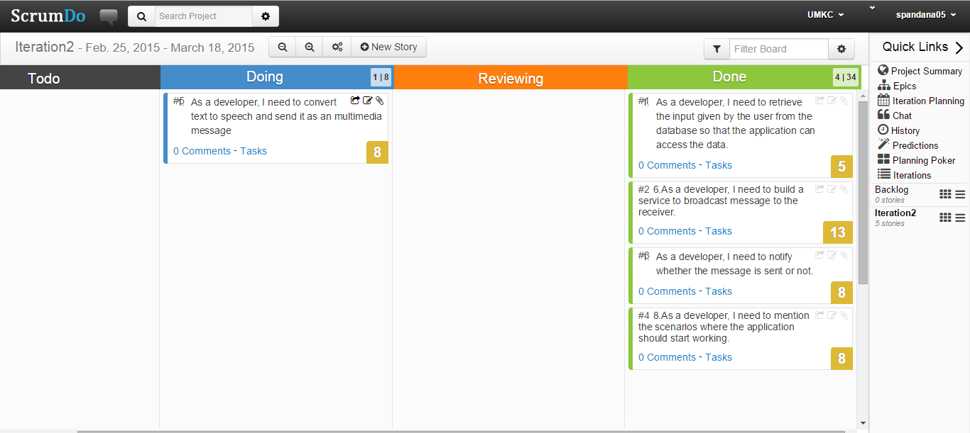

Github Link:

**Implementation status report:**

**Work Completed:**

**1. Description:** As a developer, I need to retrieve the input data given by the user from the database so that the application can use the data.

Responsibility: Bhuvana

Time Taken: 1 week

Contribution: 100%

1. As a developer, I need to mention the cases where the application should start working.

Responsibility: Bhargavi

Time Taken: 1 week

Contribution: 100%

1. As a developer, I need to build a service to broadcast the message to the caller.

Responsibility: Spandana

Time Taken: 1 week

Contribution: 100%

1. As a developer, I need to build a service to notify the message is sent or not.

Responsibility: Nagaraj

Time Taken:1 week

Contribution: 100%

**Work To be completed:**

1. We need to convert the text to speech and broadcast it as a message.

**Issues/Concerns:**

* We face difficulty in text to speech conversion.
* We are unable to save the audio.wav file, we are working on it.