**CS5551**

**ADVANCED SOFTWARE ENGINEERING**

**PROJECT INCREMENT-IV (PG-10)**

**TITLE:- AUTOPROFILE**

**Submitted By**:

Bhuvana Atluri (Class ID-3)

Spandana Surapaneni (Class ID -47)

Vepuri Bhargavi (Class ID-52)

Venkata Nagaraj Voonna (Class ID-53)

**Project Goal:**

Till now we have concentrated on sending messages, images and emails automatically whenever we are unable to attend the calls from the caller and missed call is detected. The message consists of the reason for not attending the call. If there is an emergency situation to the caller the receiver must be notified to attend the call or to communicate with the caller immediately. To get notified in case of emergency situation, the receiver sets the profile message as, in the case of the emergency reply me as “help”. When the caller gets the automatic message from the caller, then if in the case of emergency situation he replies with “help” message to the receiver. When the receiver receives help message then the notification sound will be triggered. The notification will be triggered even if the phone is in silent or vibration mode.

**Detail Design**

**User Stories:**

We have four stories in iteration4

1. As a developer, I need to send the message to the caller containing the message called reply me with “help” in case of emergency.
2. As a developer, I need to filter the messages received from the caller.
3. As a developer, I need to identify if any received message content consists of the “help” message.
4. As a developer, I need to notify in case of the emergency i.e. if any hep message is received.

**Description:** Whenever help message is received from the caller, the application matches it with the predefined text and if the matching occurs it notifies to the alarm handler and an alarm sound will be notified that the caller is in emergency situation.

**Sequence diagram:**

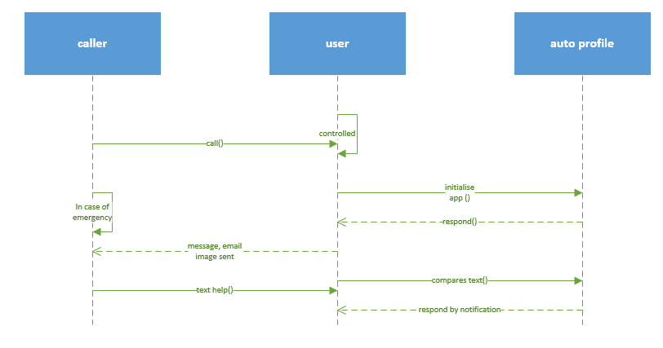

**Class diagram:**

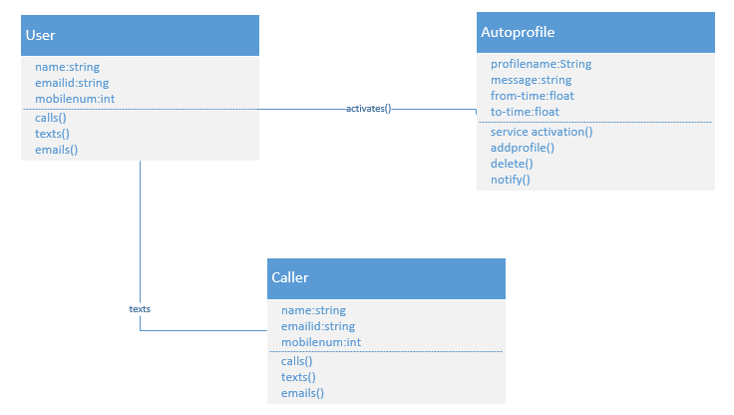

**Testing:**

Functional Testing:

Functional Testing is a process of quality assurance and it’s a type of black box testing that depends on the test cases on the specifications of the software product under test. The product and the software functionality are tested by inputting and testing the output, and the inner program features are considered rarely. The functionality of the system is tested normally. It tests just certain functionality of the system i.e. a part of the system.

We have done functional testing of auto profile by using ranorex studio, we have downloaded ranorex studio and open an empty recording file.

Start-programs-Ranorex-Ranorex studio-open empty recording file-new test solution-blank test suite project- select c# project-ranorex c# test suite-specify name-location for test suite-create.

This opens the new suite project and to start recording we have to add a device such as the mobile device and add it to the recording window. To start the application we have to select the device and start recording by clicking on the continue evaluation, start recording select mobile or desktop or web. For our application we have to select mobile and the recording is started automatically by selecting the web application and then the key press are recorded automatically and the time taken for each key press is recorded such as the timeout for the click and the type of action such as click, close window, log etc. The actions can be key press, key sequence, mouse, wait for, validate etc. The time out indicates the time taken for the click and the time in which it expires.

After recording press the stop button and then the log is created by playing the recorded video, then the results are displayed as the time, level, category, and message.

Below are the screenshots of the application when creating a profile and activating the profile, and deleting the profile.

Here we record the actions in the application by starting the profile and adding a profile and updating and deleting the profile and in the final we deactivate the profile and then deleting all the applications.

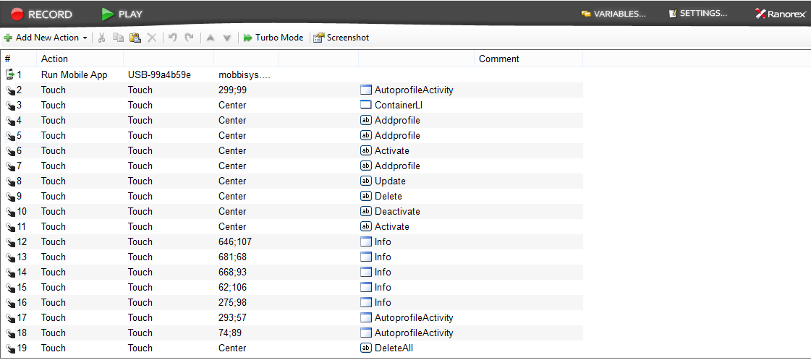

These are the results of the test case which shows the time and the category of the event and the message displayed by clicking the event.

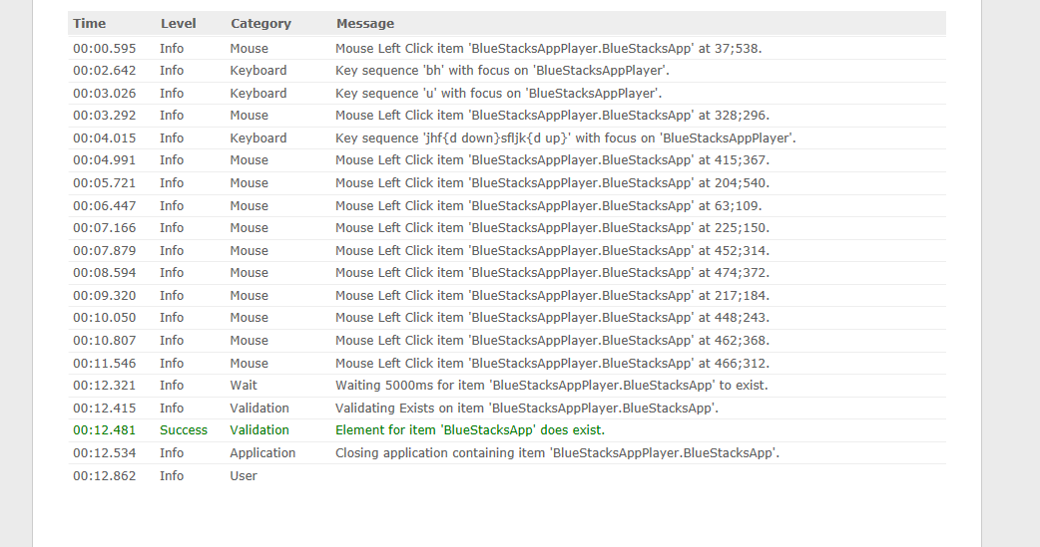

Final recording of the application giving a success output and it shows the execution time and the number of errors produced.

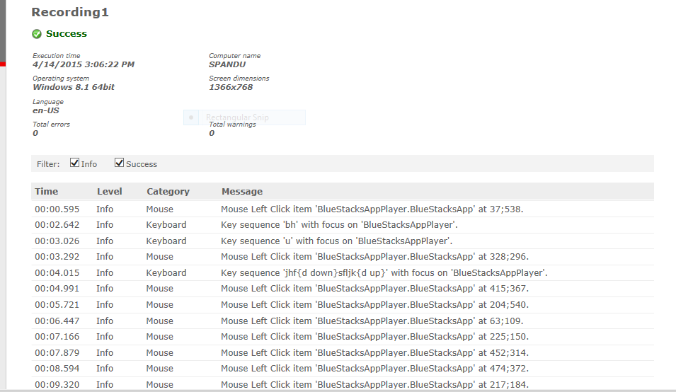

Here is another result of the event recording using the blue stack app player, the events are the same click on activating and deleting the profile and updating the profile.

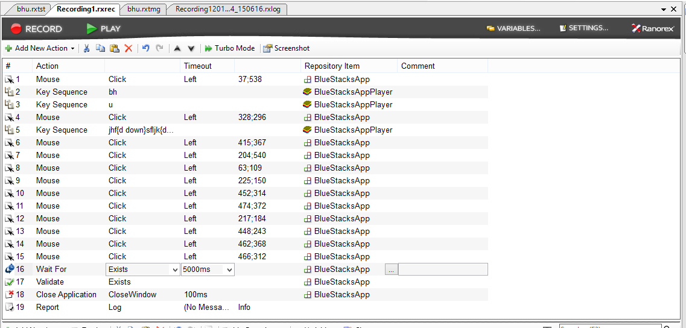

The results of the above recording are success and there are 0 errors for the above recording.

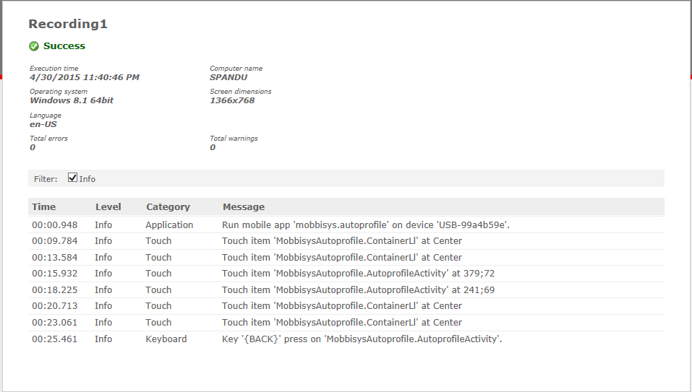

The results of the above events is given as output such as success and it denotes whether the application is success or failed or blocked.

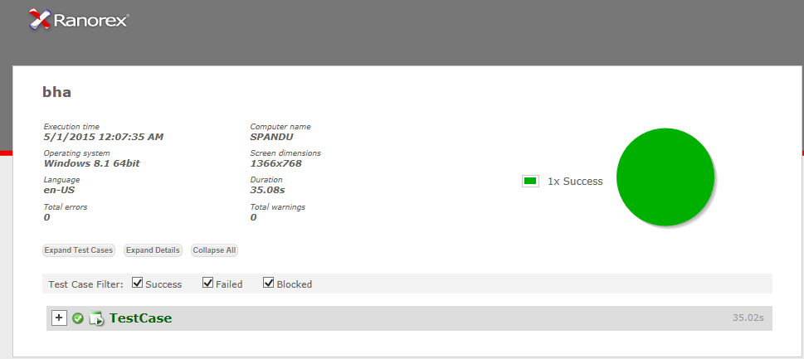

**Implementation:**

1. Whenever the receiver received “help” message then the application detects the keyword. 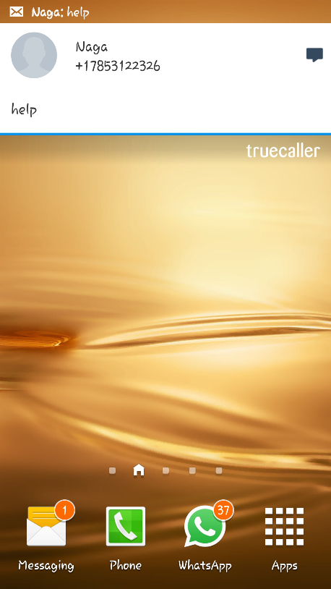

b) Whenever the keyword is detected receiver will be notified with the notification sound.

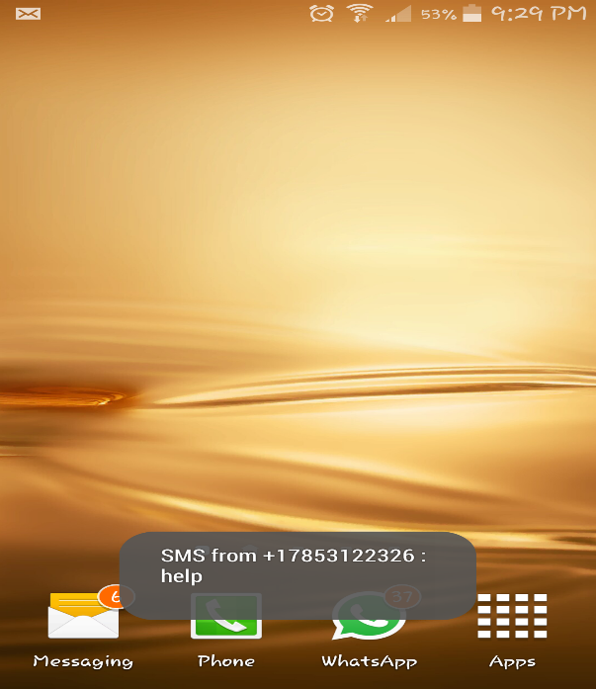

**Scrumdo :**

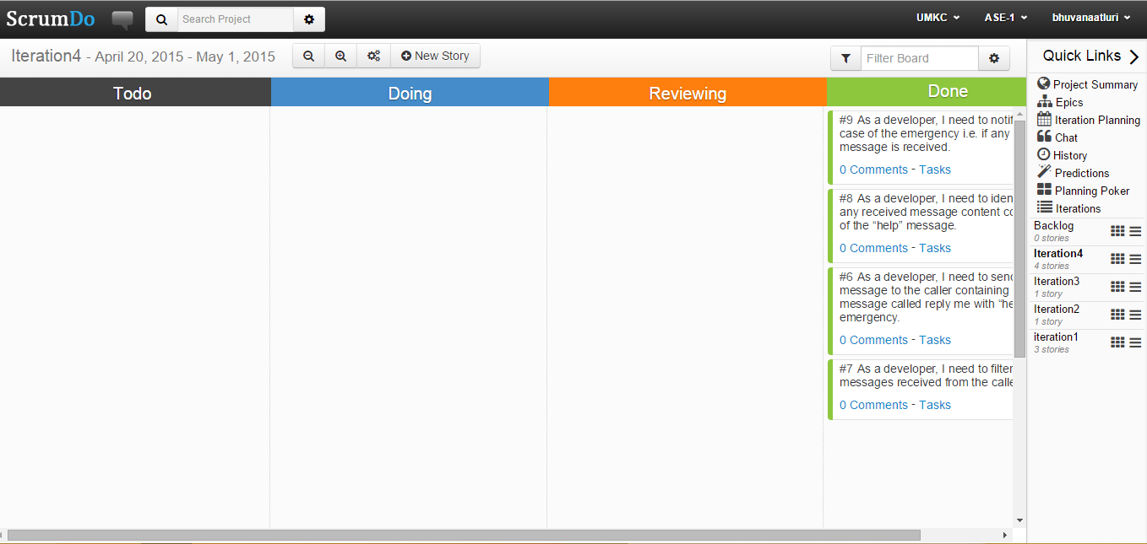

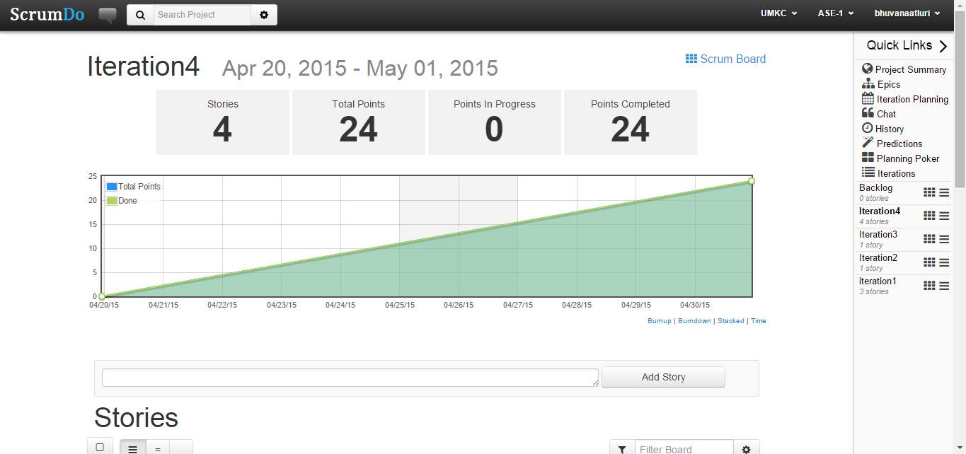

**Scrumdo link:**

<https://www.scrumdo.com/account/login/?next=/projects/project/ase-1/iteration/127057>

**GitHub link:**

**YouTube link:**

<https://youtu.be/wdVPcOZ1tKM>

**Work Completed:**

**1. Description:** As a developer, I need to filter messages received and determine if any message consists of “help”

**Responsibility:** Bhargavi, Bhuvana.

**Time Taken:** 20 hours

**Contribution:** 100%

**2. Description:** As a developer, I need to notify the receiver with notification sound.

**Responsibility:** Nagaraj, Spandana

**Time Taken:** 20 hours.

**Contribution: 100%**