**CS5551**

**ADVANCED SOFTWARE ENGINEERING**

**PROJECT INCREMENT-III (PG-10)**

**TITLE:- AUTOPROFILE**

**Submitted By**:

Bhuvana Atluri (Class ID-3)

Venkata Sai Spandana Surapaneni (Class ID -47)

Vepuri Bhargavi (Class ID-52)

Venkata Nagaraj Voonna (Class ID-53)

**Import Existing Services/API**

**Service:** Google mail

Description: To notify the caller, reason for not attending the calls.

**Detail Design**

**User Stories:**

We have four stories in iteration 3

1. As a developer, I need to send an email to the caller in order to inform him the reason for not attending the call.
2. As a developer, I am sending a picture to the caller as an mms for better view.
3. As a developer, I should be able to delete profiles which I feel unwanted.
4. As a developer, I should make sure, that at the same time two profiles should not be added.

Use case:

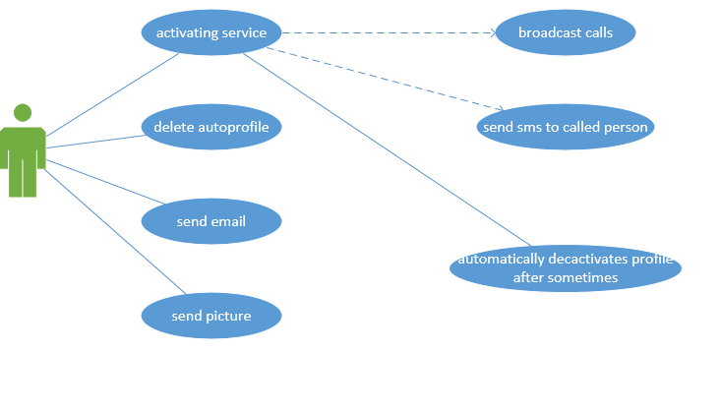

Description:

**Sending Email:**

In this module, we implemented an extension to our auto-profiling. In the previous increment we just sent a message to the called person when we not attended the call. But in this increment we send an email in addition to the message. The body of the email and the subject of the email will be set automatically, and we need to just send the email.

**Sending Picture**

In this module, we implemented an extra feature to our project, i.e. along with the message and email we are sending an image to the caller. By sending the image we can even better convey our message to the caller. And by this we can make our project even more interactive.

**Delete Profile:**

In this module, we implemented code to delete the already created profile. That is if we no longer want that profile, it is of no use. So we added this delete feature to our application. We can delete all the profiles at the same time and we will implement this in the next iteration.

**Colliding Schedules:**

In this module, we worked on colliding schedules i.e. one should not able to create two profiles at the same time. The application should restrict the user from creating such type of profiles.

Sequence Diagrams:

For Sending Email:-

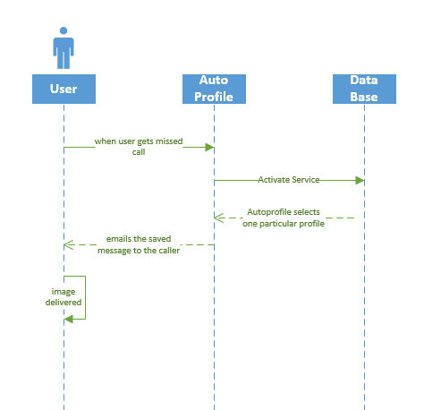

For Sending image:-

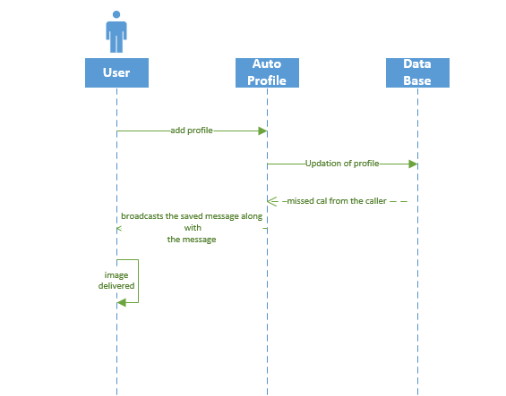

For Deleting Profile:

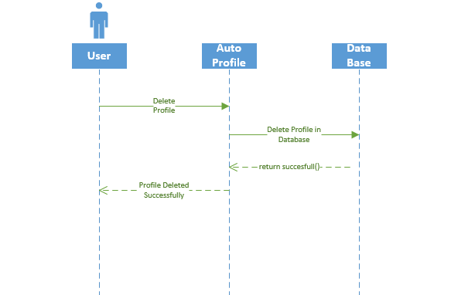

Class Diagram:

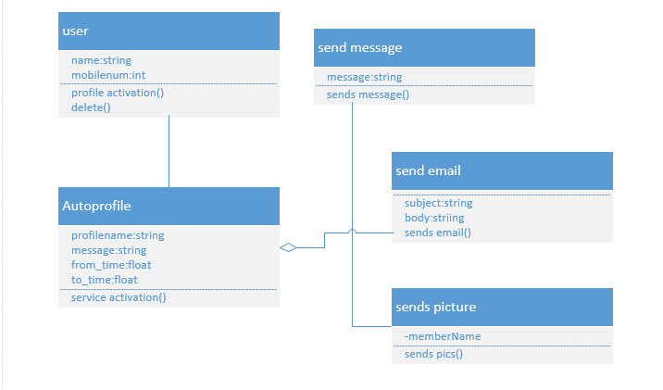

**Design of Mobile Client Interface:**

The following are the screenshots of our how our application works:

1. If we set two profiles at the same time a pop will be displayed.

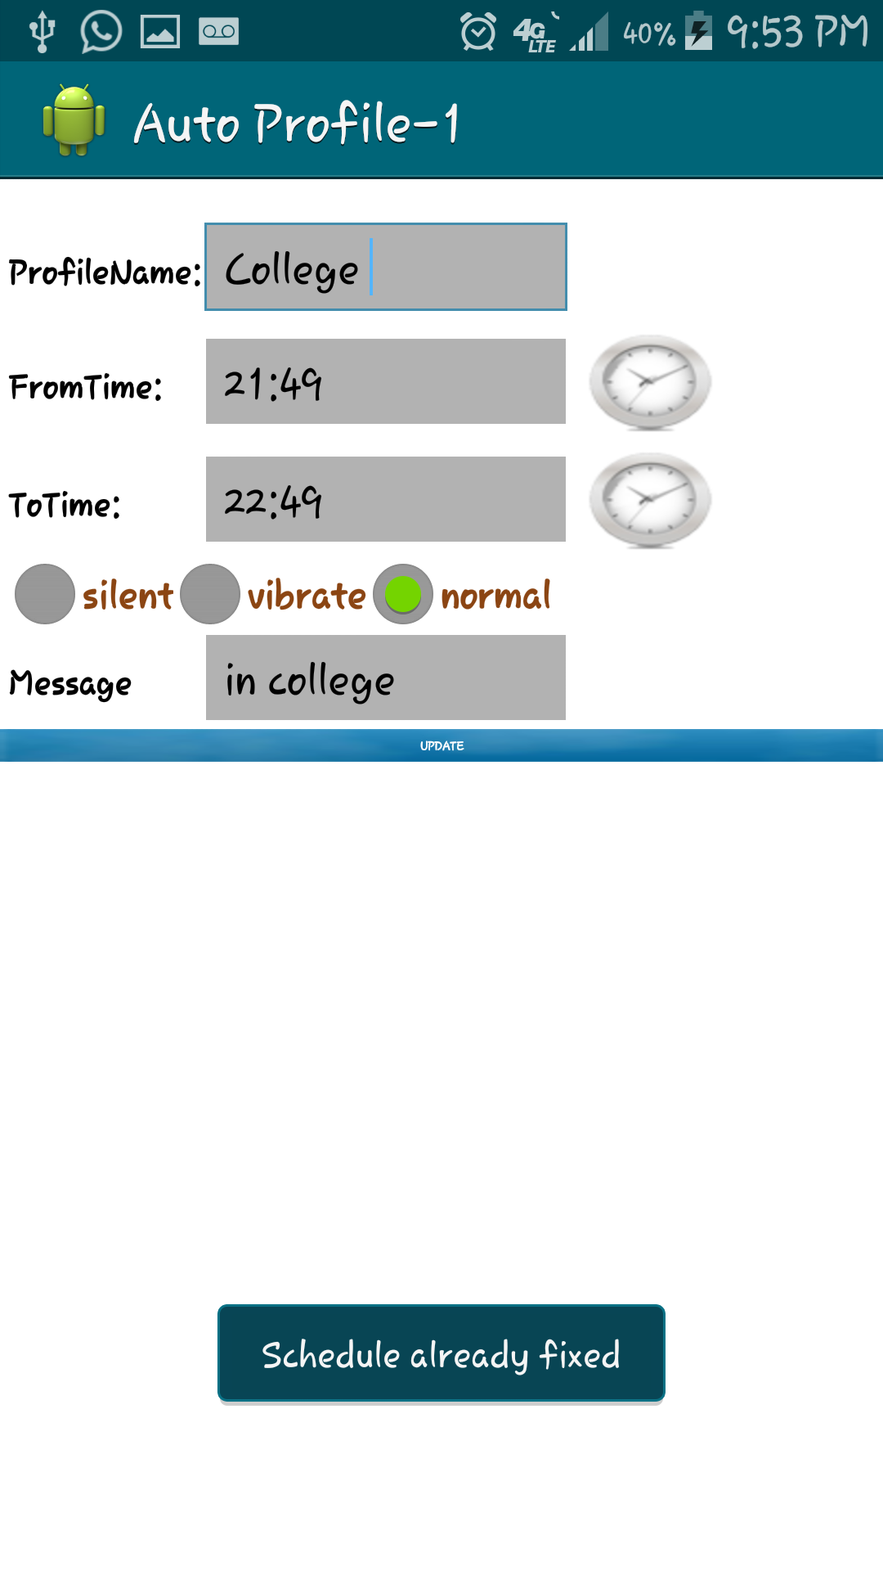

1. Sending image along with the message for interective display.

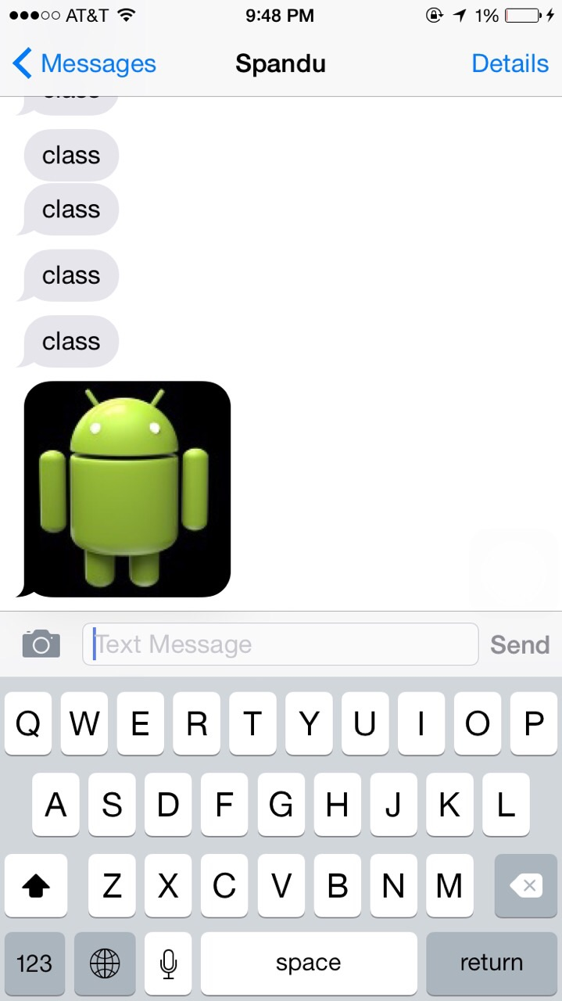

1. When a missed call is recorded in the profile set time then a pop-up appears to select the service to send the email.

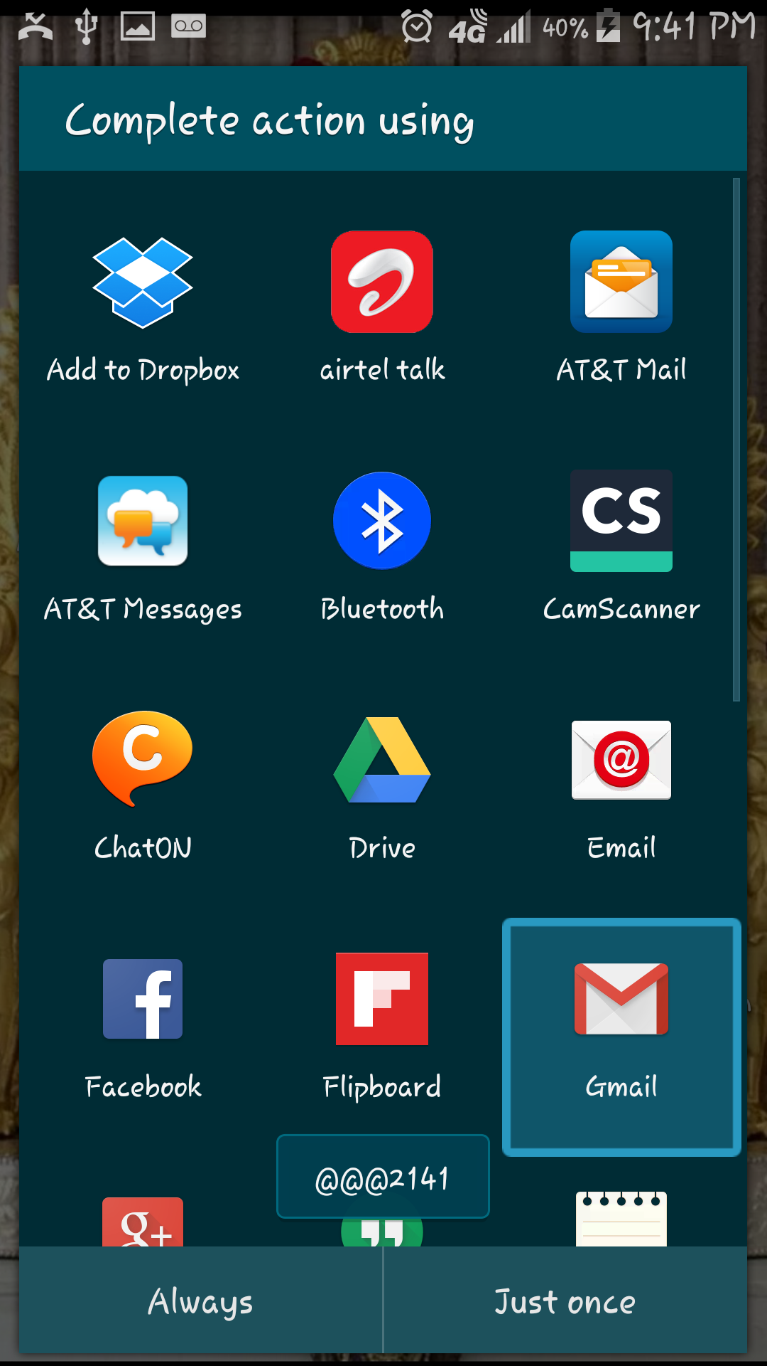

1. An email is set up in the following way:

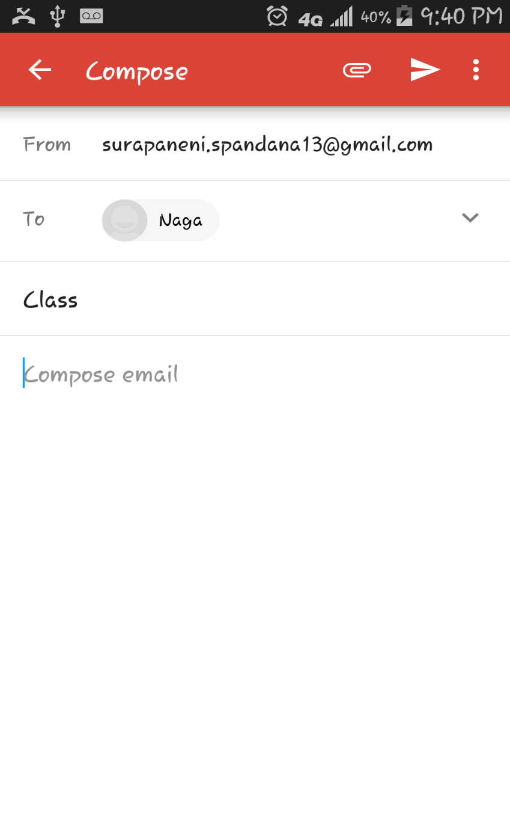

1. The called person will get the email in this way:

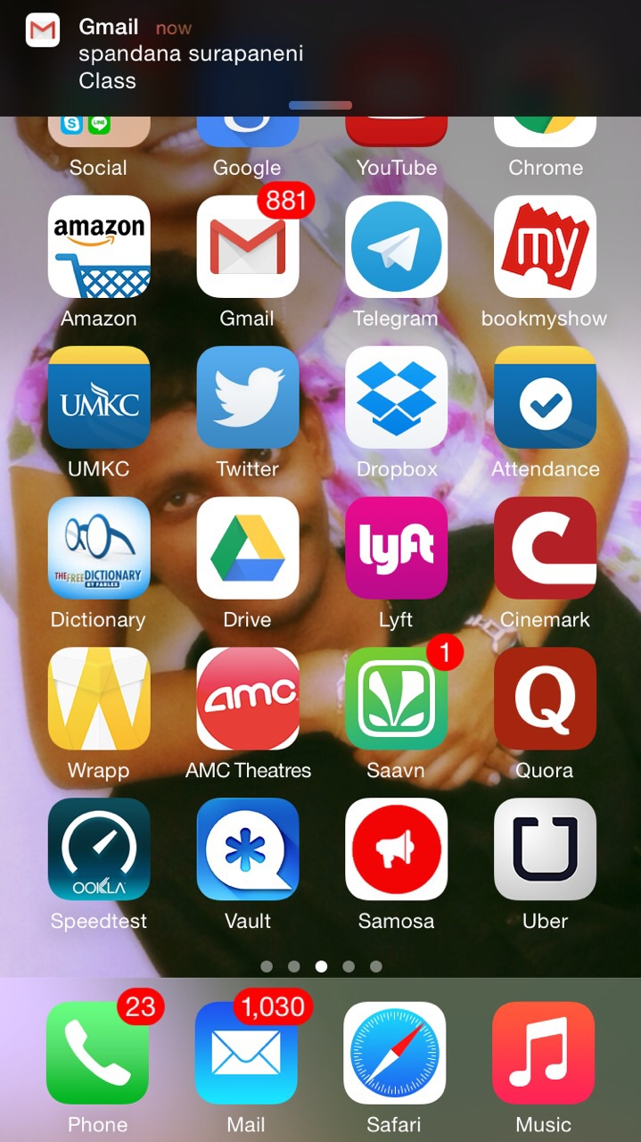

TESTING:

Functional Testing:

Functional testing is nothing but testing the application and validate the behavior of an application, it defines the systems is working in the specified manner or not. In this the tester validates the application whether the application meets the specified requirements or not. It concentrates on the customer requirements whether the customer is satisfied or not.

Functional testing of our application involves testing the functionalities of the application such as creating a profile, saving a profile, deleting a profile, sending message, sending email, text to speech conversion, sending an image when a call is rejected.

Deployment Testing:

It is a type of production testing to test whether it is working good in production or not which is performed after the code is deployed on the system. In this testing we deploy the application on the system and check whether it is working when the supporting files are removed from the system if it works then the application is not working properly and if it does not work then the application is said to be working normally.

Run time Performance testing is used to find the speed of a computer of the effectiveness of a network or a software program or a device. Testing performance involves measuring the response time i.e the time to get a response when a request is submitted. In other words it is also defined as MIPS which stands for millions of instructions per second which the system functions properly. In performance testing quality attributes such as the reliability, resource usage, interoperability, and scalability are evaluated.

Attributes in Performance Testing:

Speed, Scalability, Stability, Reliability

Speed:

The speed of the application refers to the fastness with which the application loads when it is initiated. The speed test helps us to know about the application whether it is loading fast, slow, and is it lagging for any reason.

The speed of our application on multiple android versions is calculated as follows:

1. Gingerbread:

We calculated the speed of the application by running it on various android versions several times. The time taken on average to run our application on Ginger bread version is 15 sec. To send the message from the caller to the calle is 10 seconds. We have given the screen shot when we use the app on the ginger bread version.

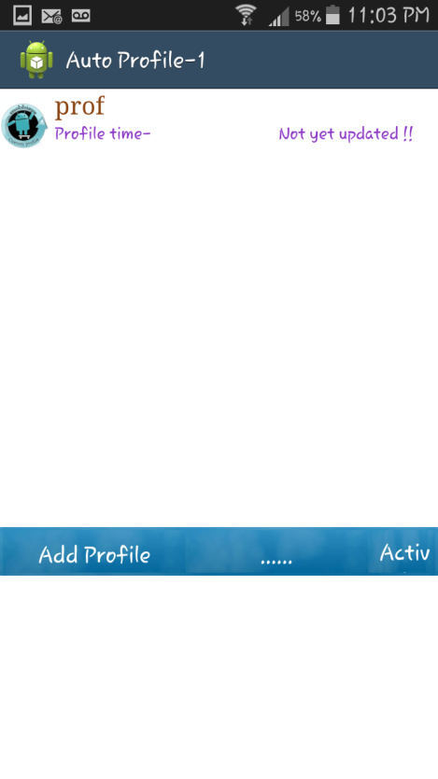

2. Honeycomb:

We calculated the speed of the application on honeycomb version as 12 sec. We have calculated this by running the application various times on the Honeycomb version. The time taking to send the message from the caller to the calle is 8 seconds.

3. Ice Cream Sandwich:

We calculated the application speed on Ice Cream Sandwich version as 10 sec, by running the application several times on this version. The time to send the message from the caller to the calle is 5 seconds.

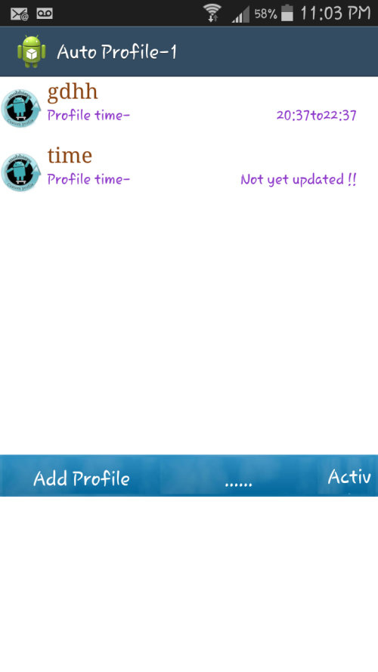

4. Jelly Bean:

The speed on the jelly bean version to run the application is 9 sec, the message is send to the calle in 4 seconds.

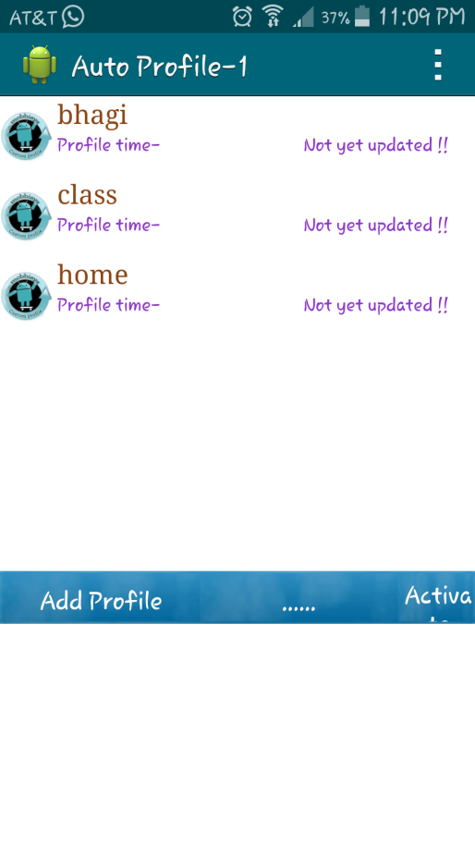

5.Kit Kat:

The speed on the kit kat version is 7 sec, and the time to send the message from the calle to the caller is 2 seconds.

Scalability:

It is nothing but the capability of a system to handle the increasing work in an effective way or the capability to grow so that to accommodate that growth. It refers to the capability of a system to with stand the increased load to produce an increased output when the resources are being added.

In our system the scalability is defined as the performance of the system when the number of profiles are increased in the application, though the profiles are increased the applications works usually by activating the profile which is set for the specified time.

Stability :

The stability of the system is defined if the application is stable for different varying loads.

In our system context when different profiles are used at a time only the first profile is active and the message will be displayed from the first profile only and the remaining profiles are said to be inactive and the messages are not displayed though the profiles are set for the same time.

Reliability:

The reliability of a system is defined as the performance of the system during an extended time period for various sets of test conditions, it is performed before deployment to discover and remove any failures from the system so as the system can function well after deployment. The main purpose of reliability testing is to find the reliability of the product whether the application meets the customer's requirements or not.

Application is said to be reliable when the application gives the same output repeatedly, is the probability of the application to perform well in the specified environment.

In our application reliability is tested by checking whether the system works for various sets of profiles set for different times and the message is delivered properly or not. The reliability is found to be successful when the system meets the user requirements i. e the profile should work properly when set for a particular time and the message should be send as it is important to send the message for the calle, also an email should be send to the person when required with an image.

Scrumdo link:

https://www.scrumdo.com/organization/umkc245/dashboard

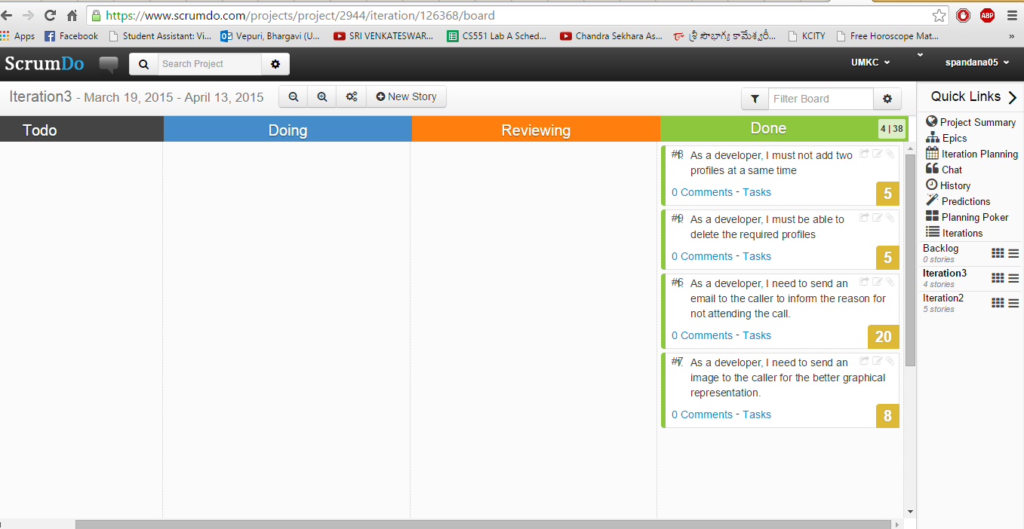

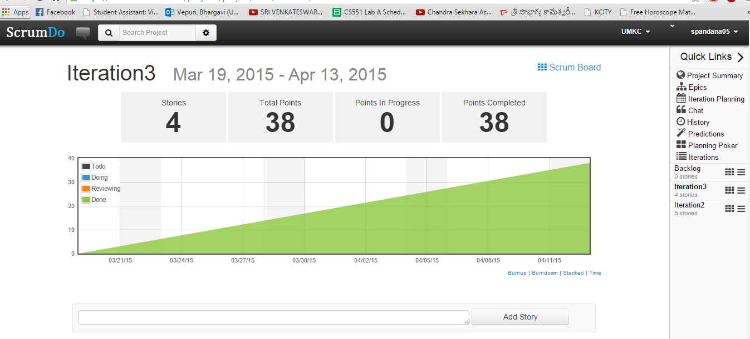

Github Link:

**Implementation status report:**

**Work Completed:**

1. **Description:** As a developer, I need to send an email to the caller in order to inform him the reason for not attending the call.

Responsibility: Bhuvana

Time Taken: 1 week

Contribution: 100%

1. As a developer, I am sending a picture to the caller as an mms for better view.

Responsibility: Bhargavi

Time Taken: 1 week

Contribution: 100%

1. As a developer, I should be able to delete profiles which I feel unwanted.

Responsibility: Spandana

Time Taken: 1 week

Contribution: 100%

1. As a developer, I should make sure, that at the same time two profiles should not be added.

Responsibility: Nagaraj

Time Taken:1 week

Contribution: 100%

**Work To be completed:**

1. We need to customize our application, so that we can send different messages to different groups such as family group, friends group etc.