|  |  |  |  |  |  |  |
| --- | --- | --- | --- | --- | --- | --- |
| **Bachelor of Technology**  **in**  **COMPUTER SCIENCE AND ENGINEERING**    **22CS2403 – DATABASE MANAGEMENT SYSTEMS**    **MINI PROJECT REPORT**  On    **PHARMACY MANAGEMENT SYSTEM**      Submitted By  **Sinchana M ENG22CS0170**  **Sneha Ilager ENG22CS0174**  **Sneha MP ENG22CS0175**  **Spandana K R ENG22CS0182**    **UNDER THE SUPERVISION**  **Prof. Sasikala N**  **Department of Computer Science, DSU**    **DEPARTMENT OF COMPUTER SCIENCE AND ENGINEERING**  **SCHOOL OF ENGINEERING**  **DAYANANDA SAGAR UNIVERSITY**  **(2023-2024)** | | | | | | |
| **School of Engineering**  **Department of Computer Science & Engineering**  Harohalli, Ramanagara - 562112  Karnataka, India    **CERTIFICATE**      This is to certify that the DBMS Mini Project titled “**Pharmacy Management System**” carried out by **Sinchana M (ENG22CS0170), Sneha Ilager (ENG22CS0174), Sneha MP (ENG22CS0175), Spandana K R (ENG22CS0182)** Bonafide students of Bachelor of Technology in Computer Science and Engineering at the School of Engineering, Dayananda Sagar University, Bangalore in partial fulfillment for the award of degree in Bachelor of Technology in Computer Science and Engineering, during the year 2023-2024.          **Prof. Sasikala N Dr. Girisha G S Dr. Uday Kumar Reddy K R**  Asst Prof, Dept. of CSE Chairman, CSE Dean  School of Engineering School of Engineering School of Engineering  Dayananda Sagar University Dayananda Sagar Dayananda Sagar University  University            **DATE: 07.06.2024** | | | | | | |
| **ACKNOWLEDGEMENT**  It is a great pleasure for us to acknowledge the assistance and support of many individuals who have been responsible for the successful completion of this DBMS MINI PROJECT  First, we take this opportunity to express our sincere gratitude to the School of Engineering & Technology, Dayananda Sagar University for providing us with a great opportunity to pursue our bachelor’s degree in this institution.  We would like to thank **Dr. Uday Kumar Reddy K R, Dean**, **School of Engineering & Technology**, **Dayananda Sagar University For** his constant encouragement and expert advice. It is immense pleasure to express our sincere thanks to **Dr. Girisha G S, Chairman**, **Department of Computer Science, and Engineering**, **Dayananda Sagar University,** for providing the right academic guidance that made our task possible.  We would like to thank our teacher **Prof Sasikala N**, **Asst Professor**, **Department of Computer Science and Engineering**, **Dayananda Sagar University**, for sparing her valuable time to extend help in every step of our DBMS MINI PROJECT, which paved the way for smooth progress and the fruitful culmination of the project.  We are also grateful to our family and friends who provided us with every requirement throughout the course. We would like to thank one and all who directly or indirectly helped us in the DBMS MINI PROJECT. | | | | | |
| **ABSTRACT**    The "Pharmacy Management System" is a comprehensive software solution developed as part of the fifth-semester Database Management System (DBMS). The project aims to address the needs of an established medical store in the city by automating various aspects of its operations. This system is designed to efficiently manage and streamline activities such as counter sales, purchases, reorder levels, supplier and customer monetary positions, and other transactions typically conducted in a medical store. | | |
| **TABLE OF CONTENTS**      **PAGE NO**        ABSTRACT  CHAPTER 1 INTRODUCTION………………………….………………………………………01  CHAPTER 2 PROBLEM STATEMENT…………….………………………………………...…02  CHAPTER 3 PROJECT DESCRIPTION……………………….………………………………..03  CHAPTER 4 DESIGN……………………………………………………………………………04  CHAPTER 5 METHODOLOGY………………………………………………….……………..05  CHAPTER 6 TESTING AND RESULT………..………………………………………………..06  CHAPTER 7 SYSTEM IMPLEMENTATION………………………………………….……….08  CHAPTER 8 CONCLUSION…………..………………………………………………………..09  CHAPTER 9 REFERENCES………………………...….……………………………………....10 | | | |
| **CHAPTER – 1**  **INTRODUCTION**    The "Pharmacy Management System" is a pivotal software project developed as a crucial component of the fifth-semester Database Management System (DBMS) laboratory, as part of the Bachelor of Engineering (BE) program in Information Science. This project addresses the imperative need for an efficient and streamlined approach to managing the operations of an established medical store in the city.  In the realm of pharmacy management, the transition from manual record-keeping to an automated system is paramount for ensuring accuracy, efficiency, and overall operational excellence. The Pharmacy Management System is meticulously designed to fulfill this need, providing a robust platform for the comprehensive management of various facets of a medical store's operations.                                    **CHAPTER - 2**    **PROBLEM STATEMENT**      Inefficient management of inventory, prescriptions, and customer records in pharmacies leads to errors, stockouts, and customer dissatisfaction. Manual processes for tracking medication expiration dates and managing supplier information are time-consuming and prone to human error. Lack of integration between inventory management, sales, and accounting systems results in inefficient operations and difficulty in tracking financial performance. Additionally, inadequate security measures leave patient data vulnerable to breaches and misuse. A comprehensive pharmacy management system is needed to streamline operations, optimize inventory levels, ensure compliance with regulations, enhance customer service, and protect sensitive information, ultimately improving the overall efficiency and profitability of the pharmacy. | |
| **CHAPTER – 3**    **PROJECT DESCRIPTION**    The Pharmacy Management System is a comprehensive software solution designed to streamline and optimize the operations of a pharmacy. It includes modules for inventory management, prescription handling, billing, reporting, and security features to ensure compliance with healthcare regulations.  With a user-friendly interface, pharmacists can easily manage medication inventory, track stock levels, and receive alerts for reorder. The system facilitates the uploading, verification, and filling of prescriptions, while also allowing for electronic prescribing and refill requests.  Integrated billing and payment processing capabilities enable seamless transactions with insurance companies, third-party payers, and cash-paying customers. Detailed reporting tools provide insights into sales trends, medication usage, and financial performance, aiding in decision-making and regulatory compliance.  Data security measures, including encryption and access controls, safeguard sensitive information and ensure compliance with HIPAA regulations. The system can also be integrated with other healthcare systems such as electronic health records (EHRs) and telemedicine platforms for enhanced interoperability.  Overall, the Pharmacy Management System enhances operational efficiency, accuracy, and compliance, ultimately improving the quality of patient care and customer satisfaction.            **SCHEMA:** | | | | |

**CHAPTER**

**-**

**4**

**DESIGN**

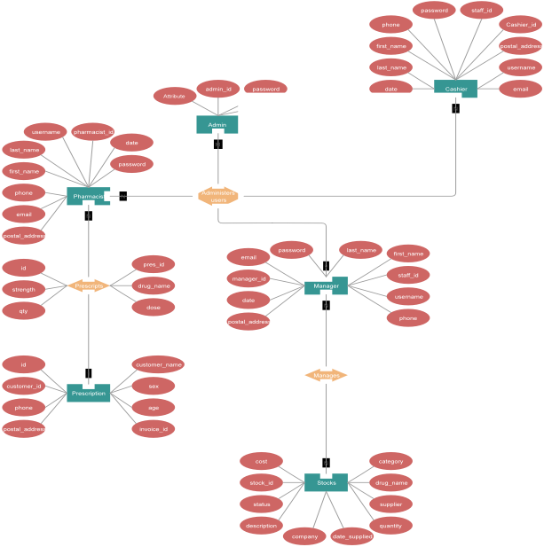

Figure. 1-ER Diagram of Pharmacy Management System

|  |  |
| --- | --- |
|  | **CHAPTER- 5**  **METHODOLOGY**    The methodology for developing a Pharmacy Management System typically involves the following steps:  1. Requirement Analysis: Gather requirements from stakeholders including pharmacists, administrators, and regulatory bodies. Define functional and non-functional requirements for the system.  2. System Design: Design the architecture and components of the system including the database schema, user interface layout, and system modules. Consider scalability, security, and integration with other systems.  3. Database Design: Create a database structure to store information such as medication details, patient records, prescriptions, inventory levels, and sales transactions. Define relationships between entities and ensure data integrity.  4. Development: Implement the system components based on the design specifications. Develop modules for inventory management, prescription handling, billing, reporting, and security features.  5. Testing: Conduct unit testing, integration testing, and system testing to ensure that each component functions correctly and meets the specified requirements. Test for usability, performance, security vulnerabilities, and compliance with regulations.  6. Deployment: Deploy the system in a production environment, either on-premises or on a cloud platform. Configure the system settings, database connections, and security controls according to the production environment requirements.  7. Training: Provide training to pharmacy staff on how to use the system effectively. Offer training materials, user manuals, and support resources to assist users in navigating the system.  8. Maintenance and Support: Provide ongoing maintenance and support services to address any issues, bugs, or updates that may arise. Monitor system performance, apply patches and updates, and make enhancements based on user feedback and changing requirements.  9. Documentation: Document the system architecture, design decisions, codebase, user manuals, and support procedures for future reference and knowledge transfer.  10. Continuous Improvement: Continuously evaluate the system performance, user feedback, and industry trends to identify areas for improvement. Implement enhancements, updates, and new features to enhance the functionality and usability o the Pharmacy Management System. |

**CHAPTER – 6**

**TESTING AND RESULT**

**LOGIN PAGE**

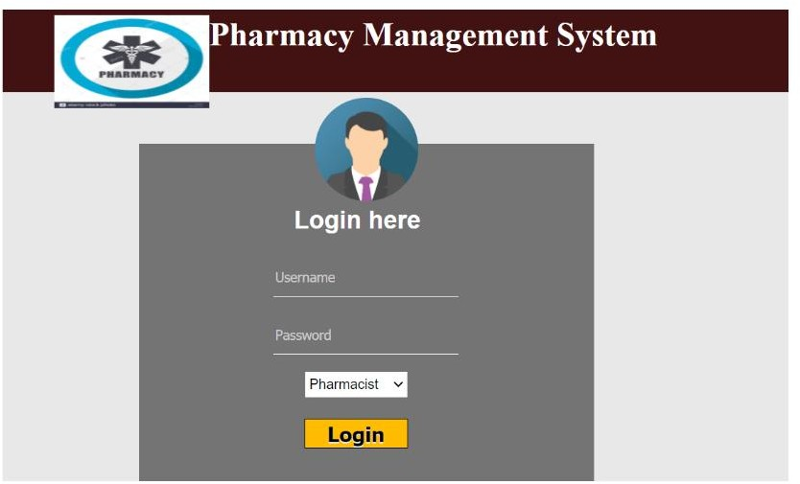

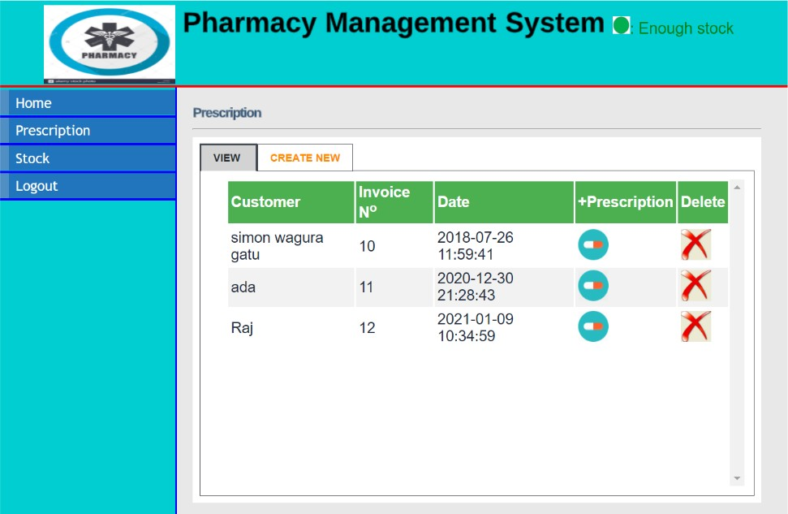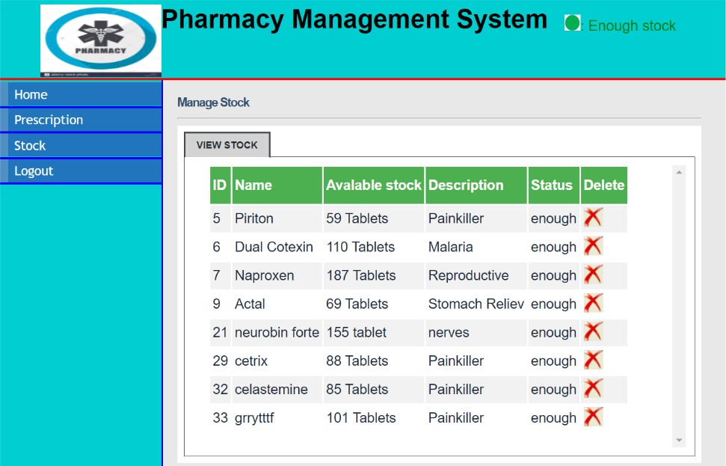

**-**

**PHARMACIST_PRESCRIPTION PAGE**

**-**

**-**

|  |
| --- |
| **CHAPTER 7**    **SYSTEM IMPLEMENTATION**    The methodology for developing a Pharmacy Management System typically involves the following steps:  1. Requirement Analysis: Gather requirements from stakeholders including pharmacists, administrators, and regulatory bodies. Define functional and non-functional requirements for the system.  2. System Design: Design the architecture and components of the system including the database schema, user interface layout, and system modules. Consider scalability, security, and integration with other systems.  3. Database Design: Create a database structure to store information such as medication details, patient records, prescriptions, inventory levels, and sales transactions. Define relationships between entities and ensure data integrity.  4. Development: Implement the system components based on the design specifications. Develop modules for inventory management, prescription handling, billing, reporting, and security features.  5. Testing: Conduct unit testing, integration testing, and system testing to ensure that each component functions correctly and meets the specified requirements. Test for usability, performance, security vulnerabilities, and compliance with regulations.  6. Deployment: Deploy the system in a production environment, either on-premises or on a cloud platform. Configure the system settings, database connections, and security controls according to the production environment requirements.  7. Training: Provide training to pharmacy staff on how to use the system effectively. Offer training materials, user manuals, and support resources to assist users in navigating the system.  8. Maintenance and Support: Provide ongoing maintenance and support services to address any issues, bugs, or updates that may arise. Monitor system performance,applypatches.  9. Documentation: Document the system architecture, design decisions, codebase, user manuals, and support procedures for future reference and knowledge transfer.  10. Continuous Improvement: Continuously evaluate the system performance, user feedback, and industry trends to identify areas for improvement. Implement enhancements, updates, and new features to enhance the functionality and usability of the Pharmacy Management System. |

**CHAPTER 9**

**REFERENCES**

1.<http://php.net/>

2.https://[www.](http://www/)<http://en.wikipedia.org/wiki/PHP>

3. https://[www.w3shools.com](http://www.w3shools.com/)