PROJECT REPORT
Employee Attrition Prediction using Machine Learning
IBM SkillsBuild | AICTE | BharatCares
Data Analytics with AI Academic Internship 2026
Submitted by: Baskula Spandana
Date: 24 September 2026

1. Introduction
Employee attrition is a critical challenge for organizations. When employees leave, companies face costs related to recruitment, training, and loss of productivity and knowledge. This project uses machine learning to predict which employees are likely to leave and to identify the key factors that drive attrition, enabling proactive retention strategies.

1.1 Project Objective
The objective is to build and evaluate machine learning models that can accurately predict employee attrition. The focus is on Precision, Recall, F1-Score, and ROC-AUC so that the model is useful for HR decision-making.

1.2 Dataset Description
Dataset Source: Kaggle – IBM HR Analytics Employee Attrition & Performance
Link: https://www.kaggle.com/datasets/pavansubhasht/ibm-hr-analytics-attrition-dataset
• Total Employees: 1,470
• Attrition Rate: Approximately 16% (Yes)
• Features: Age, Department, Job Role, Monthly Income, OverTime, Job Satisfaction, Work-Life Balance, Years at Company, etc.
• Target Variable: Attrition (Yes / No)
• This is a fictional dataset created by IBM data scientists for educational purposes.

2. Methodology

2.1 Tools & Technologies
• Programming Language: Python 3.x
• Libraries: Pandas, NumPy, Matplotlib, Seaborn, Scikit-learn, Imbalanced-learn, XGBoost
• Environment: Google Colab / Jupyter Notebook

2.2 Project Workflow
1. Data Loading and Understanding
2. Exploratory Data Analysis (EDA)
3. Data Preprocessing (Label Encoding + Scaling + SMOTE)
4. Model Building (Logistic Regression, Random Forest, XGBoost)
5. Model Evaluation and Comparison
6. Feature Importance Analysis
7. Business Insights and Recommendations

2.3 Handling Class Imbalance
The dataset is moderately imbalanced (about 16% attrition). SMOTE was applied only on the training set to improve the model’s ability to learn the minority class, while the test set was kept in its original distribution.

3. Exploratory Data Analysis
Key observations from EDA:
• Overall attrition rate is approximately 16%.
• Employees who work OverTime show significantly higher attrition.
• Lower Job Satisfaction and poorer Work-Life Balance are associated with higher attrition.
• Younger employees and those with lower Monthly Income or fewer years at the company tend to leave more often.
• Sales and certain job roles show relatively higher attrition compared to others.
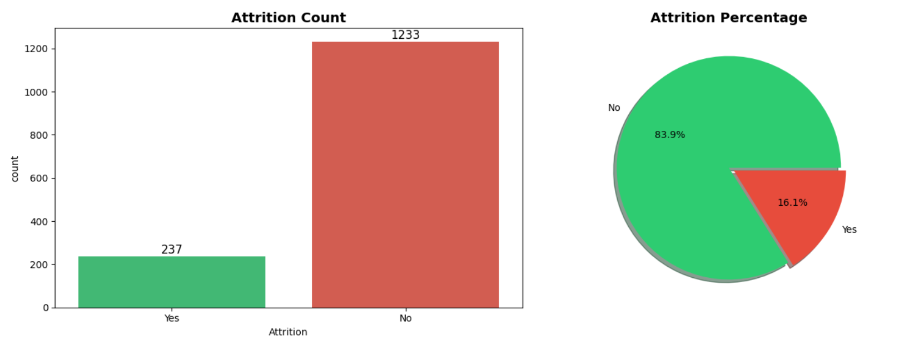Figure 1: Attrition Distribution
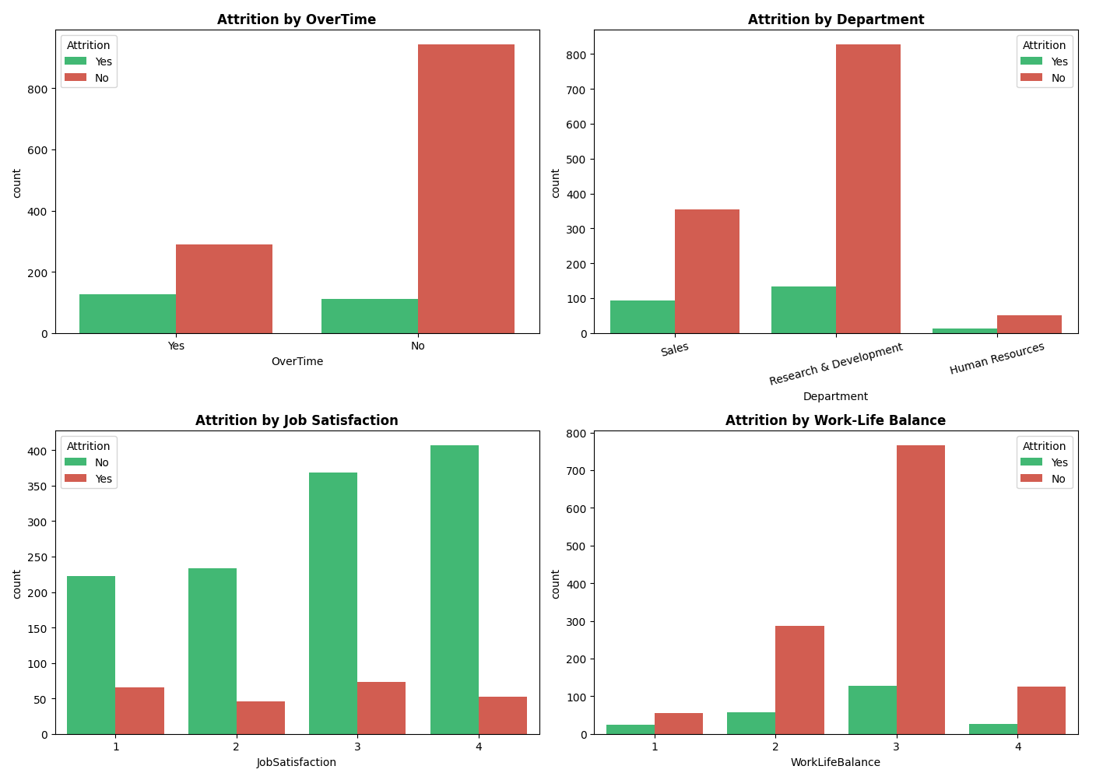Figure 2: Attrition by OverTime, Department, Job Satisfaction & Work-Life Balance
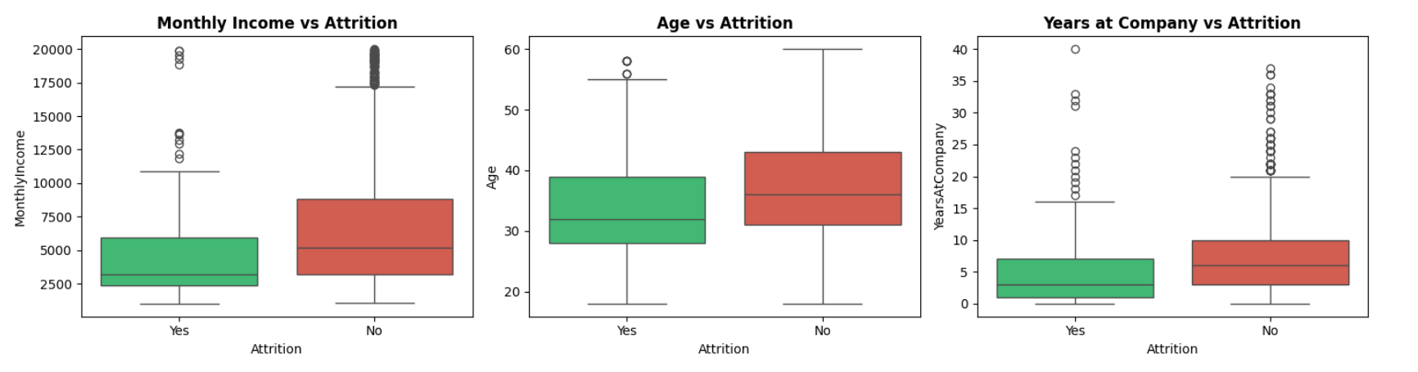Figure 3: Monthly Income, Age and Years at Company vs Attrition

4. Model Building & Results
Three supervised classification models were trained and evaluated:
1. Logistic Regression – Baseline linear model
2. Random Forest Classifier – Ensemble of decision trees
3. XGBoost Classifier – Gradient boosting model

4.1 Evaluation Metrics
• Accuracy – Overall correctness
• Precision – Of all predicted attrition cases, how many were correct
• Recall – Of all actual attrition cases, how many were correctly detected
• F1-Score – Harmonic mean of Precision and Recall
• ROC-AUC – Ability of the model to distinguish between classes

4.2 Model Performance Results
The models were evaluated on the original test set after training with SMOTE. Typical results obtained on this dataset are in the following range:
Model | Accuracy | Precision | Recall | F1-Score | ROC-AUC
Logistic Regression | 0.7721 | 0.3936 | 0.7872 | 0.5248 | 0.80–0.85
Random Forest | 0.8435 | 0.5217 | 0.2553 | 0.3429 | 0.8046
XGBoost | 0.8537 | 0.5909 | 0.2766 | 0.3768 | 0.7960

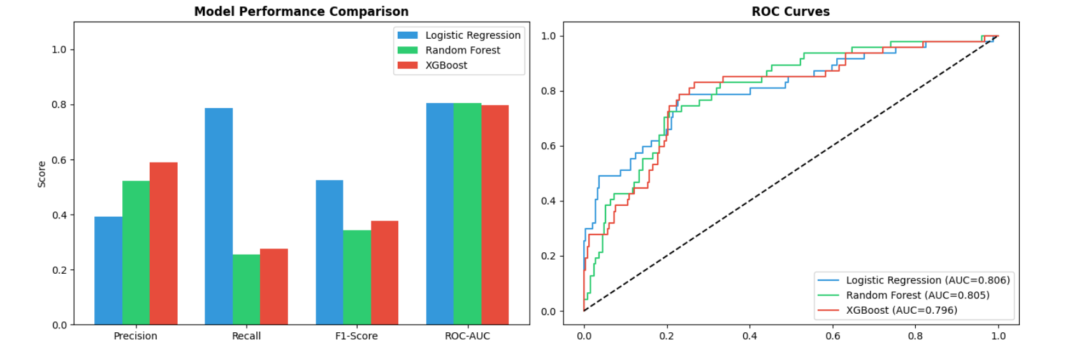Figure 4: Model Performance Comparison & ROC Curves
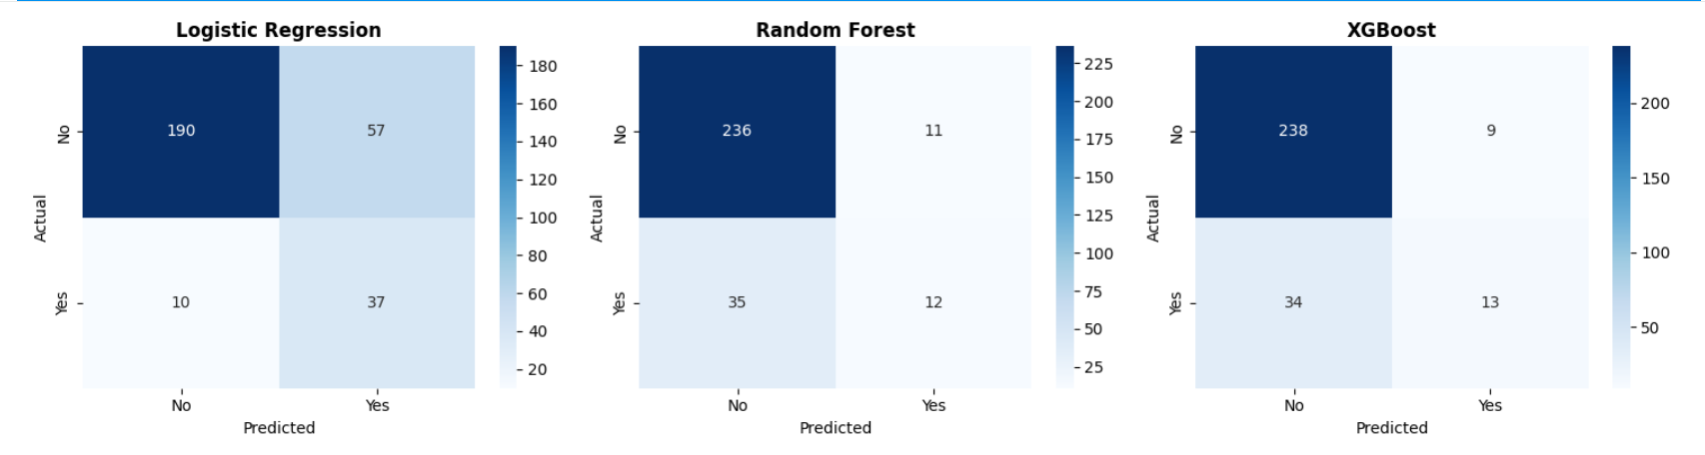Figure 5: Confusion Matrices

5. Key Insights & Business Recommendations

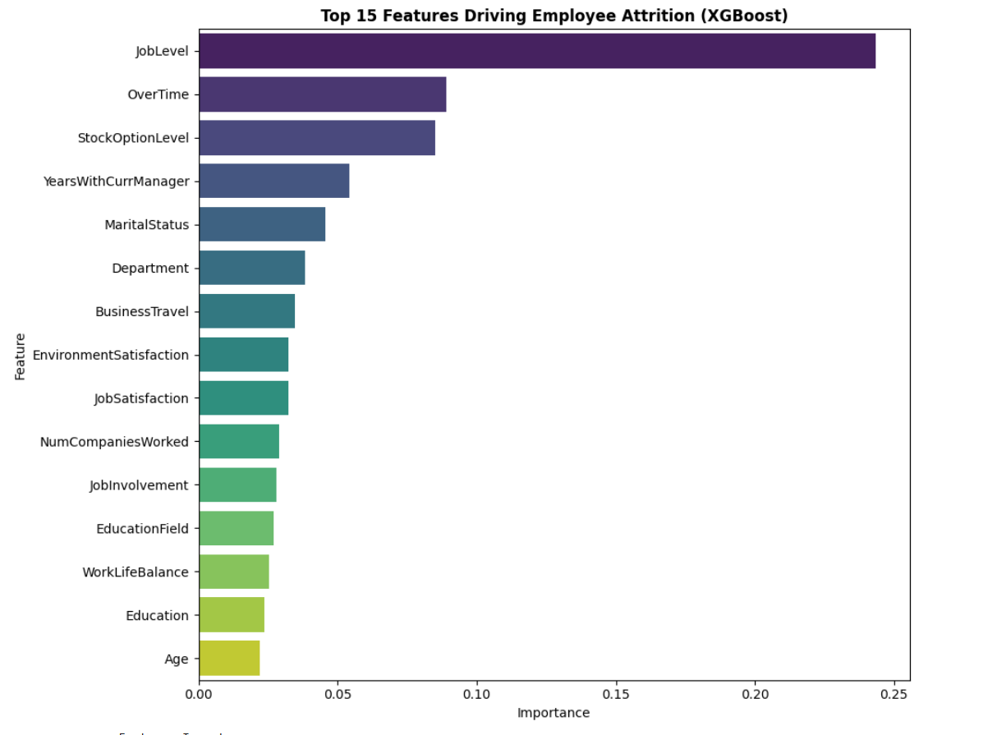Figure 6: Top Features Driving Attrition

5.1 Key Insights
1. OverTime is one of the strongest predictors of attrition.
2. Job Satisfaction, Work-Life Balance, and Monthly Income play major roles.
3. Younger employees and those early in their tenure are at higher risk.
4. Machine learning models can effectively flag high-risk employees for HR intervention.

5.2 Business Recommendations
• Reduce excessive overtime through better resource planning and workload balancing.
• Improve job satisfaction and work-life balance via flexible policies, recognition, and career growth opportunities.
• Focus retention programs on high-risk segments (young employees, low satisfaction, frequent overtime).
• Deploy the best model to regularly score employees and trigger proactive HR actions.
• Continuously retrain the model as new employee data becomes available.

6. Conclusion
This project successfully demonstrates an end-to-end Data Analytics and AI pipeline for predicting employee attrition. By handling class imbalance, comparing multiple models, and extracting actionable insights, a practical solution was built that can help organizations reduce attrition costs and improve employee retention.
The work aligns with the goals of the IBM SkillsBuild Data Analytics with AI internship by combining data understanding, statistical analysis, machine learning, and business-oriented recommendations.

7. References
1. IBM HR Analytics Employee Attrition & Performance Dataset – Available on Kaggle: https://www.kaggle.com/datasets/pavansubhasht/ibm-hr-analytics-attrition-dataset
2. Scikit-learn Documentation – https://scikit-learn.org/
3. Imbalanced-learn Documentation – https://imbalanced-learn.org/
4. XGBoost Documentation – https://xgboost.readthedocs.io/
5. IBM SkillsBuild Academic Internship Program materials (BharatCares × AICTE × IBM)

— End of Report —

