|  |
| --- |
| **DAYANANDA SAGAR UNIVERSITY**  Devarakaggalahalli, Harohalli  Kanakapura Road, Ramanagara - 562112, Karnataka, India   |

**Bachelor of Technology**

**in**

**COMPUTER SCIENCE AND ENGINEERING**

**Full Stack Development**

**Mini Project Report**

**COOKING CHAPTERS**

By

**Nidhi Nayak – ENG23CT0010**

**Tanu Badhai- ENG23CT0061**

**Keshna Bansal- ENG23CT0030**

**Srishti Chowdary- ENG23CT0042**

**Spandana D.C- ENG23CT0021**

**Under the supervision of**

**Prof. Yashaswini BV**

**Assistant Professor, Department of Computer Science and Technology**

**DEPARTMENT OF COMPUTER SCIENCE & ENGINEERING,**

**SCHOOL OF ENGINEERING,**

**DAYANANDA SAGAR UNIVERSITY.**

**(2024-2025)**

**DAYANANDA SAGAR UNIVERSITY**

Department of Computer Science & Technology

Devarakaggalahalli, Harohalli

Kanakapura Road, Ramanagara - 562112, Karnataka, India.

CERTIFICATE

This is to certify that the Full Stack Development Mini Project work titled **“COOKING CHAPTERS”** is carried out by **Nidhi Nayak(ENG23CT0010), Tanu Badhai(ENG23CT0061),Keshna Bansal(ENG23CT0030), Srishti Chowdary(ENG23CT0042),Spandana D.C(ENG23CT0021)** Bonafide students of Third semester of Bachelor of Technology in Computer Science and Technology at the School of Engineering, Dayananda Sagar University, Bangalore in partial fulfillment for the award of degree in Bachelor of Technology in Computer Science and Technology , during the year **2024-2025**.

|  |  |
| --- | --- |
| **Prof. Yashaswini BV** | **Dr. M Shahina Parveen** |
| Assistant Professor  Dept. of CST,  School of Engineering  Dayananda Sagar University  Date: 18/12/24 | Chairman CST  School of Engineering  Dayananda Sagar University  Date:18/12/24 |

**Name of the Examiner** **Signature of Examiner**

<

DECLARATION

We, **Nidhi Nayak (ENG23CT0010), Tanu Badhai (ENG23CT0061),** **Keshna Bansal (ENG23CT0030), Srishti Chowdary (ENG23CT0042),** **Spandana DC (ENG23CT0021),** are students of Third semester B. Tech in **Computer Science and Technology**, at School of Engineering, **Dayananda Sagar University**, hereby declare that the Mini Project titled **“Cooking Chapters”** has been carried out by us and submitted in partial fulfilment for the award of degree in **Bachelor of Technology in Computer Science and Technology** during the academic year **2024‑2025.**

|  |  |
| --- | --- |
| Student | Signature |
| Nidhi Nayak:  ENG23CT0010 |  |
| Tanu Badhai:  ENG23CT0061 |  |
| Keshna Bansal:  ENG23CT0030 |  |
| Srishti Chowdary:  ENG23CT0042  Spandana DC:  ENG23CT0021 |  |
| Place:Bangalore  Date :18/12/24 |  |

**ACKNOWLEDGEMENT**

*It is a great pleasure for us to acknowledge the assistance and support of many individuals who have been responsible for the successful completion of Full Stack Development mini project work.*

*First, we take this opportunity to express our sincere gratitude to School of Engineering & Technology, Dayananda Sagar University for providing us with a great opportunity to pursue our Bachelor’s degree in this institution.*

*We would like to thank* ***Dr. Udaya Kumar Reddy K R, Dean, School of Engineering & Technology, Dayananda Sagar University*** *for his constant encouragement and expert advice.*

*It is a matter of immense pleasure to express our sincere thanks to* ***Dr. M. Shahina Parveen,******Department Chairman****,* ***Computer Science and Technology****,* ***Dayananda Sagar University,*** *for providing right academic guidance that made our task possible.*

*We would like to thank our guide, Prof****.Yashaswini BV*** *Assistant* ***Professor****,* ***Dept. of Computer Science and Technology****,* ***Dayananda Sagar University****, for sparing her valuable time to extend help in every step of our project work, which paved the way for smooth progress and fruitful culmination of the project.*

*We are also grateful to our family and friends who provided us with every requirement throughout the course.*

*We would like to thank one and all who directly or indirectly helped us in the mini Project work.*

**TABLE OF CONTENTS**

LIST OF FIGURES

LIST OF TABLES

ABSTRACT

Page

CHAPTER 1 INTRODUCTION………................................................................. 1

CHAPTER 2 OVERVIEW OF PROJECT……..................................................... 3

2.1. Purpose and Goals.......................................................................... 4

2.2. Technologies Used........................................................................... 5

CHAPTER 3 FUNCTIONAL REQUIREMENTS..................................................... 6

CHAPTER 4 CODE SNIPPETS………...................................................................... 7

CHAPTER 5 RESULT………………………........................................................... 10

CONCLUSION……………………………………………………………………... 15

**Abstract**

The *Cooking Chapters* is an innovative web-based solution that provides a platform for users to search for recipes based on ingredients they have or specific meal preferences. The system integrates modern technologies to fetch and display recipes dynamically from a third-party API. By bridging the gap between available ingredients and cooking options, the website aims to reduce food wastage, encourage home cooking, and provide an efficient solution for meal planning. Developed using a combination of **HTML, CSS, JavaScript**, and **Python Flask**, the project offers a user-friendly experience, responsive design, and quick access to a variety of recipes. This report discusses the purpose, architecture, functionality, and results of the project.

**CHAPTER 1**

INTRODUCTION

Cooking meals at home is an integral part of daily life, but users often struggle to decide what to cook with available ingredients. This inspired the development of *Cooking Chapters*, a web-based platform that solves this problem efficiently. The project allows users to:

* Input ingredients they already have.
* View recipes curated based on their preferences.
* Explore new cuisines and meal types.

**FIRST LEVEL OF HEADING:**

The Cooking Chapters website is designed to solve the problem of meal planning by suggesting recipes based on user-provided ingredients. The platform provides a comprehensive solution for users who want to minimize food wastage, discover new recipes, or prepare meals quickly.

**Second Level of Heading:**

The aim of the Cooking Chapters project is to create a **web-based solution** that allows users to quickly discover recipes tailored to their needs. The scope of the project includes the following:

**THIRD LEVEL OF HEADING:**

The Cooking Chapters website addresses a common problem in households: **What can I cook with the ingredients I already have?** Studies show that a significant portion of food waste is caused by unused ingredients. By leveraging technology to suggest relevant recipes

**figures and Tables**

Center Align all the figures. Caption should appear at the bottom of the Fig. To give the caption, right click the figure and choose figure caption with numbering as <chap No.>.<fig number>

Figure 1.1 A sample Figure

Table 1.1: A sample table

|  |  |  |  |
| --- | --- | --- | --- |
| **Sl.No.** | **This is a** | **Sample** | **Table** |
| 1 | ITEM 1 | SAMPLE1 | SOMETHING |
| 2 | ITEM2 | ANOTHER SAMPLE LINE SPREADING OVER | SOMETHING |

Center Align all the Tables. Caption should appear at the top of the table. To give the caption, right click the table and choose caption with numbering as <chap No.>.<fig number>

**CHAPTER 2**

**OVERVIEW OF PROJECT**

**2.1. Purpose and goals**

The purpose of the *Cooking Chapters* project is to offer a practical tool for individuals who need inspiration or ideas for meals using what they have in their kitchen. Key goals include:

* Reduce food wastage: by suggesting recipes using leftover ingredients.
* Simplify meal planning: enable users to plan meals based on specific dietary needs.
* Promote exploration: introduce users to a variety of cuisines and meal ideas.
* Enhance usability: deliver an intuitive and responsive platform accessible on both desktop and mobile devices.

**2.2. Technologies Used**

The following technologies were used to develop the project:

* Frontend: html5, css3, javascript
* Backend: nodejs

**CHAPTER 3**

**FUNCTIONAL REQUIREMENTS**

| **Requirement ID** | **Description** | **Status** |
| --- | --- | --- |
| FR-1 | Search recipes by ingredient | Implemented |
| FR-2 | View recipe details | Implemented |
| FR-3 | Filter results by cuisine | Future Scope |
| FR-4 | Save favourite recipes | Future Scope |
| FR-5 | Responsive design for mobile | Not Implemented |

**CHAPTER 4**

**CODE SNIPPETS**

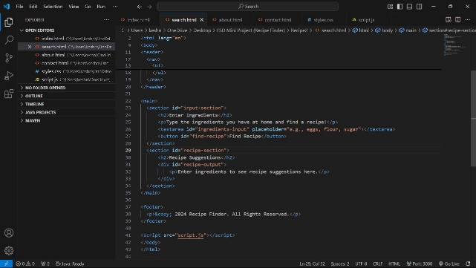

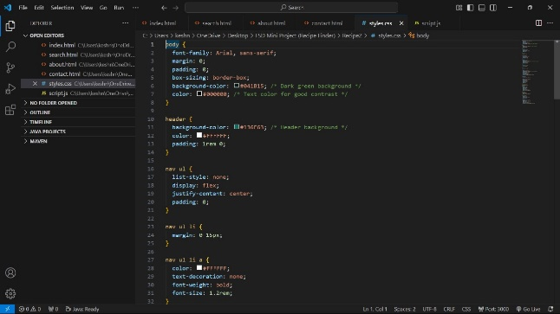

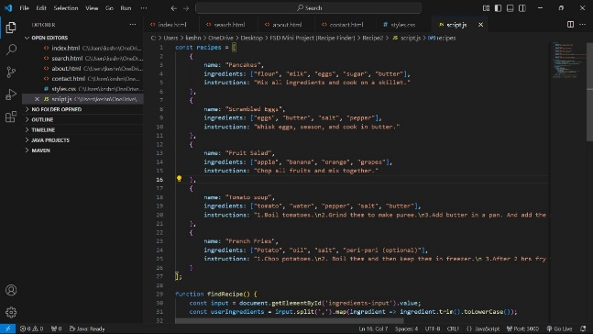

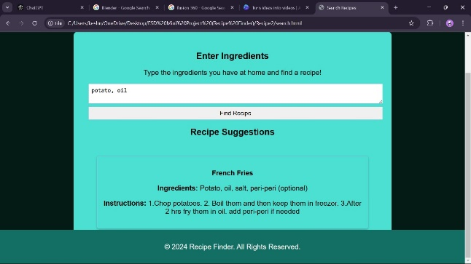

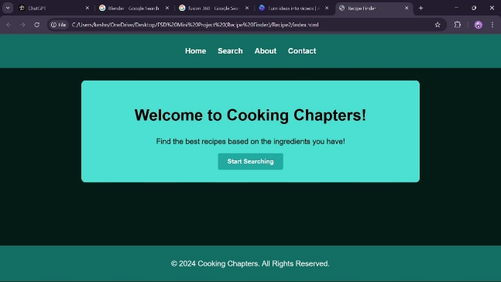

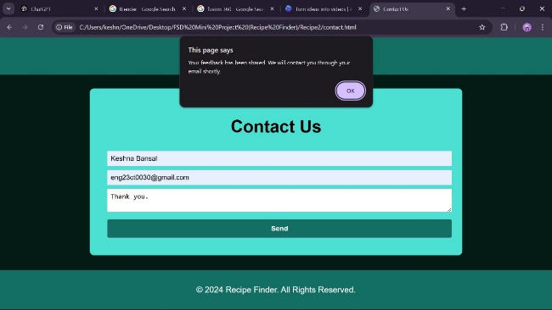

**CHAPTER 5**

**RESULT**

The *Cooking Chapters* was tested with various inputs. Below are sample results:

| Test case | Input | Output |
| --- | --- | --- |
| Tc-1 | Recipe suggestions: flour, milk, eggs, sugar, butter | Pancakes |
| Tc-2 | Recipe suggestions: eggs, butter, salt, pepper | Scrambled eggs |
| Tc-3 | Recipe suggestions: mashed potatoes, fries | Fruit salad |
| Tc-4 | Recipe suggestions: tomato, water, pepper, butter | Tomato soup |
| Tc-5 | Recipe suggestions: potato, oil, salt, peri peri(optional) | French fries |
|  |  |  |
|  |  |  |

**CONCLUSION**

The *Cooking Chapters* project is a functional and user-friendly web-based platform designed to help users efficiently discover recipes based on the ingredients they already have at home. By focusing on a **local recipe database** instead of relying on external APIs, the system ensures complete control over the data, resulting in a more reliable and self-sustaining solution.

The *Cooking Chapters* project successfully fulfils its purpose of simplifying meal preparation while promoting sustainability and minimizing food wastage. By offering a reliable, user-centric, and offline-capable platform, it bridges the gap between available ingredients and creative meal solutions.

This project serves as a foundation for further development and innovation, paving the way for a more comprehensive and feature-rich solution in the future. The *Cooking Chapters* is not just a tool but an enabler of smarter, more efficient cooking practices for individuals and families alike.