**Stored Procedure -**

1)

CREATE PROCEDURE GetCustomerInfo

@customer_id VARCHAR(5),

@first_name VARCHAR(50) OUTPUT,

@last_name VARCHAR(50) OUTPUT,

@address VARCHAR(100) OUTPUT,

@city VARCHAR(50) OUTPUT

AS

BEGIN

SELECT

@first_name = First_Name,

@last_name = Last_Name,

@address = Address,

@city = City

FROM Customer

WHERE Customer_ID = @customer_id;

END;

-- Declare variables for input and output parameters

DECLARE @CustomerID VARCHAR(5) = 'C001';

DECLARE @FirstName VARCHAR(50);

DECLARE @LastName VARCHAR(50);

DECLARE @CustomerAddress VARCHAR(100); -- Renamed the variable to avoid conflicts

DECLARE @CustomerCity VARCHAR(50);

-- Execute the stored procedure

EXEC GetCustomerInfo

@customer_id = @CustomerID,

@first_name = @FirstName OUTPUT,

@last_name = @LastName OUTPUT,

@address = @CustomerAddress OUTPUT,

@city = @CustomerCity OUTPUT;

-- Display the result

SELECT

'Customer ID: ' + @CustomerID AS 'Input Parameter',

'First Name: ' + ISNULL(@FirstName, 'N/A') AS 'First Name',

'Last Name: ' + ISNULL(@LastName, 'N/A') AS 'Last Name',

'Address: ' + ISNULL(@CustomerAddress, 'N/A') AS 'Address',

'City: ' + ISNULL(@CustomerCity, 'N/A') AS 'City';

Output -

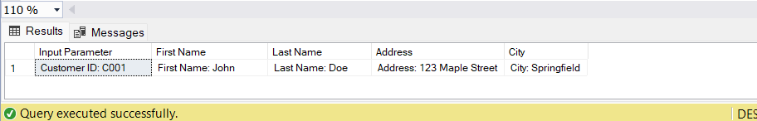

2)

CREATE PROCEDURE GetBillingDetails

@invoice_number VARCHAR(50),

@customer_id VARCHAR(5) OUTPUT,

@plan_name VARCHAR(100) OUTPUT,

@payment_status VARCHAR(20) OUTPUT

AS

BEGIN

SELECT

@customer_id = c.Customer_ID,

@plan_name = p.Plan_Name,

@payment_status = b.Payment_Status

FROM Billing b

INNER JOIN Customer c ON b.Customer_ID = c.Customer_ID

INNER JOIN Plans p ON b.Plan_ID = p.Plan_ID

WHERE b.Invoice_Number = @invoice_number;

END;

-- Declare variables for input and output parameters

DECLARE @InvoiceNumber VARCHAR(50) = 'INV0001';

DECLARE @CustomerID VARCHAR(5);

DECLARE @PlanName VARCHAR(100);

DECLARE @PaymentStatus VARCHAR(20);

-- Execute the stored procedure

EXEC GetBillingDetails

@invoice_number = @InvoiceNumber,

@customer_id = @CustomerID OUTPUT,

@plan_name = @PlanName OUTPUT,

@payment_status = @PaymentStatus OUTPUT;

-- Display the result

SELECT

'Invoice Number: ' + @InvoiceNumber AS 'Input Parameter',

'Customer ID: ' + ISNULL(@CustomerID, 'N/A') AS 'Output Parameter',

'Plan Name: ' + ISNULL(@PlanName, 'N/A') AS 'Output Parameter',

'Payment Status: ' + ISNULL(@PaymentStatus, 'N/A') AS 'Output Parameter';

**Output →**

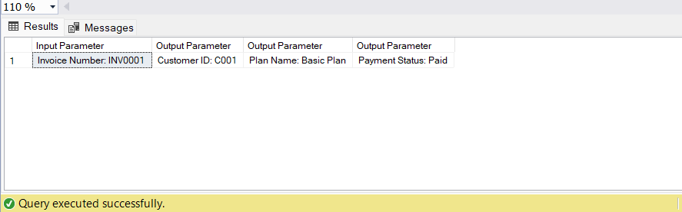

3)

CREATE PROCEDURE UpdateEmployeeSalary

@employee_id VARCHAR(5),

@new_salary DECIMAL(10, 2),

@message VARCHAR(255) OUTPUT

AS

BEGIN

UPDATE Employee

SET Salary = @new_salary

WHERE Employee_ID = @employee_id;

IF @@ROWCOUNT > 0

SET @message = 'Salary updated successfully.';

ELSE

SET @message = 'Employee not found.';

END;

DECLARE @outputMessage NVARCHAR(255);

EXEC UpdateEmployeeSalary 'E001', 80000.00, @message = @outputMessage OUTPUT;

PRINT @outputMessage;

**Output →**

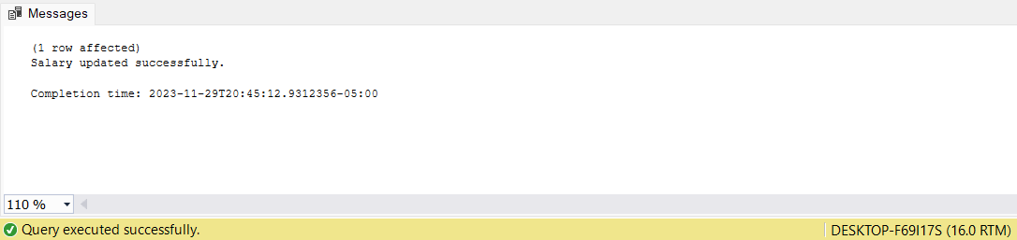

4)

CREATE PROCEDURE CalculateEmployeeBonus

@EmployeeID VARCHAR(5),

@BonusPercentage DECIMAL(5, 2),

@BonusAmount DECIMAL(10, 2) OUTPUT

AS

BEGIN

DECLARE @EmployeeSalary DECIMAL(10, 2);

-- Get the employee's salary

SELECT @EmployeeSalary = Salary

FROM Employee

WHERE Employee_ID = @EmployeeID;

-- Calculate the bonus

SET @BonusAmount = @EmployeeSalary * (@BonusPercentage / 100);

END;

-- Declare variables for input and output parameters

DECLARE @employeeID VARCHAR(5) = 'E001';

DECLARE @bonusPercentage DECIMAL(5, 2) = 10;

DECLARE @bonusAmount DECIMAL(10, 2);

-- Execute the stored procedure

EXEC CalculateEmployeeBonus @employeeID, @bonusPercentage, @bonusAmount OUTPUT;

-- Display the calculated bonus

SELECT 'Bonus Amount: ' + CAST(@bonusAmount AS VARCHAR(20)) AS Result;

**Output →**

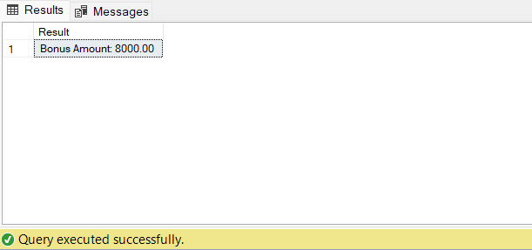

**VIEW (often used for reporting purposes) →**

1.

CREATE VIEW CustomerBillingView AS

SELECT

c.Customer_ID,

c.First_Name,

c.Last_Name,

b.Invoice_Number,

b.Payment_Status

FROM Customer c

INNER JOIN Billing b ON c.Customer_ID = b.Customer_ID;

SELECT * FROM CustomerBillingView;

**Output →**

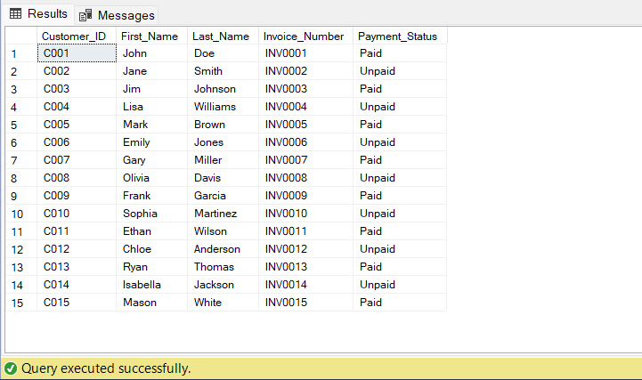

2)

CREATE VIEW EmployeeDepartmentView AS

SELECT

e.Employee_ID,

e.First_Name,

e.Last_Name,

d.Department_Name

FROM Employee e

INNER JOIN Department d ON e.Department_ID = d.Department_ID;

SELECT * FROM EmployeeDepartmentView;

**Output →**

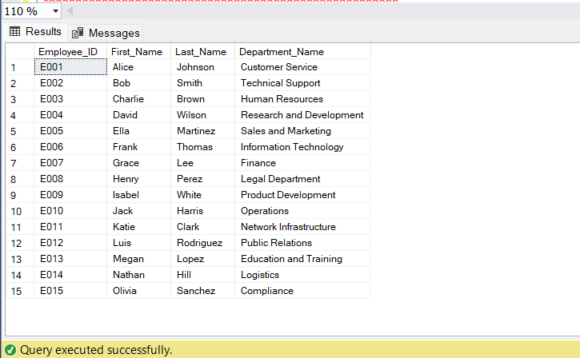

3)

CREATE VIEW ServiceSubscriptionDetailsView AS

SELECT

ss.Subscription_ID,

ss.Start_Date,

ss.End_Date,

p.Plan_Name,

s.Service_Type

FROM ServiceSubscription ss

INNER JOIN Plans p ON ss.Plan_ID = p.Plan_ID

INNER JOIN Service s ON ss.Service_ID = s.Service_ID;

SELECT * FROM ServiceSubscriptionDetailsView;

**Output →**

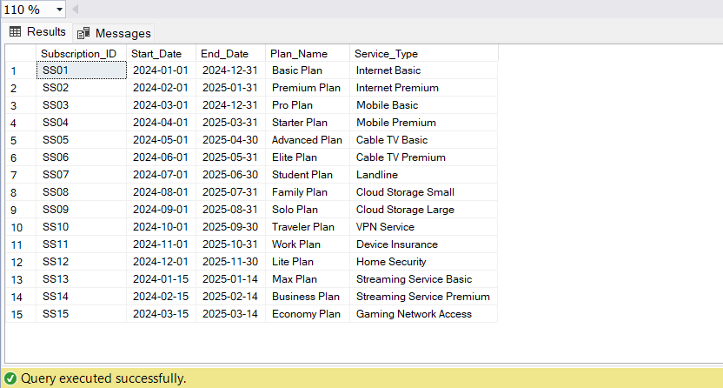

4)

-- View 4th Code

CREATE VIEW EmployeeLocationView AS

SELECT

E.Employee_ID,

E.First_Name,

E.Last_Name,

E.Salary,

L.Location_Name,

L.Population

FROM

Employee E

INNER JOIN

Location L ON E.Location_ID = L.Location_ID;

SELECT * FROM EmployeeLocationView;

**Output →**

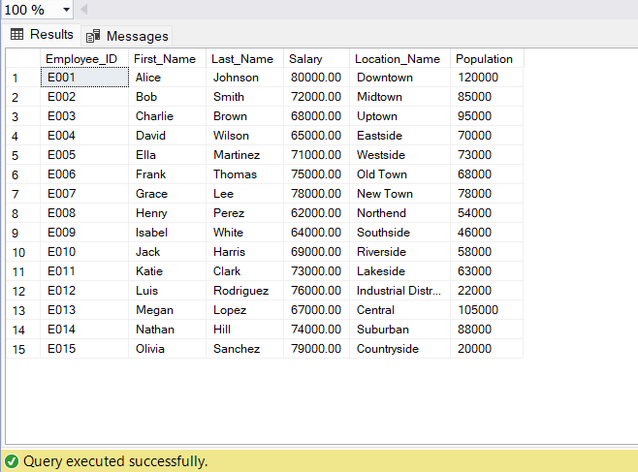

* **Trigger →**

CREATE TRIGGER UpdateServiceSubscription

ON ServiceSubscription

AFTER UPDATE

AS

BEGIN

-- Trigger logic to perform actions after updating ServiceSubscription table

-- Example: Logging the update in an audit table

INSERT INTO ServiceSubscriptionAudit (Subscription_ID, Updated_At)

SELECT Subscription_ID, GETDATE()

FROM INSERTED;

END;

* **Check Constraints →**

ALTER TABLE Customer

ADD CONSTRAINT CheckAgeConstraint CHECK (DATEDIFF(YEAR, Date_of_Birth, GETDATE()) >= 18);

ALTER TABLE ServiceSubscription

ADD CONSTRAINT CheckEndDateConstraint CHECK (End_Date > Start_Date);

ALTER TABLE Location

ADD CONSTRAINT CheckPopulationConstraint CHECK (Population >= 0);

* **User- Defined function (UDF) →**

CREATE FUNCTION dbo.CalculateDiscount

(

@InvoiceAmount DECIMAL(10, 2)

)

RETURNS DECIMAL(5, 2)

AS

BEGIN

DECLARE @Discount DECIMAL(5, 2);

-- Example discount calculation logic: 10% discount for amounts greater than 100

IF @InvoiceAmount > 100

SET @Discount = 0.10 * @Invoice_Amount;

ELSE

SET @Discount = 0;

RETURN @Discount;

END;

ALTER TABLE Billing

ADD Invoice_Amount FLOAT;

UPDATE Billing

SET Invoice_Amount = RAND() * 1000;

ALTER TABLE Billing

ADD Discount AS dbo.CalculateDiscount(Invoice_Amount);

SELECT * , Discount

FROM Billing;

**Output →**

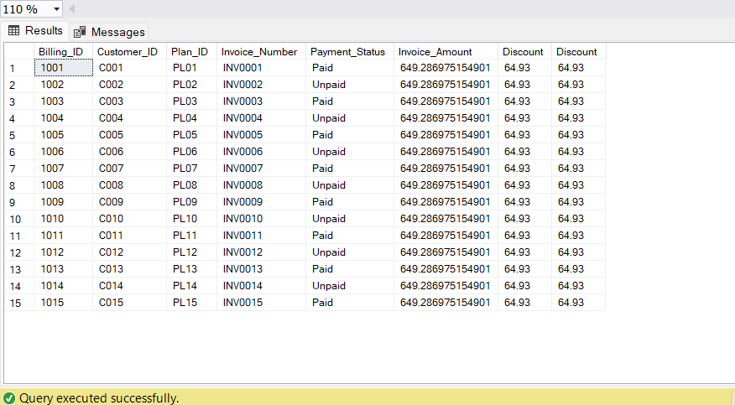

* **Column Data Encryption →**

CREATE SYMMETRIC KEY Customer_IDKey

WITH ALGORITHM = AES_256

ENCRYPTION BY PASSWORD = 'DMDD123';

ALTER TABLE Customer

ADD EncryptedCustomer_ID VARBINARY(MAX);

OPEN SYMMETRIC KEY Customer_IDKey

DECRYPTION BY PASSWORD = 'DMDD123';

UPDATE Customer

SET EncryptedCustomer_ID = ENCRYPTBYKEY(KEY_GUID('Customer_IDKey'), CONVERT(VARBINARY(MAX), Customer_ID));

CLOSE SYMMETRIC KEY Customer_IDKey;

SELECT * FROM Customer;

**Output →**

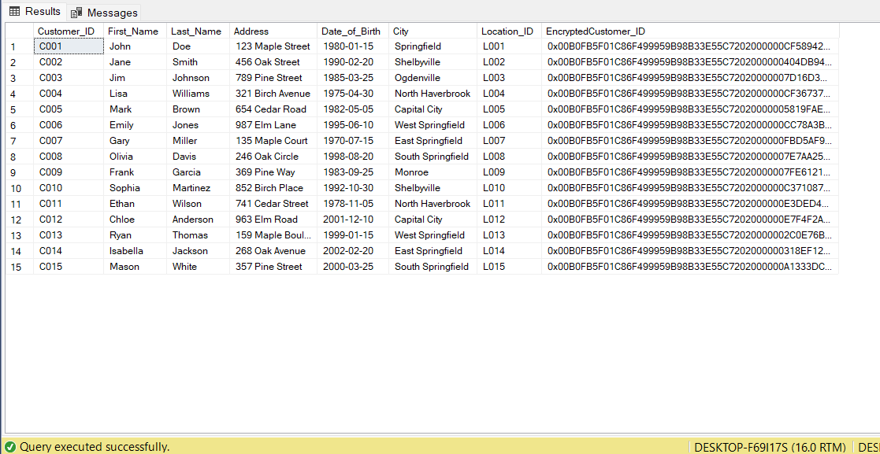

* **Non-Clustered Indexes →**

CREATE NONCLUSTERED INDEX IX_Customer_LastName

ON Customer(Last_Name);

CREATE NONCLUSTERED INDEX IX_Employee_DepartmentID

ON Employee(Department_ID);

CREATE NONCLUSTERED INDEX IX_Billing_PlanID

ON Billing(Plan_ID);