MLB League-Wide ERA and Slugging Percentage Analysis

# 1. League-Wide ERA Over Time

This chart visualizes the trends in Earned Run Average (ERA) across the American League (AL) and National League (NL) from 1946 to present. The introduction of the Designated Hitter (DH) in the AL in 1973 is marked by a dashed line, and the extension of the DH to the NL in 2022 is also noted. The overall trend shows a consistent variation in ERA over time, with clear differences between the leagues, especially after the introduction of the DH rule.

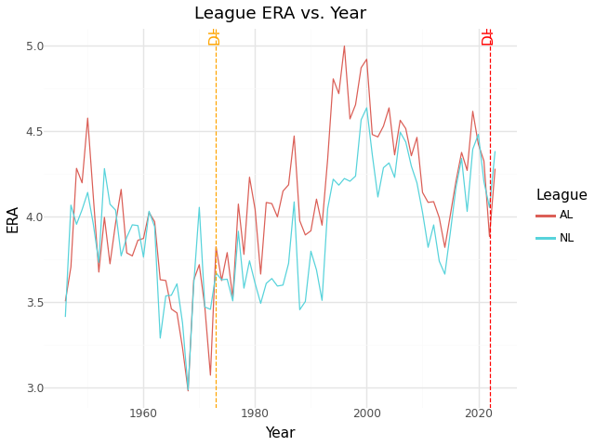

# 2. League-Wide Slugging Percentage Over Time

This chart shows the trends in slugging percentage (SLG) across both leagues. Slugging percentage captures the total bases achieved per at-bat, reflecting the power-hitting capabilities of teams. Over time, slugging percentages have risen, with the introduction of the DH rule potentially contributing to higher offensive performances, especially in the AL. The introduction of the DH in the NL in 2022 might similarly impact future trends.

