COSC450- Assignment 1

Nick Sparrow (4742998)

Department of Computer Science

University of Otago

April 7, 2017

In this assignment I wanted to produce a procedurally generated building that one might see in a big city. Therefore it looks best when it’s at a large scale with multiple floors.

**Rendered Results:**

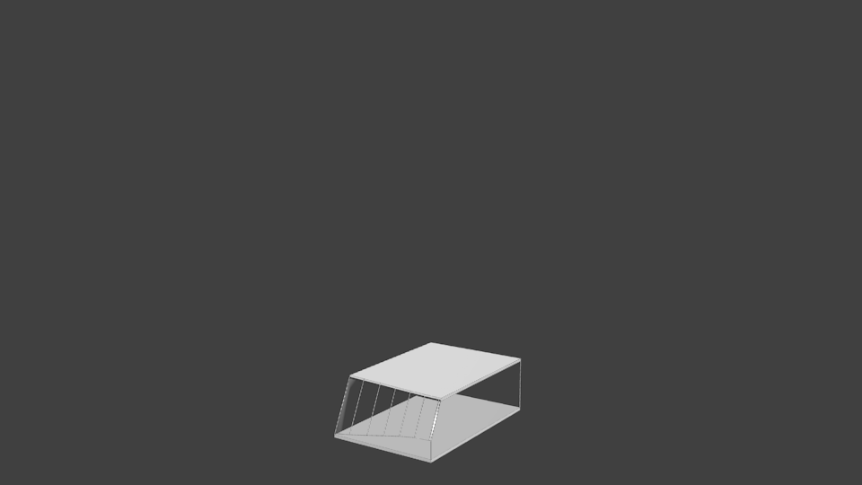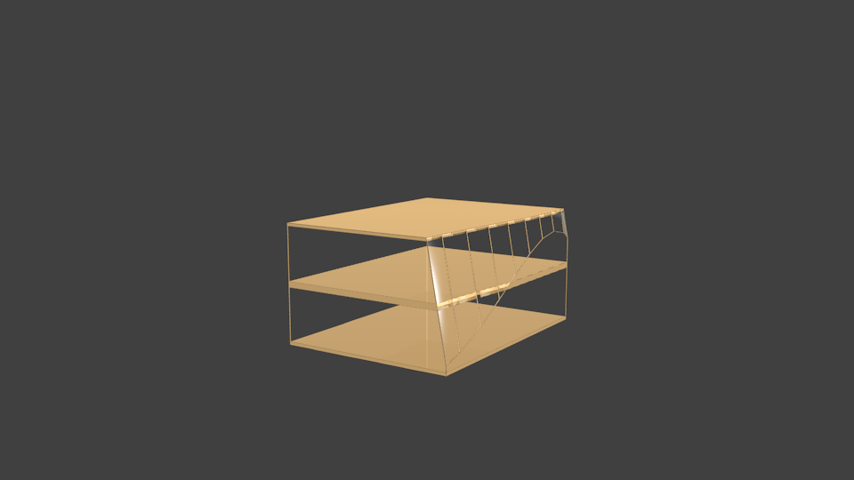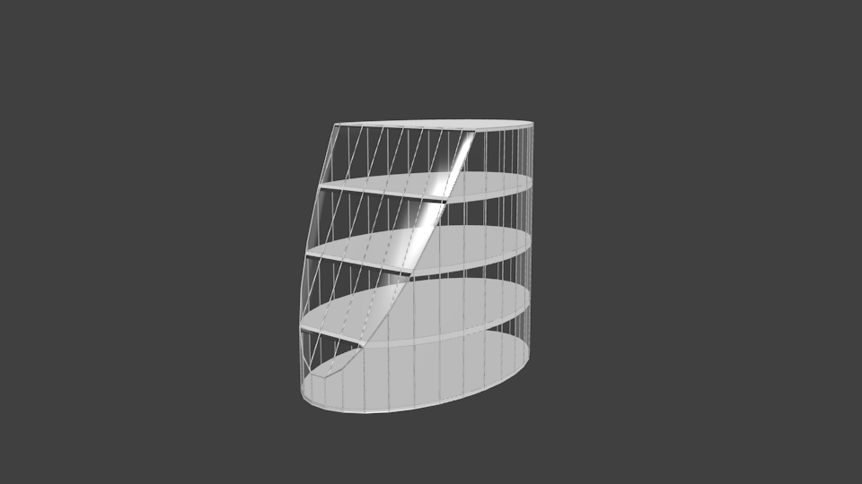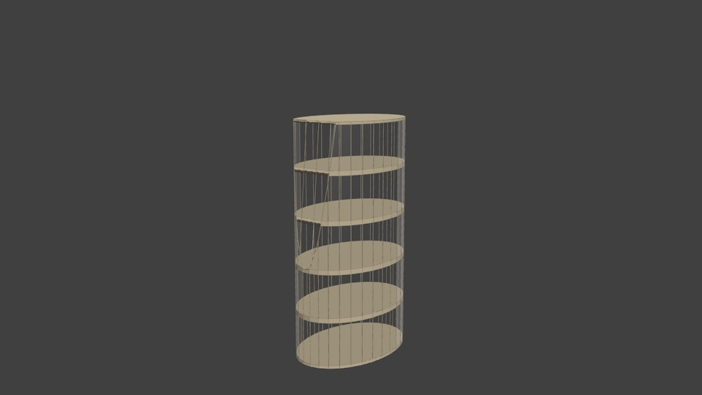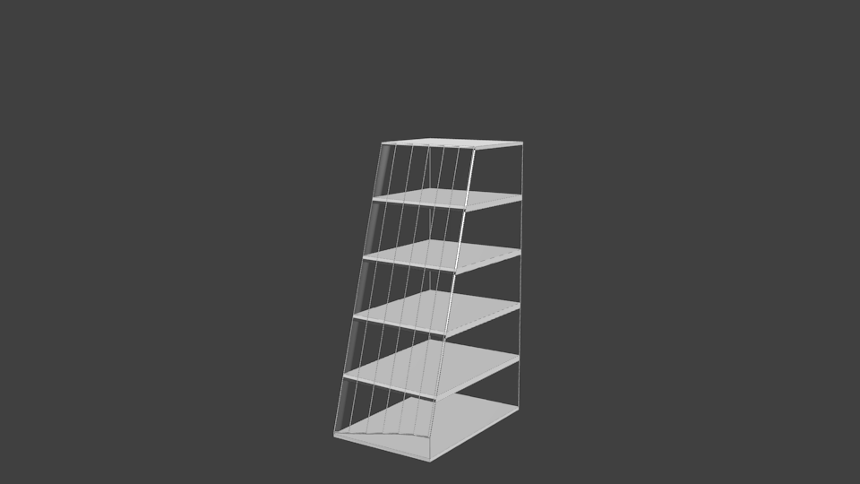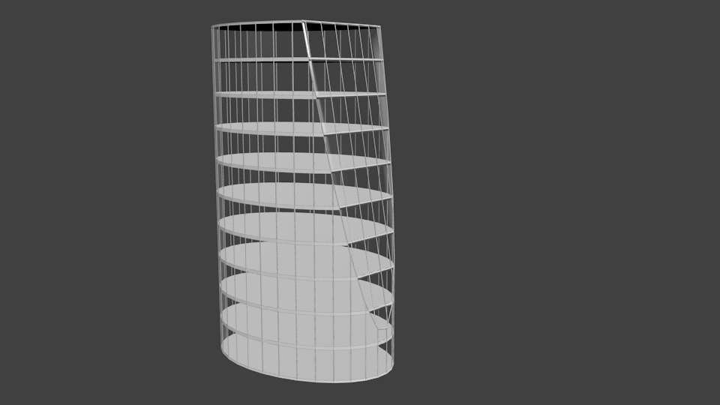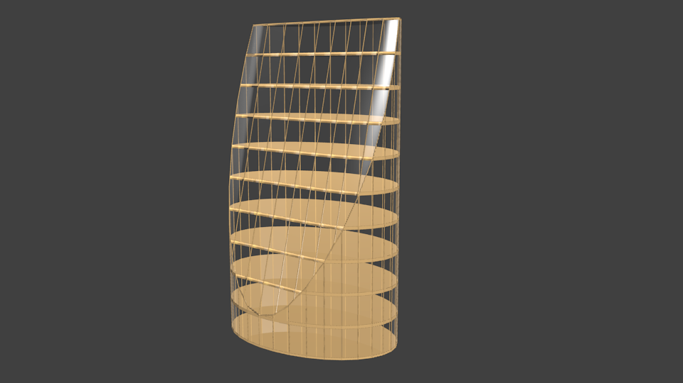

**Design Overview:**

I use the sample_building.blend file as a skeleton for my program leaving most of the scripts as is, modifying the create() method to make the building. I begin with creating either a cube or cylinder the size of the input dimensions making the basic outline of the building, after which I create a Bezier curve on a random angle intersecting the primitive shape and apply a Boolean modifier on the curve and the outline so that what’s left is the final outline shape of the building. Once the building has its final shape I set its material to be glass and get the material to be used for the floors by picking a random material from some that I hardcoded in the Init.py file and saving it to a variable as long as its not glass. The floors are created by a for loop that goes up to the height that’s given on the create() call. The loop makes a cube that intersects with the building setting its size accordingly if it’s the ground/ceiling cube or a middle floor and sets its location to be in the center of the building with its z value changing as the for loop is executed. I then use the Boolean modifier again to cut the floor to be the same shape as the building where it intersects. To give the building more definition I make a duplicate of the outlining shape and apply a wire frame modifier so that it gives the building some structure rather than some floors floating in a tube of glass.

**Problems Faced:**

* **Bezier Curve:**
  + I started out wanting to have the curve to randomly be either a horizontal or vertical wave adding an extra degree of randomness, however I discovered that having the curve horizontal meant that sometimes it wouldn’t intersect the building leading to it crashing the script when it tried to apply the Boolean modifier. Therefore I decided to settle having the curve made on either the x or y side and only having the vertical wave.
  + For the angle of the curve I found that hardcoding its maximum amount of rotation lead to it sometimes cutting off the top of the building meaning it was no longer the users intended size and at that point I wanted to stay away from adding in additional objects to make up space. As a solution to this I used math.atan2(base, height) to find the radians from either the xSize to height or ySize to height depending on what side of the building that the curve was created on. With the maximum radians I then found a random uniform up to the max_rads*0.75 so that the whole ceiling is not removed.
  + Remaining Problems:
    - 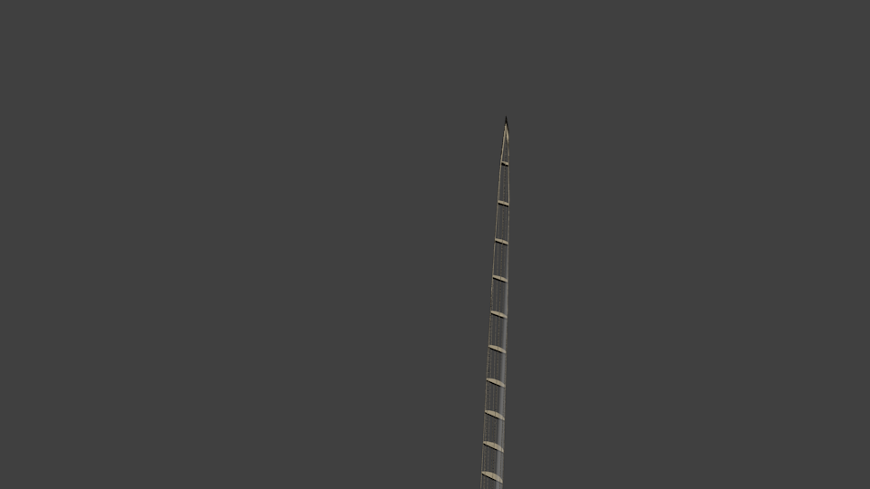Using the math.atan2(base, height) cut out most of the problems that I was having with setting the curves angle however I found that if the height value was far larger than the size of the base, for instance base=1, height=100 then it would produce some interesting results. This was at about 70 stories with its x and y values both set to 1. It also has floating floors above this that don’t show in the render.
* **Creating the Floors:**
  + When I started my design I thought that the floors would be one of the easiest parts because of the “loop cut and slide” function that blender has, however after many hours I came to accept that “loop cut and slide” function does not like cylinders or cubes with waves cut out of them rendering this option for making the floors a dead end.
  + After trying to use the “loop cut and slide” function I looked into using planes at each floor location and applying a Boolean modifier on the planes and building. I decided against this method because I was having a lot of trouble figuring out how to cut the building whilst also keeping the building as a whole a found that the only way it would work would be to duplicate the whole building multiple times and I thought exploring different options would be better.
  + Next method I tried was using the “Bisect” tool with having its fill value set to True. This worked for making the floors however from there the problem was selecting the correct vertices and after discussing with Dr. Steven Mills he suggested trying “bmesh”. I toyed with the “bmesh” tools for a few days and made slight progress with understanding how it worked and some of the advantages to using it. I managed to get all of the top floors vertices selected and was beginning to be able to start manipulating it. Unfortunately I was still not making enough progress, with the deadline approaching it didn’t warrant spending more time on getting a hang of the “bmesh”.
  + As I had already had success with using the Boolean modifier in my script I looked into how I might use a cube to make the floors when I found that a Boolean with its operation set to “Intersect” would cut the cube to be the same shape as the building. Using this method also made it easy to set the floors material as it was just setting an objects material rather that trying to find specific vertices.
  + 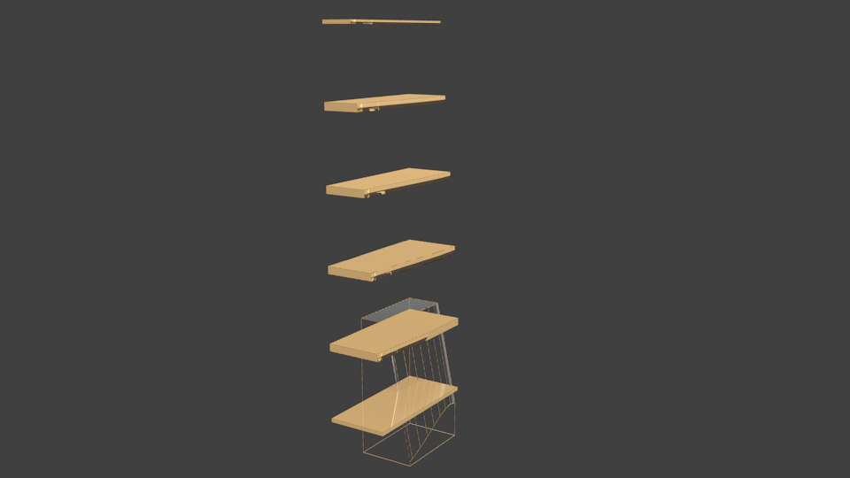Remaining Problems:
    - When I try setting the floors parent to be the building mesh it messes with the floors location in some way that I was unable to fix creating this for example.
    - Therefore I tried making the floors parent the empty object “axes”. However this also had a strange effect on the floors making them unable to be seen through the glass when you’re in “object mode” but still is seen when the scenes rendered.
* 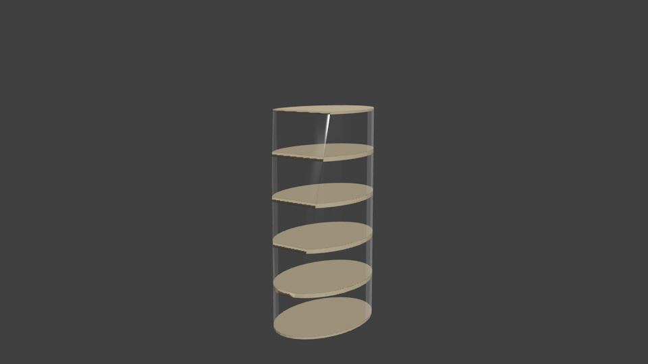**Wire Frame:**
  + The buildings that were being generated lacked form because the majority of it was glass and when rendered it was hard to make out the feature of the cut out curve, so I wanted some way to show the mesh of the glass as it made it obvious where it was cut and made it look more structural.
  + 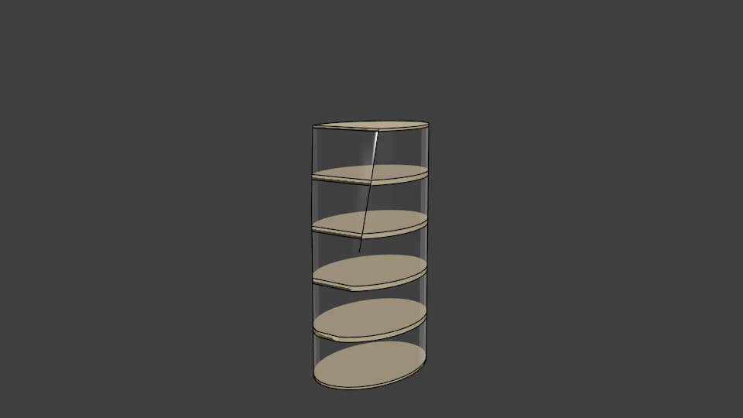I researched how to make the mesh lines appear in the rendering and found suggestions to try using the “Freestyle” tools under the scene options, however with a bit of playing around with settings found I couldn’t produce a satisfactory result with it alone.
  + 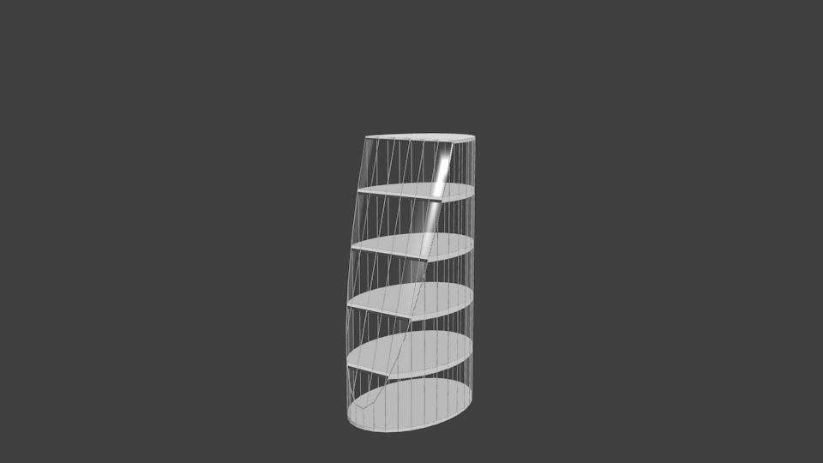Finally I found the modifier “Wireframe” which takes the mesh of an object and extrudes its edges. After duplicating the building object that was currently glass and applying the wireframe modifier to it I ran into a problem with the frames material and found that I needed to remove the glass material from its material list where I could then add the material that was used on the floors giving it a uniform look.
  + I decided that using the wireframe along with having the freestyle function on with a very small line thickness gave the best-looking results.
  + Remaining Problems:
    - Occasionally the frame creates small triangles where the corner of the cut out section meets the ceiling that protrudes out slightly.

**Review:**

Half way into the assignment I found that I was already regretting how I was doing the assignment because it left me with few ways that I could add randomness to my design and made doing things like giving it floors more difficult. If I was to do it again I would use multiple objects that could be varied with materials and size then be stacked together to fill out the desired size of the building making the outputs more randomized.

I found this assignment challenging in areas and put my google search skills to the test especially trying to find material settings that were in the new version of blender but I’m happy with how the glass turned out and the general output of my script with only a few bugs remaining in places.