“Kyiv Professional College of Communications”

Computer Engineering Cycle Commission

**PERFORMANCE REPORT**

**Work Case №3**

in the discipline: "Operating Systems"

Performed by students

RPZ-93B group

Team:

Бушовська О.В,

Білобровенко О.С.,

Скворцов Д.Є.

The teacher checked:

Сушанова В.С.

***Готував матеріал студент Скворцов Дмитро***

**Tasks:**

**1. In the Virtual Box work environment, VMWare Workstation (or another of your choice) must use:**

**- Clone your virtual workstation (Work-case 2). How can this be done?**

**Demonstrate all the stages;**

1. Shut down the cloned VM and on its tab in the main VMware window, click the Clone this virtual Machine link. This will launch the clone wizard.

2. After the greeting, the wizard will prompt you to choose which state of the cloned VM to consider as "reference". For a new VM that has not yet been snapshotted, this is the current state, and therefore only the From current state radio button will be available in the wizard window, as shown in Picture 2.1.

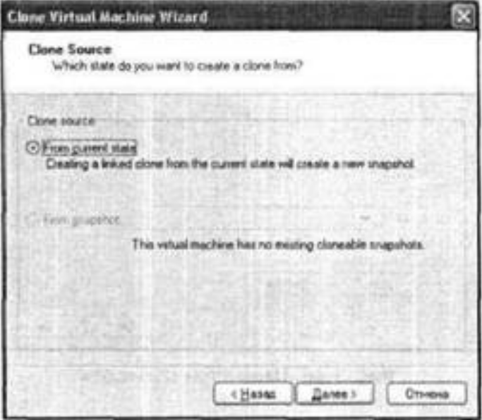

Picture 2.1

3. In the next window of the wizard, select the cloning method (Picture 3.1)

* Create a linked clone - in this case, not a clone is actually created, but a "mirror image" of the original VM, since the contents of virtual disks and some other data are not copied, they are only referenced, respectively, each change in the original VM leads to identical changes to the clone (this option is convenient because it does not require significant space on the hard disk of the host computer; however, the linked clone can only work on the host computer where the source VM is located);
* Create a full clone - In this case, all files of the original VM are duplicated and placed in a user-specified folder on the hard disk of the host computer.

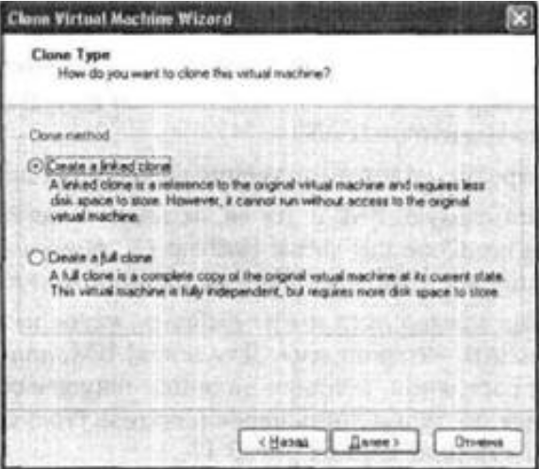

Picture 3.1

4. At the next step of the wizard, regardless of the chosen cloning method, you will need to specify the name of the new VM and its location.

**- It may be necessary to transfer (clone) the OS to another virtual environment. What should I do to export your virtual desktop?**

**--- --- --- --- ---**

**2. During operation, one working virtual machine can interact with another. To do this, you need to deploy a network between them. Write what types of network aggregations are supported in virtual machines, especially each of them:**

**- Network address translation (NAT);**

Network Address Translation (NAT) is a process in which one or more private IP addresses are converted to one or more public IP addresses and vice versa to provide Internet access for local hosts.

In addition, NAT performs port number conversion, ie masks the host port number with another port number in the packet to be sent to the destination. At the same time, NAT not only stores a pool of public IP addresses, but also hides the addressing scheme of your network. It then enters the appropriate IP address and port number entries in the NAT table.

The algorithm of the technology is that when a client on the network sends a request to the Internet, the router sends a request to a special NAT device. it then converts the sender's address to the public IP address of the device before sending the request to the Internet and to further obtain information from the server. When the response comes from an external source, NAT converts the public IP address to a private IP address before forwarding the packet to the client. To do this, NAT creates a mapping between the pair PrivateSrcIP, PrivateSrcPort and the pair PublicSrcIP, PublicSrcPort, to know for sure how to convert the IP address and destination port number. NAT usually runs on a router or firewall.

***Готувала матеріал студентка Бушовська Ольга***

**- Network bridge;**

Algorithm of bridges operation:

From incoming network traffic, the bridge, when it receives a signal, checks and then determines whether to forward or discard the traffic or signal according to its destination.

For example, an Ethernet bridge scans each Ethernet input frame, including frames that have an output and end MAC address. And then sends an individual decision on what to do with the signal. Connect the gas to one inlet and one outlet, thus making it a two-port device. The database relies on determining the route of transmission, transmission or rejection of the signal.

When the data frame is actively involved, if the received frame is intended for a segment that is in the same host network, the frame will be transmitted to this node, and the bridge at the receiving end will reject it. If the frame has the MAC address of the connected network, it will transmit a signal / data.

Now that we use the bridge. Although there are other network devices when we use the bridge? In the next section, we will look at the benefits of a bridge, thus answering the question of why we use them.

**- Virtual host adapter (Host-only);**

VirtualBox Host-Only Network - is a network virtual interface that creates a network between the host machine (host) and guest (VirtualBox).

* The VirtualBox Host-Only Network virtual network adapter works by default on the network 192.168.56.0/24, the adapter's gateway/IP address is 192.168.56.1, distributes IP addresses to guests via DHCP. Connects subnet and host system without direct internet access (network available to host and guest).
* When it is necessary that the guest be transparently visible on the local network (LAN), then it is necessary to select the Network bridge and the physical network adapter, then if there is a DHCP server on the local network, the guest will automatically receive an IP address, if not then manually.

і

* Also, in order for the virtual machine to get the Internet, you can simply select the NAT option through the VirtualBox settings - a software router that gives the Internet to the virtual machine. Externally, from the host side, it just looks like a certain VirtualBox process has established an Internet connection (similar to VMware).

**- Internal network.**

A local area network (LAN) is a computer network within a small geographic area, such as a home, school, computer lab, office building, or group of buildings.

A local area network consists of interconnected workstations and personal computers that can access data and devices, such as printers, scanners, and storage devices. Local area networks are characterized by higher speeds of communication and data transfer and no need for leased lines.

***Готувала матеріал студентка Білобровенко Олександра***

**3. Deploy the network between your operating OS and its clone (task 1):**

**- Demonstrate basic commands for configuring network parameters of the OS, explain what they use.**

In Debian, if we want to permanently change the network card settings, we need to edit the file / etc / network / interfaces

*Program ettool*

Through the ettool program we can consult, list and change the parameters of the network card, such as connection speed, automatic negotiation, checking the amount at download - unloading checksum, etc. It is available in the repositories of almost all distributions.

buzz @ sysadmin: ~ $ sudo aptitude install ethtool

[sudo] password for updates:

buzz @ sysadmin: ~ $ sudo ethtool eth0

Settings for eth0: Supported ports: [TP] Supported communication modes: 10baseT / Half 10baseT / Full 100baseT / Half 100baseT / Full 1000baseT / Full support for pause frame usage: No Supports auto-negotiation: Yes Advertised communication modes: 10baseT / Half 10baseT / Full 100baseT / Half 100baseT / Full 1000baseT / Full advertising Advertisement pause frame usage: No Advertised auto-matching: Yes Speed: 100 Mbps Duplex: Full port: Twisted pair PHYAD: 1 Transceiver: internal Auto-matching: MDI- X: on (auto) Supports wake-up call: pumbg Wake-up call: g Current message level: 0x00000007 (7) link to drv probe Link found: yes

The changes we make with this tool are temporary and will be lost the next time you restart your computer. If we need constant changes made by ettool, we should add the directive "previous" or "before raising the interface" to the file / etc / network / interfaces as follows:

auto eth1

internet DHCP IFACE eth1

pre-up / sbin / ethtool -s eth1 speed 1000 duplex full

Thus, the eth1 network card, which receives its IP address from a DHCP server, is constantly modified to operate at 1000 Mbps in Full Duplex mode.

**- Both operating systems have access to the Internet. Open a browser and watch any video on youtube**

**--- --- --- --- ---**

**- Configure and demonstrate messaging between two operating systems on the local network. What commands in the terminal must be entered?**

Select the virtual machine for which you want to configure a shared folder with the main OS, if there are several (virtual machines). In the VirtualBox manager window, click the button on the toolbar of the "Configure" program. Picture 3.1

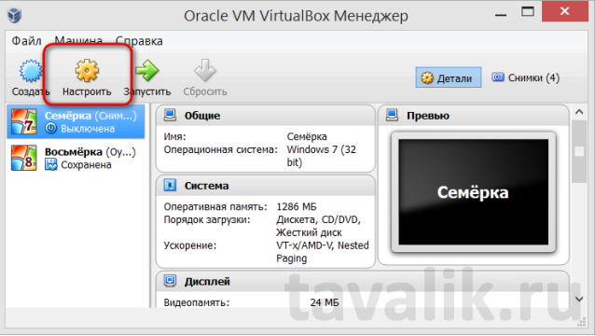

Picture 3.1

The virtual machine settings window opens. On the left select the section "Public folders". On the right, click the button in the form of a folder with a plus - this is a browse button to select a folder, which is intended to be shared with the main and guest OS. In Explorer, select a folder on a real computer or create a new one specifically for working with two systems. In the window for adding a shared folder, check the "Auto-connect" option and click "OK". To protect yourself from possible malware from the guest to the main OS, you can set the option "Read-only". In this case, files placed in a shared folder in the main OS can be opened or copied to any other location in the guest OS. But it will be impossible to fill the shared folder with guest OS files.

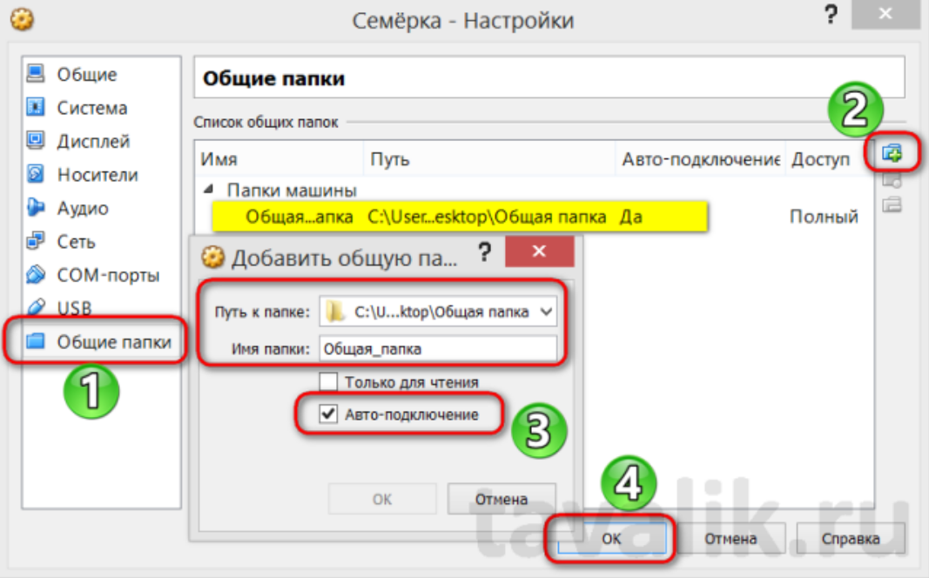

Picture 3.2

**- Configure a shared network folder for both operating systems. Try copying files from this directory to the user's home directory (virtual desktop) and desktop (virtual desktop clone).**

I have already had the opportunity to describe a similar task in **Task 1**.

**4. How can I organize the exchange between your main OS (for example, Windows) and virtual OS? Copy the free audio file from your main OS to the virtual OS desktop and its clone. How do I do the opposite when I need to copy a document from the virtual OS desktop to your main desktop OS?**

I have already had the opportunity to describe a similar task in **Task 1**.

**Conclusion:**

During this lab I learned how network systems work in a virtual operating system and how I can interact with my main OS both through a virtual OS and vice versa.