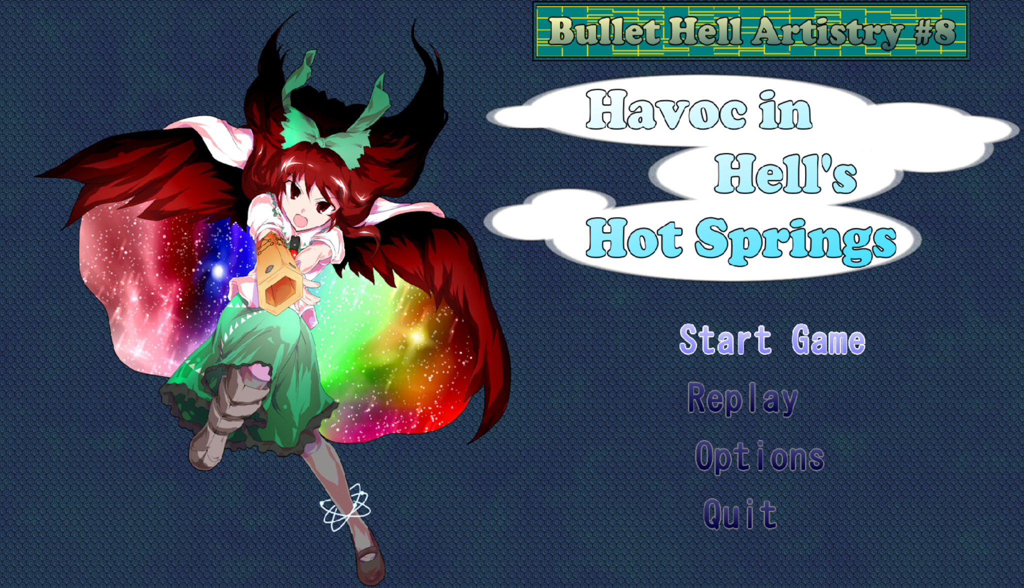

| **Havoc in Hell’s Hot Springs Developer: Asthmagician** |
| --- |

The most negative things I feel I can say about this are as follows:

* It’s not a looker of a game and makes no effort to convince you otherwise.
* The mechanic to fire is kinda jank.
* Some sounds could use a bit more polish.

And I still have some negatives to say but honestly, I feel it’s a disservice in how cute of an effort this game is.

It’s a pretty standard Okuu fight, all things considered, with spell cards that fit the character and provide a pretty standard challenge in comparison to everything else in this contest.

I like the idea of how they went about handling the concept of having a non-straight forward shot type as I feel it has a lot of potential to be very deliberate in design if it were to be fleshed out a lot more.

In a way it does KINDA succeed in that goal of deliberate design. It’s another entry adapting a fighting game mechanic, this time the barrier mechanic from some of the Touhou Fighter story modes (Soku, ULiL and AoCF… I guess Gyoukou Ibun also even if it’s not a fighter).

In a way it does help crux the design of the shot, THOUGH I will say I did have a couple of fumbles in capturing the spell cards with how different the play is. I think that’s perfectly fine to have given the very short nature of this, though if we’re to ever see something like this expanded into a more full game I’d definitely advocate for something where you can practice.

With that said, let’s get into the scores:

| Game Flow | Difficulty | Sound | Control | Quality of Life |
| --- | --- | --- | --- | --- |
| 25 | 10 | 15 | 20 | 15 |

**Game Flow:**There have been moments where I have had the shot lock up on me, but I feel this is the germ of an idea that could really be made super fun.

**Difficulty:**These are very standard Okuu spell cards that comparatively don’t crack much over Normal in terms of difficulty structure. Albeit there is faithfulness to the character in design but it does limit replayability.  
  
**Sound:**  
I definitely feel like there could’ve been better sounds picked out for the game as some sounds I feel either are too loud or too odd in some cases. The menu sounds in particular I believe need work.  
  
**Control:**Whilst I do love the idea, I feel like it could do with more polish. Homing amulets are probably the most effective in terms of shot options available with the other two feeling like they could use buffs or be more thought out.

**Quality of Life:**The only thing present here is replays. This is a very short entry so by all means it’s not like Practice modes not being here is all that upsetting.  
  
Initially I was going to give critique to how Judgement Mode may be overbearing to have in the base game, however upon quickly having a session with Challenge Mode I’ve found that there isn’t a proper Game Over state. This definitely hurts more finding out about this now.

As for the subcategories:

| Sprites/Portraits | User Interface | Aesthetic | Music |
| --- | --- | --- | --- |
| 10 | 10 | 10 | 5 |

**Sprites/Portraits:**

They’re very simple custom player sprites with Dairi portraits. It conveys pretty honestly that looks weren’t the #1 priority.

**User Interface:**It does what it needs to but it’s very dry in that regard.

**Aesthetic:**It’s mostly themed around Okuu. Okuu is definitely a favourite character to me but there wasn’t really anything that made her, her spell cards or the player characters really pop.

**Music:**…I mean I guess what else are you going to do when some of this stuff isn’t your forte but I will say the Nuclear Fusion midi does sound kinda ugly in a few areas.

I’ll give my full **+20 bonus points** because I do hope that something gets built upon after this.

**Overall**

**140/325**

**Around 43%  
…I do honestly feel harsher than what I lead on with this rating.**