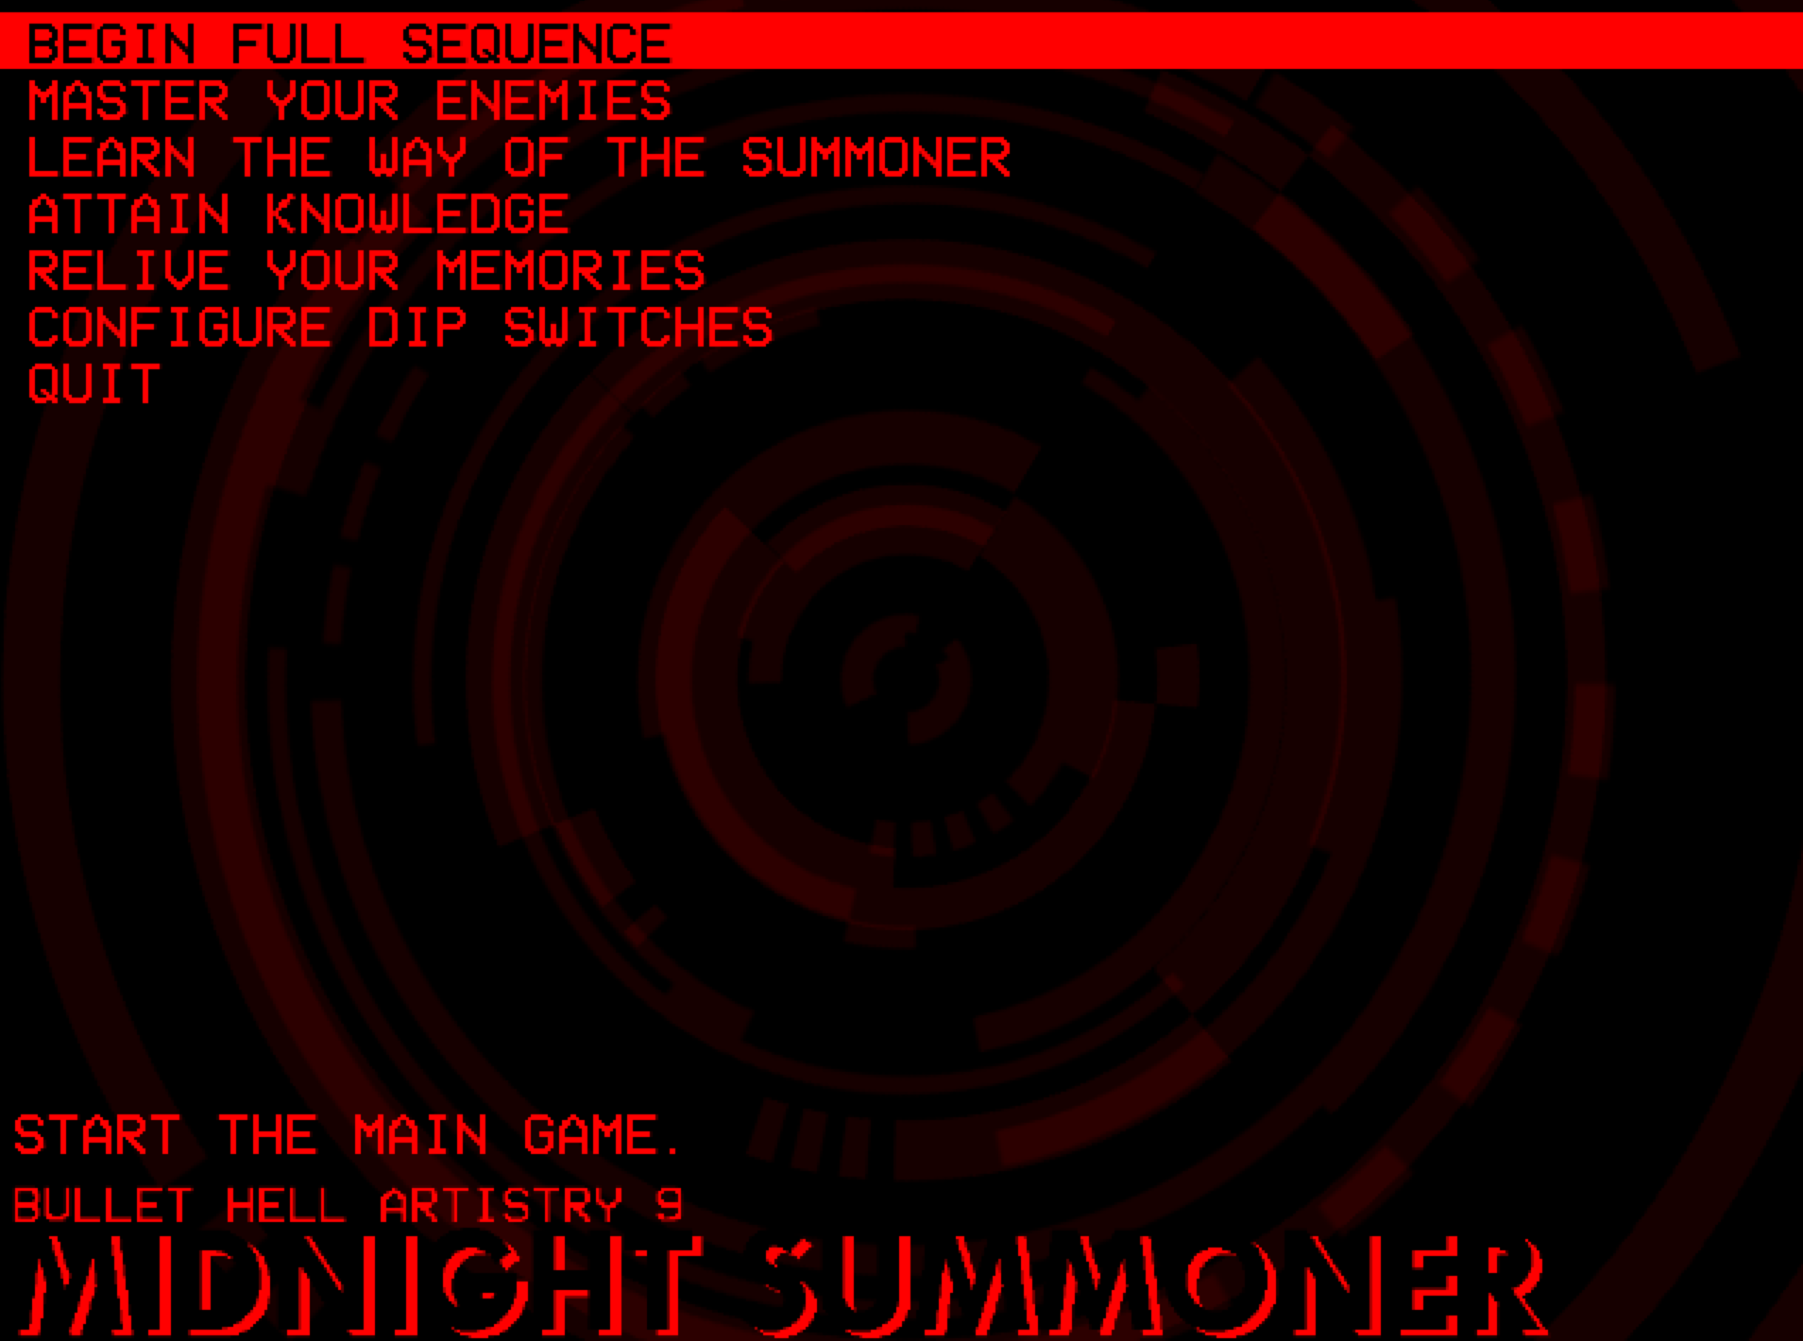

| **Midnight Summoner Developer: Makuta Matara** |
| --- |

To my knowledge, this is I think the first entry in a BHA that isn’t tying itself to Touhou even if it is using Danmakufu as the engine of choice.

There’s definitely a lot of raw vibes I get from the games presentation, maybe a few other things in there that aren’t restricted to the shmup genre but overall I feel that this entry alone commands respect in deviating from the norm into its own thing.

In that respect also I feel despite some very complicated gameplay, this might be an entry I can see people replaying and finding enjoyment in well past the time of the contest as the foundation laid here is incredibly engrossing.

There is an issue in it with how complex everything is laid out. Like there does seem to be a rotation of moves that is intended to set up your player character and demon for the most effective offense, but with how much is happening it’s pretty easy to get lost in the shuffle of that.

It has thrown me off before in trying to play difficulties higher than Normal and even Easy in some cases but the strengths of the system really do feel as if they outweigh what are issues, which for clarification are issues I feel would be worth looking into.

I feel this would be easier to explain however with getting into categories:

| Game Flow | Difficulty | Sound | Control | Quality of Life |
| --- | --- | --- | --- | --- |
| 40 | 40 | 25 | 35 | 50 |

**Game Flow:**

There is an intriguing level of attention to how the summoner plays in contrast to the enemies they fight and the demon they have to keep in check throughout the progression of the game. Everything in the kit has purpose though I do think the game suffers from not being obvious in the rotation of moves, especially within the moment to moment gameplay. Still it’s solid enough to where I find enjoyment in finding something resembling a good rotation of moves and cleaving away through the game.

**Difficulty:**After giving it some thought, I do think it’s worth to consider that the difficulty can end up being more than what I would consider most people comfortable with, but I do feel that with what is mechanically present here and something in regards to the QoL segment, this game is pretty good at giving you opportunities to learn the game and get accustomed to how it works.

**Sound:**

I do think this is probably the weakest part of the game as I do think some sound effects either drown each other out or don’t really give much indication as to what you’re doing in the game. I am aware these are public domain sounds being used so I can only imagine there was only a certain amount in the library they had which felt fitting for the game. I would say it wouldn’t hurt to maybe find methods or sounds that make things seem more distinct, even if it’s with a sound library of pre-existing sounds.

**Control:**

It’s in Danmakufu PH3, so movement is more typical to Touhou in how twitchy it is. When it comes to performing attacks and moves though I do feel that it’s much to really take in the rotation of moves you’re suppose to do but otherwise, things work as intended.  
  
**Quality of Life:**There are *a lot* of options in terms of learning and approaching the game. A pretty thorough practice mode, being able to toggle your rank in both the main play and practice play, replays, the fact that the game has some sauce to how scoring functions, I do genuinely think this will be the most replayable entry of this contest after it’s over.

Now for the subcategories:

| Sprites/Portraits | User Interface | Aesthetic | Music |
| --- | --- | --- | --- |
| 15 | 10 | 25 | 15 |

**Sprites/Portraits:**Generally I would say this is a very clean looking game and at a standstill, everything looks really good. I do think things suffer however in motion, where it can be pretty hard to judge certain graphics when a lot of stuff happens on screen. Mainly in the sense that the sprites are big and can overlap easily with each other.

**User Interface:**

In a way the UI in game is not very distracting which is generally pretty good, but also kind of double edged in how small the details are where it takes awhile to actually look at your lives and power. Couple the fact that there’s a lot of movement around the screen and it’s easy to get confused with what asset goes where. It wasn’t uncommon for me to not know how many lives I had with the layout.

**Aesthetic:**There is a sense of aura about this entry that feels nostalgic and ominous, in many ways I’m kind of reminded about old doujin shmup games, especially Radio Zonde and Hellsinker with the general aesthetic. Definitely a good entry to highlight how this isn’t just restricted to Touhou or Touhou adjacent things anymore.

**Music:**Aside from how incredibly thick the menu screen is, the rest of the tracks achieve what they need to do and just provide background for the gameplay itself. Nothing really offensive, in-fact I appreciate that the tracks sound as good as they do… Just not something I’d hear outside of the game at least.

I’ll probably just throw in a **+5 bonus points** for the thick atmosphere of the title menu.

**Overall**

**260/325**

**80%  
That’s pretty good!**