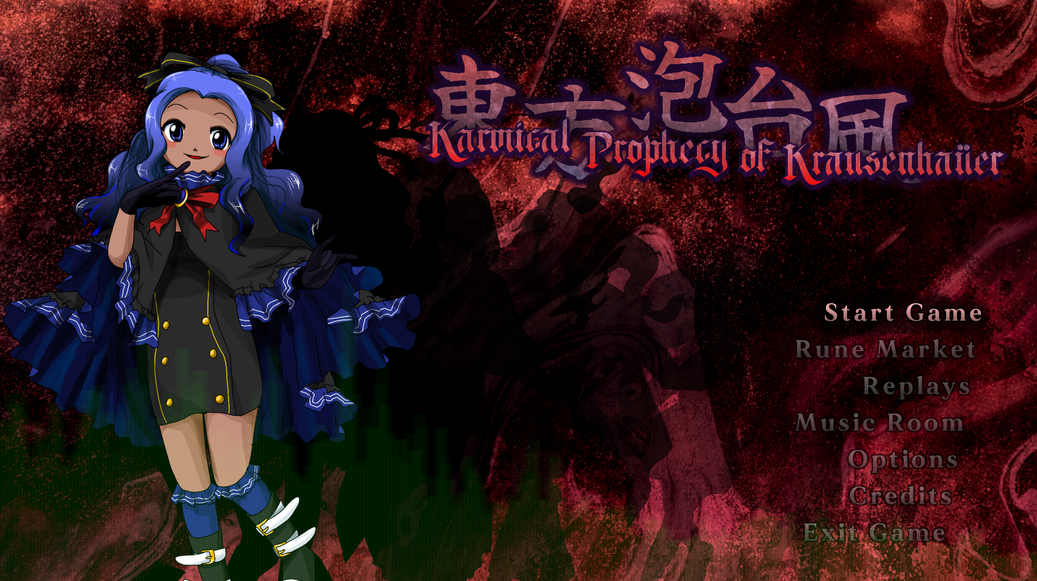  
Omg it’s misaki.

| **東方泡台風　～ Karmical Prophecy of Krausenhaüer  Developer: Ryaan Thierry** |
| --- |

This has definitely become the big hotness of the contest. And honestly it’s pretty easy to see. It’s an entry that goes really REALLY hard in being as authentic of a product as it can be even outside of the contest's scope.

I feel like in terms of what is here, it feels very self indulgent for the author and those they collaborated with on the project. Generally though it does feel humble enough in that presentation where it’s more or less having fun with who’s there and giving a hurrah to the things that brought people here. It’s something I feel a good chunk of fan games can find themselves pretty guilty of to where I just completely tune out after a while in how the vibe ends up suffocating everything else.

There are definitely bits where I do kinda feel the suffocation, though thankfully it’s just related to small text and not so much bleeding into the gameplay. In which I can at least say this entry isn’t dull in terms of it.

The balance of the game I feel is really hard to put my finger on. On one hand you have some spell cards that feel pretty obtuse in terms of understand how they function off the bat (Act 2 Scene 2 and Act 3 Scene 3 are big examples of this) but also how this game becomes incredibly easy once you either understand how the patterns work or using the games Rune system to have a combo that allows you to survive for as long as you need if you’re more of someone to brute force things (Act 3 Scene 4 and Act 3 Scene 5 primarily just require vertical movement. Rune cards don’t give much meaningful penalty on use unless you’re scoring).

Also I dunno where to squeeze this in but I will say I do think Act 4 Scene 3 is pretty messy visually with Misaki’s flamethrowers and the hazy look of the coloured bullets that can sometimes block out the visible safe spot is kinda ass in terms of design. It’s easy when you look hard enough but still my eyes feel very confused after that.

I’m more inclined to call the game easy and I feel it’s kind of a shame that it is pretty short as I feel some stuff here could’ve been more further elaborated on. Which in saying that is probably more of a good thing as who knows what the developer of this game might do after this.

Time for the scores!:

| Game Flow | Difficulty | Sound | Control | Quality of Life |
| --- | --- | --- | --- | --- |
| 40 | 35 | 45 | 35 | 40 |

**Game Flow:**

Even if it’s a short experience, I felt the game did a good job at compelling me to go through every scene to see all that the game has to offer. Even if some shots and patterns were rough to understand at first, repeat playthroughs kept me going and I do think the ideas presented are pretty interesting.

**Difficulty:**

It’s definitely on the easy side and I feel maybe 1 or 2 more acts would’ve helped in terms of scaling the difficulty to become something more outstanding and possibly more polished, but at the very least it’s hard to say the game is dull because of it.

**Sound:**Kind of docking this by 5 points as I feel there has been one spell card that would have benefitted from having a sound indicator (Act 5 Scene 5) but overall things sound as they should, if not with a bit more flash and flair to help it be distinct.

**Control:**

Some shot types are easier to understand compared to others, especially in terms of how these shots are being applied to each scene. Given the scene nature of the game however I think it’s fine to say that solving that is going to be a relatively quick task.

**Quality of Life:**

The scene game structure means continues are generally infinite by how you just need to restart the one pattern. Replays being here are generally pretty good and the runes do offer some neat experimentation to an extent. If anything I’m holding this score back on the basis that there really could be more to this.

Now for the subcategories:

| Sprites/Portraits | User Interface | Aesthetic | Music |
| --- | --- | --- | --- |
| 20 | 25 | 20 | 20 |

**Sprites/Portraits:**

All the portraits were done with the combined effort of Primary and PumpkinPielex. They all convey a ZUN-esque style with details that are also unique to them, whether they be original to the developers here or towards developers of other respected games.

All the sprites for the player characters are very nicely done also, possibly being tweened a bit but not to an obnoxious distracting degree.

Though I will say one design I am confused about is Albretch’s. I get we don’t have a lot of guys designed in ZUNs artstyle so actually trying to draw a guy in it is probably going to come off more strange than normal. Can’t say I give much complaint to that though as it is an attempt I do find at least interesting.  
  
**User Interface:**

Does what it needs to and has a bunch of unique extras to it also. Good UI!  
  
**Aesthetic:**The mixture of black and crimson against how colourful every character and pattern are is good design! Especially for a shmup! Sometimes being very drab in certain areas helps certain shmup design philosophies pop out more in how more colourful they are in comparison.

**Music:**

I feel in a more casual sense I’d probably downplay the music as something I wouldn’t listen to much outside of the game, but ultimately the music does a good job at conveying the mood and livening up the experience. I will say some favourite tracks of mine include Trigirls’ Spectacle and Wrath of an Earthly Tempest.

Also **a bonus +10 points** for Misaki’s presence in the game. I love how she and her friend/lover/backpack/whoever she is, Belle are in two entries this year. I seriously at least like Misaki’s design. Belle is okay also I guess.

**Overall  
290/325**

**Somewhere above 89%  
Big Ups!**