<!-- Before opening your first issue we highly recommend reading this post https://www.snoyman.com/blog/2017/10/effective-ways-help-from-maintainers -->

### Prerequisites

<!-- Please don't just check the box unless you have done these things... -->

* [x] Put an X between the brackets on this line if you have done all of the following:
* Did you perform a search at https://github.com/issues?q=is%3Aissue+user%3ASparkDevNetwork+-repo%3ARock to see if your bug or enhancement is already reported?
* Can you reproduce the problem on a fresh install or the [demo site](http://rock.rocksolidchurchdemo.com/)?
* Did you include your Rock version number and [client culture](https://github.com/SparkDevNetwork/Rock/wiki/Environment-and-Diagnostics-Information) setting?

### Description
The InteractionWrite Lava command is writing interactions to the wrong component.

### Steps to Reproduce

1. Use InteractionWrite Lava Command to Create a New Channel
**Sample Lava:**
`{% interactionwrite channeltypemediumvalueid:'668' channelname:'Some Channel' componentname:'Some Component' operation:'View' summary:'Viewed Some Page' %}findme-interactiontest
{% endinteractionwrite %}`

![sms-reply-create-channel](https://user-images.githubusercontent.com/36978982/108251162-54261a80-7114-11eb-8382-cb8e519bfb7b.png)
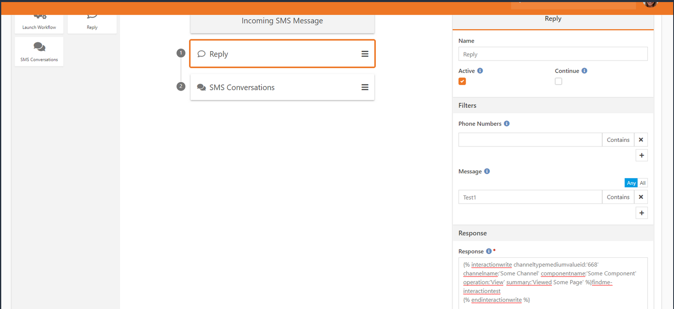

**View New Channel Created**
![new-channel-created](https://user-images.githubusercontent.com/36978982/108251264-6a33db00-7114-11eb-9862-2e20ea04a003.png)
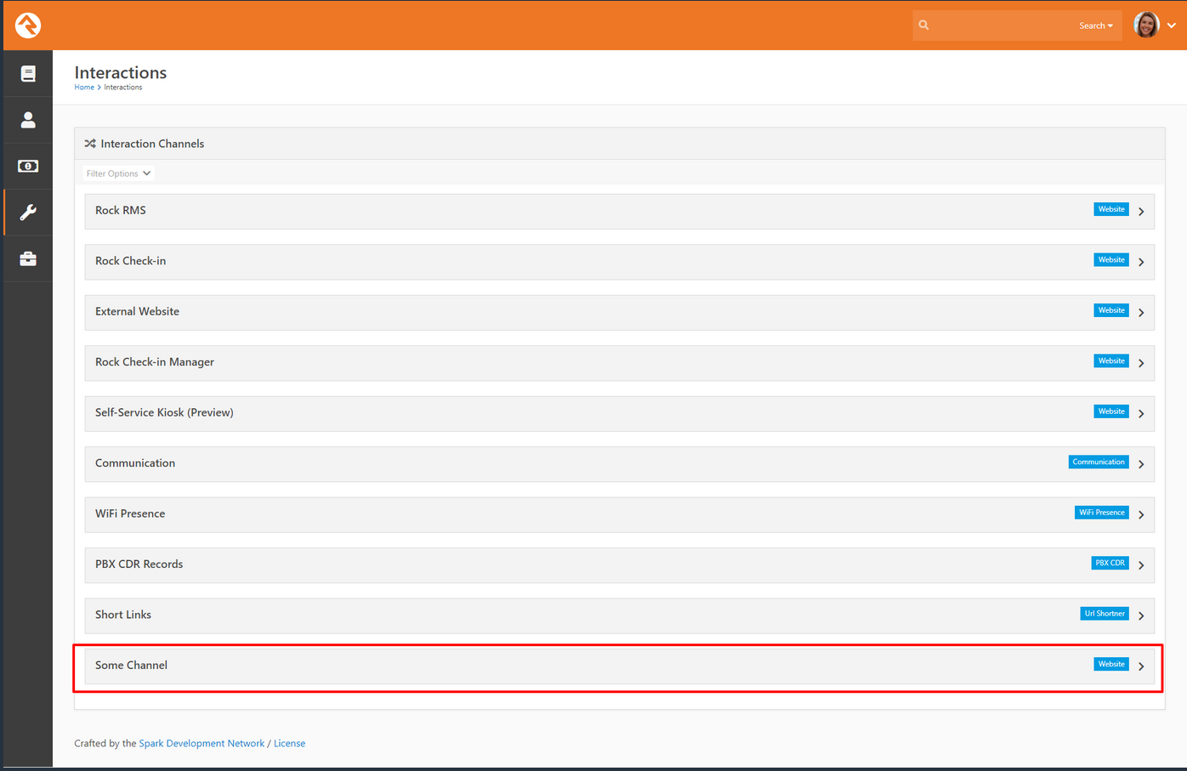

**View Interaction Created**
![interaction-created](https://user-images.githubusercontent.com/36978982/108251286-715ae900-7114-11eb-8946-b29c99884153.png)
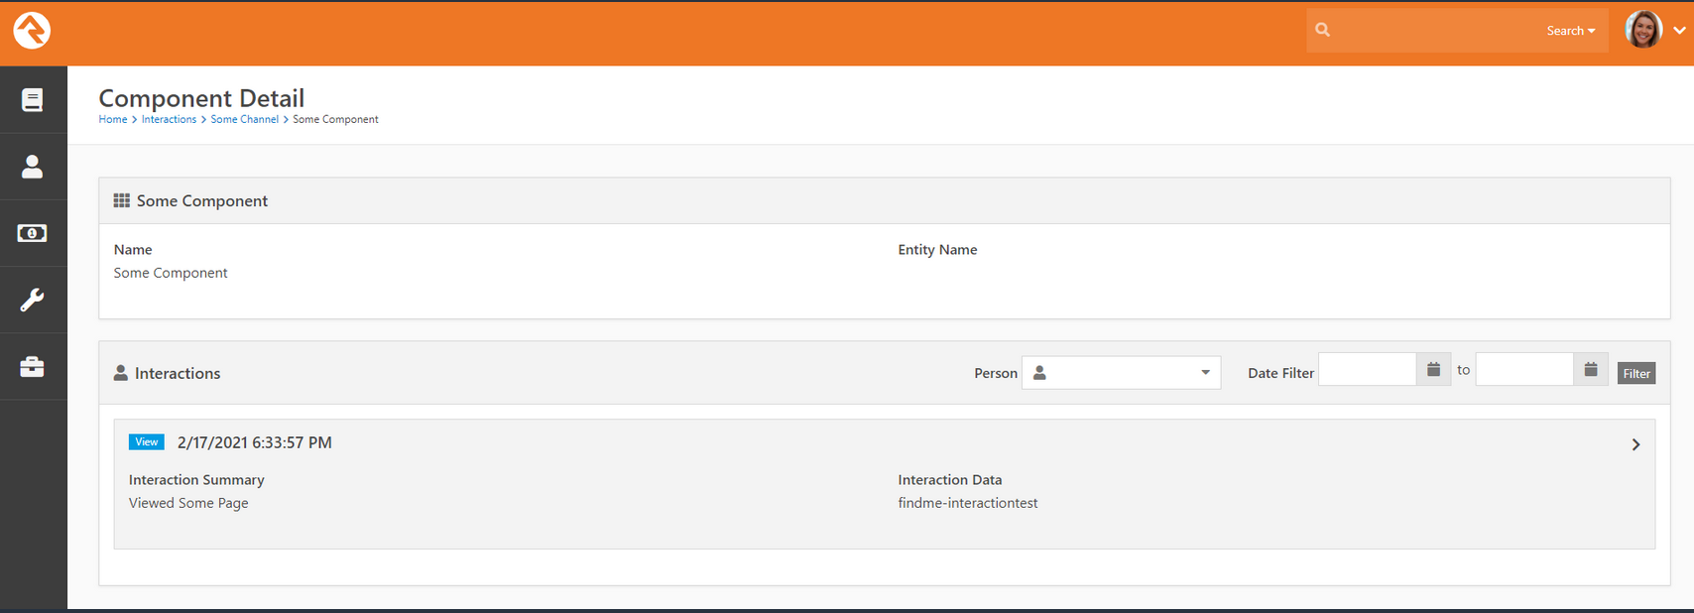
2. Update InteractionWrite Lava to Write Multiple Interactions with At Least One Command Writing to the New Channel
**Sample Lava:**
`{% interactionwrite channeltypemediumvalueid:'668' channelname:'Some Channel' componentname:'Some Component' operation:'View' summary:'Viewed Some Page' %}findme-interactiontest1
{% endinteractionwrite %}
{% interactionwrite channeltypemediumvalueid:'668' channelname:'Configuration Landing' componentname:'Test Component' operation:'View' summary:'Viewed Some Page' %}findme-interactiontest2
{% endinteractionwrite %}
{% interactionwrite channeltypemediumvalueid:'668' channelname:'Configuration Landing' componentname:'Some Component' operation:'View' summary:'Viewed Some Page' %}findme-interactiontest3
{% endinteractionwrite %}`

![updated-interactionwrite-lava](https://user-images.githubusercontent.com/36978982/108251650-e5958c80-7114-11eb-9be4-dd431a185b44.png)
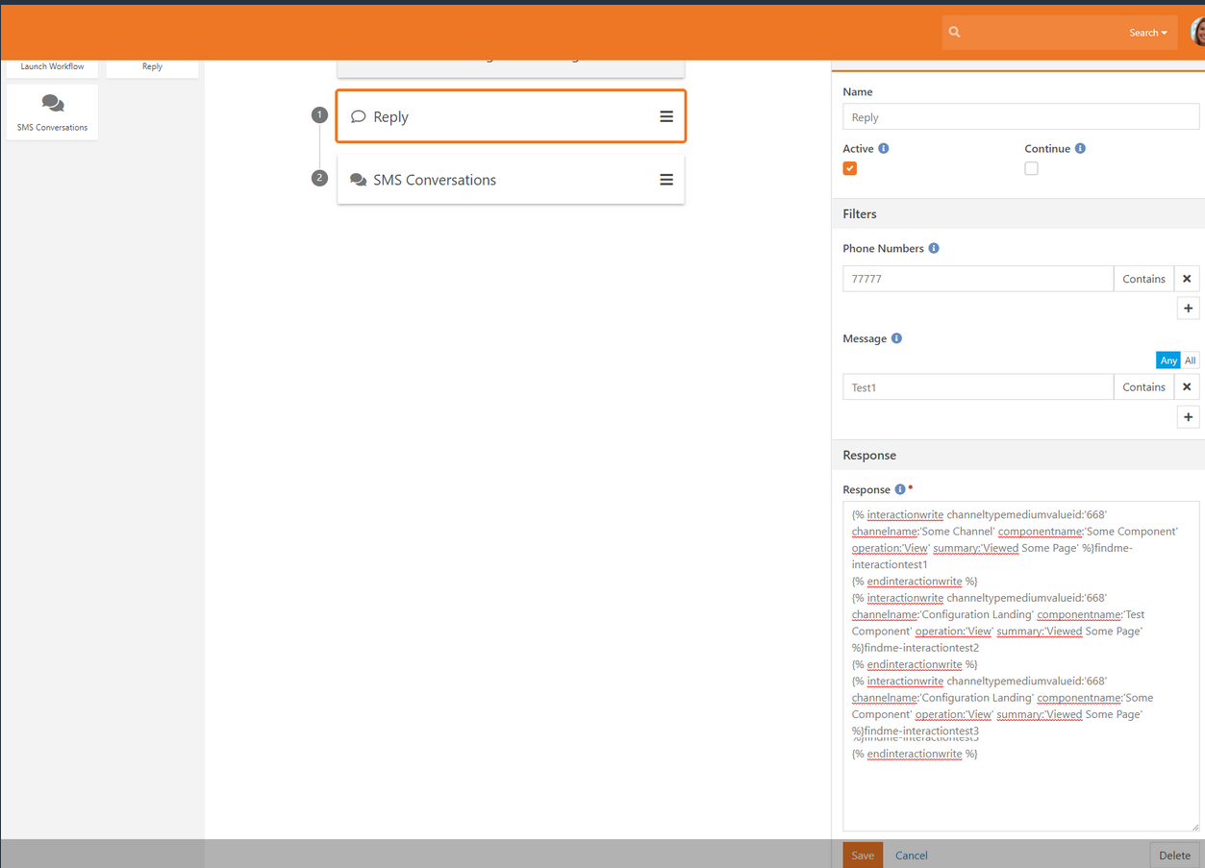

**View Interactions Created**
![old-channel-new-interactions](https://user-images.githubusercontent.com/36978982/108251823-242b4700-7115-11eb-8b12-0bfed13867b6.png)
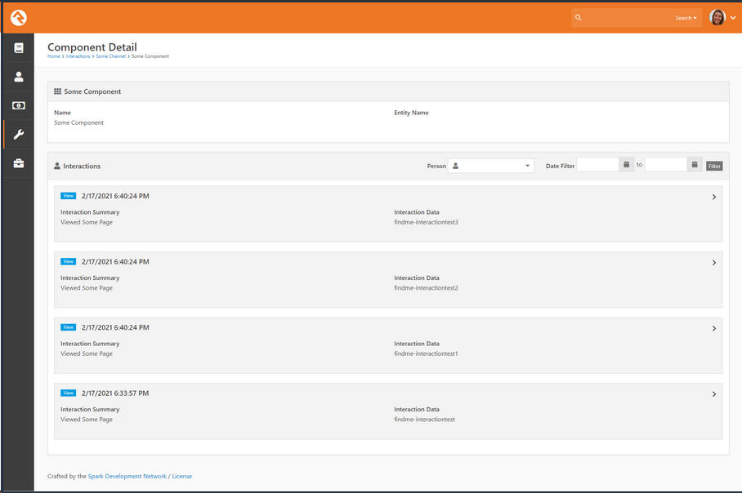

**Expected behavior:**

In the sample lava, we are creating new channels and components. The expected behavior is that a new channel called, "Configuration Landing" would be created in addition to an interaction being written to the "Some Channel" channel and "Some Component" component.

**Actual behavior:**

In the sample lava, we are creating new channels and components, however these new channels and components are being added to "Configration Landing" channel and "Test Component" component. These interactions are being added to the previously created channel and component.

### Versions

* **Rock Version:** v13.0
* **Client Culture Setting:** en-us

