***Mercredi, 29 Octobre 2025***

**21U2144**

**TIOMELA ZANGUE JOREL**

**INF M1-GL**

**TD1 INF4067: UML et Design Patterns**

Master 1 – 2025-2026

1. **SRP – Single Responsibility Principle**

* **Diagramme UML Avant**

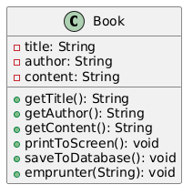

* **Diagramme UML Apres**

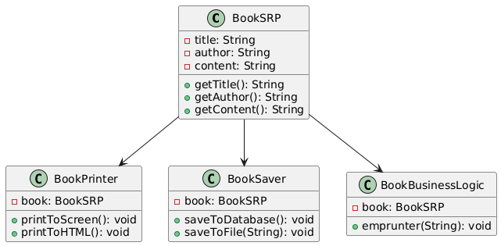

1. **OCP – Open-Closed Principle**

* **Diagramme UML Avant**

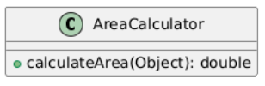

* **Diagramme UML Apres**

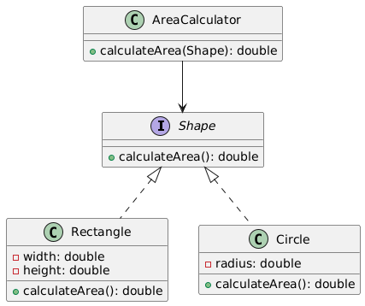

1. **LSP – Liskov Substitution Principle**

* **Diagramme UML Avant**

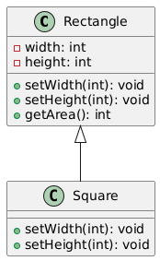

* **Diagramme UML Apres**

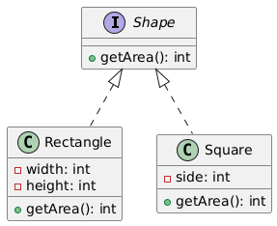

1. **ISP – Interface Segregation Principle**

* **Diagramme UML Avant**

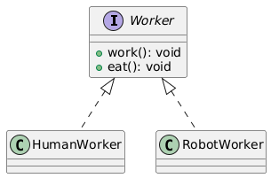

* **Diagramme UML Apres**

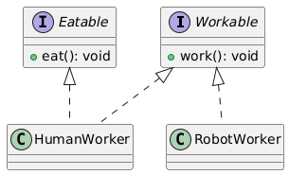

1. **DIP – Dependency Inversion Principle**

* **Diagramme UML Avant**

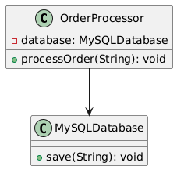

* **Diagramme UML Apres**

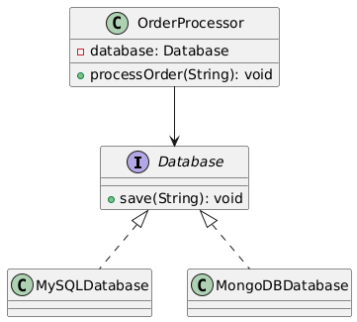

**Lien Github : https://github.com/SparkJorel/solide_principes.git**