

**C# Assessment Quiz: Lessons 1 – 5**

**Part A – True or False (2 points each)**

1. In C#, everything is an object.  
     
   **True  False**
2. Class Object is the base class for all reference-type objects only.  
     
   **True  False**
3. In C#, value-type objects store their data directly; however, for reference-type objects, we use reference variables to access the actual object.  
     
   **True  False**
4. Class fields *have* to be labeled as private, otherwise, the compiler will generate an error.  
     
   **True  False**
5. Properties provide an easy way for *controlled access* to an object’s attributes.  
     
   **True  False**
6. In C#, you can define certain areas as collapsible regions, by wrapping the desired code between two directives: #beginregion and #endregion  
     
   **True  False**
7. XML comments are produced by typing /* and */ before a method or property.  
     
   **True  False**
8. When writing formatted output to the console window, each format item is numbered, *starting* from 1.  
     
   **True  False**
9. Console.ReadLine() returns a string; we must convert the string to the appropriate datatype that we wish to use.  
     
   **True  False**
10. This statement will print a number in currency format within a field width of 10 characters, right-justified: Console.WriteLine(“{0, 10:C}”, 1234.55);  
      
    **True  False**
11. The method *signature* must have a return type, name and parameter list specified. The only exception to this rule are constructors which have only a name, and no parameter list or return type.  
      
    **True  False**
12. You specify the overriding of ToString by coding the keyword – **override** – just before the return type.  
      
    **True  False**
13. The ToString() method is called each time we print an object that is *not* of a String datatype.  
      
    **True  False**
14. Arrays of value-types have elements which store the data directly. Arrays of reference-types have elements that are references to the actual objects.  
      
    **True  False**
15. When you declare an array, each element is initialized to null (for reference-type arrays), or 0 (for numeric arrays).  
      
    **True  False**
16. While loops are easy to use for iterating (traveling through each element) of an array. This is because they *automatically increment* the counter variable that you use as the index into the array’s elements.  
      
    **True  False**
17. When running your program in debug mode, several options are made available to you. These options include: ‘Step Into’, ‘Step Out’, ‘Step Sideways’  
      
    **True  False**
18. A breakpoint marks a point in your code where your program will crash.  
      
    **True  False**
19. Namespaces are used to organize classes and prevent name clashes from similarly-named classes.  
      
    **True  False**
20. A namespace *cannot* be defined inside another namespace.  
      
    **True  False**

**Part B – Short Answers (5 points each)**

1. In your own words, explain why we need to keep the fields of an object private.  
     
   
2. When is it best to use a property, and when is it best to use a method? Explain the difference between the two.  
     
   
3. Why would you want to override ToString()? Give an example of such a situation.  
     
   
4. How would arrays be useful since they don’t change size?  
     
   
5. In Visual Studio, you have the ability to generate Windows Forms (GUI) applications by simply dragging and dropping text boxes, buttons, etc… onto the window form. Visual Studio generates this code for you. What good does this do, and how can it help programmers?  
     
   

**Part C – Check My Code (6 points)**

The following code segment contains errors. In the following textbox, write down what errors exist and how to fix them.

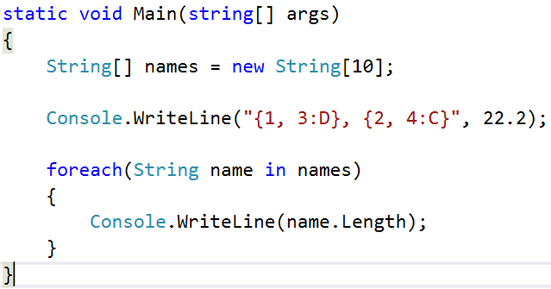  
  
  
  
<https://www.facebook.com/pages/Concord-Spark-Tutoring/415848731922060>