**SpecFlow**

Spec flow setup steps:

**Installation:**

* Install visual studio2017 community version and install the .net necessary plugins
* File New project 🡪Test 🡪unit testproject

To add References

Go to View🡪solution Explorer

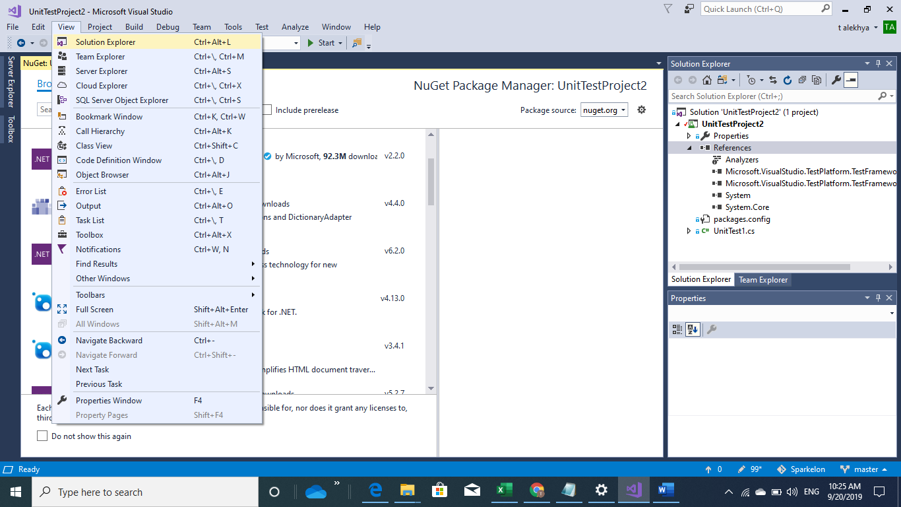

In solution explorer 🡪references-right click 🡪select Manage Nuget packages

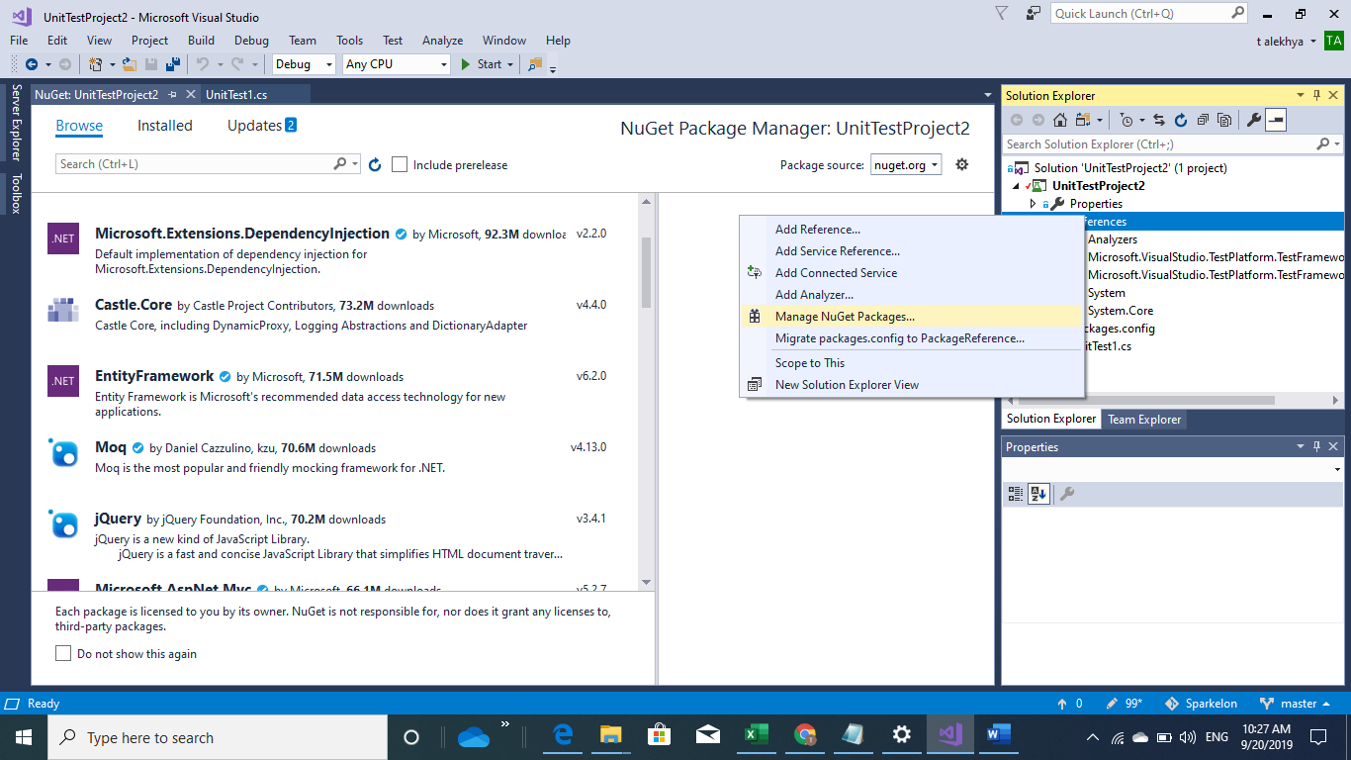

In Browse section search specflow and install the packages Specflow and specrun.Specflow

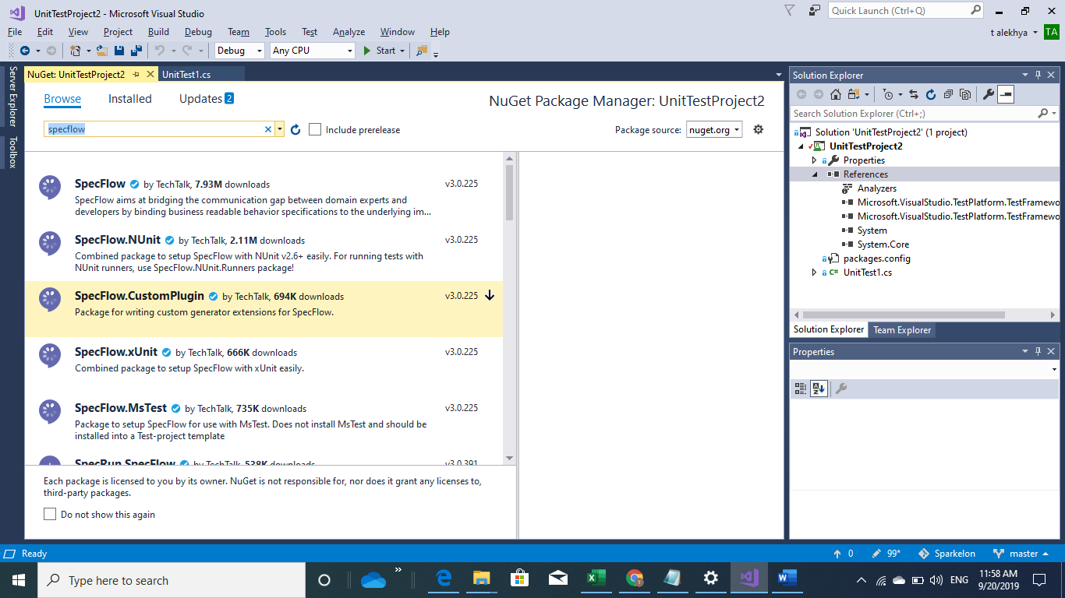

Tools🡪Extensions and update

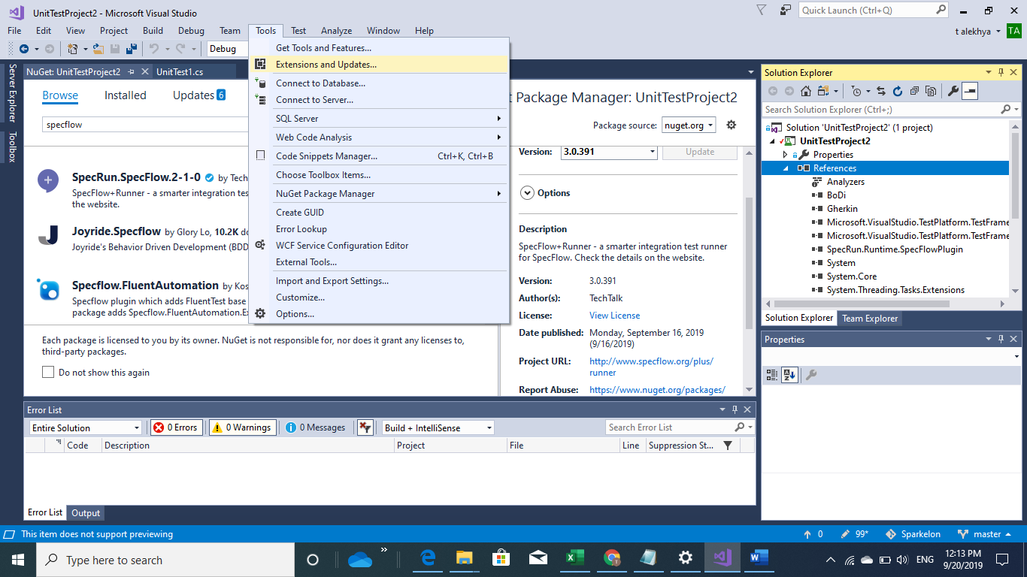

New project🡪Visual C# 🡪classLibrary(.Net framework)Name it as SpecflowSetup

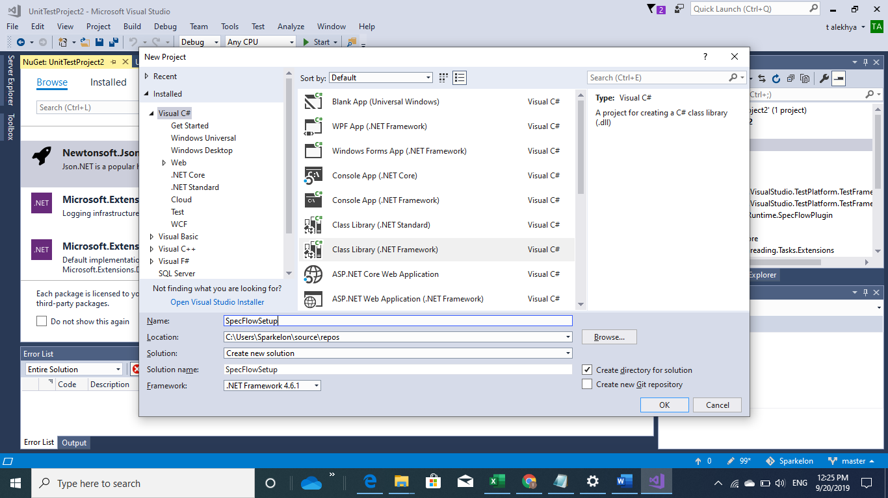

Go to Tools🡪Extensions& Updates🡪online -search Specflow

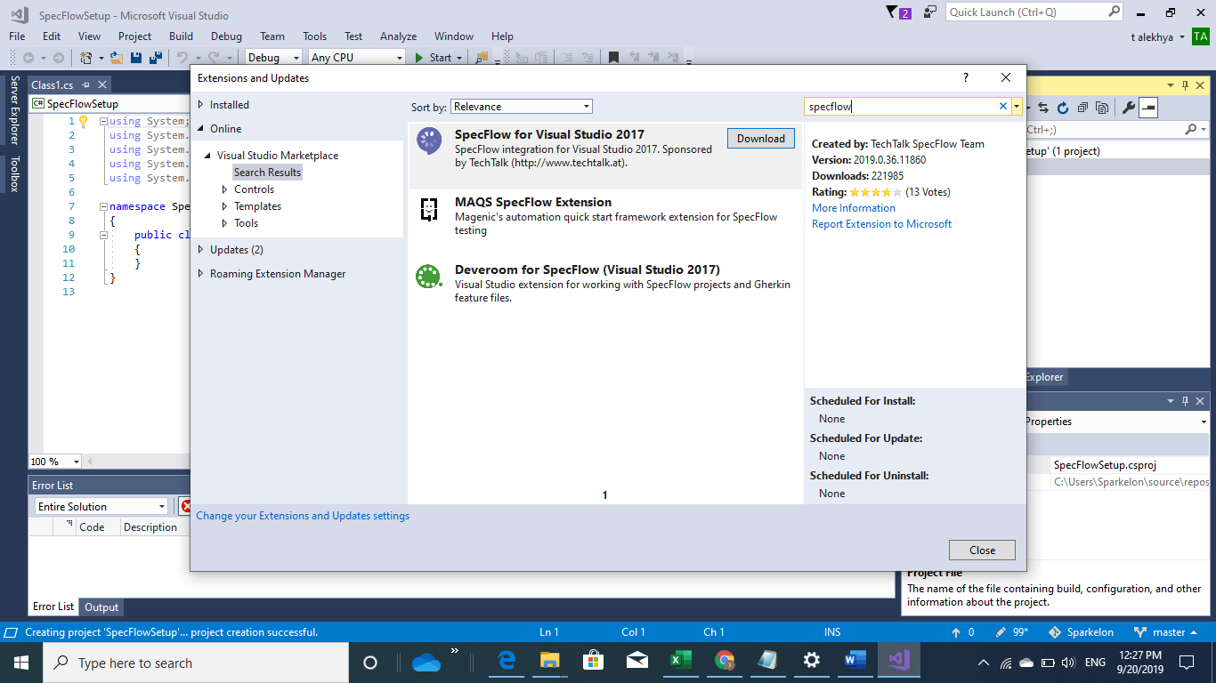

Download specflow for Visual studio 2017

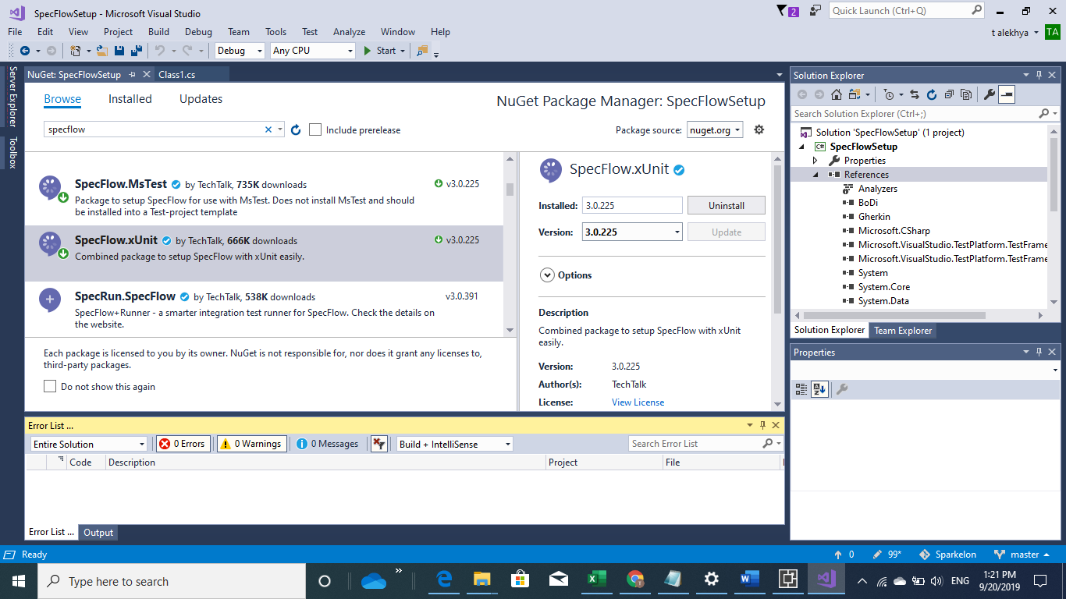

To create new feature file

Specflowsetup->rightclick add new item

